CODEN STJSAO ISSN 0562-1887
ZX470/1604 UDK 663.5:620.9:504.06
Bioethanol production and power generation for co-production*

Yasuki KANSHA, Akira KISHIMOTO and Atsushi TSUTSUMI

Collaborative Research Center for Energy Engineering, Institute of Industrial Science, The University of Tokyo, 4-6-1 Komaba, Meguro-ku, Tokyo 153-8505, Japan

a-tsu2mi@iis.u-tokyo.ac.jp

Keywords
Bioethanol production
Energy
Self-Heat Recuperation
Process Design
Co-production
Ključne riječi
Proizvodnja bioetanola
Energija
Povrat topline
Izvedba procesa
Koprodukcija
Primljeno (Received): 2012-05-15
Prihvaćeno (Accepted): 2012-09-10
Original scientific paper
Abstract: The concept of co-production of energy and products has recently been developed in order to consider the energy and production system from the point of view of improving energy conversion efficiency and saving energy. The authors have developed self-heat recuperation technology to optimize the energy of individual processes and realize co-production for energy saving. In this technology, process stream heat is recuperated and recirculated into the process using heat exchangers and compressors, leading to marked reductions in the process energy required.
In this paper, the feasibility of co-production of bioethanol and power by integration of self-heat recuperative processes and biomass gasification for power generation is examined and the relationship between production energy and biomass components is discussed using the energy balance calculation.
*Koprodukcija bioetanola i električne energije
Izvorni znanstveni članak
Sažetak: Nedavno je razvijen koncept koprodukcije energije i proizvoda u cilju unapređenja efikasnosti pretvorbe energije i ostvarivanja energetskih ušteda, uzimajući u obzir energiju i sustav proizvodnje. Autori su razvili tehnologiju povrata topline za optimizaciju pojedinih procesa i ostvarenje energetske uštede koprodukcijom. U ovoj tehnologiji, toplinski tok se vraća i reciklira u procesu putem izmjenjivača i kompresora, što vodi do značajnog smanjenja potrebne energije u procesu. U ovom radu ispituje se izvedivost koprodukcije bioetanola i električne energije integrirajući proces povrata topline i rasplinjavanja biomase za proizvodnju energije, a veza između proizvodnje energije i komponenata biomase objašnjena je koristeći proračun energetske bilance.

Introduction

The reduction of carbon dioxide (CO2) emission has become a major target in efforts to suppress global warming. Biomass use for fuel has attracted an increased interest in many countries for a number of reasons [1-3]. In particular, many researchers anticipate the possibility of bioethanol as a substitute for petroleum [4]. Indeed, bioethanol production loses less energy and exergy potential during the chemical reactions used in its production because it is produced merely through energy conversion by chemical reactions [5]. However, after fermentation, the product contains a large amount of water, which lowers the heat value of the product. Therefore, separation of the ethanol-water mixture is required to obtain pure ethanol for fuel [6-8]. In practice, distillation is widely used for this separation but conventional distillation is well-known as a high energy consumption process and pure fuel ethanol cannot be produced from a simple distillation column because ethanol and water form an azeotropic mixture [9]. To separate pure ethanol from ethanol-water mixtures by distillation, it is necessary to use an entrainer (azeotroping agent). This means that it is necessary to separate twice and to obtain three products, leading to increased energy consumption. As alternatives to distillation, membrane separations [10] or pressure swing adsorption (PSA) [11] have been investigated to achieve efficient separation [12]. However, many investigations have paid little attention to the overall process scheme or have developed heat integration processes based on conventional heat recovery technologies [13]. As a result, the minimum energy required for the overall process has not been reached. Thus, the price of product bioethanol remains high compared with fossil fuels.
Currently, by reconsidering the energy and production system from the point of view of improving the energy conversion efficiency and saving energy, the concept of poly-generation and co-production of energy and products has been developed and the feasibility of biomass utilization have been analyzed [14-16]. However, to realize energy saving through poly-generation and co-production, it is necessary to analyze and optimize the heat and power required for production in each process. To achieve this, the authors have developed self-heat recuperation technology based on exergy recuperation [17] and have applied it to several chemical processes related to the production of biofuels [18-23].
In this paper, a co-production system for bioethanol production and power, based on self-heat recuperation technology, is proposed and the relationship between production energy and biomass components is discussed, based on an overall energy balance for bioethanol production.

Energy balance for conventional bioethanol production
To consider the overall energy balance for bioethanol production, we assumed the following: 1) the amount of energy in the feed stock wet biomass is 100%, 2) the energy value of wet biomass consists of 50% from the energy value of reactant sugars such as starch, cellulose and others, 3) half of the product energy is required to produce pure ethanol by distillation and azeotropic distillation as heat and 4) non-reactants contain a large amount of water, for which the higher heat value is almost equal to the evaporation heat, leading to a net heat value of zero.
The amount of energy of the original wet biomass is divided into two flows: wet biomass transfers to production as a reactant (36%) and to fuel for distillation (17%) as shown in Fig. 1. The amount of energy of the original sugar component (36%) transfers to ethanol (33%) and heat (3%) through chemical reactions (pretreatment, saccharification and fermentation) with water. This energy is calculated from the following: the caloric value of sugar is 685 kcal/mol, the caloric value of ethanol is 316 kcal/mol and 2 mol ethanol is produced from 1 mol sugar through the above reactions. The pure ethanol product is then separated by distillation and additional heat energy (17%) is required for this distillation work when azeotropic distillation is used for the separation. This additional energy (11%) is used to dry the wet biomass in a heater to produce dry biomass that is used as fuel for distillation. Although the moisture content of the feed stock biomass is therefore changed, the above-mentioned relationships are not markedly changed because the reaction conditions remain and work as a buffer.
Figure 1 shows the total energy balance, including this additional energy. It is noted that 50-80% moisture content in the wet biomass is assumed in this energy analysis, because many types of wet biomass exist in this range, such as those that originate from ligneous materials, garbage and sludge. It can be seen from Fig. 1 that the energy in the wet biomass feed stock is transferred to the energy of ethanol (33%). Thus, 2/3 of the wet biomass feed stock energy is wasted. Even though this wasted heat energy could potentially act as heat sources for other processes, the exergy ratio and temperature of the waste heats are quite low. In particular, the wet residue still offers a large potential for utilizing the energy source, however, the moisture content of this wet residue is quite high without drying and it consumes a large amount of energy in drying. Thus, it cannot be utilized without highly energy-efficient drying and is normally wasted as a compost material or burned with a fuel of higher heat value. Thus, it is difficult to achieve energy savings from this by heat integration technologies such as cascading utilization. In fact, the highest required temperature during bioethanol production is normally at the distillation column reboiler and this temperature is lower than 150 °C. This heat is exhausted from the condenser at below 100 °C.
To utilize the biomass energy more effectively, it is clear that the energy consumption during distillation for separating water and product ethanol and for drying of the wet biomass must be reduced. When an integrated system of distillation and membrane separation processes are utilized to substitute for azeotropic distillation, the energy required can be decreased from 17% to 9% (6%: distillation, 3%: membrane separation). However, the pressure difference for membrane separation requires electric power. If we assume that the power generation efficiency from dry biomass is 30% and that 75% of the energy for the membrane separation process is provided by electricity, it can be estimated that almost equal amounts of wet biomass are required as a fuel for azeotropic distillation and dehydration by membrane separation. According to this energy balance, the moisture content of the biomass feed stock affects only the amount of additional heat used for distillation and azeotropic distillation.

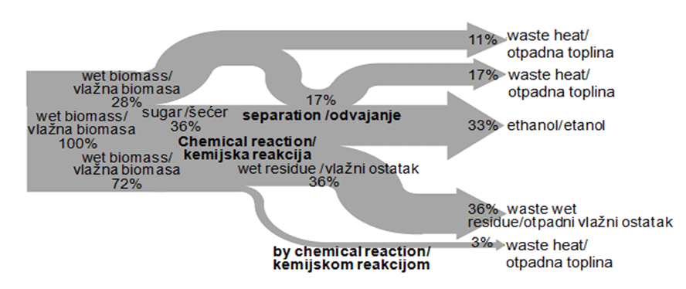
Figure 1. Energy balance for bioethanol production
Slika 1. Energetska bilanca za proizvodnju bioetanola

Self-heat recuperation technology
To realize co-production of bioethanol and power, it is necessary to optimize the energy of each process for energy saving. Kansha et al. proposed self-heat recuperation technology that facilitates recirculation of not only latent heat but also sensible heat in a process, and helps to reduce the energy consumption of the process by using compressors and self-heat exchangers based on exergy recuperation [17]. In this technology, 1) a process unit is divided on the basis of functions required to balance the heating and cooling loads by performing enthalpy and exergy analysis, 2) the cooling load is recuperated by compressors and exchanged with the heating load. As a result, the heat of the process stream is perfectly circulated, without heat addition, and thus, the energy consumption for the process can be greatly reduced. By applying this technology to each process (distillation and dehydration) [20], the energy balance for the ethanol production can be changed significantly.
A self-heat recuperative thermal process is introduced to illustrate the design methodology based on self-heat recuperation. To reduce the energy consumption in a process through heat recovery, heating and cooling functions are generally integrated for heat exchange between feed and effluent to introduce heat circulation. A system in which such integration is adopted is called a self-heat exchange system. To maximize the self-heat exchange load, a heat circulation module for the heating and cooling functions of the process unit has been proposed, as shown in Figure 2 [17].
Figure 2 (a) shows a thermal process for vapor/liquid streams with heat circulation using self-heat recuperation. In this process, the feed stream is heated with a heat exchanger (1→2) from a standard temperature, T₀, to a set temperature, T₁. The effluent stream from the subsequent process is pressurized with a compressor (3→4). The latent heat can then be exchanged between feed and effluent streams because the boiling temperature of the effluent stream is raised to T_{b'} by compression. Thus, the effluent stream is cooled through the heat exchanger for self-heat exchange (4→5) while recuperating its heat. The effluent stream is then depressurized by a valve (5→6) and finally cooled to T₀ with a cooler (6→7). This leads to perfect internal heat circulation by self-heat recuperation. It is noted that the total heating duty is equal to the internal self-heat exchange load, Q_{HX}, without any external heating load, as shown in Fig. 2 (b). It is clear that the sensible heat of the vapor and liquid in the feed stream can be exchanged with the sensible heat of the corresponding effluent stream and the vaporization heat of the feed stream exchanged with the condensation heat of the effluent stream. In the case of ideal adiabatic compression, the input work provided to the compressor performs a heat pumping role, in which the effluent temperature can achieve perfect internal heat circulation without exergy dissipation. Therefore, self-heat recuperation can dramatically reduce energy consumption. As a result, the energy required by the heat circulation module is reduced to 1/22–1/2 of the original by the self-heat exchange system in not only the vapor/liquid streams but also the gas streams. This design for a self-heat recuperative thermal process can be applied to the distillation processes [18-21] and dehydration processes such as drying [22, 23]. Such self-heat recuperative processes consume 1/6-1/8 of the energy required of the heat exchanged in conventional processes.
Nippon Steel Engineering Co., Ltd. reported that 65% of the total energy required for their conventional bioethanol production was consumed during distillation. This value is almost consistent with our analysis as shown in Fig. 1. Then, they applied this self-heat recuperation technology to their pilot distillation plant for bioethanol production and achieved an 85% reduction of energy requirement as compared with their conventional distillation plant for bioethanol production. At the same time, they reported that this process requires only 3.3 years as the payout period [24].
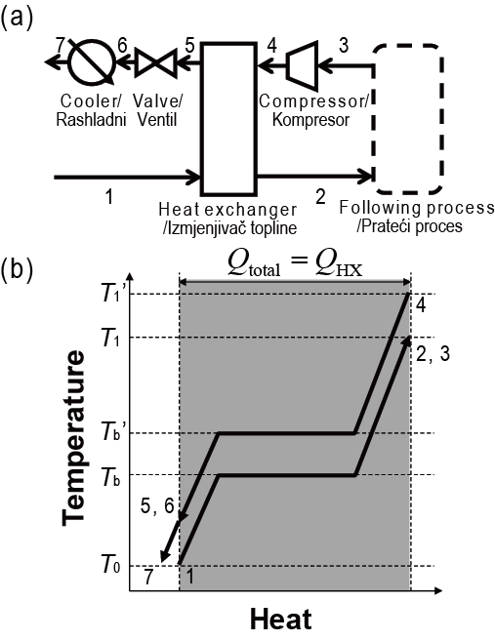
Figure 2. Self-heat recuperative thermal process a) process flow of gas streams, b) temperature-heat diagram for the vapor/liquid stream
Slika 2. Toplinski process povrata topline a) tijek procesa plinskog toka, b) dijagram temperature-toplina toka pare/ tekućine

Integration with biomass gasification
To adopt self-heat recuperative processes, it is necessary to generate power to substitute for heat energy. According to the energy balance shown in Fig. 1, plenty of residue is produced during bioethanol production with a heat value insufficient for utilization because of its high moisture content. By integrating a drying process based on self-heat recuperation [22, 23] with power generation, this wet residue can be utilized for energy. Thus, an integrated system for self-heat recuperative bioethanol production with biomass gasification is introduced.
One of the easiest ways to generate power from biomass is through its direct combustion in a boiler, wherein thermal energy is produced and power is generated from biomass using a steam turbine (boiler and turbine generator). However, the energy conversion efficiency is insufficient under this approach. To increase the efficiency of energy conversion from biomass to power, the biomass gasification reaction is used. Gasification reactions can be divided into two mechanisms: pyrolysis and gasification by chemical reaction (partial oxidation, etc.) Biomass gasification normally passes through both of these. After passing through a series of gasification procedures, the gases are fed into a gas turbine, thus generating power. Gasification reactions are normally endothermic so they must be provided with heat. However, overall energy conversion efficiency is higher than a boiler and turbine generator. In addition, a further increase in energy conversion efficiency, through a biomass-based integrated gasification combined cycle (IGCC) technology, has been investigated [25, 26].
It is currently assumed that the energy conversion efficiency of biomass through power generation and biomass gasification is 30% [14]. The energy amount of the wet residue is assumed to be 100%. It assumed that half of the energy amount of this wet residue can be utilized for drying the biomass. According to the analysis for self-heat recuperative drying, 1/7–1/8 of the amount of the energy for water evaporation is required for power to dry this wet residue using self-heat recuperative drying. This means that power (17%) can be generated and part of this power (13%) is used for drying, as shown in Fig. 3.
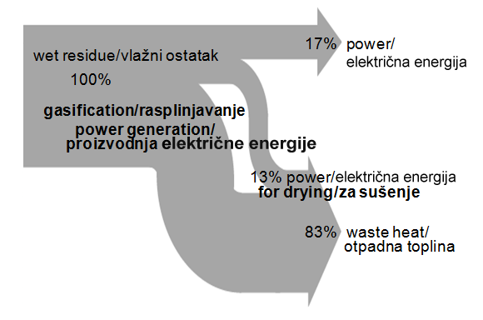
Figure 3. Power generation from wet residue
Slika 3. Proizvodnja električne energije iz vlažnog ostatka

Energy balance of self-heat recuperative bioethanol production
For consistency, the assumptions described above are made. By applying the self-heat recuperative distillation and azeotropic distillation process to the distillation and dehydration process, the additional heat energy for distillation is converted to power. The wet biomass (28%) required to provide the distillation heat (17%) is no longer necessary for this bioethanol production. Thus, additional ethanol (13%) can be generated from the feed stock wet biomass by using a self-heat recuperative drying process and biomass gasification. At the same time, the energy (17%) in Fig. 1 increases to 23 as heat energy, by increasing ethanol production, is converted to power (3%) by self-heat recuperation. This value was estimated from the energy reduction results from the self-heat recuperative processes using a commercial simulator (PRO/II Ver. 8.1).
By integrating the aforementioned biomass gasification with the self-heat recuperative processes introduced, bioethanol (46%) and power (6%) can be produced as co-products from wet biomass (100%) during bioethanol production. Wet residue can be utilized as the energy supply. Thus, it can be seen that 46% of the energy of the wet biomass is transferred to bioethanol and 6% of the energy is transferred to power.

Effect of moisture content of feed stock biomass
The effect of the moisture content of feed stock biomass is strongly related to the power generation [15], because 1/8 of the energy amount for water evaporation heat energy is required as power to dry this wet residue using self-heat recuperative drying [22, 23]. Many types of wet biomass contain more than 50-80% moisture. In the self-heat recuperative drying process, as the amount of steam eliminated from the biomass increases, the power required for drying increases proportionally, because the compression ratio can be maintained and the flow rate through the compressor increases.
We assumed the same feed stock biomass moisture content as the previous results to analyze a co-production system based on self-heat recuperation, as shown in Fig. 4. The following results were obtained: 46% of the energy of the wet biomass is transferred to bioethanol and 6% is transferred to power for co-production. In this case, we attempted to increase ethanol production using the self-heat recuperation. Alternatively, we can increase the power and maintain the ethanol production rate. It can be concluded that this bioethanol production procedure achieves not only energy savings but also reduces exergy dissipation for the whole process, leading to optimal co-production.

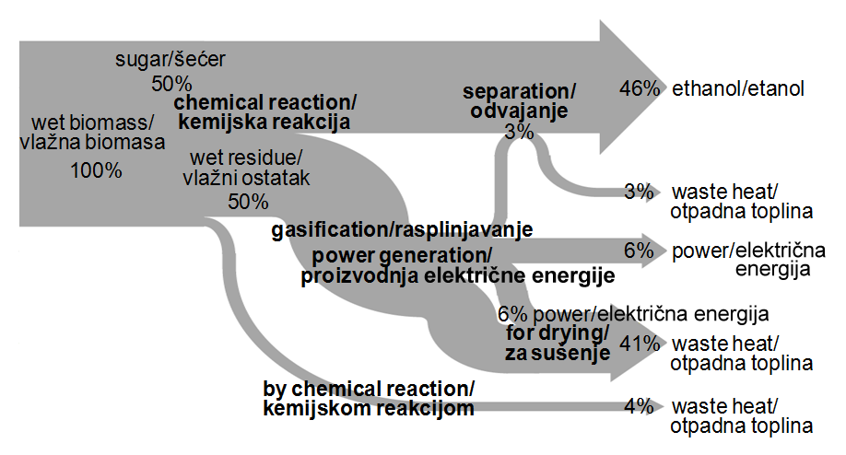
Figure 4. Total energy balance of bioethanol production with self-heat recuperation
Slika 4. Ukupna energetska bilanca proizvodnje bioetanola s povratom topline

Conclusion
In this paper, the feasibility of the co-production of bioethanol and power through integration of recently developed self-heat recuperative processes and biomass gasification for power generation is examined based on energy balances. In addition, the effect of feed stock biomass moisture content on the total energy is examined. From the analysis of the energy balance for conventional bioethanol production processes, a large amount of energy is consumed for the separation of water (distillation and drying) so that the operational costs for bioethanol production are high, limiting the potential contribution of bioethanol to society. Moreover, feed stock biomass moisture content only affects power generation efficiency. However, by incorporating self-heat recuperative processes for distillation, azeotropic distillation and drying, not only are the energy requirements reduced dramatically due to heat circulation within the processes but also wasted residue can be utilized as a power source through biomass gasification. Thus, it is shown that co-production of bioethanol and power has potential, facilitating the economic impact of bioethanol products.
References
[1] MOUSDALE, D.M.: Introduction to Biofules, CRC Press, FL, USA 2010.
[2] DEMIRBAS, A.: Competitve liquid biofuels from biomass, Appl. Energy (2011) 88, 17-28.
[3] FINK, R.; MEDVED, S.: Environmental Impacts of the first generation liquid biofuels production and emerging global climate changes, Strojarstvo (2009) 51, 537-545.
[4] BALAT, M.; BALAT, H.: Recent trends in global production and utilization of bio-ethanol fuel, Appl. Energy (2009) 86, 2273-2282.
[5] CARDONA, C.A.; SANCHEZ, O.J.; GUTIERREZ, L.F.: Process Synthesis for Fuel Ethanol Production, CRC Press, FL, USA 2010.
[6] ZAMBONI, A.; SHAH, N.; BEZZO, F.: Spatially Explicit Static Model for the Strategic Design of Future Bioethanol Production Systems. 1. Cost Minimization, Energy Fuels (2009) 23, 5121-5133.
[7] ZAMBONI, A.; SHAH, N.; BEZZO, F.: Spatially Explicit Static Model for the Strategic Design of Future Bioethanol Production Systems. 2. Multi-Objective Environmental Optimization, Energy Fuels (2009) 23, 5134-5143.
[8] HUANG, H.J.; RAMASWAMY, S.; TSCHIRNER, U.W.; RAMARAO, B.V.: A review of separation technologies in current and future biorefineries, Sep. Purif. Technol. (2008) 62, 1-21.
[9] MUSSATI, M.C.; AGUIRRE, P.A.; ESPINOSA, J.; IRIBARREN O.A.: Optimal Design of Azeotropic Batch Distillation, AIChE J. (2006) 52, 968-985.
[10] OKABE, K.; YUSHIO, Y.; HOSOYA, T.; KANAZAWA, S.; KASHIHARA, H.; NAKAI, R.: Energy and cost evaluation for concentration and dehydration process of bioethanol by zeolite membranes, Kagaku Kougaku Ronbunshu (2010) 36, 486-493.
[11] MODLA, G.; LANG, P.: Feasibility of new pressure swing batch distillation methods, Chem. Eng. Sci. (2008) 63, 2856-2874.
[12] FROLKOVA, A.K.; RAEVA, V.M.: Bioethanol dehydration: state of the art, Theor. Found. Chem. Eng. (2010) 44, 545-556.
[13] KEMP, I.C.: Pinch Analysis and Process Integration A User Guide on Process Integration for the Efficient Use of Energy 2nd Ed., Elsevier, Oxford, UK 2007.
[14] SAGA, K.; IMOU, K.; YOKOYAMA, S.; MINOWA, T.: Net energy analysis of bioethanol production system from high-yield rice plant in Japan, Appl. Energy (2010) 87, 2164-2168.
[15] SONG, H.; STARFELT, F.; DAIANOVA, L.; YAN, J.: Influence of drying process on the biomass-based polygeneration system of bioethnol, power and heat, Appl. Energy (2012) 90, 32-37.
[16] STARFELT, F.; DAIANOVA, L.; YAN, J.; THORIN, E.; DOTZAUER, E.: The impact of lignocellulosic ethanol yields in polygeneration with district heating- A case study, Appl. Energy (2012) 92, 791–799.
[17] KANSHA, Y.; TSURU, N.; SATO, K.; FUSHIMI, C.; TSUTSUMI, A.: Self-heat recuperation technology for energy saving in chemical processes, Ind. Eng. Chem. Res. (2009) 48, 7682-7686.
[18] KANSHA, Y.; TSURU, N.; FUSHIMI, C.; SHIMOGAWARA, K.; TSUTSUMI, A.: An innovative modularity of heat circulation for fractional distillation, Chem. Eng. Sci. (2010) 65, 330-334.
[19] KANSHA, Y.; TSURU, N.; FUSHIMI, C.; TSUTSUMI, A.: Integrated process module for distillation processes based on self-heat recuperation technology, J. Chem. Eng. Jpn. (2010) 43, 502-507.
[20] KANSHA, Y.; TSURU, N.; FUSHIMI, C.; TSUTSUMI, A.: New design methodology based on self-heat recuperation for production by azeotropic distillation, Energy Fuels (2010) 24, 6099-6102.
[21] MATSUDA, K.; KAWAZUISHI, K.; KANSHA, Y.; FUSHIMI, C.; NAGAO, M.; KUNIKIYO, H.; MASUDA, F.; TSUTSUMI, A.: Advanced energy saving in distillation process with self-heat recuperation technology, Energy (2011) 36, 4640-4645.
[22] FUSHIMI, C.; KANSHA, Y.; AZIZ, M.; MOCHIDZUKI, K.; KANEKO, S.; TSUTSUMI, A.; MATSUMOTO, K.; YOKOHAMA, K.; KOSAKA, K.; KAWAMOTO, N.; OURA, K.; YAMAGUCHI, Y.; KINOSHITA, M.: Novel drying process based on self-heat recuperation technology, Drying Technol. (2011) 29, 105-110.
[23] AZIZ, M.; FUSHIMI, C.; KANSHA, Y.; MOCHIDZUKI, K.; KANEKO, S.; TSUTSUMI, A.; MATSUMOTO, K.; HASHIMOTO, T.; KAWAMOTO, N.; OURA, K.; YOKOHAMA, K.; YAMAGUCHI, Y.; KINOSHITA, M.: Innovative energy-efficient biomass drying based on recuperation technology, Chem. Eng. Technol. (2011) 34, 1095-1103.
[24] Institute of Industrial Science Press Conference Web page (Final Access: 10. May.2012) http://www/publication_e/press_e.html#2012/02/02
[25] BRIDGWATER, A.V.: The technical and economic feasibility of biomass gasfication for generation, Fuel (1995) 74, 631-653.
[26] GARCIA-GALINDO, D.; ROYO, F.J.; SEBASTIÁN, F.: Assessment of biomass co-firing potentials in coal power plants, Strojarstvo (2010) 52, 411-427.

