Comparison of cystometric capacities
and leak-point intravesical pressures between tetraplegic
and paraplegic spinal cord injury patients
with neurogenic detrusor overactivity

Saša MOSLAVAC¹, Ivan DŽIDIĆ¹, Zoran FILIPAN²
¹Spinal Unit, Special Medical Rehabilitation Hospital, Varaždinske Toplice, Croatia,
²Department of Urology, Varaždin General Hospital, Varaždin, Croatia
Primljeno / Received : 2010-04-01; Prihvaćeno / Accepted: 2010-07-13
Correspondence to:
Saša Moslavac, MD
Spinal Unit Special Medical Rehabilitation Hospital
HR-42223 Varaždinske Toplice
Croatia
Tel. +385 42 630 224
Fax. +385 42 630 827
E-mail: sasa.moslavac@vz.t-com.hr

Abstract

The aims were to compare cystometric capacities and leak-point intravesical pressures between tetraplegic and paraplegic spinal cord injury patients with neurogenic detrusor overactivity, and to assess eligibility of using suprapubic tapping voiding with external collection device in tetraplegic patients. Filling cystometry at non-physiological filling rate was performed in 122 spinal cord injury patients at rehabilitation or annual check-up using Dantec Etude urodynamic machine. Sixty-seven tetraplegic and 55 paraplegic patients were diagnosed with neurogenic detrusor overactivity, all with suprasacral level of injury. The mean cystometric capacity (CC) was 260±117 mL (range 53-500) in tetraplegic group and 289±135 mL (range 42-530) in paraplegic group. There was no significant between-group difference in CC (P=0.220). The mean leak-point intravesical pressure (Pves LPP) at CC was 72±25 cm H₂O (range 25-124) in tetraplegic group and 70±27 cm H₂O (range 25-140) in paraplegic group. The difference was not significant (P=0.711).

The findings were equally unfavorable in both groups, suggesting the method of suprapubic tapping voiding with external collection device to be no more advisable in tetraplegic than in paraplegic patients. Neurogenic bladder should be managed with the same caution in cervical (tetraplegic) and thoracolumbar (paraplegic) patients, including intermittent catheterization as the first treatment choice, as opposed to the use of the less carer-time-consuming suprapubic tapping voiding with external collection device.

Key words: spinal cord injury, cystometry, detrusor overactivity, suprapubic
tapping.

Usporedba cistometrijskih kapaciteta i intravezikalnih tlakova kod prokapavanja u
tetraplegičnih i paraplegičnih bolesnika s ozljedom kralježničke moždine i neurogenom
hiperaktivnošću detruzora

Sažetak

Ciljevi rada bili su usporediti cistometrijske kapacitete i intravezikalne tlakove kod prokapavanja u tetraplegičnih i paraplegičnih osoba s ozljedom kralježničke moždine i neurogenom hiperaktivnošću detruzora, i ocijeniti podobnost suprapubičnog lupkanja s kondom urinal drenažom u tetraplegičnih bolesnika. Cistometrija nefiziološkom brzinom punjenja učinjena je kod 122 bolesnika s ozljedom kralježničke moždine tijekom rehabilitacije ili godišnje evaluacije stanja uporabom urodinamskog aparata Dantec Etude. Neurogenu hiperaktivnost detruzora imalo je 67 bolesnika s tetraplegijom i 55 bolesnika s paraplegijom, svi sa suprasakralnom razinom ozljede. Srednja vrijednost cistometrijskog kapaciteta (CK) za tetraplegičnu skupinu bila je 260±117 ml (raspon 53-500), a za paraplegičnu skupinu 289±135 ml (raspon 42-530). Nije nađena značajna razlika CK među skupinama (P=0,220). Srednja vrijednost intravezikalnog tlaka kod promokravanja pri CK za tetraplegičnu skupinu bila je 72±25 cm H2O (raspon 25-124), a za paraplegičnu skupinu 70±27 cm H2O (raspon 25-140). Razlika među skupinama nije bila značajna (P=0,711). Nalazi su bili podjednako loši u obje skupine, stoga se metoda suprapubičnog lupkanja s kondom urinal drenažom ne može preporučiti u tetraplegičnih bolesnika više no u paraplegičnih. Neurogeni mjehur treba pažljivo liječiti u cervikalnih (tetraplegičnih) i torakolumbalnih (paraplegičnih) bolesnika, što uključuje intermitentnu kateterizaciju kao metodu izbora naspram za asistenta manje vremenski zahtjevnim suprapubičnim lupkanjem s uporabom kondom urinal drenaže.

Ključne riječi: ozljeda kralježničke moždine, cistometrija, hiperaktivnost
detruzora, suprapubično lupkanje

Introduction

Neurogenic detrusor overactivity (NDO) is a common consequence of suprasacral spinal cord injury (SCI), along with loss of motor and sensory functions below the injury level. NDO may lead to potentially life-threatening complications like urinary tract infections, vesico-ureteral reflux, hydronephrosis and pyonephrosis, especially when accompanied by detrusor-sphincter dyssynergia. Besides morphological changes observed by renal and bladder ultrasonography scan, urodynamic filling cystometry is done to monitor pressure-volume relation in the bladder, where the values of cystometric capacity (CC) and leak-point intravesical pressure (Pves LPP) represent important findings in validating the risk of upper urinary tract damage and in setting-up and revising bladder emptying program, since the severity of vesico-ureteral dysfunction cannot be assessed by clinical observation alone (1,2). SCI patients with cervical level of injury (e.g., tetraplegia) suffer from various degrees of hand function impairment with difficulties or inability to perform intermittent (self)catheterization (IC), which has been proven to be the best method of bladder emptying (3). Therefore, bladder program in tetraplegic patient includes around-the-clock nursing care within rehabilitation facility, or by carers in post-discharge time. Patients with distal level of injury (e.g., paraplegia) retain more abilities for self-care including self-catheterization, but both groups of patients are in equal need for carefully adjusted and maintained bladder emptying program. Besides IC, the program may consist of other methods such as suprapubic tapping voiding with external collection device use (condom urinals) for reflex bladder, in some cases with external sphincterotomy for treating patients with high urethral resistance and detrusor-sphincter dyssynergia (4,5), suprapubic cystostomy or urethral stents, although reported with temporary beneficial effects (6). Generally, the first methods of treatment are intermittent catheterization or suprapubic tapping voiding, but the chosen method should depend on the dynamic voiding dysfunction and bladder behavior, whereas reflex bladder should remain low-pressured with preserved capacity and low residuals to allow tapping voiding. The objective was to compare CC and Pves LPP between cervical and thoracolumbar spinal cord injury patients with neurogenic detrusor overactivity. If there were more favorable findings for tetraplegic patients, it would be clinically convenient to prescribe suprapubic tapping voiding and external collection device use (condom urinals) as the first treatment choice instead of intermittent catheterization, which requires more carer’s time.

Patients and methods

This was a retrospective study conducted during a 5-year period (2004-2009) in male spinal cord injury patients undergoing water filling cystometry during rehabilitation or annual check-up at Spinal Unit, Special Medical Rehabilitation Hospital in Varaždinske Toplice, Croatia. Their neurological injuries were stable and they were out of spinal shock, and their neurogenic bladders had definitive characteristics. The level of injury was assessed by standard neurological classification of spinal cord injury, according to key muscles and dermatomes (7). Filling cystometry is a method by which the pressure/volume relationship of the bladder is measured during filling with heated saline. The procedure was performed with Dantec Etude urodynamic machine at non-physiological filling rate, with double-lumen 8F catheter inserted transurethrally into the bladder. CC and Pves LPP at terminal detrusor overactivity (a single, involuntary detrusor contraction occurring at CC, which cannot be suppressed and results in incontinence) were recorded. Cystometry was stopped at the onset of incontinence or appearance of the symptoms of autonomic dysreflexia. Urodynamic evaluations conformed to the International Continence Society standardization (8). Only patients with urodynamic findings consistent with neurogenic detrusor overactivity (involuntary detrusor contractions during the filling phase) and without symptoms of autonomic dysreflexia were included in the study. Two groups of NDO patients were formed: cervical (C1-C8) and thoracolumbar (T1-L5) neurological level of injury. All patients agreed with the procedure as a routine clinical investigation. The study was approved by the local Ethics Committeeand the procedures followed were in accordance with ethical standards of the the Helsinki Declaration of 1975, as revised in 1983. Independent sample t-tests for equality of means were used to determine if differences existed between the groups. For all analysis, significance was set at P<0.05. Descriptive statistics was used and data are presented as mean ± standard deviation. Distribution was tested with Kolmogorov-Smirnov test. Statistical analysis was performed using SPSS for Windows, version 13.0 (SPSS Inc., Chicago, IL, USA).

Results

Sixty-seven patients with cervical (C1-C8 tetraplegia) and 55 patients with thoracolumbar (T1-L5 paraplegia) spinal cord injury were diagnosed with NDO, all of them male patients with suprasacral level of injury. The mean CC was 260±117 mL (range 53-500) in tetraplegic group and 289±135 mL (range 42-530) in paraplegic group. There was no significant between-group difference in CC (P=0.220) (Figure 1). The mean Pves LPP at CC was 72±25 cm H₂O (range 25-124) in tetraplegic group and 70±27 cm H₂O (range 25-140) in paraplegic group. The difference was not significant (P=0.711) (Figure 2). Despite data dispersion, distribution remained normal.
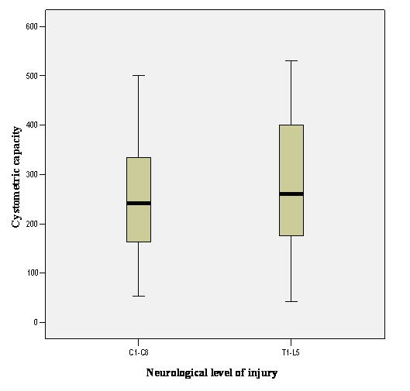

Figure 1 Cystometric bladder capacities (CC) in cervical (C1-C8 tetraplegia) and thoracolumbar (T1-L5 paraplegia) spinal cord injury patients

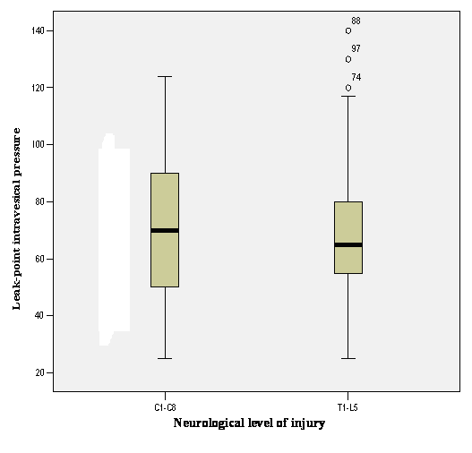

Figure 2 Leak-point intravesical pressures (Pves LPP) in cervical (C1-C8 tetraplegia) and thoracolumbar (T1-L5 paraplegia) spinal cord injury patients

Discussion

In our study, no differences were recorded in CC and Pves LPP at terminal detrusor overactivity between cervical (tetraplegic) and thoracolumbar (paraplegic) spinal cord injury patients. The CC and Pves LPP findings were equally unfavorable in both groups; however, it is more important in cervical patients as they have to follow the intermittent catheterization program, which is difficult to organize and maintain for life. Both CC and Pves LPP values showed large variability in the two groups, indicating high risk patients with extreme findings in both groups, with a potential to develop upper urinary tract damage in those with lower bladder capacity and higher intravesical pressure. The mean cystometric capacities in both groups (260 mL and 289 mL, respectively) represent reduction by almost half of normal values, which clinically denotes frequent urination or need for an increased number of intermittent catheterization a day. Similarly, the means of Pves LPP in both groups (72 cm H₂O and 70 cm H₂O, respectively) are higher than in able-bodied population, since 40 cm H₂O is proposed as a cut-off value between intravesical low pressure and high pressure (9).
Such pressures might lead to vesico-ureteral reflux, especially if detrusor-sphincter dyssynergia accompanies NDO, and bladder management program in both SCI groups must be carefully set and revised according to urodynamic findings throughout lifetime. In the majority of cases, intermittent catheterization with anticholinergic medication is the safest treatment, while further urologic treatments as sphincterotomy, urethral stents or suprapubic cystostomy may also be used (4-6). The method of suprapubic tapping voiding with the use of external collection device is no more advisable in tetraplegic than in paraplegic patients, and may be used in some patients with balanced, compliant bladders from both groups. We were not able to demonstrate difference in either bladder CC or Pves LPP between tetraplegic and paraplegic patients; therefore, generally we should insist on careful maintenance of life-long intermittent catheterization bladder program in both groups. The level of care for tetraplegic patients who are unable to perform the program themselves should remain equally dedicated post-discharge as it is in rehabilitation facility where the program is done by nurses. This poses heavy burden upon carers, and maintaining intermittent catheterization and incidence of urinary tract complications indicate the level of community health care in spinal cord injury patients.
Conclusion

Neurogenic bladder should be managed by the same caution in cervical (tetraplegic) and thoracolumbar (paraplegic) patients, including intermittent catheterization as the first treatment choice as opposed to less carer time-consuming suprapubic tapping voiding with the use of external collection device.
Conflict of interest statement

The authors declare that there is no conflict of interest.
Literature:

1. Kaplan SA, Chancellor MB, Blaivas JG. Bladder and sphincter behavior in patients with spinal cord lesions. J Urol 1991;146:113-7.

2. Schurch B, Schmid DM, Karsenty G, Reitz A. Can neurologic examination predict type of detrusor-sphincter dyssynergia in patients with spinal cord injury? Urology 2005;65:243-6.

3. Wyndaele J-J, Maes D. Clean intermittent self-catheterization: a 12-year follow up. J Urol 1990;143:906-8.

4. Pan D, Troy A, Rogerson J, Bolton D, Brown D, Lawrentschuk N. Long-term outcomes of external sphincterotomy in a spinal injured population. J Urol 2009;181:705-9.

5. Vaidyanathan S, Soni BM, Sett P, Singh G, Oo T, Hughes PL, Mansour P. Flawed trial of micturition in cervical spinal cord injury patients: guidelines for trial of voiding in men with tetraplegia. Spinal Cord 2003;41:667-72.

6. Mehta SS, Tophill PR. Memokath stents for the treatment of detrusor sphincter dyssynergia (DSD) in men with spinal cord injury: the Princess Royal Spinal Injuries Unit 10-year experience. Spinal Cord 2006;44:1-6.

7. Maynard Jr FM, Bracken MB, Creasey G, et al. International Standards for Neurological and Functional Classification of Spinal Cord Injury. American Spinal Injury Association. Spinal Cord 1997;35:266-74.

8. Abrams P, Cardozo L, Fall M, et al. The standardisation of terminology of lower urinary tract function: Report from the Standardisation Sub-Committee of the International Continence Society. Neurourol Urodynam 2002;21:167-78.

9. McGuire EJ, Cespedes RD, O’Connell HE. Leak-point pressures. Urol Clin North Am 1996;23:253-62.

