Apophyseal avulsion injury of the anterior inferior iliac spine: rehabilitation
sine qua non – a case report

Nural ALBAYRAK AYDIN, Nisa UNLU, Kamil YAZICIOGLU
Guven Hospital Physical Therapy and Rehabilitation Department, Ankara/TURKEY

Primljeno / Received : 2010-02-18; Prihvaćeno / Accepted: 2010-10-20

Correspondence to:
Nural Albayrak Aydin,MD
Guven Hospital Physical Therapy and Rehabilitation Department
Dikmen Cad. No 479/11 Albayrak Apt. Keklikpinari-Ankara/TURKEY
Phone: 00 90 312 457 24 35
E-mail: nalbayrak@yahoo.com

Abstract

Apophyseal injuries of the anterior superior iliac spine and pubic bone are common, whereas injuries to the anterior inferior iliac spine are only rarely encountered. When it occurs in children, it may be difficult to diagnose and is easily mistaken for slipped capital femoral epiphysis. To make timely and correct diagnosis, the physician must have thorough understanding of the basic anatomical relationships and awareness of the existence of this injury. In this case report treatment and follow-up period in a 12-year-old patient with apophyseal avulsion of anterior inferior iliac spine is described and the differential diagnosis is discussed..

Key words: avulsion, pelvic, diagnosis, treatment, rehabilitation

Apofizealne avulzijske ozljede prednje donje šiljaste izbočine: rehabilitacija
sine qua non – prikaz slučaja

Sažetak

Apofizealne ozljede prednje gornje šiljaste izbočine bočne kosti i stidne kosti su česte, dok su ozljede prednje donje šiljaste izbočine bočne kosti rijetke. Kada se dogodi u djece ponekad je teško postaviti dijagnozu i lako se zamijeni s poskliznućem epifize glave femura. Da bi se postavila točna i pravovremena dijagnoza liječnik mora temeljito razumijeti osnovne anatomske odnose i biti svjestan mogućnosti pojave ove ozljede. U ovom prikazu slučaja iznosi se liječenje i praćenje tijekom dvije godine 12-godišnjeg bolesnika s apofizealnom avulzijom prednje donje šiljaste izbočine bočne kosti, a raspravljeno je o diferencijalnoj dijagnozi.

Key words: avulzija, zdjelični, dijagnoza, liječenje, rehabilitacija

Introduction

Apophysis is a secondary ossification center characteristically located at a bony prominence, which acts as the insertion site for a tendon. Unlike epiphysis, apophysis does not participate in longitudinal growth and does not form an articular surface. The hip and pelvis have several apophyses, which enable circumferential growth. In growing children, stresses during sportive activities, trauma and/or repetitive activity can make apophysis susceptible to acute or chronic avulsion injury as a result of tension forces from attached musculature. Acute apophyseal avulsion fractures are most common during the second decade, just prior to physeal fusion. The apophyses are particularly vulnerable in this group of children because they represent a relatively weak link in the immature skeleton. Common sites include the anterior superior iliac spine, ischial tuberosity, iliac crest and medial epicondyle of distal humerus. Search of the literature on apophyseal avulsion of anterior inferior iliac spine (AAAIIS) and surfing through PubMed database yielded a limited number of cases reported (1,2). In this paper, we present clinical and radiological features in a patient diagnosed with AAAIIS and complete regression upon appropriate conservative treatment.
Case Report

A 12-year-old male presented to our hospital with a 1-day history of severe right hip pain and refusal to bear weight. Prior to evaluation in our hospital, he was treated with ice, rest and partial weight bearing. He could not ambulate because of complaints of the right anterolateral groin pain after the trauma. However, he felt less pain while lying in bed. He stated that he had slipped and fallen on his hip during a football match.

He had no previous neurologic or extremity problems. There were no associated abdominal or urinary symptoms. There was no relevant past medical history of any note. Physical examination revealed an obese, healthy appearing 12-year-old boy in mild acute distress. He was afebrile and his vital signs were stable. His right hip was moderately limited in forward flexion (0-60°), external rotation (0-40º), internal rotation (0-30°) and abduction (0-50º) due to pain and tenderness, but there was no apparent soft tissue swelling or effusion. All other joints had a full range of motion (ROM) and were symptom-free. Neurological examination revealed weakness of the right iliacus, iliopsoas and quadriceps muscles due to pain. Sensation was intact. His leg lengths were equal. Posteroanterior pelvis and posteroanterior and lateral hip radiographs of both sides were obtained under the presumed diagnosis of a slipped capital femoral epiphysis (SCFE), but the results came out normal. His laboratory findings showed no inflammatory, metabolic or hormonal abnormalities. Magnetic resonance image (MRI) performed within 2 days of presentation demonstrated widening of the apophysis with bone marrow edema of the surrounding bone at the anterior inferior iliac spine within rectus femoris origo (Figs. 1 and 2).

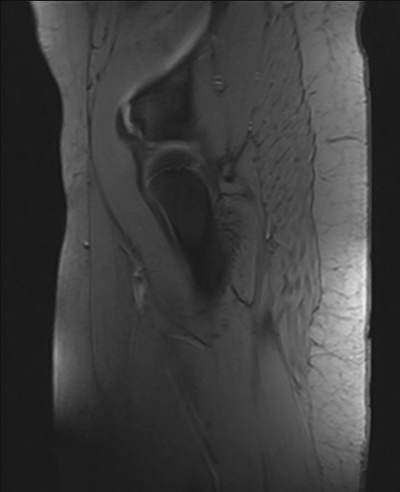
Slika 1. Gradient echo sagittal sequence of magnetic resonance imaging showing separation of the rectus femoris attachment at the anterior inferior iliac spine.

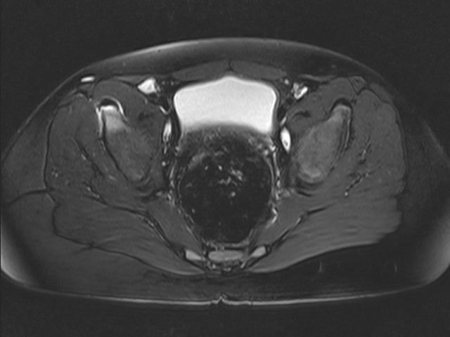

Slika 2. T2-weighted fat suppression transverse sequence of magnetic resonance imaging showing bone marrow edema of apophysis and surrounding bone within the anterior inferior iliac spine, origo of rectus femoris.

With these physical and radiographic findings, the diagnosis of AAAIIS was made. The child was restricted from sportive activities for 6 weeks. When the pain subsided with a non-steroid anti inflammatory drug (tenoxicam 20 mg/day), superficial cold therapy (4 times/day, 20 minutes per application) and rest for 10 days, we started transcutaneous electrical nerve stimulation (conventional mode-high frequency TENS, 100 Hz, 60-100 mA, 20 minutes/day) and rehabilitation treatment 5 days a week for 3 weeks. During rehabilitation phase, which focused on improving strength, endurance and balance, active-assisted ROM of hip and knee exercises, stretches for hip flexor, adductor, gastrocnemius and hamstring muscles, isometric quadriceps sets hip abduction, adduction, flexion and extension exercises, straight-leg raises in all planes, hip strengthening exercises with therabands (10 repetitions, 3 sets for each exercise) and closed kinetic chain exercises (leg press) without weight bearing were applied at the increasing level as tolerated. Partial weight bearing started in fourth week when the patient succeeded full pain-free hip ROM. Low-level functional activities, stationary bike (the bicycle seat was initially set as high as possible and gradually lowered to increase flexion), thirty-degree wall squats, stair-climbing exercises, balance and proprioception activities were encouraged gradually six weeks after onset.
On his last follow-up at six months in our clinic, he was completely asymptomatic and had returned to his previous normal daily activities. His control MRI showed complete regression within normal pelvis MRI findings (Fig. 3).

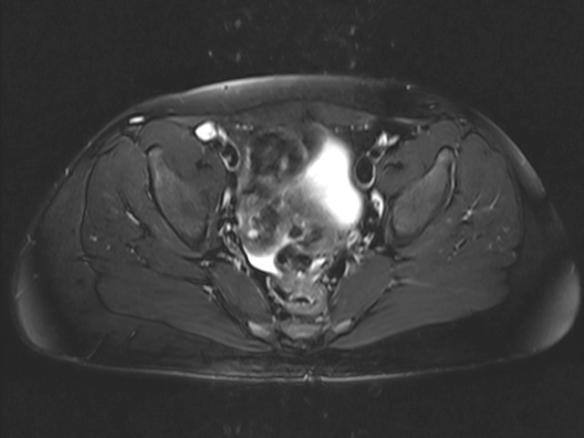

Slika 3. Normal MRI findings; T2-weighted fat suppression transverse sequence.

Discussion

Hip pain, which is a common complaint in childhood and adolescence, is usually located in the groin, upper thigh or buttock (3). Anterior hip pain is a clinical entity that may result from abnormalities of multiple structures in the hip, which may not be palpable. Pathologic conditions such as apophyseal and epiphyseal injuries, juvenile inflammatory arthritis, juvenile spondylitis, tuberculosis, osteomyelitis and inherited multicentric osteolysis can produce similar anterior hip pain syndromes as a cause of significant functional impairment (4-6). The principal concern in adolescent anterior hip pain is to distinguish inflammatory disorders from mechanical diseases. Subacute or chronic presentation of hip pain with constitutional symptoms such as fever, weight loss, generalized pain, rash, lymphadenopathy or early morning stiffness as well as high acute phase reactants in blood tests may be indicative of inflammatory disorders. The diagnosis of Legg-Calve Perthes and SCFE is often apparent on initial radiographs, although special imaging techniques may be needed in some cases. On physical examination, there were no constitutional symptoms or any sign of inflammation in our patient. In addition, laboratory findings and direct radiography were normal.
The diagnostic and therapeutic algorithm for many causes of hip pain in children, such as SCFE, Legg-Calve Perthes, transient synovitis, septic arthritis and apophyseal avulsion fractures of the pelvis, are well described and established. However, the diagnosis and treatment algorithm for AAAIIS is less clear.
Apophyseal injuries in adolescents (i.e. anterior inferior and superior iliac spine and ischial tuberosity) are thought to be due to overuse from repetitive traction, compression or shear forces. Boys are affected more often than girls are. Growth and mechanical factors seem to play an important role in the etiology of this condition as well. The apophyses of the pelvis appear and fuse later than the growth plates in long bones, placing adolescents at an increased risk of avulsion injury. As the volume and repetition of activity increase, the ability of the body to repair itself can be overwhelmed, leading to inflammation and tissue damage. A delay in the diagnosis may result in increased morbidity. The long-term sequels of apophyseal injuries include functional impairment and residual weakness (7).
Clinical presentations of AAAIIS are generally localized pain, swelling and limited ROM of the hip, resembling that of transient synovitis, SCFE and septic arthritis of the hip.
Radiographs may demonstrate displacement of the apophyseal center from its normal position or bony reaction. In patients who have normal radiography findings with considerable intractable pain due to contusion of the hip, early use of MRI should be considered to determine whether symptoms are caused by apophyseal avulsion. MRI provides increased soft tissue contrast and more detailed evaluation of articular and physeal cartilage, subchondral bone, periosteum, synovium and bone marrow elements. Results of a study in 50 consecutive children presenting with acute non-traumatic hip pain indicated good sensitivity and specificity of MRI in the investigation of acute hip pain in children and suggest it to be a more accurate method than ultrasonography and direct radiography (8).
The management is usually non-operative and includes rest, ice, modified activity and rehabilitation (9,10). The time to full recovery has been reported to vary from 3 weeks to 4 months (11). Some patients who have persistent pain and/or major displacement can be treated by surgical resection and reattachment of the rectus femoris muscle.
There is no accepted guideline in the literature for rehabilitation of this process. We first aimed to achieve pain relief by rest, ice, avoidance of aggravating activities, taking non-steroid anti-inflammatory drugs for 7-10 days and non-weight bearing with two crutches. In the subacute phase, 10 days after onset, in order to obtain pain-free hip and knee ROM and to improve quadriceps muscle function, we started rehabilitation that addressed ROM, strength and neuromuscular control of the hip and knee for 3 weeks. The patient was asked to use double crutches without weight bearing for the first 4 weeks. Full and painless ROM returned within 1 month and the patient gradually resumed his daily routine, while light sportive activities were initiated 2 months after trauma.
This case highlights a unique cause of traumatic hip pain, which, although rare, should be considered on the differential diagnosis of hip pain. Recognition of this rare injury by using MRI may allow for early diagnosis and treatment, thus preventing permanent deformities in children

Conflict of interest statement

The authors declare that there is no conflict of interest.

Literatura:

1. Ducloyer P, Filipe G. Apophyseal avulsion of the pelvis in children. Chir Pediatr. 1988;29(2-3):91-2.

2. Yildiz C, Aydin T, Kalyon TA, et al. Anterior inferior iliac spine apophyseal avulsion fracture. J South Orthop Assoc. 2003;12(1):38-40.

3. Zacher J, Gursche A. Regional musculoskeletal conditions: ‘hip’ pain. Best Pract Res Clin Rheumatol. 2003;17(1):71-85.

4. Tüzüner T, Ozturan KE, Karaca E, Ulgür M. Avulsion fracture of the anterior superior iliac spine in a volleyball player. Acta Orthop Traumatol Turc. 2003;37(4):340-3.

5. Adib N, Owers KL, Witt JD, Owens CM, Woo P, Murray KJ. Isolated inflammatory coxitis associated with protrusio acetabuli: a new form of juvenile idiopathic arthritis? Rheumatology (Oxford). 2005;44(2):219-26.
6. Lee SJ, Whitewood C, Murray KJ. Inherited multicentric osteolysis: case report of three siblings treated with bisphosphonate. Pediatr Rheumatol Online J. 2010:17;8:12.

7. Sanders TG, Zlatkin MB. Avulsion injuries of the pelvis. Semin Musculoskelet Radiol. 2008;12(1)42-53.

8. White PM, Boyd J, Beattie TF, et al. Magnetic resonance imaging as the primary imaging modality in children presenting with acute non-traumatic hip pain. Emerg Med J. 2001;18:25-9.

9. Houghton KM. Review for the generalist: evaluation of the pediatric hip pain. Pediatr Rheumatol Online J. 2009;18:7-10.

10. Waters PM, Millis MB. Hip and pelvic injuries in the young athlete. Clin Sport Med. 1988;7(3):513-26.

11. Atalar H, Kayaoğlu E, Yavuz OY, Selek H, Uraş I. Avulsion fracture of the anterior inferior iliac spine. Ulus Travma Acil Cerrahi Derg. 2007;13(4):322-5

