Predhodno priopćenje

Enes Šeperovič, Alma Imamović

BOSNIA AND HERZEGOVINA WITHIN THE CONCEPT OF TRANSBOUNDARY RIVER BASIN MANAGEMENT

Abstract
Transboundary river basin management is a challenge everywhere in the world. EU Water Framework Directive set principles and objectives of transboundary river basin management for EU member states but usually followed by non-members states sharing with them river basins. Bosnia and Herzegovina has taken direction towards cooperation on transboundary river basin management as member of commissions and signing bilateral agreements. Due to the complex institutional arrangements of water management sector in BH problems, related to the activities within the international bodies such as ICPDR, exist. Recommendations for improvements of transboundary river basin management are dominantly related to the improvements within the country’s water management sector. Understanding and positive attitude towards good cooperation with riparian countries is present in BH.

Key words: Integrated River Basin Planning, International River Basins, Water Management Sector

BACKGROUND
The UNECE Convention on Protection and Use of Transboundary Watercourses and International Lakes (Helsinki, 1992) is clearly focused on developing consensus between countries via joint approaches of riparian states on the management of international water bodies. (IWAC-RIZA, 2001)
There are 263 transboundary lake and river basins in the world covering nearly half of the Earth's land surface. A total of 145 nations include territory within international basins, and 21 countries lie entirely within international basins. While most basins are shared between just two countries, there are many basins where this number is much higher. There are 13 basins worldwide that are shared between 5 and 8 riparian nations. Five basins, the Congo, Niger, Nile, Rhine and Zambezi, are shared between 9 and 11 countries. The river that flows through the most nations is the Danube, which travels within the territory of 19 nations. (http://www.un.org)
Achieving transboundary cooperation is always a long and complex process. It is almost always difficult to initiate strong political driver for initiating cooperation on transboundary waters. Political will and commitment from all Governments, at all levels, are prerequisites for successful transboundary water management (UN-Water Thematic Paper, 2008). As there is no universal solution, we only can rely on the examples, both positive and negative in the process of designing the long-term and sustainable transboundary cooperation.
There is a consensus among the majority of riparian countries that transboundary agreements need to be concrete and to set out institutional arrangements for cooperation, measures for management and protection of water resources and related ecosystems as well as enforcement (UN-Water Thematic Paper, 2008).
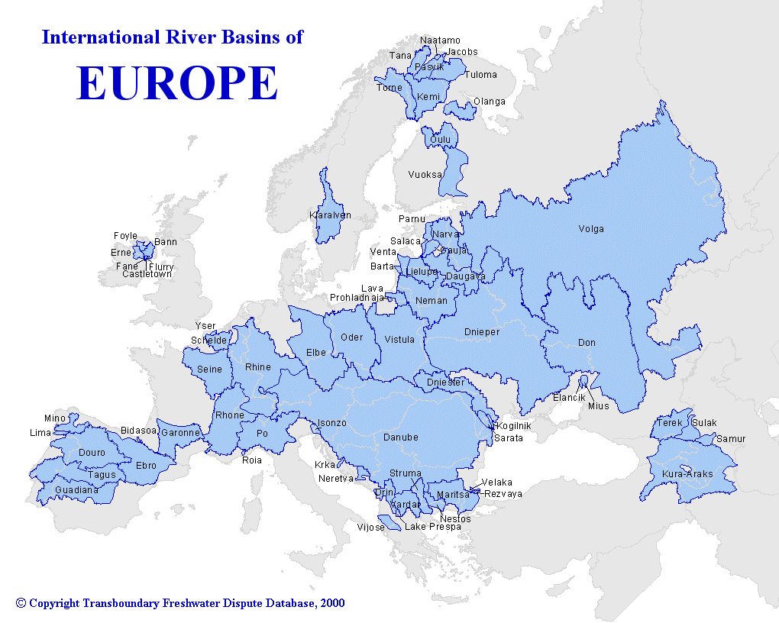
Geostrategic position of Bosnia and Herzegovina, surrounded by transboundary river basins, sharing aquifers, lakes and Adriatic sea, requires serous approach to deal with transboundary cooperation. On the other hand, the complex institutional arrangements and political situation in Bosnia and Herzegovina demand coordinated and effective management at all levels to achieve common orientation and respond to challenges. This is particularly important concerning its commitment to EU accession path.
This paper aims to present BH transboundary cooperation, identify and address present conditions, problems and obstacles related to the transboundary river basin management in the country, and to recommend how those obstacles can be mitigate or avoid.

- Integrated River Basin Planning and the EU Water Framework Directive
To achieve the objectives of the Water Framework Directive (WFD) and “good ecological status” of water bodies it was agreed that water management and planning must be organized at the level of the river basin – the natural geographical and hydrological unit. The WFD defines the river basin as: “the area of land from which all surface run-off flows through a series of streams, rivers and possibly lakes, to a particular point into the sea at a single river mouth, estuary or delta” (WFD, 2000).
The definition of the river basin given by the WFD presents a natural management unit that goes beyond the political, administrative, social or cultural boundaries. On the other hand, there are around 70 international river basins in Europe, with different characteristic, that are shared sometimes only between EU member states, but also between member and non-member states (e.g. Danube River Basin). The number of international RBDs identified under the WFD is also significant.
Two most important challenges for managing water resources in accordance with the WFD principles and objectives can be distinguished:
- to ensure multifunctional use of water resources promoting concept of sustainable development and
- to consider different interests within the trounsboundary (international) river basin management.
As the concept of Integrated Water Resources Management (IWRM) considers all relations between the natural environment (ecological function of water) and the human activities that contribute to water quality deterioration including water demand, pollution, overuse of water, possibilities of recycling and reuse (Teodosiu et al, 2003), for the implementation of the WFD the Integrated River Basin Planning (IRBP) and Management is recognized as the most appropriate tool. IRBP and Management must identify all domain of use and impacts on the water within the river basin (water supply, pollution control, irrigation, power generation, wastewater treatment, agricultural and industrial activities, tourism and recreation, fisheries, etc) and try to gather all of them into a unified framework, in which every domain has a specific importance, depending on the priorities in that river basin. Within the international river basin this task becomes even more difficult considering traditional, cultural, social differences between transboundary countries.
Therefore, WFD defines the River Basin District is the administrative unit for river basin management and all the stakeholders within the river basin need to take an active role in this framework. All the stakeholders in the river basin district form the unified framework mentioned above. In this framework communication is the most important element, interconnecting different sectors and their specific actions (www.riverbasin.org).
Under the Water Framework Directive, Member States need to identify international river basins and set up appropriate administrative structures for them (Article 3(4)). So far, Member States have only designated national authorities as competent authorities: thus, international river basin commissions have remained coordinating structures and do not directly administer the directive (WISE 2008).
The present experience about cooperation in transboundry river basins in Europe gives good examples among which the two large basins Danube and Rhine basins are leading examples. However, EU experts recommend more activities to ensure improvement in sharing information and establishing common methods. While Member States have worked successfully with the EU's neighbors in the Rhine and the Danube basins, in some other stronger cooperation with neighboring countries still needs to be established (WISE 2008).
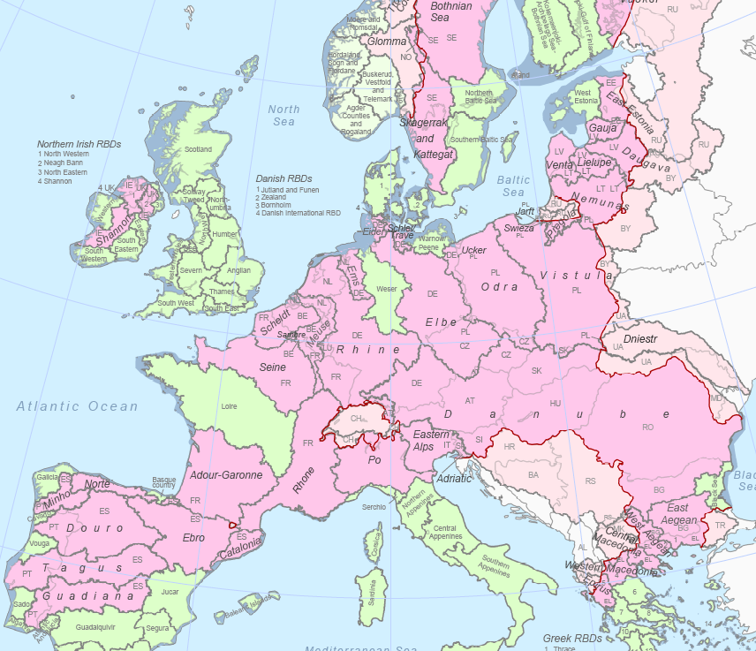
^{O = transboundary} International River Basins Districts in Europe

Map of Danube River Basin
A review of existing transboundary water management structures and practices in Europe concluded that “problems of communication and information exchange among different levels of governance as well as across borders present major difficulties for water policy implementation” (Timmerman and Interwies 2007). After setting up administrative structures, the next step in implementing the directive was the environmental and economic analysis of river basins (Article 5). This meant bridging different national traditions in water management. For example, while some countries already used a river basin approach, others did not (WISE 2008).

- Transboundary River Basin Management in Europe – Danube River Basin
Concerning transboundary river basin management the example of Danube river basin is almost always used in discussion. For purpose of this paper this will not be just example of the good cooperation between repairing countries, both EU members and non-members, but also as the one of the most important tasks for BH as a member of The International Commission for the Protection of the Danube River (ICPDR). ICPDR is the coordinating platform to compile multilateral and basin-wide analysis on what has been termed - the roof-level. 19 countries share the Danube River Basin, which makes it the world’s most international river basin. More than 81 million people of different cultures and languages call the Danube Basin their home and are since centuries interconnected through the widely ramified water system of the Danube. All countries sharing over 2,000 km² of the Danube River Basin and the European Union are contracting parties of the ICPDR. Upstream states of Danube Basin (Germany and Austria) are highly developed, while downstream states have experienced fundamental economic changes, followed by both economic growth and serious economic crises including a complex political situation and inter-state tensions. As a consequence, riparian states have very different interests in the use and the protection of the river.
The International Commission for the Protection of the Danube River (ICPDR) works to ensure the sustainable and equitable use of waters and freshwater resources in the Danube River Basin. The work of the ICPDR is based on the Danube River Protection Convention signed 1994, the major legal instrument for cooperation and transboundary water management in the Danube River Basin (www.ICPDR.org).
On the basis of WFD the ICPDR coordinated the preparation and compilation of this Danube River Basin Management Plan which includes both a detailed analysis of the status of Danube waters as well as the identification of the program of measures needed to address existing problems.
The ICPDR has a very specific organizational structure that suits the specific needs of the basin (see graph prepared by Schmeier 2010).
Convention, the highest-level body is the Conference of Parties, uniting representatives of the Contracting Parties to the Danube Convention in order to discuss policy issues concerning the implementation of the Convention (Danube Convention, 1994). Cooperation through this Conference of Parties is institutionalized in the form of the Commission. It meets regularly once per year in December (with extraordinary meetings being possible if requested by at least three delegations) (Schmeier 2010).
The operational work of the organization is coordinated by the Standing Working Group (Art. 5 Rules of Procedure of the ICPDR), in which delegates from various parties meet regularly and coordinate the work of the institution and the activities of the different technical bodies. This also includes financial and administrative management issues.
Expert Groups can be established by the ICPDR for the management of specific issues (Art. 10 of Danube Convention). Currently, there are seven Expert Groups: the River Basin Management EG, the Pressures and Measures EG, the Flood Protection EG, the Information Management and GIS EG, the Monitoring and Assessment/Water Quality EG, the Public Participation EG and the Strategic EG.
The Permanent Secretariat performs administrative functions such as: the preparation and distribution of reports on ICPDR activities, the preparation of the organization’s budget, the coordination with external actors, the management of data and information, etc. (Schmeier 2010).
The ICPDR Secretariat manages to fulfill its tasks with 14 permanent staff (Austria, Bosnia and Herzegovina, Bulgaria, Croatia, Czech Republic, Germany, Hungary, Moldova, Montenegro, Romania, Slovakia, Slovenia, Serbia, Ukraine) and a limited bureaucratic structure only.
Organization Structure of ICPDR (source: Schmeier 2010)

- Institutional Arrangements of Water Management Sector in Bosnia and Herzegovina
Bosnia and Herzegovina has complex institutional arrangement and political situation. Pursuant to the provisions of the Dayton Peace Accord, water management is the responsibility of the entities, and in the FBiH some competences are even devolved to the cantons. Under the terms of the Federal Law on Waters (2006), the following institutions are responsible for water management: the FBiH Ministry of Agriculture, Water Management and Forestry, two Water Agencies (Agency for Watershed of the Sava River and Agency for Watershed of the Adriatic sea), cantonal ministries of agriculture, water management and forestry, and the municipal authorities responsible for water management. The municipal and town councils are responsible for water supply, sewerage and treatment of wastewater.
Under the terms of the Law on Waters of RS (2006), the Ministry of Agriculture, Forestry and Water Management and two Water Agencies (Water Agency for Sava River District and Water Agency for Trebišnjica River District) are responsible for water management in RS. The municipalities are responsible for water supply and sewerage systems, while public utilities are under the responsibility of the Ministry of Regional Planning, Construction and the Environment.
Water Management in Brčko District is under responsibilities of Department for Agriculture, Forestry and Water Management.
At the state level Ministry of Foreign Trade and Economic Relations (department for Water Management) is responsible for overall co-ordination of policy and serves as an interface for the country’s international presence. As there is no Water Law at state level the role of this Ministry is rather limited to coordination.
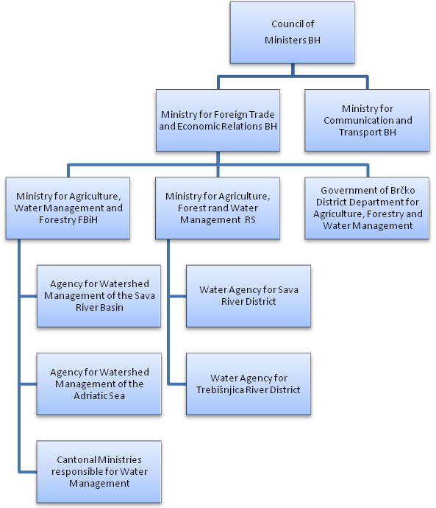
Graph: Institutional arrangement of water management sector in BH
An Inter-Entity Committee was established in 1998 to coordinate water management issues, on the basis of a Memorandum of Understanding signed by the entity governments.
Although WFD has been transposed into entity Water Laws in 2006, many difficulties regarding water management in BH including transboundary river basin management stayed unsolved. Reading through numerous reports and assessments prepared by EU for different purposes the common conclusion comes into focus: the state of water management in BH is characterized by an extremely complicated and inadequate institutional structure.
This is not just a statement when it comes to the practice. It is more than visible in the issues dealing with international obligation of the country in the water management sector, including transboundary water management.

- Transboundary River Basin Management in Bosnia and Herzegovina
As a member of ICPDR, BH has taken many obligation regarding transboundary river basin management and implementation of WFD. The general organizational structure of ICPDR has been explained earlier. Beside Danube Convention two very important treaties for BH transboundary river basins management are enforced:
- Framework Agreement on the Sava River Basin (FASRB) and
- Bilateral Agreement with Republic of Croatia (among the other issue concerning water management of Adriatic Sea river basins Neretva-Trebišnjica, Krka and Cetina) – signed 1996
Also, two Bilateral Agreements are in preparation: the Agreement with Republic of Serbia is in preparation, with the aim to deal with Management of Drina River Basin (Sava’s tributary) dominantly regarding flood protection and hydropower generation and the Agreement with Republic of Crna Gora.

- Sava Commission
Basic idea of the Sava Initiative contained in the “Letter of Intent” was to utilize, protect and control the Sava River Basin water resources in a manner that would enable “better life conditions and raising the standard of population in the region”, and to find appropriate institutional frame in order to enhance the cooperation (www.savacommission.org).
Framework Agreement on the Sava River Basin (FASRB) was signed on December 03, 2002. International Sava River Basin Commission (ISRBC) was established for implementation of the FASRB in June 2005. ISRBC consist of 8 representatives of 4 countries (Bosnia-Herzegovina, Croatia, Serbia, Slovenia).
Secretariat of the ISRBC is an executive and administrative body of the ISRBC, established in January 2006 and seated in Zagreb (HR). The Secretariat consists of 8 experts from the 4 countries covering: Navigation, Integrated RBM and Water Planning, Protection of Water and Aquatic Ecosystem, Legal and General Affairs and Economic and Financial Affairs.
Organizational structure of FASRB (source: www.savacommission.org)
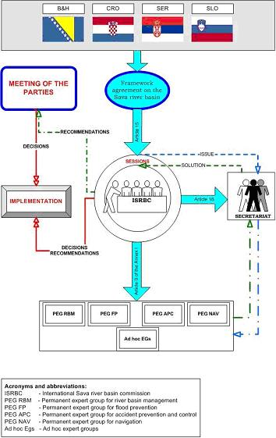
In order to foster cooperation and assure synergy in achieving its goals, the Sava Commission is entitled to establish permanent and ad-hoc expert groups, composed of delegated experts from each Party. Permanent expert groups (PEGs) cover the key issues in the Sava River Basin, while the ad-hoc expert groups (AH EGs) deal with more specific issues and tasks.
The expert groups are chaired by the officials of the Secretariat. The Secretariat, in principle, prepares all material for consideration by the groups (www.savacommission.org).
Permanent expert groups are:
- Navigation (PEG NAV)
- River Basin Management (PEG RBM)
- Accident Prevention and Control (PEG APC)
- Flood Prevention (PEG FP)
Forms of transboundary cooperation within Sava River Basin (SEB) consider: Creation and realization of joint plans of the SRB, Preparation of development programs of the SRB, Harmonization of legislation (national with EU) and Creation of protocols among the members of the Commission.

- Commission for water management between Republic of Croatia and Bosnia and Herzegovina
Bilateral agreement for water management between Republic of Croatia and Bosnia and Herzegovina was signed in 1996. The Commission has regular meetings once per year. If there is a need on additional meeting it can be requested from the each country. The commission works in two sub-commissions usually dealing with specific issues.
- Sub-commission for Adriatic Sea River Basins
- Sub-commission for Black Sea River Basin
Beside work related to the cooperation on transboundary water resources management very important issue is protection of water resources located in one country and used for public water supply sources in the other country. So far the very good cooperation has been achieved.
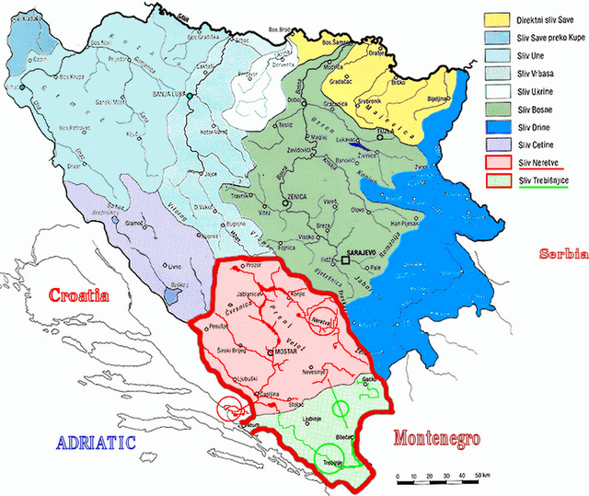
Map of the Neretva –Trebišnjica River Basin
The work of this body resulted with the development of the “Neretva and Trebisnjica River Basin Management Project” supported by GEF funds and implemented through the World Bank. The aim of this Project is to provide mechanisms for the efficient and equitable water allocation amongst the users of the Neretva and Trebisnjica river basin at the transboundary level, and for enhancing the basin ecosystems and biodiversity through improved water resources management (http://web.worldbank.org).

- Challenges of Transboundary River Basin Management in BH
Representatives of BH in expert groups of ICPDR and Sava Commission as well as in sub-commissions for the implementation of specific tasks of the Bilateral Agreement with Croatia are usually delegated from the Water Agencies from both entities. Therefore in each expert group (e.g. ICPDR RBM EG), BH has two representatives, one from FBiH and one from RS. The volume of expert work in implementing WFD and preparation of RBM plans is rather huge, especially under responsibilities towards ICPDR. Some of the most significant problems identified are: lack of human resources and expert capacity to carry out work, lack of funds, lack of institutional support from the state level, etc.
Coordination and information exchanges between state via entity ministries to the representatives in the expert groups (from the Water Agencies) is missing. This situation has already created some problems such as accepting obligation that cannot be met with the existing capacity, or on the other hand, representatives in expert groups are not in the position to response as representatives from other countries if they do not have support, consensus and authorization for that, as they are delegated from the entity level (e.g. hosting meetings of expert groups in BH).
The other example is related to the process of signing protocols prepared by Sava Commission as defined forms of documents in the process of Sava River Basin Management and cooperation dealing with specific issues (navigation, flood protection, sediments, etc). Coordination of the entities in defining final state attitude sometimes takes ages, especially if the entities’’ views are different or even opposite. There is no strong mechanism at the state level to decide on the issue.
Although facing lot of constrains and difficulties in the practice, general BH attitude regarding transboundary river basin management is positive and oriented to cooperation with neighboring countries in sustainable use of water resources and implementation of WFD and other EU water directives. After the first RBM plans for Sava River Basin and Neretva and Trebišnjica River Basin (but also Krka and Cetina) are prepared it could be expected that views will be more cleared and opened for improvements.

CONCLUSIONS AND RECOMMENDATIONS
Based on everything what has been researched and presented in this paper it is certain that BH has entered into transboundary river basin management as set up through WFD. General principles were defined through the entities Water Laws and accession to the international commissions. Lack of human resources and expert capacities, lack of financial support and complex and inefficient institutional arrangement of water sector are defined as significant problems in process of meeting requirements given through the transboundary treaties and conventions.
General conclusion comes to the mind – there must be a well organize water management in the country before country is able to become a strong partner to riparian states in the transboundary river basin management. This certainly applies to BH water management.
“BH Mid Term Development Strategy - Poverty Reduction Strategy Paper” was prepared by EU analyzing BH in the context for EU enlargement in 2004. This report recommended improvements of the legal and institutional framework in water management sector. Although it was seven years ago, it seems that most of them are still applicable. Most of them can be updated and used as basis for recommendations that are result of this paper:
- harmonize and adopt the legislation in conformity with the EU WFD and with other EU water directives and applicable international conventions on both state and entities levels,
- improve the efficiency of the institutional structure of the water management sector in compliance with WFD,
- establish mechanism at the state level, to permit BH to meet its international obligations and establish cooperation with other countries in solving water management-related problems,
- improve mechanisms for resolving inter-entity disputes,
- establish a sustainable system of funding in the water management sector,
- support development of human resources and experts capacity within water management sector through adequate education and training.
As for the end, one more think need to be pointed out, although it was not focus of this paper. It is a necessity to develop understanding of the importance of strong cooperation for transboundary water management within the river basins among stakeholders. It is important to assess mechanism that will ensure adequate public participation dealing with this issue.

References:
- 2000/60/EC, Luxembourg (WFD, 2000), Directive of the European Parliament and of the Council establishing a framework for Community action in the field of water policy, 2000
- Danube Convention (1994), Convention on the Cooperation for the Protection and the Sustainable Use of the Danube River, signed in Sofia/Bulgaria, 29 June 1994
- EU Paper (2004), EU Enlargement Bosnia and Herzegovina Mid Term Development Strategy - Poverty Reduction Strategy Paper (PRSP)
March 2004
- IWAC-RIZA (2001), International Water Assessment Centre: Assessment Practices and Environmental Status 10 Transboundary Rivers in Europe ISBN No. 9036954398 (December 2001), www.IWAC-RIZA.org and/or www. IWAC-UNECE.org.
- Schmeier S. (2010), The Organizational Structure of River Basin Organizations Lessons Learned and Recommendations for the Mekong River Commission (MRC) Paper Prepared for the Mekong River Commission (MRC) June 2010
- Teodosiu C, Barjoveanu G, Teleman D. (2003), Sustainable water resources management: 1.Rtiver basin management and the EC WFD/Environmental Engineering and Management Journal 2, 4, 377-395. 378 (2003)
- UN-Water Thematic Paper (2008), Transboundary Waters: Sharing Benefits, Sharing Responsibilities, 2008
- WISE (2008), European Commission (DG Environment) - WISE Joining Forces for Europe's Shared Waters: Coordination in international river basin districts (March 2008)
- http://www.un.org/waterforlifedecade/transboundary_waters.shtml
- http://ec.europa.eu/environment/water/water-framework
- http://www.un.org
- www.riverbasin.org
- www.savacommission.org
- www.ICPDR.org
- http://web.worldbank.org

For an electronic version of this map with an explanation of assumptions and methods, please see http://ec.europa.eu/environment/water/water-framework/facts_figures/index_en.htm

