The rehabilitation protocol
for low grade bone stress injury of the talus

Nural ALBAYRAK AYDIN, Kamil YAZICIOGLU
Guven Hospital Physical Therapy and Rehabilitation Department,
Guven Hospital, Ankara/TURKEY

Primljeno / Received : 2010-06-16; Prihvaćeno / Accepted: 2011-01-30

Correspondence to:
Nural Albayrak Aydin,MD
Dikmen Cad. No 479/11 Albayrak Apt. Keklikpinari, Ankara, TURKEY
Phone: 00 90 312 457 24 35
Mobile number:00 90 532 365 04 74
E-mail: nalbayrak@yahoo.com

Abstract

Bone stress injuries are common overuse injuries seen in active people. The pathogenesis is multifactorial and usually involves repetitive submaximal stresses. No comprehensive studies describing rehabilitation protocol of low grade bone stress injury of the talus have been published. The aim of this case series was to describe a conservative treatment protocol for low grade bone stress injury of the talus.
The rehabilitation and pain features in 15 patients with low grade bone stress injury of the talus, as confirmed by magnetic resonance imaging (MRI), were reviewed retrospectively.
Of 15 patients (8 female and 7 male; age range 16-50 years; median age 29.1 years; mean duration of symptoms 2.5 (range, 1 to 12) weeks, MRI studies showed low grade bone marrow edema of the talus in six cases, whereas in other nine cases (5/15 calcaneus, 3/15 navicular and 1/15 cuboideum) adjacent osseous structures were affected as well. In four cases, the entire talus was involved and in eleven cases, only a portion of the bone was affected. The mean visual analogue scale for pain before treatment was 53.5 mm. The median duration of walking boot usage was 16.2 (7 to 70) days. Patients became symptom free in a mean of 23.2 (12-40) days. Ten patients returned to daily life and sportive activities without difficulty.
Early diagnosis and appropriate conservative treatment of low grade bone stress injury of the talus allow favorable outcome in most cases.

Key words: bone marrow, edema, stress fracture, talus, magnetic resonance imaging, rehabilitation

Rehabilitacijski protokol
kod stres frakture talusa niskog stupnja

Sažetak

Stres ozljede kosti su uobičajene ozljede prenaprezanja u aktivnih osoba. Njihova patogeneza je multifaktorijalna i obično uključuju ponavljajući submaksimalni stres. Do sada nisu objavljene sveobuhvatne studije koje bi opisale rehabilitacijski protokol stres ozljeda talusa niskog stupnja.
Cilj ove serije slučajeva je bio opisati konzervativni terapijski protokol za stres ozljede talusa niskog stupnja.
Osobine rehabilitacije i boli u 15 pacijenata sa stres ozljedom talusa niskog stupnja, potvrđeno magnetskom rezonancijom (MR), su retrospektivno pregledani.
Od 15 pacijenata (8 žena i 7 muškaraca; raspon dobi 16-50 godina; medijan dobi 29,1 godina; srednje trajanje simptoma 2,5 tjedana (raspon 1 do 12 tjedana), MR je pokazala edem koštane srži niskog stupnja talusa u šest slučajeva, dok je u preostalih devet slučajeva (5 petnih kostiju, 3 navikularne kosti I 1 kuboidne kosti) obližnje koštane strukture su bile također zahvaćene. U četiri slučaja bio je zahvaćen cijeli talus a u jedanaest slučajeva samo dio kosti. Srednja vrijednost jačine boli na vizualnoj analognoj ljestvici (VAS) je prije liječenja bila 53,5 mm. Srednje trajanje primjene imobilizacije (čizma) je bilo 16,2 dana (raspon 7 do 70). Pacijenti su postali bez simptoma za prosječno 23,2 dana (raspon 12-40). Deset pacijenata se vratilo aktivnostima svakodnevnog života i sportskim aktivnostima bez da imaju bilo kakve poteškoće.
Rana dijagnoza i odgovarajuće konzervativno liječenje stres ozljede talusa niskog stupnja omogućuje povoljan ishod u većini slučajeva.

Key words: koštana srž, edem, stres fraktura, talus, magnetska rezonancija,
rehabilitacija

Introduction

Bone stress injuries (BSI) are injuries of bones due to repetitive loading rather than a single traumatic event. They are common overuse injuries seen in active people. The pathogenesis is multifactorial and usually involves repetitive submaximal stresses. There are a number of prospective studies in the literature, which were conducted among competitive female runners, military recruits to demonstrate the incidence of BSI of lower extremities (1,2). However, in a study by Rauh et al., the overall incidence of overuse injury in female recruits was 48.4% (3). In another prospective sensitive scintigraphy study of 295 military recruits, a 31% incidence of stress fracture was found. Eighty percent of these fractures were in the tibial or femoral shaft, whereas only 8% occurred in tarsal and metatarsal bones (4).
BSI of the talus is a well documented, rare cause of pain in the foot, which was first published by McGlone in 1965 (5). According to the literature, BSIs of the foot are mostly located in the metatarsal bones and the calcaneus, whereas involvement of the talus is not so often (6).
Niva et al. (7) report on the talus and calcaneus as the most commonly affected single bones, while injuries to other bones of the foot were usually associated with other stress injuries. Injuries of the talus usually exist as high grade BSI (grade IV-V) with a fracture line on magnetic resonance imaging (MRI) and early surgery is recommended in these high-risk talus stress fractures (8). To our knowledge, there is no published comprehensive study describing rehabilitation protocol for low grade BSI (grade I-III) of the talus.
Prescribing an optimal treatment to ensure successful talus BSI rehabilitation remains a challenging problem because there is no generally accepted clinical guideline based on objective data. However, previous studies recommend a period of non-weight bearing rest with changing durations (8). The other treatment options are analgesic and anti-inflammatory medication, physical therapy, parenteral iloprost administration, and surgical treatment such as core decompression (9).
The purpose of this study was to describe a conservative treatment protocol and determine the outcome of BSI of the talus treated in our Department with physical therapy, exercise and non-weight bearing.
Patients and Methods

Fifteen patients with low grade stress injuries (grade I-III) of the talus manifesting only as bone marrow edema, without a fracture line on MRI were included in this study. BSIs were graded as follows: grade I, endosteal marrow edema; grade II, periosteal edema and endosteal marrow edema; grade III, muscle edema, periosteal edema and endosteal marrow edema; grade IV, fracture line; and grade V, callus in cortical bone (7, 10, 11).
None of the patients had a history of previous foot or ankle problems. The exclusion criteria were a known rheumatic disorder, infection or recent macro trauma involving the ankle or the foot. The study was approved by the local medical Ethics Committee.
We identified clinical symptoms, such as pain with daily ambulation and physical examination findings, including localized talus tenderness and pain on direct percussion in all patients. The onset and duration of pain as well as the relation to physical activities were recorded before treatment. We assessed pain during walking using a 100-mm visual analogue scale. Patients were instructed to rate pain during walking from 0 mm, which indicated “no pain”, to 100 mm, which indicated “most intense pain imaginable”. Physical examination included careful history taking (medications, trauma), evaluation of soft tissue edema, joint effusion, inflammation, skin changes, and range of motion of the ankle joints. Anterior drawer test and the talus tilt test were also done to exclude ankle joint instability. All patients underwent initial plain radiography (anteroposterior and lateral views), which was negative for fracture line. MRI was performed in all patients on 1.5-T units. Anatomic distribution of bone stress injuries in the talus (head, neck and/or body) and integrity of other tarsal bones and degeneration (joint space narrowing, osteophytes, subchondral sclerosis, ankylosis) were evaluated from MR images. Besides MRI, bone scintigraphy was used in only one patient to reveal reflex sympathetic dystrophy. Prior to treatment initiation, all patients were examined by the same orthopedic surgeon specialized in foot injuries.
In the beginning of rehabilitation, all patients were given walking boot and crutches to reduce weight bearing to the affected ankle. Only one of the patients rejected to use both. All patients received their regular weekday physical therapy sessions, which consisted of whirlpool (25 minutes with water temperature 12.8˚C), transcutaneous electrical nerve stimulation (conventional TENS therapy once a day for 20 minutes, with a frequency of 60 Hz and impulse duration of 100 µsec), water-ultrasound (3 Watt/cm² for 10 minutes) and exercise training for three weeks. Therapeutic exercises consisted of muscle strengthening (resisted dorsiflexion, plantar flexion, inversion and eversion of ankle with elastic strap - Thera-Band, straight leg raises, quadriceps sets), stretching exercises (supine hamstring muscle stretch with towel, side-lying quadriceps femoris muscle stretch, therapist-assisted manual passive ankle plantar and dorsal flexor stretch), proprioception and balance education (wobble board and single limb stance) and walking with full weight bearing were started as soon as tolerated in all patients. We continued walking boot and non-weight bearing until walking caused no or mild pain.
Results

We studied 15 patients (8 female and 7 male) with bone stress injury of the talus, which was confirmed by MRI. Their mean age was 29.1±9.95 (range, 16-50) years. The mean time from reported onset of pain to the diagnosis of stress injury on MRI was 2.5±2.9 (1 to 12) weeks. Bone stress injuries occurred on the right side in 7 cases and on the left side in 8 cases. While single talus bone stress injury occurred in only 6 cases, the other tarsal bones, i.e. calcaneus (n=5), navicular (n=3) and cuboideum (n=1), were also affected in the other 9 cases. Based on MRI findings, bone stress injuries were detected in the following anatomic regions of the talus: 8 (53.3%) in the body, 3 (20%) in the head and neck, and 4 (26.7%) in both.
The mean visual analogue scale for pain before treatment was 53.5±9.67 mm (range, 40-70 mm). As for clinical findings, ten patients presented with joint effusion and soft tissue edema, whereas limitation in the ankle range of motion was seen in eight of 15 patients. Only one patient experienced reflex sympathetic dystrophy sign and symptoms during the healing process.
Degeneration changes were visible on plain radiographs only in one patient (Table 1).

Table 1. Initial data of patients with talus bone stress injuries

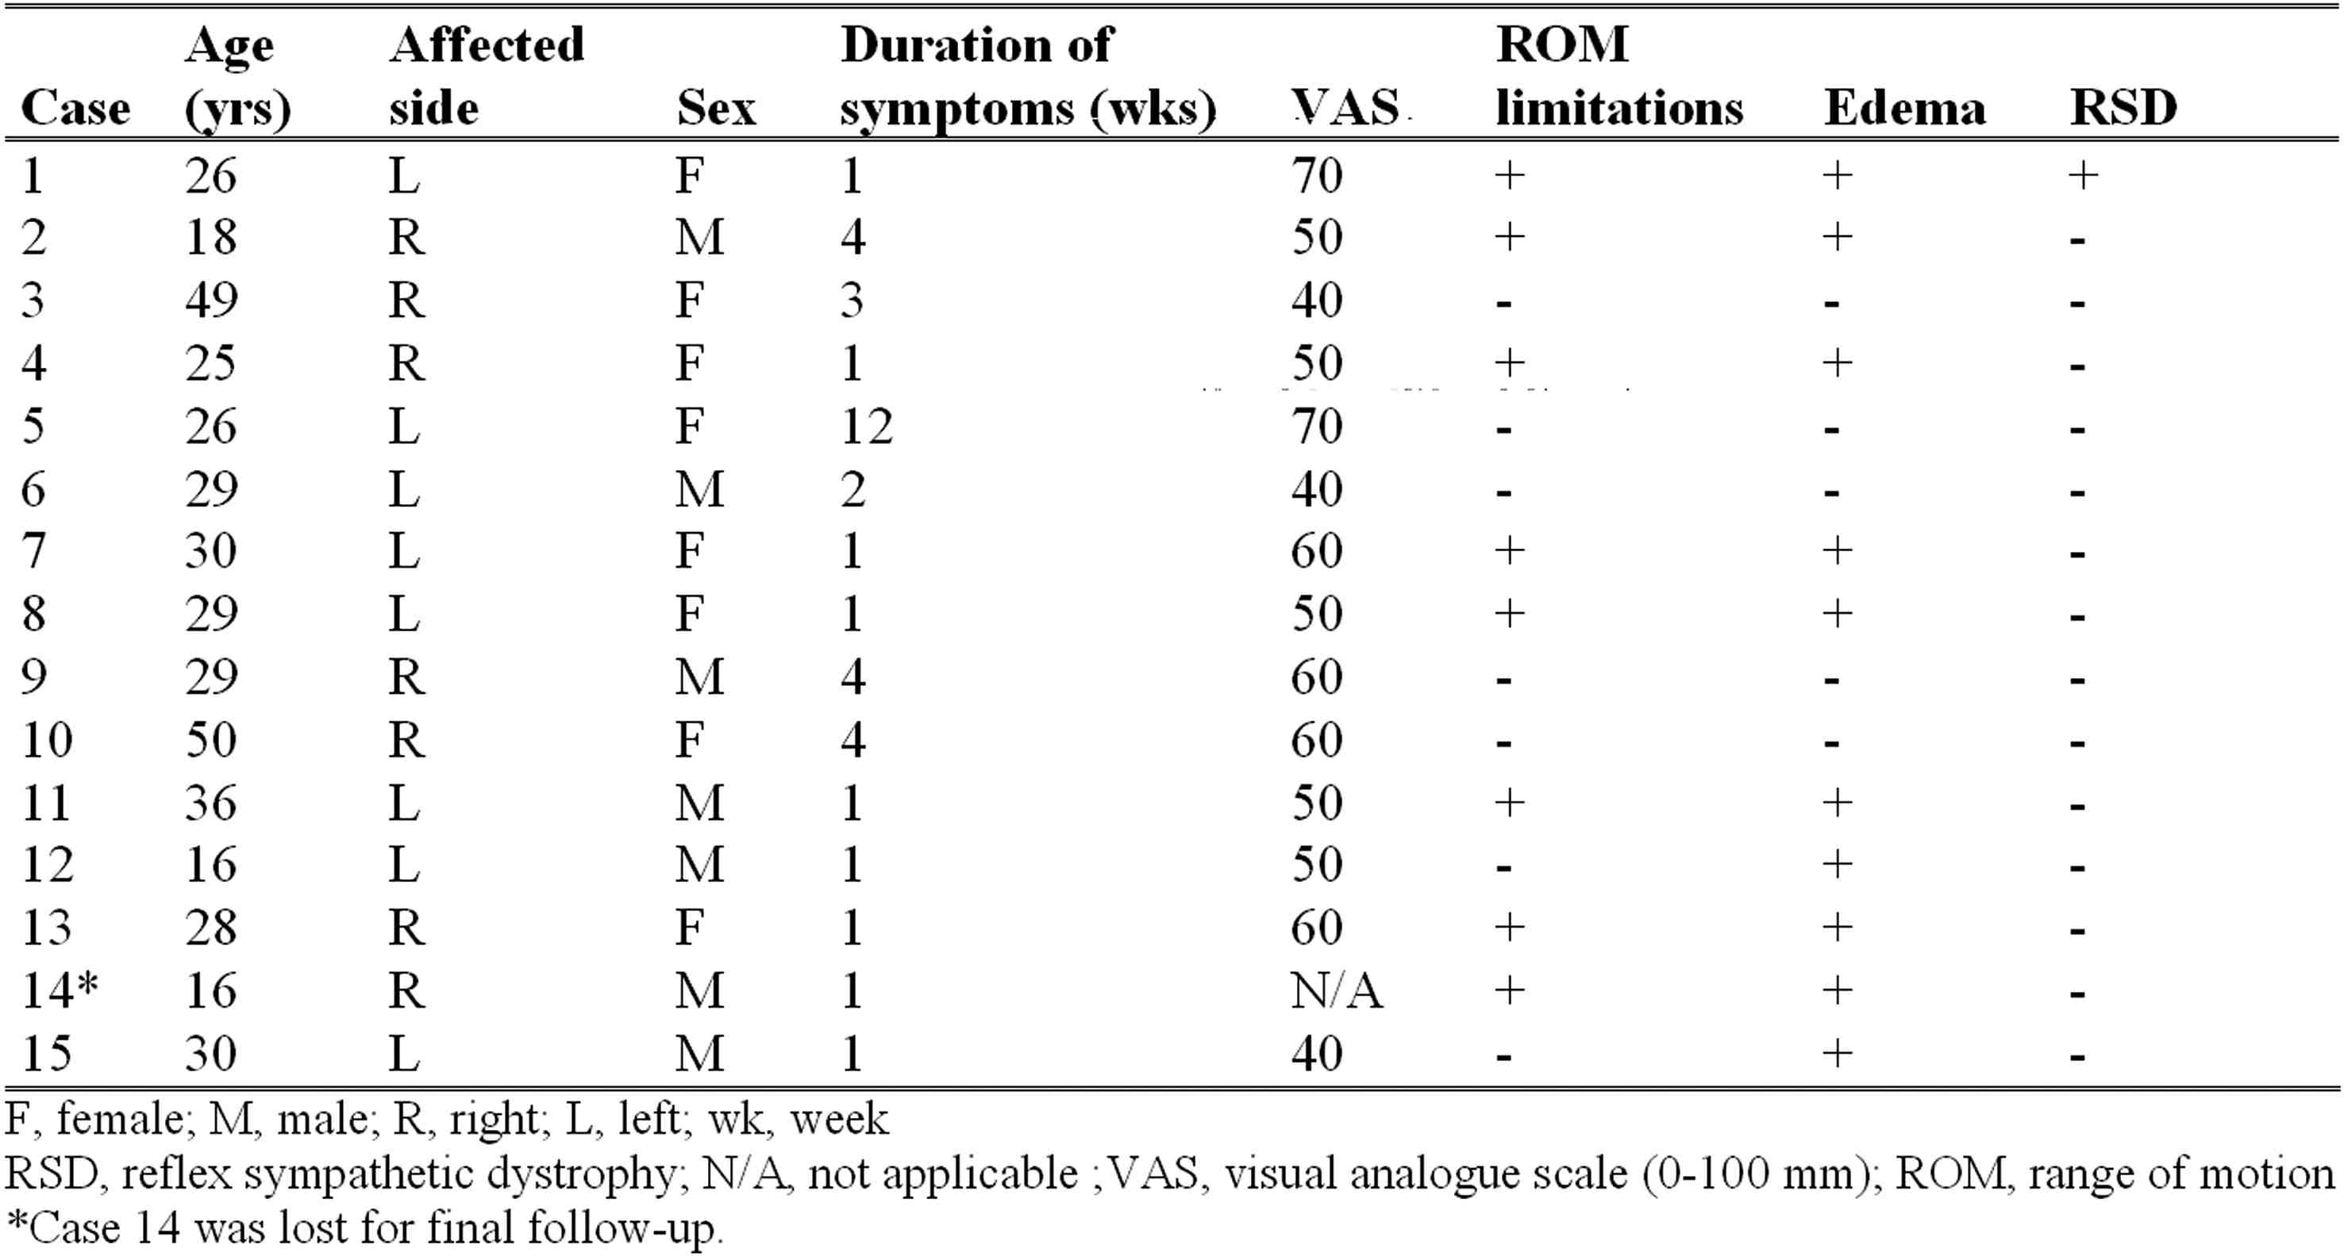
The median duration of walking boot usage was 16.2±6.59 (range, 7-30) days.
After our conservative therapeutic approach patients became symptom free in a mean of 23.2±7.79 (range, 12-40) days starting from the date of diagnosis. In all patients we reached normal ankle range of motion limits symmetric to the other side (n=14). Ten patients considered themselves completely recovered from the injury. They returned to daily life and sportive activities without difficulty. Five patients reported occasional pain or swelling of the ankle with long distance walking or running but they were pain free in daily life (Table 2).

Table 2. Rehabilitation outcomes of talus bone stress injuries

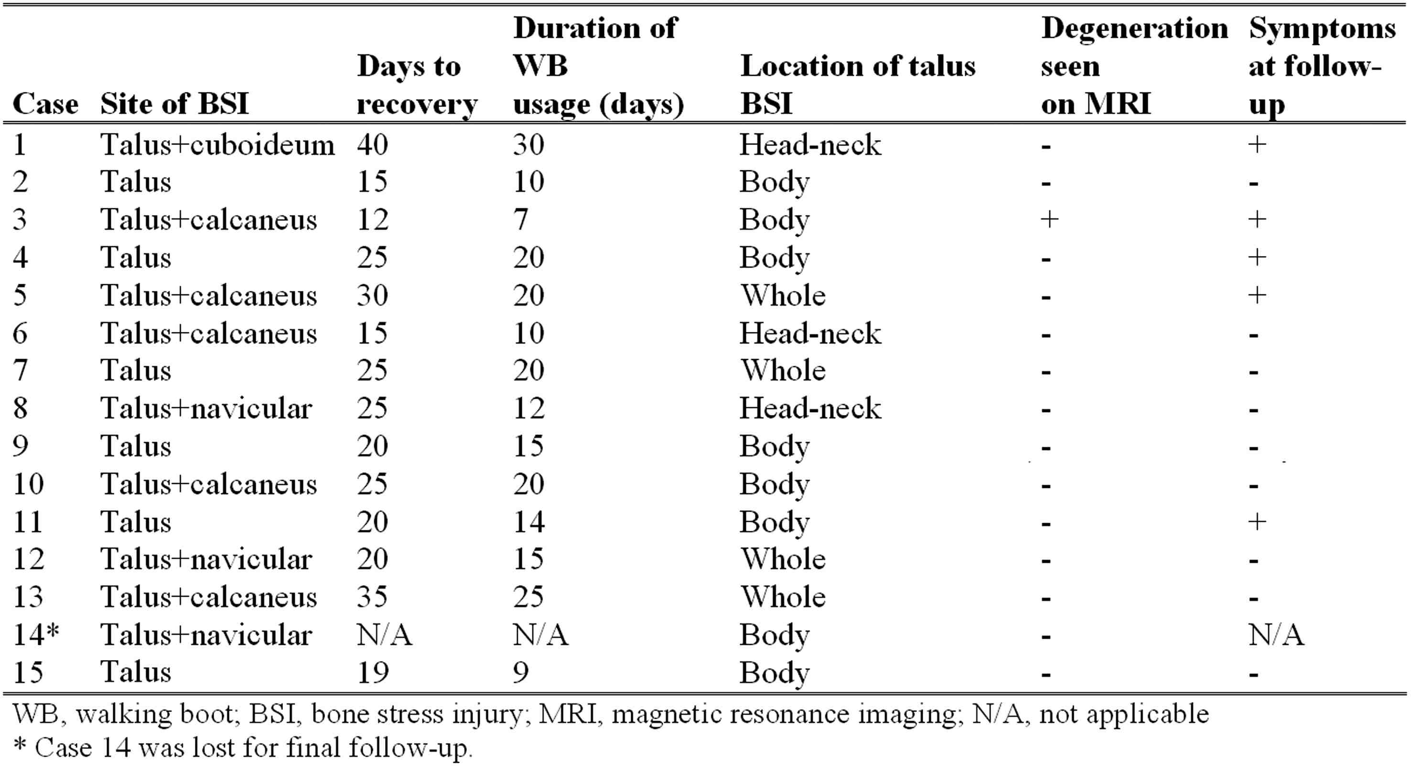
Discussion

The talus has an irregular shape with articular surfaces for tibia, fibula, calcaneus and navicular (Figure 1). It functions as a complex universal joint between the leg and the foot created by the ankle, subtalar and midtarsal joints. Injury may disturb the function and create serious disability. As in femoral head, osteonecrosis is a serious problem after injury to the talus (12).
Bone marrow edema (BME) seen with low grade injuries is a common nonspecific finding on ankle MRI; this finding has a wide diagnostic differential, including etiologies such as trauma, atraumatic osteonecrosis, osteochondral defect, tumors and tumor-like conditions, metabolic disease, tarsal coalition, transient bone marrow edema, infection, arthritis, as well as tendinopathy and plantar fasciitis (10, 13, 14). Schweitzer and Lawrence have previously described that altered biomechanics resulted in the development of BME (15). Moreover, it has been suggested that the development of BME is related to increased intramedullary pressure secondary to disturbed venous outflow (16).

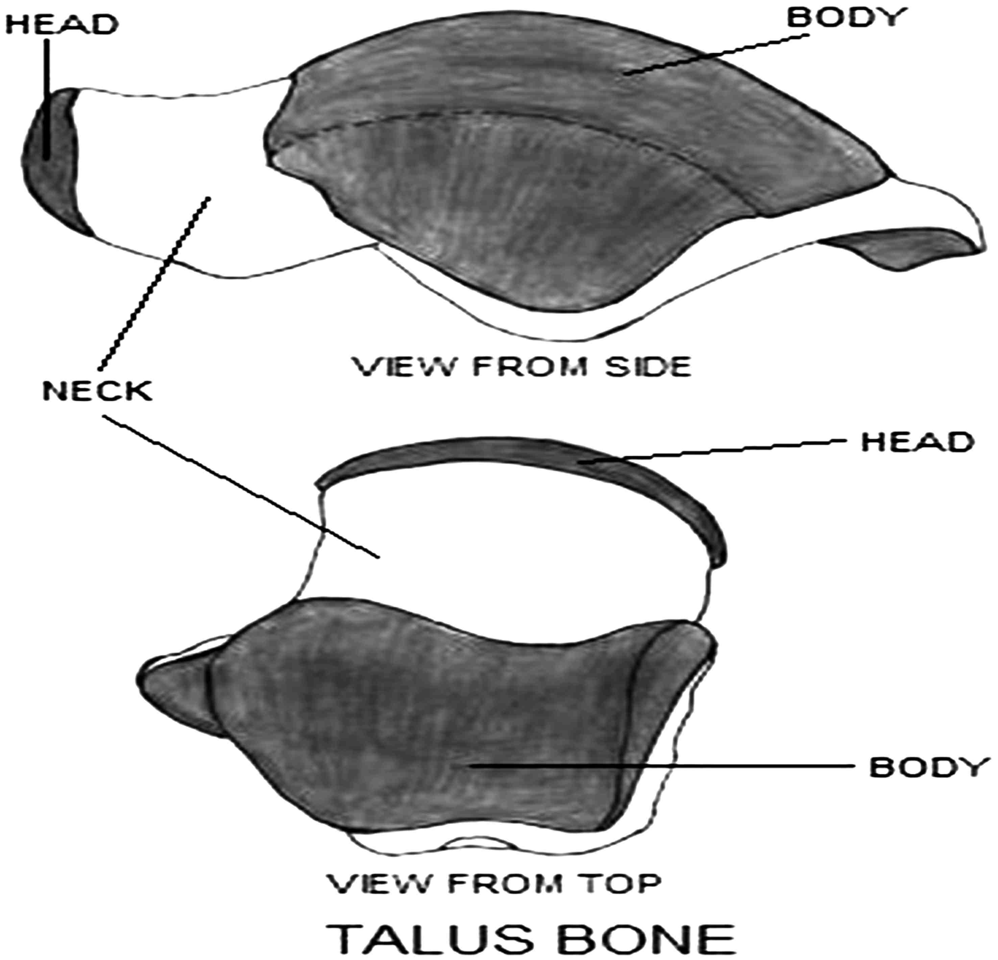

Figure 1. Anatomy of talus bone

Elias et al. consider BME to be a sign of overuse syndrome and may indicate an earlier and less severe bone stress injury of the talus (13). Stress injury is a continuum from the normal response to altered mechanics, to the symptomatic stress response, and eventually to stress fracture.
Stress injuries can occur in almost any bone in the body, with the lower extremity weight bearing bones, especially the tibia, calcaneus, tarsals and metatarsals being affected most frequently. The classic presentation of BSI is a patient who experiences insidious onset of pain, noted not only during activity but occasionally at rest and at night, after an abrupt increase in the duration or intensity of exercise. It may resolve spontaneously after 6 to 12 months (17). On physical examination, the most obvious feature is localized bony tenderness. Occasionally, redness, swelling or periosteal thickening may be present at the site of stress injury. Despite similar clinical symptoms, there is no specific finding on clinical examination to point to the diagnosis of BSI. Therefore, imaging studies are necessary (plain radiography, bone scintigraphy, computed tomography, and MRI). In case of talus BSI, plain radiographs are usually normal and MRI should be performed to confirm clinical suspicion of BSI (7).
Based on the study of Sormaala (10), BSIs of the talus occur usually in the head and less frequently in the body of the talus. In this study, the body of the talus was the most frequently affected part of the talus. Studies suggest that in most cases there is simultaneous stress injury present in other tarsal bones, which was the case in this study too. Injuries of the upper part of the talus body are usually associated with calcaneal stress injuries, and injuries of the talus head are associated with stress injuries in the navicular (10).
According to severity, the majority of BSI are low grade (MRI grade I-III) and can be detected with MRI (not by plain radiographs) (10). Our retrospective study included only patients with low grade BSI and plain radiographs were normal in all cases.
In previous studies, good results were recorded with conservative treatment consisting of non-weight bearing cast immobilization for 6 to 8 weeks, followed by gradual weight bearing in a boot for 2 to 6 weeks until reaching pain-free condition. Cast treatment, analgesic and anti-inflammatory medication, physical therapy, parenteral iloprost, sympathetic nerve blockage, and core decompression are known treatment options up to date (9,18). Albisetti et al. report that good result can be obtained with rest, extracorporeal shock wave therapy, pulsed electromagnetic fields and low-intensity ultrasound in metatarsal stress fractures (19). In addition, Brand et al. found that treatment of tibial stress fractures with daily low-intensity ultrasound and non-weight bearing for 4 weeks could be effective in pain relief and early return to daily activities (20).
To our knowledge, the present study is the first to describe the outcome of low grade talus stress injuries treated with physical therapy, reduced exercise and non-weight bearing. The major limitations of our study were retrospective design, small sample size, and the lack of control group and follow-up imaging to observe changes in this pattern over time.
The reason we chose walking boot instead of cast in our treatment protocol was to provide flexibility to patients in their daily life and better sleep with removing the boot while sleeping. Short leg walking boots have been shown to be an effective alternative to total contact casting for the reduction of plantar pressure (21).
As seen from previous studies, the recommended non-weight bearing period varies from 4 to 6 weeks, whereas in our study the mean time of using walking boot was 16.2 (7-70) days (8). Short time usage of walking boot decreases disuse muscular atrophy and weakness induced by immobilization and non-weight bearing.
During rehabilitative treatment of talus stress injuries, muscle strengthening and stretching exercises can begin immediately. Non-impact activities such as cycling and swimming can be used to maintain cardiac fitness. At least 1-2 weeks of pain-free normal ambulation should be achieved before returning to impact activities. Impact activities should start at low intensity for short periods (10-15 minutes) in the first few days and increase gradually as tolerated.
Ankara Rehabilitation Protocol for Lower Grade BSI of the Talus
• Start with rest and/or activity modification. It is required to reduce
symptoms to a level that can achieve pain-free activity.
• Crutch-assisted ambulation for the first 20 days is recommended.
• Use removable walking boot for 2-3 weeks. Boot can be removed during
ROM exercises four to six times a day.
• Gentle non-weight bearing exercises; active range of motion and
isometric exercises can be started in the first week.
• Physical therapy modalities:
- ultrasound
- TENS
- whirlpool can be recommended.
• Weight bearing is enhanced from walking in boot with crutches to weight
bearing in boot only. Pain is the guiding factor for progression of weight
bearing. In the 3rd week, weight bearing without crutches is allowed in
the boot as tolerated.
• Proprioception exercises with board, balance activities, progress to open-
chain strengthening with therabands can start as pain allows in the 3rd
week. Balance board exercises can be done for 3x15 sec on each
leg with the knee in a slightly flexed position and should be increased
progressively with the degree of difficulty.
• Stationary bicycling can be started when the patient tolerates
ambulation comfortably.
• High-impact exercises are held until patient has been completely
asymptomatic for 1-2 weeks
Conclusion

Low grade BSI of the talus have favorable outcome in most cases when treated conservatively. Removable walking boot can be used instead of cast immobilization for treatment of low grade BSI of the talus to reduce negative impact of immobilization on ROM and muscle strength. Pain is the most important guiding factor for progression of weight bearing.

Conflict of interest statement

The authors declare that they have no conflict of interest.

References:

1. Friedl KE, Nuovo JA, Patience TH, Dettori JR. Factors associated with stress fracture in young army women: indications for further research. Mil Med 1992;157:334-8.

2. Almeida SA, Williams KM, Shaffer RA, Brodine SK. Epidemiological patterns of musculoskeletal injuries and physical training. Med Sci Sports Exerc 1999;31:1176-82.

3. Rauh MJ, Macera CA, Trone DW, Shaffer RA, Brodine SK. Epidemiology of stress fracture and lower-extremity overuse injury in female recruits. Med Sci Sports Exerc 2006;38:1571-7.

4. Milgrom C, Giladi M, Stein M, Kashtan H, Margulies JY, Chisin R, Steinberg R, Aharonson Z. Stress fractures in military recruits. A prospective study showing an unusually high incidence. J Bone Joint Surg Br 1985;67:732-5.

5. McGlone JJ. Stress fracture of the talus. J Am Podiatry Assoc 1965;55:814-7.

6. Greaney RB, Gerber FH, Laughlin RL, Kmet JP, Metz CD, Kilcheski TS, Rao BR, Silverman ED. Distribution and natural history of stress fractures in U.S. Marine recruits. Radiology 1983;146:339-46.

7. Niva MH, Sormaala MJ, Kiuru MJ, Haataja R, Ahovuo JA, Pihlajamaki HK. Bone stress injuries of the ankle and foot: an 86-month magnetic resonance imaging-based study of physically active young adults. Am J Sports Med 2007;35:643-9.

8. Brockwell J, Yeung Y, Griffith JF. Stress fractures of the foot and ankle. Sports Med Arthrosc 2009;17:149-59.

9. Aigner N, Petje G, Steinboeck G, Schneider W, Krasny C, Landsiedl F. Treatment of bone-marrow oedema of the talus with the prostacyclin analogue iloprost. An MRI-controlled investigation of a new method. J Bone Joint Surg Br 2001;83:855-8.

10. Sormaala MJ, Niva MH, Kiuru MJ, Mattila VM, Pihlajamäki HK. Bone stress injuries of the talus in military recruits. Bone 2006;39:199-204.

11. Boden BP, Osbahr DC, Jimenez C. Low-risk stress fractures. Am J Sports Med 2001;29:100-11.

12. Kleiger B. Injuries of the talus and its joints. Clin Orthop Relat Res 1976;121:243-62.

13. Elias I, Zoga AC, Raikin SM, Peterson JR, Besser MP, Morrison WB, Schweitzer ME. Bone stress injury of the ankle in professional ballet dancers seen on MRI. BMC Musculoskelet Disord 2008;9:39.

14. Umans H, Pavlov H. Stress fractures of the lower extremities. Semin Roentgenol 1994;29:176-93.

15. Schweitzer ME, White LM. Does altered biomechanics cause marrow edema? Radiology 1996;198:851-3.

16. Gigena LM, Chung CB, Lektrakul N, Pfirrmann CW, Sung MS, Resnick D. Transient bone marrow edema of the talus: MR imaging findings in five patients. Skeletal Radiol 2002;31:202-7.

17. Lakhanpal S, Ginsburg WW, Luthra HS, Hunder GG. Transient regional osteoporosis. A study of 56 cases and review of the literature. Ann Intern Med 1987;106:444-50.

18. Boos S, Sigmund G, Huple P, Nurbakhsch I. [Magnetic resonance tomography of so-called transient osteoporosis. Primary diagnosis and follow-up after treatment.] Rofo 1993;158:201-6. (in German).

19. Albisetti W, Perugia D, De Bartolomeo O, Tagliabue L, Camerucci E, Calori GM. Stress fractures of the base of the metatarsal bones in young trainee ballet dancers. Int Orthop 2010;34:51-5.

20. Brand JC Jr, Brindle T, Nyland J, Caborn DN, Johnson DL. Does pulsed low intensity ultrasound allow early return to normal activities when treating stress fractures? A review of one tarsal navicular and eight tibial stress fractures. Iowa Orthop J 1999;19:26-30.

21. Crenshaw SJ, Pollo FE, Brodsky JW. The effect of ankle position on plantar pressure in a short leg walking boot. Foot Ankle Int 2004;25:69-72.

