Pavao Komadina*
MORSKO BRODARSTVO
Dragan Čišić**
Bojan Hlača***

ISSN 0469-6255
(183-189)

GLOBALIZATION IN MARITIME TRANSPORT INDUSTRY
Globalizacija u industriji pomorskog prijevoza

UDK 339.92:656.61
Prethodno priopćenje
Preliminary communication

Summary
Globalization is a new trend in world economy, fully influencing maritime transport industry. Maritime trade is one of the key driver of globalization, furthermore picture of vessel in open ocean is ultimate globalization emblem. In this paper authors review trends in maritime transport industry induced by globalization.

Sažetak
Globalizacija je novi trend u svjetskoj ekonomiji, koji u cjelosti utječe na transportnu industriju. Pomorska trgovina je jedan od ključnih pokretača globalizacijskog emblema. U ovom članku, autori izlažu trendove u industriji pomorskog prijevoza koji su potaknuti globalizacijom.

Introduction
Uvod
Globalization, as a phenomenon, is defined as a substantial (exponential) “expansion of cross-border networks and flows.” Such flows may include the creation of a global financial market, expansion of governance, or the increasing ubiquity of the Internet and other forms of communications via modern information technology. Frost, E (2000) describes globalization as a long-term process leading to “globality—a more interconnected world system in which interdependent networks and flows surmount traditional boundaries (or make them irrelevant).”
The maritime world can also be seen as a primary source of globalization because it is the medium by which 90 percent of world trade (when measured by weight and volume) is transported. Without the maritime trade, the barriers to global commerce would be insurmountable,

*dr. sc. Pavao Komadina, Pomorski fakultet, Rijeka
** dr. sc. Dragan Čišić, Pomorski fakultet, Rijeka
*** dr. sc. Bojan Hlača, Pomorski fakultet, Rijeka
and the history of the world would have been vastly different. E-commerce and the Internet may be the symbols of the most modern version of globalization, but historically the symbols have been the ever-increasing size and speed of ships and the shrinking cost of commercial transport. Transportation and logistics can be seen as a real parts of virtual business. Ultimately, the open ocean is still the prime medium and symbol of globalization
Modern economies are complex, often involving production entailing large amounts of capital and labour, and embracing numerous interactions among the actors involved. Globalization and internationalization have added to the integrated nature of systems, but with them have come more complex networks and a larger role for transportation
Containers and unitization have played an integral part in the development of global supply chains since the 1960s because they reduce shipment times and insurance and other costs by minimizing the amount of physical handling of goods during transit. Containers, in conjunction with the deregulation of transportation markets, the application of information technology, improvements in fuel efficiency and opening of markets have contributed to the development of modern global supply chains. Containerization has also contributed to the merging of shipping companies and global alliances, the deployment of larger vessels that are handling an increasing share of the world's container traffic, and the growth of massive transhipment ports.

Maritime Transport is Changing its Clock Speed
Pomorski prijevoz mijenja brzinu sata
In the past few decades many trade barriers have fallen. Key factors in demand and supply have resulted in a burgeoning of trade relationships between nations and regions across the world At a global level, the growth of the value of international trade since 1989 (up 190%) has substantially outstripped the growth in production (up by 80%) (HIDC, 1998).
Complex trading networks have evolved primarily to exploit labour cost differentials and the availability of raw materials in particular countries. Their development has also been facilitated by major regulatory and technological trends. Trade liberalization, particularly within trading blocks such as the EU and NAFTA, has removed constraints on cross-border movement and reduced related ‘barrier costs’. Advances in telecommunications and information technology have given companies the means to manage the physical movement of product over long, often circuitous, routes.
Around 90% of merchandise is transported by sea According to WTO data world seaborne trade amounted to 5.9 billion tons of loaded goods in 2002, up by 0.8 per cent from the previous year. In 2002, the share of seaborne exports of developing countries was equal to 49.4%, while that of developed countries was 40.4% (developed countries’ share in seaborne imports was 60.3%, while that of developing countries was 31.4%)...
The global economy is expected to expand, but much will depend on the rate of industrial development in Asia, import and export growth in the United States and in Europe, as well as the price of oil.
In line with the above developments, European ports showed in 2003 a throughput of 60 million TEU, an average 10,5% increase compared to 2002.
All this shows that maritime transport industry is changing clock-speed. From industry where changes were expected in decades, maritime transport is suddenly changing into industry with fast clock speed, where changes are constant and new logistic strategies are daily operated.
A recent study by Lloyd’s Register and Ocean Shipping Consultants estimated that an Asia-Europe service carrying 1.5 m TEU a year would cost US$92 million less to operate if served by 12,500 TEU rather
Picture 1. Ship capacity change [G.de Monie research corp. ]
Slika 1. Izmjena kapaciteta broda

than 4,000 TEU plus vessels. On a cost per container slot4basis, a 4,000teu vessel making five port calls in Europe and five in Asia would have fully built up costs of US$253/slot, compared with US$215/slot for the 8,000teu vessel, and US$192 for the 12,500teu vessel.

Shipping Companies
Brodarske kompanije
The general picture of world shipping developments was very favourable during 2004. Oil tanker demand and revenues were volatile. Bulk carriers enjoyed a more steady development, from last quarter 2003 to early 2004 showing almost unrecalled strong demand and rates. Developments in the container market showed a similar positive picture with an unexpectedly high demand for capacity, notwithstanding substantial phasing in of large new buildings, resulting in high charter rates.
The change is especially shown in increase of the liner vessel capacity. The growth of average TEU capacity was, according to Gilman ,1999 steady from 1980.
Intense competition and economies of vessel size lie behind recent increases in the size of container ships. Economies of vessel size arise from the technical characteristics of container shipping: the capital cost per container slot falls as vessel size increases, while the ratio of crew to carrying capacity and the consumption of fuel per unit of cargo carried also decline as vessel size increases.
The historical tendency for ship size to increase re-emerged in the mid 1990s, several owners choosing to order vessels that were too large to transit the Panama Canal, thus sacrificing operational flexibility. Hyundai, Maersk, Mitsui-OSK, NYK, OOCL and P & O Nedlloyd ordered ‘post-panamax’ tonnage in the latter years of the 1990s. Maersk bought several 6,000-6,600 TEU post-Panamax vessels, while P & O Nedlloyd introduced four 6,700 TEU vessels and NYK five 5,700 TEU vessels into Europe-Asia service (Containerisation International Yearbook, 1999).

In August 2000, Ocean Shipping Consultants predicted that vessels of 8,500teu capacity would be operating in the Europe-Asia trade by 2005 while 12,500teu vessels would be introduced by 2010 (Shipping Times, 28 August 2000). There has been some discussion of the technical and commercial feasibility of introducing 18,000teu – Malaccamax – container vessels in the long run.

Vertical and Horizontal Integration
Vertikalna i horizontalna integracija
In recent years, there have been well-marked trends for vertical and horizontal integration in the international maritime logistics chain. Shipping companies in particular have been taking the initiative in this development. One consequence has been an increase in the market power of the large shipping companies over the other service suppliers, such as port authorities.Shippers have various influences on the patterns of vertical and horizontal reorganisation. Perhaps there strongest influence is their indirect influence through the preferences that they express in the market in their purchases of transport and logistics services. Consolidation among the shippers is adding weight to the need for service suppliers with a global capability. Characteristics of supply-chain management are encouraging vertical integration.
Alliances, acquisitions and mergers have been seen as elements of an industry-wide strategy to return to profitability via cost cutting and rationalisation (UNCTAD 1998).

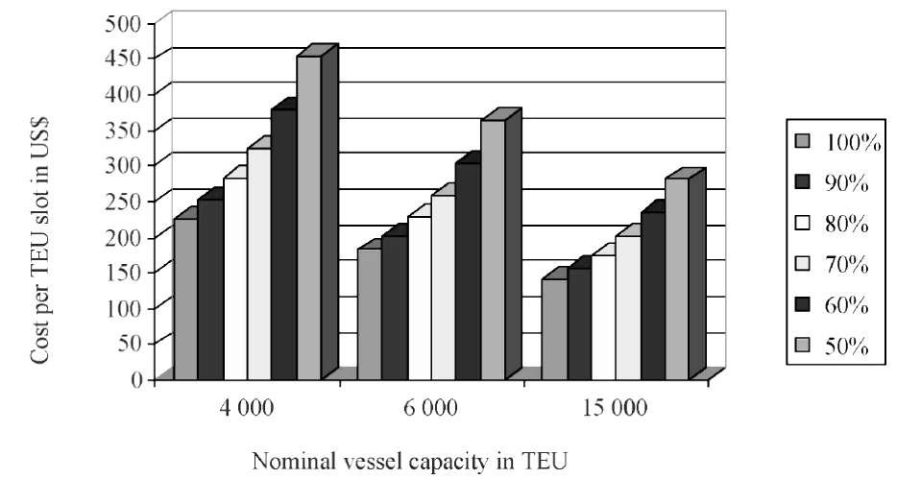
Picture 2. Slot costs [G.de Monie Research Corp. ]
Slika 2. Presjek troškova [G.de Monie Research Corp. ]

Intense competition and low profitability have encouraged rationalisation, the preferred method of achieving the objective has changed over time. Strategic alliances were preferred in the late 1980s and early 1990s, culminating in the formation of the Grand and Global Alliance. More recently the emphasis has switched to merger and acquisition. Despite their potential advantages, alliances are not stable and participants are therefore hesitant to make long-term commitments. The lack of long-term commitments precludes alliances from realizing the full potential of synergies and cost savings. This weakens their stability and promotes mergers to achieve the desired stability.
Alliances tend to have a short life; the high mortality rate among alliances often being attributable to mergers between lines belonging to competing alliances.
Vertical integration of different maritime industries occurs, for example, when a shipping line buys a container leasing company, when a freight forwarder purchases a shipping company, when an international port operator merges with a shipping line or when an international investor purchases a shipyard and a shipping line.
Merging or acquisition of shipping lines and ports or dedicated port terminals today is a common attribute. Concentration in ports and shipping may one day reach new dimensions should conglomerates of freight forwarders, carriers, and port operators become reality.

Ports
Luke
The most significant development in the transformation of ports has been the remarkable changes in the technology associated with the transportation and distribution of cargo, particularly the widespread introduction of containerisation since the 1970s. The most dramatic effects of containerisation have been reduced ship turn-round time, which has massively reduced labour costs. Economy of scale and large container vessels are introducing the concept of port concentration.
The phenomenon of port concentration on a world scale can be generally measured by looking at the evolution of the top 10 world ports' traffic market share. In fact a tendency to concentrate port traffic has been existing for nearly fifteen years.

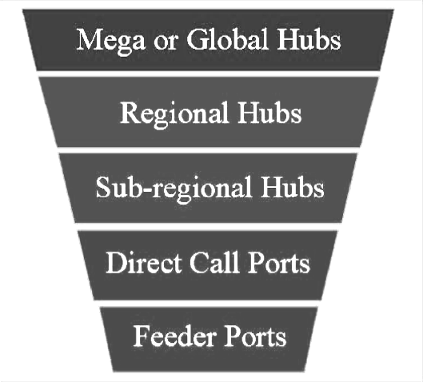

Picture 3. Hierarchical port structures
Slika 3. Hijerarhija lučkih struktura

Container lines have sought to minimise costs by limiting the number of port calls. In so doing they have re- emphasised the importance of regional hub ports. It is suggested that in the future there will be only 4 to 5 big hub ports serving leviathan vessels of 18 000 TEU.
The feeder networks based on major hub ports will then expand geographically.
Serving mega-size container ships presents several problems for ports including ensuring: adequate deep water (including environmental concerns related to required dredging), wider channels, deeper berths, suitable highspeed cargo-handling equipment (including longer out-reach post-Panamax sized, quay-side gantry cranes), a highly productive and reasonably priced labour supply, suitable berths for coastal feeder vessels, and good road and rail intermodal connections to inland destinations.

Although longer out-reach post-Panamax cranes are being built and delivered to various ports. their longer out-reach could create load limitations due to the terminal’s marginal wharf capacity and pile bearings. Such load limitations might lead to additional expensive retrofits.
Alternative ship handling arrangements such as providing a slot berth for mega-size container ships to enable post-Panamax cranes to serve both sides of the vessel simultaneously have been proposed. The first slot berth is under construction at the Ceres Paragon terminal in Amsterdam (Champion 2000).
All these changes that take place in the liner industry have a direct effect on the way ports operate. In their effort to attract more business, ports enter into fierce
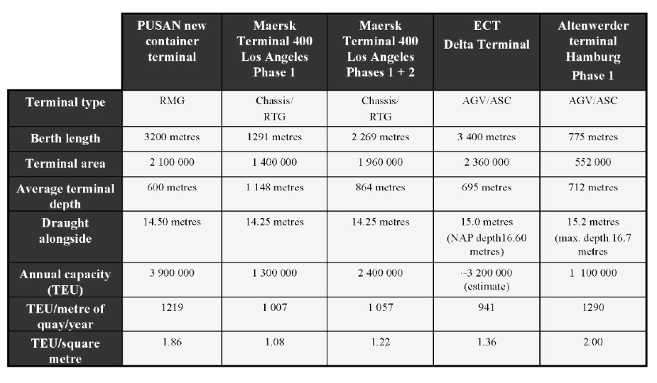
Picture 4. Specification of present and planned port terminals
Slika 4. Specifikacija sadašnjih I planiranih lučkih terminala

Another important aspect is the appearance of large international port operators, such as Hutchison Port Holdings of Hong Kong, Stevedoring Services of America (SSA), International Container Terminal Services (ICTS) of the Philippines and P&O Ports of Australia. These companies benefit from the recent surge in privatizations. According to a recent study by Drewry Shipping consultants(1998), the major international terminal
operators have, on average, an operating cost advantage of US$ 12 per TEU because of their
economies of scale.
Other port trends include container handling performance, automation of port labour , productivity and rationalization.
Port cooperation, by creation of port clusters, will be one of the principal model of survival of small ports. Treatment of assets in terms of function and availability, rather than as physical objects, would have a big impact
competition between each other. According to Fleming and Baird (1999), port competition is divided into four categories:
1. Competition companies offering the same services within the same port
2. Competition between ports; based on geographical borders
3. Competition between port clusters; with a common geographical characteristic.
4. Competition between port ranges. With more or less the same hinterland.
Competition is now creating port differentiation of ports in hub ports , feeder ports and niche ports.

on the classical port hinterland creation, because of the dissociation of the control of the assets from their physical location will change the individual port corridors into common one. For example there should be only North Adriatic corridor, instead of the Trieste-port, Portorose-port and/or Rijeka- port corridor corridors, defining common logistic and physical resources. First step in cooperation should be dissociation of the information from physical movements, represented by the common information resources system, creating first step into the cooperation.

Logistic Systems
Sustavi logistike
The convergence of maritime transport and logistics may be largely attributed to the physical integration of modes of transport facilitated by containerization and the evolving demands of end-customers that require the application of logistics concepts and the achievement of logistics goals. At the centre of maritime logistics is the concept of integration, be it physical (intermodal), economic/strategic (vertical integration, governance structure) or organizational (relational, people and process integration across organizations).
New logistic technologies and business models are directly accepted by maritime industry. Supply chain creation is a mode where participants share the same values and views on what information and related performance indicators that are necessary to secure the total efficiency
Information and communication technology (ICT) has played, and will continue to play, a key role in transforming logistics and supply chain planning.
E-commerce shifts the role of transport and changes the relation and power structures between companies in supply chains. Small companies (with complementary expertise) can team up in virtual organizations, leading to virtual concentration (not necessarily physical!).
The Internet and E-commerce initially offered a level playing field for SME’s and larger companies: everyone has easier access to world markets. Most concepts for improving supply chain efficiency are based on sharing of information throughout the supply chain in order to improve transparency and to eliminate the Forrester/Bullwhip effect. In many cases, while from a functional perspective it is clear that there are benefits to the supply chain as a whole, the distribution of the benefits remains a difficult task.
Introduction of the electronic documents, as shown in (Komadina et all 2000), can lower significantly transaction and administration costs.
A major consequence of ICT is that it changes the structure of supply chains. This is caused by the fact that information and physical flows can be de-coupled. As a consequence, processes become more flexible and/or agile and companies can become more footloose. This may lead to quick changes in the configuration of a supply chain, in which possible negative (external) effects are not taken into account.
Supply chain management trends yield both opportunities and threats to intermodal transport. The main opportunity is brought about by the increasing volume of flows, transported over longer distances and better planning and co-ordination possibilities of logistics activities through ICT. This increases consolidation opportunities and the relative competitiveness of intermodal solutions.

Conclusions
Zaključci
Intense competition has forced owners to adopt innovative, productivity-enhancing and cost cutting strategies. Successively larger vessels have been employed on mainline East-West Northern Hemisphere trades. New service patterns have evolved.. In their search for cost reduction and faster transit times, lines have reduced the number of port calls, leading to the growth of ‘hubs’ or ‘load centres’ and the evolution of feeder networks

Bibliography
Literatura
- Champion, V. (2000), ‘Keen to Bridge the Gap’, The World of Cargo Handling - Annual Review 2000, International Cargo Handling Association, Rumford, Essex, United Kingdom, pp. 47-49.
- ‘Cullinane, K, Khanna, M. and Song, D. W. (1999), ‘How Big is Beautiful: Economies of Scale and the Optimal Size of Containership’, Liner Shipping: What's Next?, Proceedings, Halifax Conference of the International Association of Maritime Economists, September, pp. 108-140.
- Cullinane, K. & Khanna, M. (1997), ‘The Economics of Deploying Large Containerships’, International Conference of Maritime Economists, 1997 International Conference, London: International Association of Maritime Economists.
- Frankel, E.G. 1999, ‘The Economics of Total Trans-ocean Supply Chain Management’,
- International Journal of Maritime Economics, 1(1), September, 61-9.
- Durvasula, S, Lysonski, S and Mehta, SC. (2001): Understanding the interfaces. How ocean freight shipping lines can maximize customer satisfaction. Industrial Marketing Management 31: 1–14.
- Evangelista, P and Morvillo, A. (1999): Alliances in liner shipping: an instrument to gain operational efficiency or supply chain integration? International Journal of Logistics: Research & Applications 2: 21–38.
- Evangelista, P and Morvillo, A. (2000): Co-operative strategies in international and Italian liner shipping. International Journal of Maritime Economics 2: 1–16.
- Ferrari, C, Morchio, E and Parola, F. (2005): Southern European ports and the spatial distribution of EDCs. Proceedings of the International Association of Maritime Economists Conference, Limassol, Cyprus.
- Fleming D. K.; Baird A. J. 1999 Comment Some reflections on port competition in the United States and western Europe Maritime Policy & Management, Volume 26, Number 4, 1 October 1999, pp. 383-394(12)
- Frankel, E. (1999): Intermodal integration. Lloyd's Shipping Economist 21: 10–11.
- Frost, E ( 2000) “Globalization and National Security: A Strategic Agenda,” in The Global Century: Globalization and National Security, ed. Richard Kugler and Ellen L. Frost (Washington, DC: National Defense University Press, 2000),
- Gilman, S. 1999, ‘The Size Economies and Network Efficiency of Large Containerships’, International Journal of Maritime Economics, 1(1), July- September, 39-59.
- Holland International Distribution Council, ‘Worldwide Logistics, The Future of Supply Chain Services’, HIDC, The Hague, 1998
- Pavao Komadina Dragan Cisic Milojka Pocuca , 2000. "Modelling The Documentation Flow In Transport Supply Chain - Results From The Simulation Experiments," International Trade 0004004, EconWPA

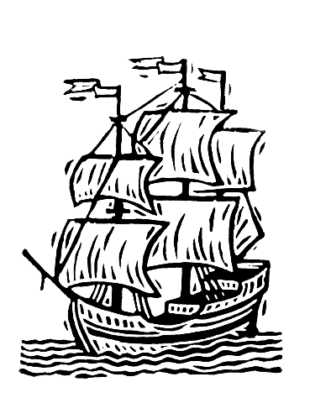

- Notteboom T ( 2006 ) The Time Factor in Liner Shipping Services Maritime Economics & Logistics (2006) 8, 19–39
- United Nations Conference on Trade and Development, Review of Maritime Transport (annual - various issues). New York: UNCTAD.
- U.S. Department of Transportation, Office of Intermodalism, The Impacts of Changes in Ship Design on Transportation Infrastructure and Operations, U.S. Department of Transportation.

Rukopis primljen: 30. 11. 2006.

