Vlatko Lipovac*
POMORSKE KOMUNIKACIJE
Amir Kraljušić**

ISSN 0469-6255
(220-227)

PRACTICAL ESTIMATION OF VOIP QOS BASED ON CORRELATED ANALYSIS OF TRANSPORT PROTOCOL IMPAIRMENTS AND PERCEPTUAL SPEECH QUALITY Praktična procjena kvalitete paketskog govora (VoIP) koreliranom analizom nesavršenosti implementacije prijenosnih protokola i perceptualne kvalitete govora

UDK 004.77:621.395
Izvorni znanstveni članak
Original scientific paper

Summary
The request for QoS in packet transmission networks (specifically in Voice-over-Internet Protocol (VoIP) networks) can be considered as two-fold: to ensure satisfactory performance at (relevant) protocol levels (IP, TCP/UDP, RTP), as well as at perceptual speech quality level, observed in between end points of the system. With this respect, in this paper, correlation between these two levels of testing is proposed in a chosen typical test environment, where in addition to signaling protocols decoding and expert analysis, RTP packet jitter and loss have been measured and statistically analyzed. Then these results have been correlated with the results of the objective perceptual speech quality testing, providing the integral practical QoS criterion.
Key words: voice-over-IP, quality-of-service, Internet, packet, perceptual

Sažetak
Zahtjev za osiguranjem adekvatne kvalitete usluge u mrežama za paketski prijenos govora (u užem smislu, pomoću Internet protokola (VoIP)), može se razmatrati dvojako: kao zahtjev za zadovoljavajućom performansom (relevantnih) slojeva protokola (IP, TCP/UDP, RTP) i perceptualnom kvalitetom govora, promatranom između krajnjih točaka sustava. S tim u vezi, u ovome radu se razmatra korelacija između ove dvije razine ispitivanja u odabranoj tipičnoj ispitnoj sredini, gdje su, pored dekodiranja signalizacijskih protokola i njihove ekspertne analize, mjerene i statistički analizirane slučajne varijacije i intenzitet gubitaka RTP paketa, a zatim ovi rezultati

* dr. sc. Vlatko Lipovac, Sveučilišta u Dubrovniku
** mr. sc. Amir Kraljušić, Sveučilište u Sarajevu
korelirani sa rezultatima objektivne analize perceptualne kvalitete prenesenoga govora, što rezultira praktičnim kriterijem za integralnu kvalitetu usluge.
Ključne riječi: govor-putem-Internet-protokola, kvaliteta usluge, Internet, paket, perceptualni

1. Introduction
Uvod
All-IP multiservice networks are fast becoming standard, especially in local area networks (LAN) environments such as the ones of large ships, where variety of communications services onboard the ship as well as from/to outside world must be accomplished in most efficient and flexible way. This applies to voice services as well, so one of the most important technical aspects of practical implementation of Voice-over-Internet Protocol (VoIP) systems is to provide appropriate level of Quality-of-Service (QoS) [1] - [4].
However, this is anything but easy, as packet networks with connectionless and so unreliable protocols (such as IP that does not guarantee packet delivery and tolerate significant delays and delay variations during data transmission), are inherently not good candidates for transmission of real-time signals such as speech.
Therefore, during installation and maintenance of VoIP networks, it is of particular importance to have a near real-time insight into the overall QoS.
In this paper, we propose a test procedure for the overall QoS, which consists of measurements of typical impairments that the transport protocol packet [6] encounters throughout the network and, in parallel, investigates the end-to-end perceptual quality of speech.

- Typical Signaling Problems in VoIP Networks
Tipični problemi signaliziranja u mrežama s paketskim prijenosom govora
Apart from general problems not typical only for VoIP networks, such as cable breaks, misconfigured and malfunctioning equipment, congestion, etc., there are many others associated exclusively with the ITU-T’s H.323 environment (or with IETF’s SIP, if applicable). Generally, these fall into two categories that are, in turn, driven by requests for:
-cooperation with the existing multimedia networks [5] such as traditional PSTN and ISDN, Fig.1
Fig. 1. Cooperation between the IP-based and traditional network
Sl. 1. Koegzistencija IP i tradicionalne mreže

Fig. 2. Protocol set in a gateway
Sl. 2, Skup protokola usmjerivača

-interoperability [1], [5] between pieces of equipment coming from different vendors who might implement the H.323 recommendations not exactly the same way, or with different interpretations of optional features of the evolving suite of standard protocols (see Fig.2), so creating non-neglectable incompatibilities in codecs, port assignments etc.
For example, registration, media control and signaling protocol sequence, may be implemented with slight variations throughout equipment from different vendors and so lead to interoperability problems.

B. QoS for VoIP Networks
Kvaliteta usluge u VoIP mrežama
While for the traditional PSTN environment, voice quality standards have been established long ago, with the packet-based transmission of voice, it is necessary to ensure some sort of tracking of the quality of service (QoS). However, while this can be accomplished at different levels of protocol hierarchy, it is not straightforward how impairments from various levels interrelate. In practice, this implies that the overall criterion for the achieved QoS must encompass analysis of signaling and transport protocols (within their IP environment), as well as an objective measure of perceptual quality of transmitted speech.
Among the most important factors which determine the quality of service are: required bandwidth (though relatively narrow but preferably constant for real-time speech signals with both linear and non-linear compression techniques present in a multimedia – desktop – environment), processes at gateways (e.g. silence supression and echo cancellation), packet jitter and packet loss, delay (due to signal digitization, packetization, transmission, routing and buffering).
Specifically, in the following section, after briefly addressing typical signaling protocols verification and troubleshooting process, we will point out the importance of measuring and statistical analysis of jitter and loss of RTP packets, to complete the proposed test procedure for the QoS with voice quality measurements.

- RTP Jitter and Packet Loss
RTP slučajne promjene trenutka uzorkovanja i intenzitet gubitaka paketa

Fig. 3. Packet jitter and loss
Sl. 3. Slučajne promjene trenutka uzorkovanja i intenzitet gubitaka paketa

IP protocol is not isochronous, as, generally, it delivers its protocol data units to the destination at a speed different from the one at the source. Datagrams can be lost, duplicated, delayed or out of sequence. Small variations of datagram delays – jitter – can be compensated by the reproduction buffer at the destination, where the incoming data are stored before reproduction. When the amount of buffered data reaches a predefined threshold K (playback point), expressed in time units, reproduction starts. As each packet carries a time stamp, the reproduction can be according, even for incoming packets out of sequence.
If no jitter is present, arrival and departure frequencies of data in the buffer will be equal, implying K time units of data preserved in it. Moderately delayed packets will only decrease the buffer content before arrival and increase it after arrival. However, long delayed packets will be lost (see Fig 3).
This implies that buffer size is a compromise between loss and delay. However, in spite of some obvious advantages that adaptive buffering (based on dynamically changing K by estimating network delay and jitter) may offer, fixed-K implementations are still mostly in use.
Therefore, as an important constituent of the overall practical QoS criterion, it is crucial to accomplish mutually time-correlated measurements and statistical analysis of RTP packet jitter and packet loss.
Of course that packet loss can occur due to other causes, too, such as e.g. network congestion and consequent overflow of router buffers, routing changes (when some links quit operation) etc. However, for non-real-time applications, such as e.g. file transfer, packet loss is not critical, and can be countered by packet retransmission.

- Objective Measures for Perceptual Speech Quality
Objektivne mjere perceptualne kvalitete govora
For traditional PSTN networks, where Linear Time Invariant (LTI) system model and waveform signal encoding is used (opposite to VoIP), there are some straightforward speech quality expressions, such as e.g. the one for the Signal-to-Noise Ratio due to quantization noise:

${\left(S/N\right)}_{\text{out}}=\frac{M^{2}}{1+4\left(M^{2}−1\right)P_{e}}$ (1.)

where M is the number of quantizing steps in the uniform quantizer, and P_{e} represents Bit-Error-Rate (BER). For non-uniform quantizers (u-law and A-law) much more complicated logarhytmic expressions are used.
However and unfortunately, it is not that simple with VoIP networks. There are three basic constituents of the end-to-end voice quality, specifically applicable to VoIP networks: clarity (encompassing: fidelity, clearness, distortionlessness, intelligibility), end-to-end delay and echo (see Fig.4.). Mutual relationships of the three can be very complex and the quality decreases with increasing distance from the crossing point of the three axes.

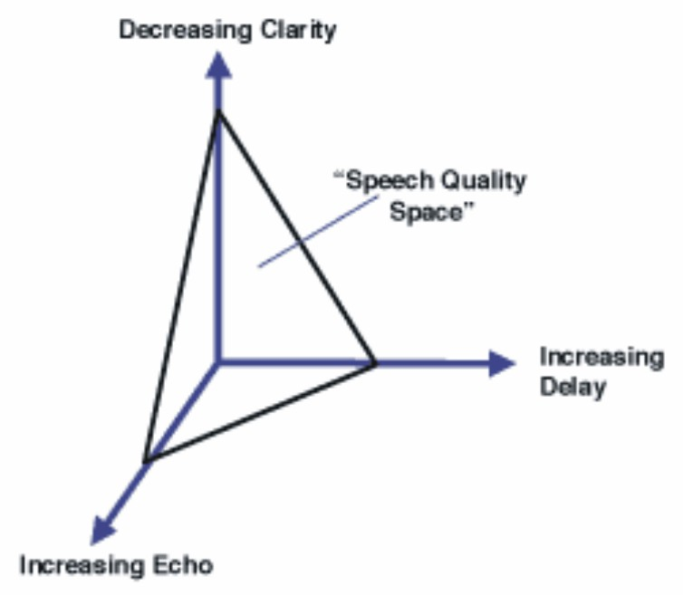
Fig. 4. Impact of clarity, delay and echo on the voice quality
Sl. 4. Utjecaj jasnoće, kašnjenja i odjeka na kvalitetu govora

So e.g. clarity and delay are mutually independent and orthogonal aspects of speech, while echo depends on delay and echo impacts clarity. However, the representation

on Fig.4 is just conceptual, and unfortunately, there is no ground to develop a unique scalar representation for the voice quality (VQ).
There are a number of standard objective VQ testing techniques, such as PSQM, PAMS and PESQ [4], [5]. Our practical VQ measurements are based on PSQM.

II. Test Results

Rezultati ispitivanja

Experimental System

Eksperimentalni sustav
In order to practically demonstrate usefulness of the proposed QoS testing procedure, a number of measurements have been accomplished on the experimental system, presented on Fig.5.
We used two PC workstations, operating under Windows2000 and WindowsXP and having installed MS NetMeeting. Measurements were accomplished by means of the (multi)protocol analyzer Agilent Advisor LAN, running Expert TCP/IP and VoIP Commentators, Decodes and RTP Statistical Analysis, as well as Voice Quality Perceptual Speech Quality Measurements (VQ PSQM).

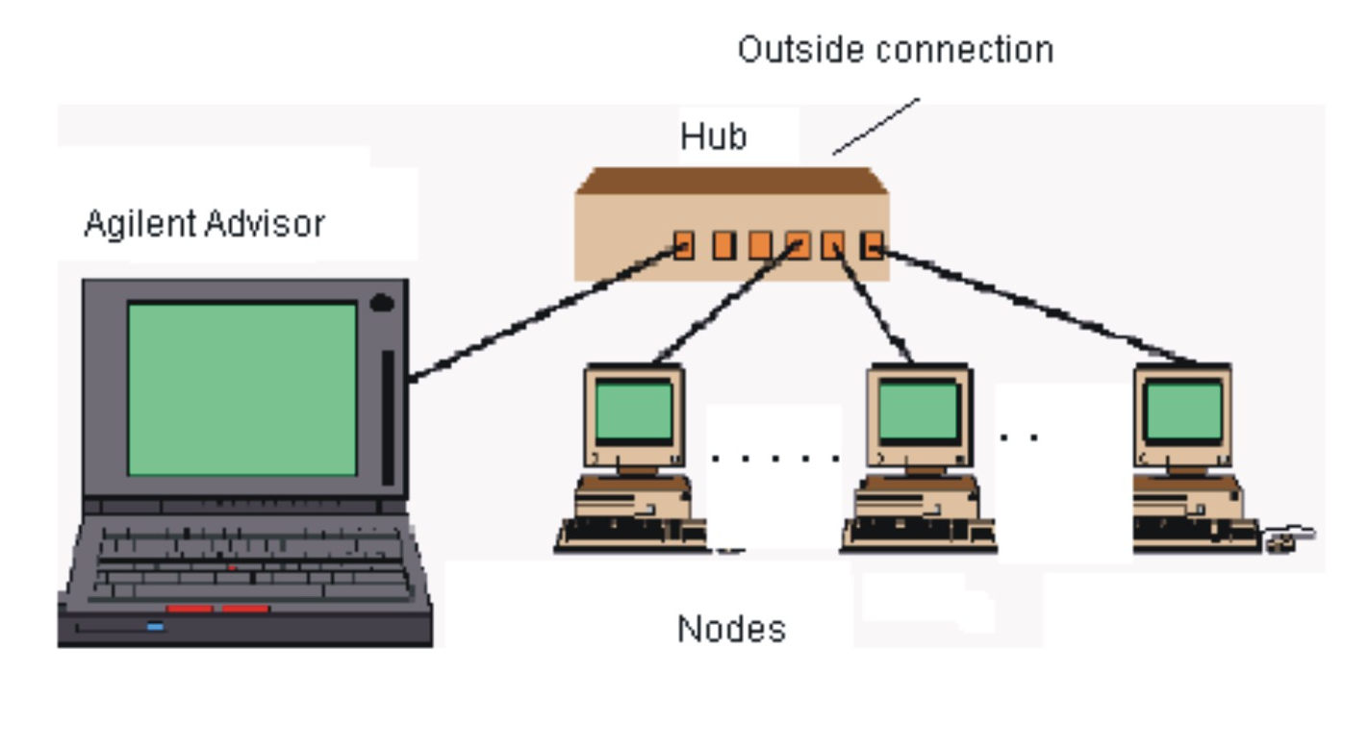
Fig. 5. Experimental system configuration
Sl. 5. Konfiguracija eksperimentalnoga sustava

- Expert and Statistical Protocol Analysis
Ekspertna i statistička analiza protokola
Essentially, classical protocol analysis provides decoding of Protocol Data Units (PDU) as presented at Fig.6. However, while this can be very useful as a means to discover and ultimately verify incompatibility and interoperability problems with signaling protocols, it is mostly accompanied with expert analysis that points out what most likely causes degraded performance. We used the Agilent Advisor Expert Commentators at various protocol levels for this purpose and configured it for TCP/IP and VoIP as shown at Figs. 7 and 8, respectively.

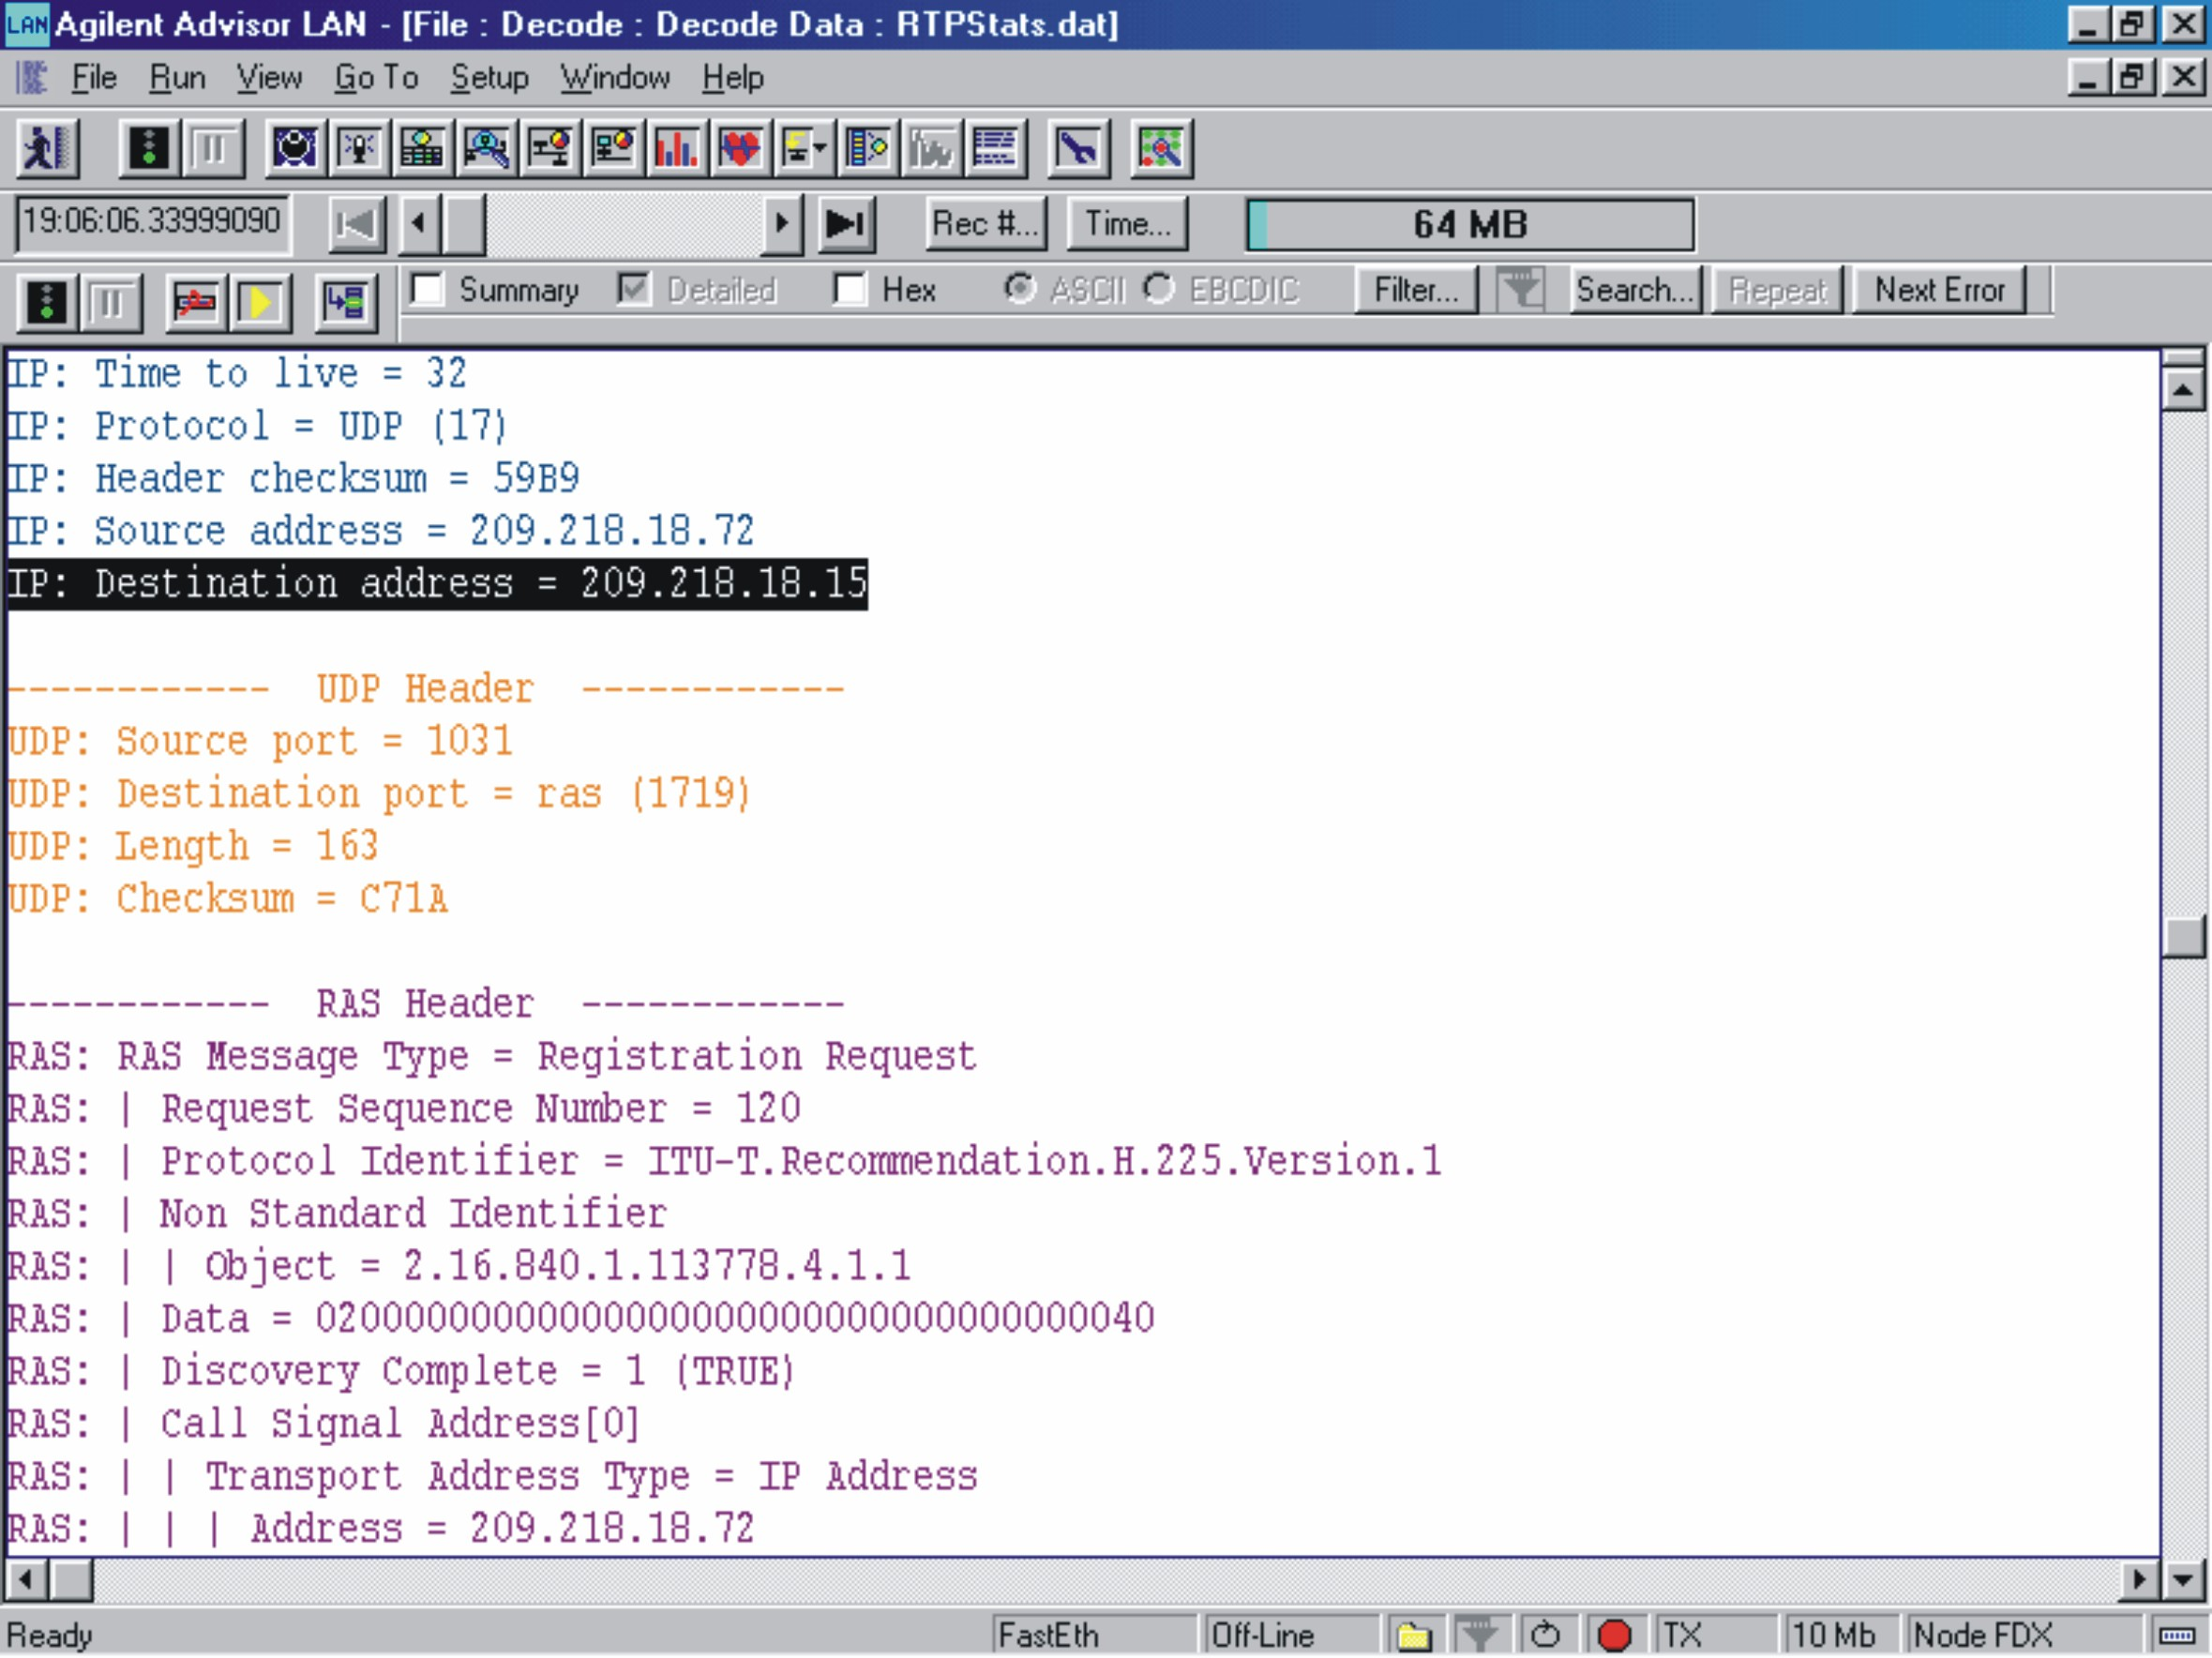

Fig. 6. Decoding of PDUs for discovering and/or verification of signaling incompatibility and interoperability problems

Fig. 6. Dekodiranje jedinica podataka protokola radi otkrivanja i/ili verificiranja signalizacijskih nekompatibilnosti i problema koegzistencije različite opreme

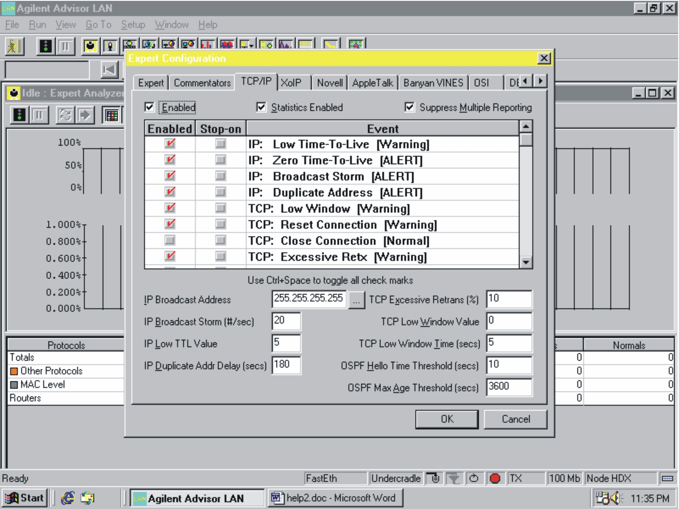

Fig. 7. Selecting measurements and thresholds to determine significant events for the TCP/IP Expert Commentator

Sl. 7. Odabir mjerenja i pragova za određivanje značajnih događaja TCP/IP ekspertnog komentatora

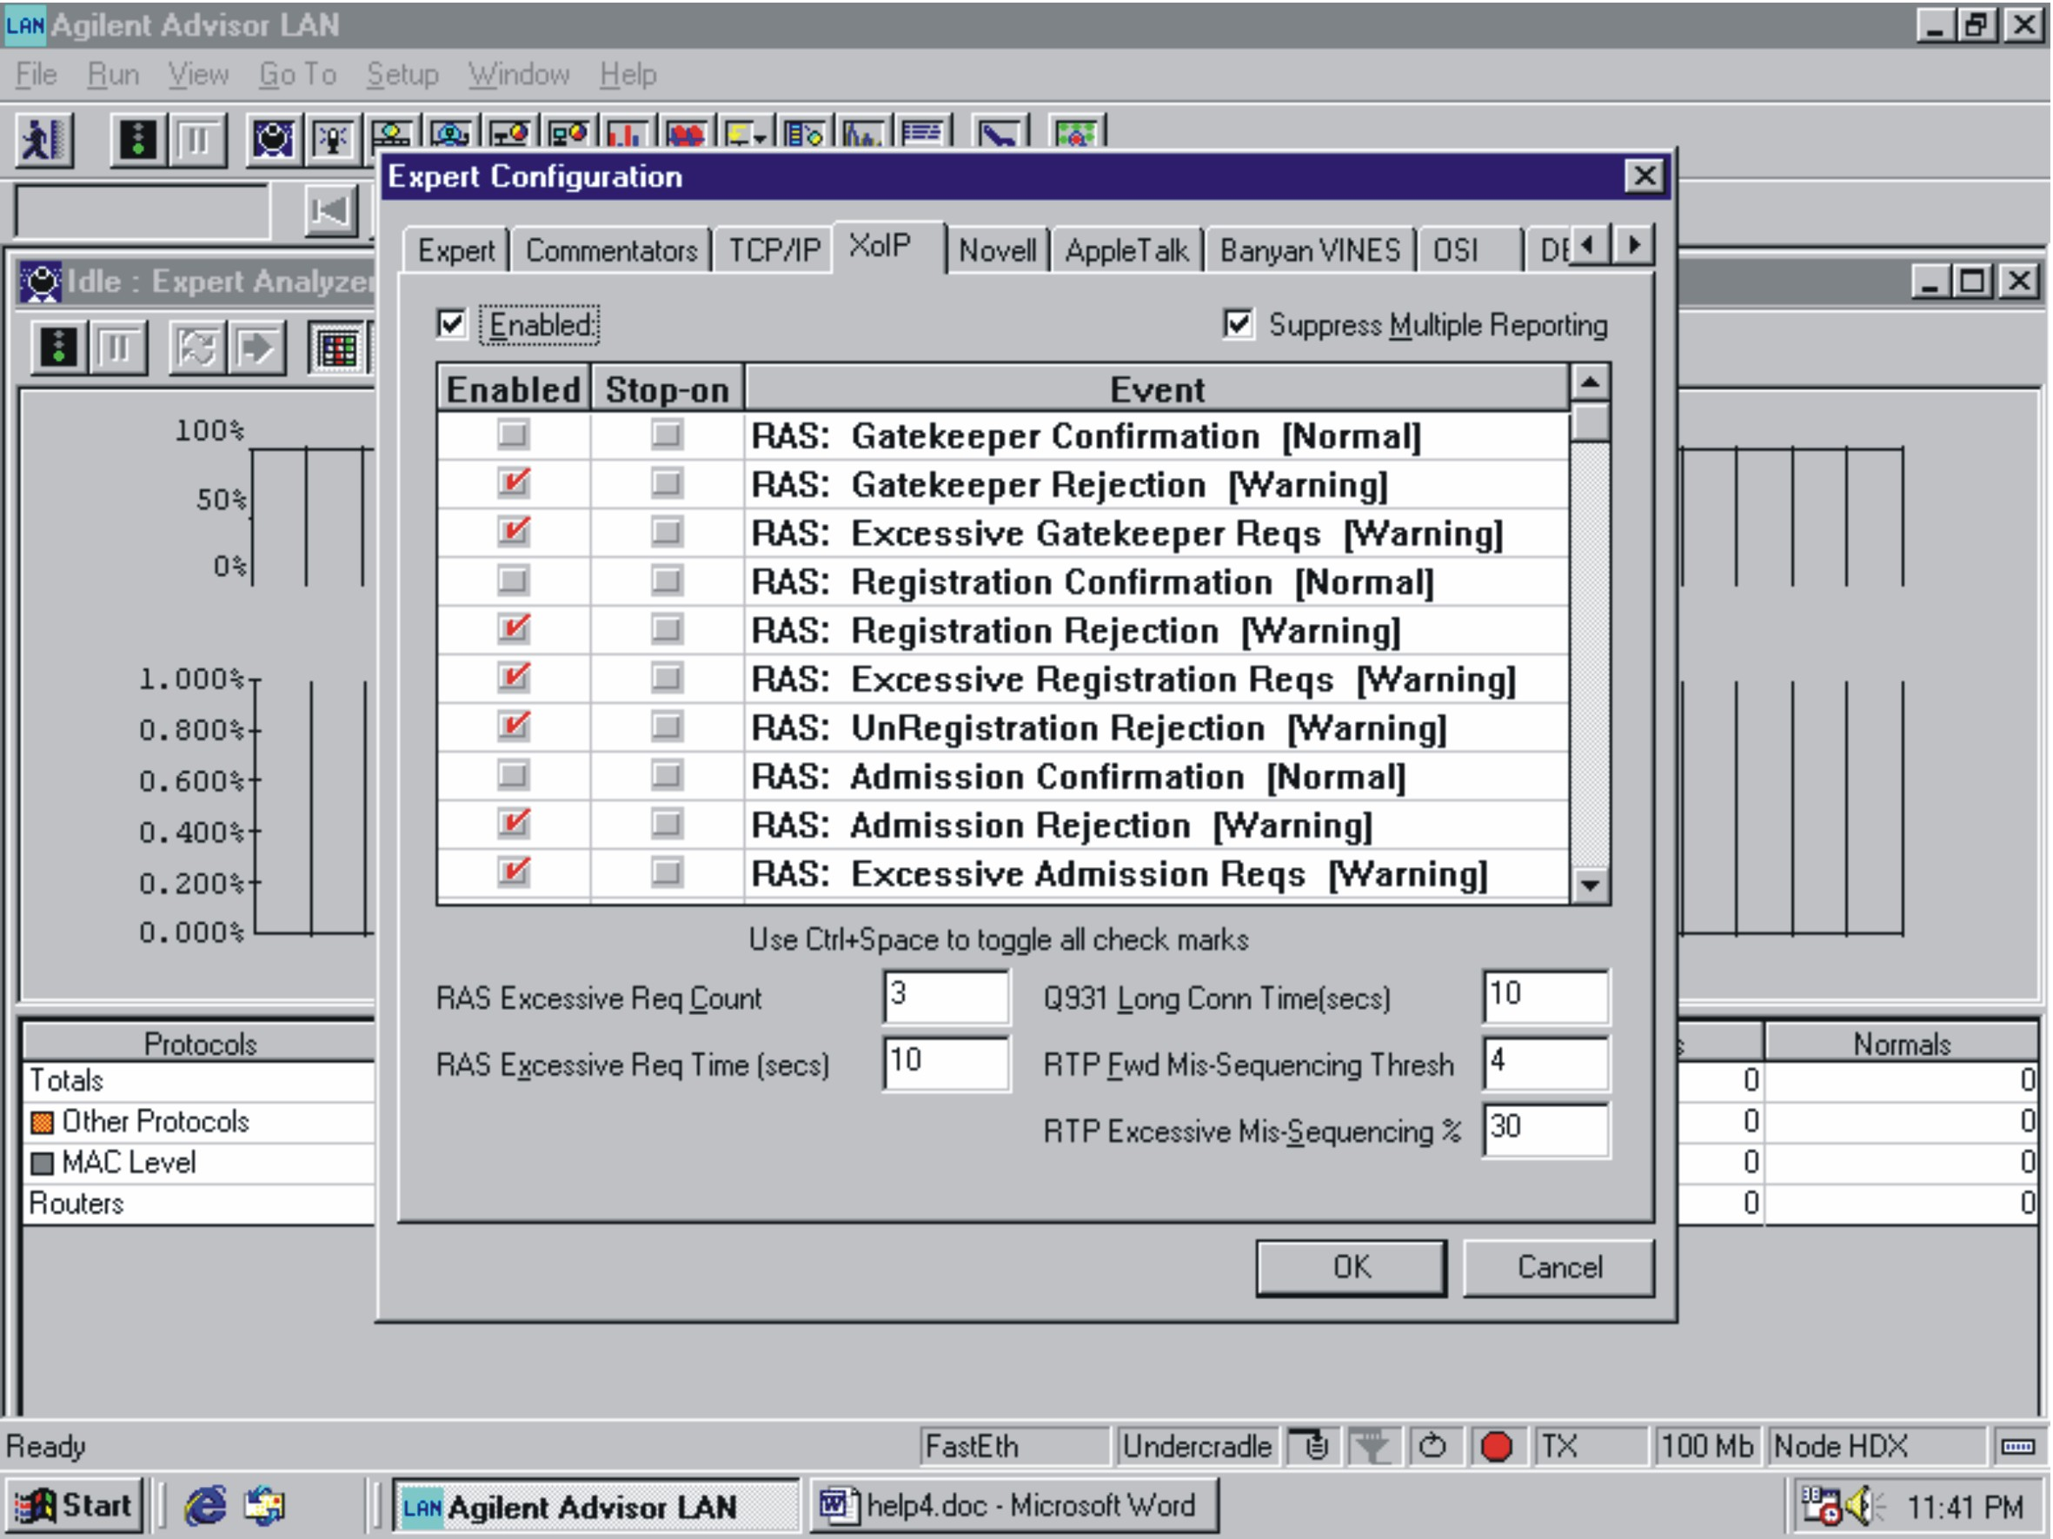

Fig. 8. Selecting measurements and thresholds to determine significant events for the VoIP Expert Commentator

Sl. 8. Odabir mjerenja i pragova za određivanje značajnih događaja VoIP ekspertnog komentatora

An example of a typical expert analysis top-level result in our case is presented on Fig.9, where too many retransmissions at TCP layer have been reported (likely caused by noisy lines and/or inadequate IP Time-To-Live – TTL setting). This was further investigated and verified through examining the frames with bad cyclic redundancy check (FCS), as well as through out-of-service bit-error-ratio (BER) tests.
In addition, TCP connection resets, Q.931 protocol anomalies and RTP protocol mis-sequencing have been discovered, too.
On Fig.10, statistical analysis of traffic is shown for a selected test station of interest in a correlated view: Station→Protocols→Connection(s), providing an insight into the network activity of interest.

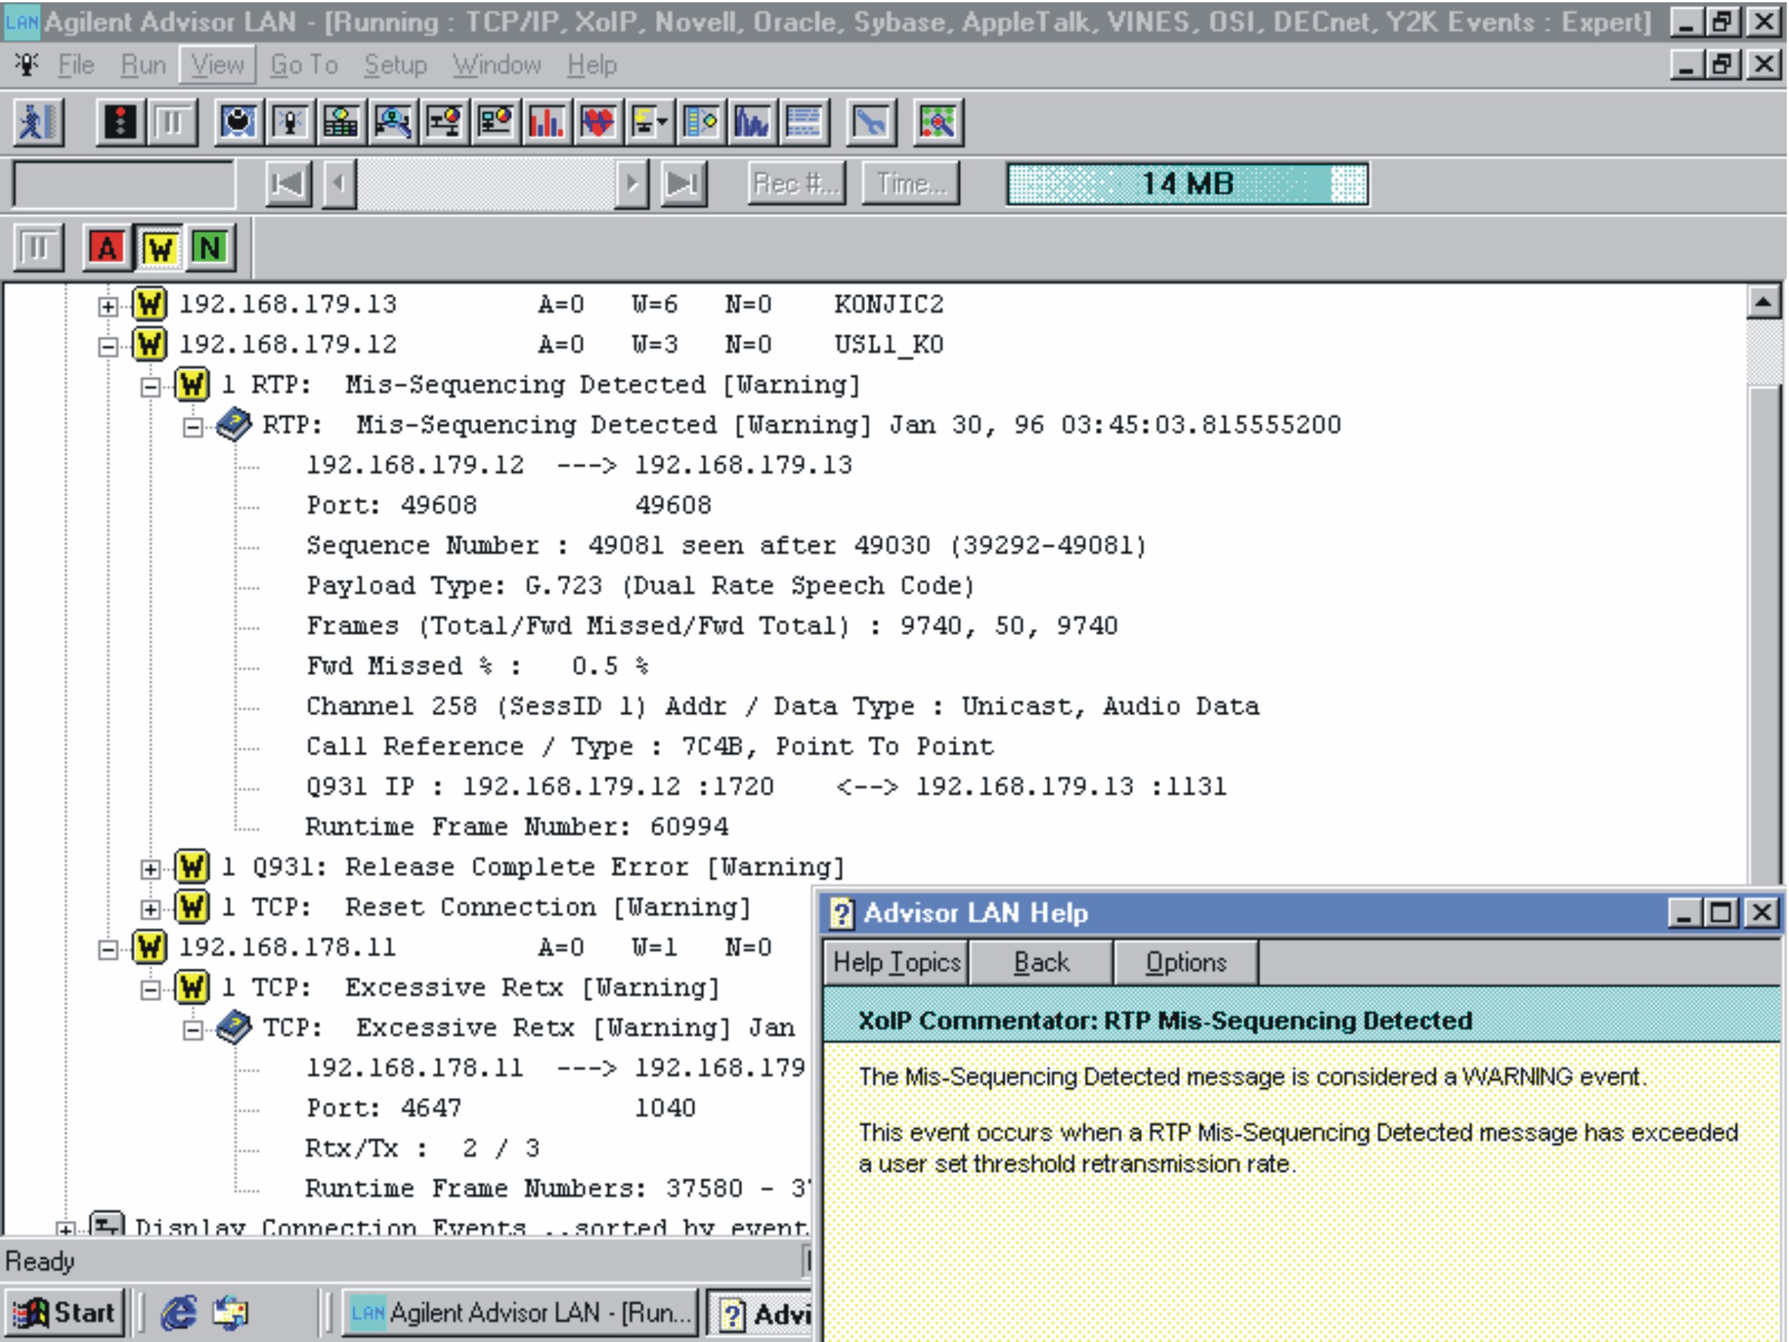

Fig. 9. Discovered departures of multiple measurements results from their thresholds – reported events for TCP/IP and VoIP protocols

Sl. 9. Otkrivena odstupanja rezultata višestrukih paralelnih mjerenja od pripadajućih im pragova - događaji u vezi s TCP/IP i VoIP protokolima

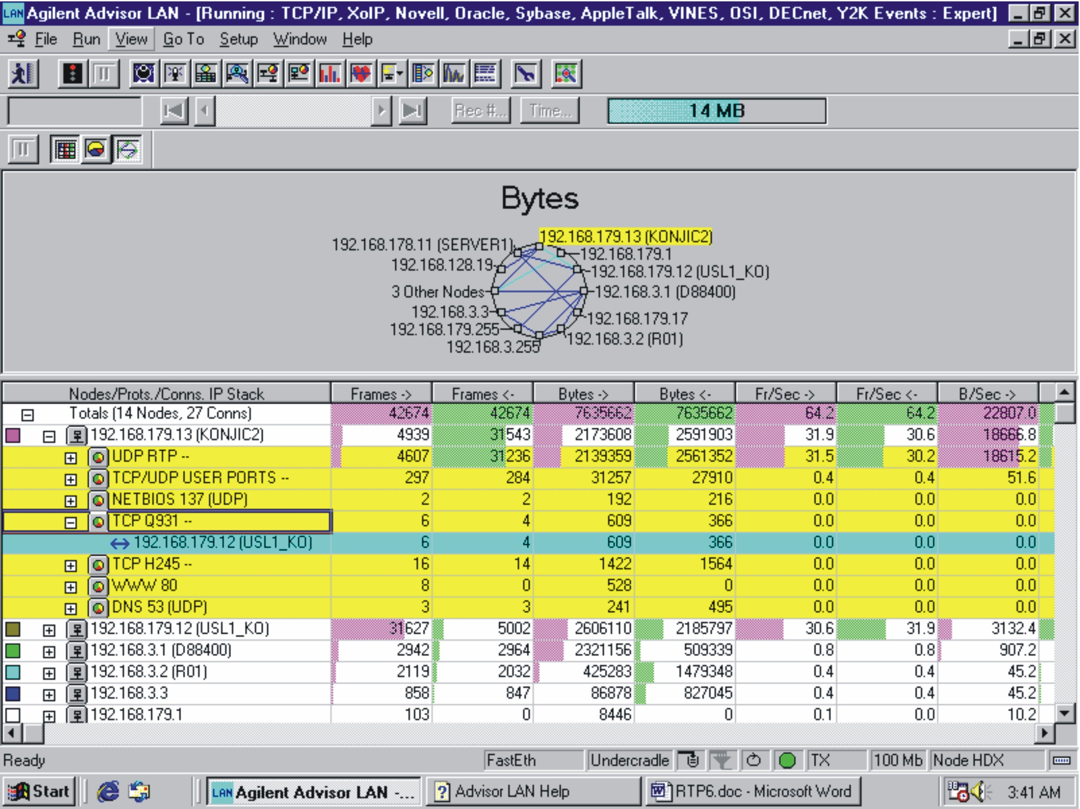

Fig.10 Statistical analysis of the nodes traffic

Sl.10 Statistička analiza prometa mrežnih čvorova

- RTP Statistical Analysis
Statistička analiza RTP paketa
The analysis of Real Time Transport Protocol (RTP) is certainly of particular interest here. While one of the potential RTP problems has already been mentioned (mis-sequencing of messages between the two experimental stations) as detected by the used expert system, more comprehensive statistical analysis must be done, too, specifically on the measured RTP packets jitter and loss. As the purpose of these measurements and the obtained results was not to simulate diverse realistic situations (requiring material presumptions and resources far exceeding the currently available ones in this case), but to define a practical QoS test procedure, we consider the series of progressing measurements presented on Figs. 11-12 as a typical example. The stations involved in the RTP session of interest are identified, together with their RTP and RTP Control Protocol (RTCP) ports, assigned QoS, total transmitted and total received packets numbers, and finally packet jitter and loss measured values. Jitter threshold (triggering the alarms shown on Fig. 12) was set to 10,000 microseconds (which resulted with the alarms for the two displayed larger jitter values), but this can be changed accordingly, depending on the network topology. Furthermore, it is utmost important to track the jitter in time, correlated to the packet loss, which best practically illustrates the jitter tolerance of the network under test. As an example arising from simple measurement system we implemented, it comes out that even excessive jitter may not necessarily result in packet loss. However, if it accumulates steadily, this can likely happen.

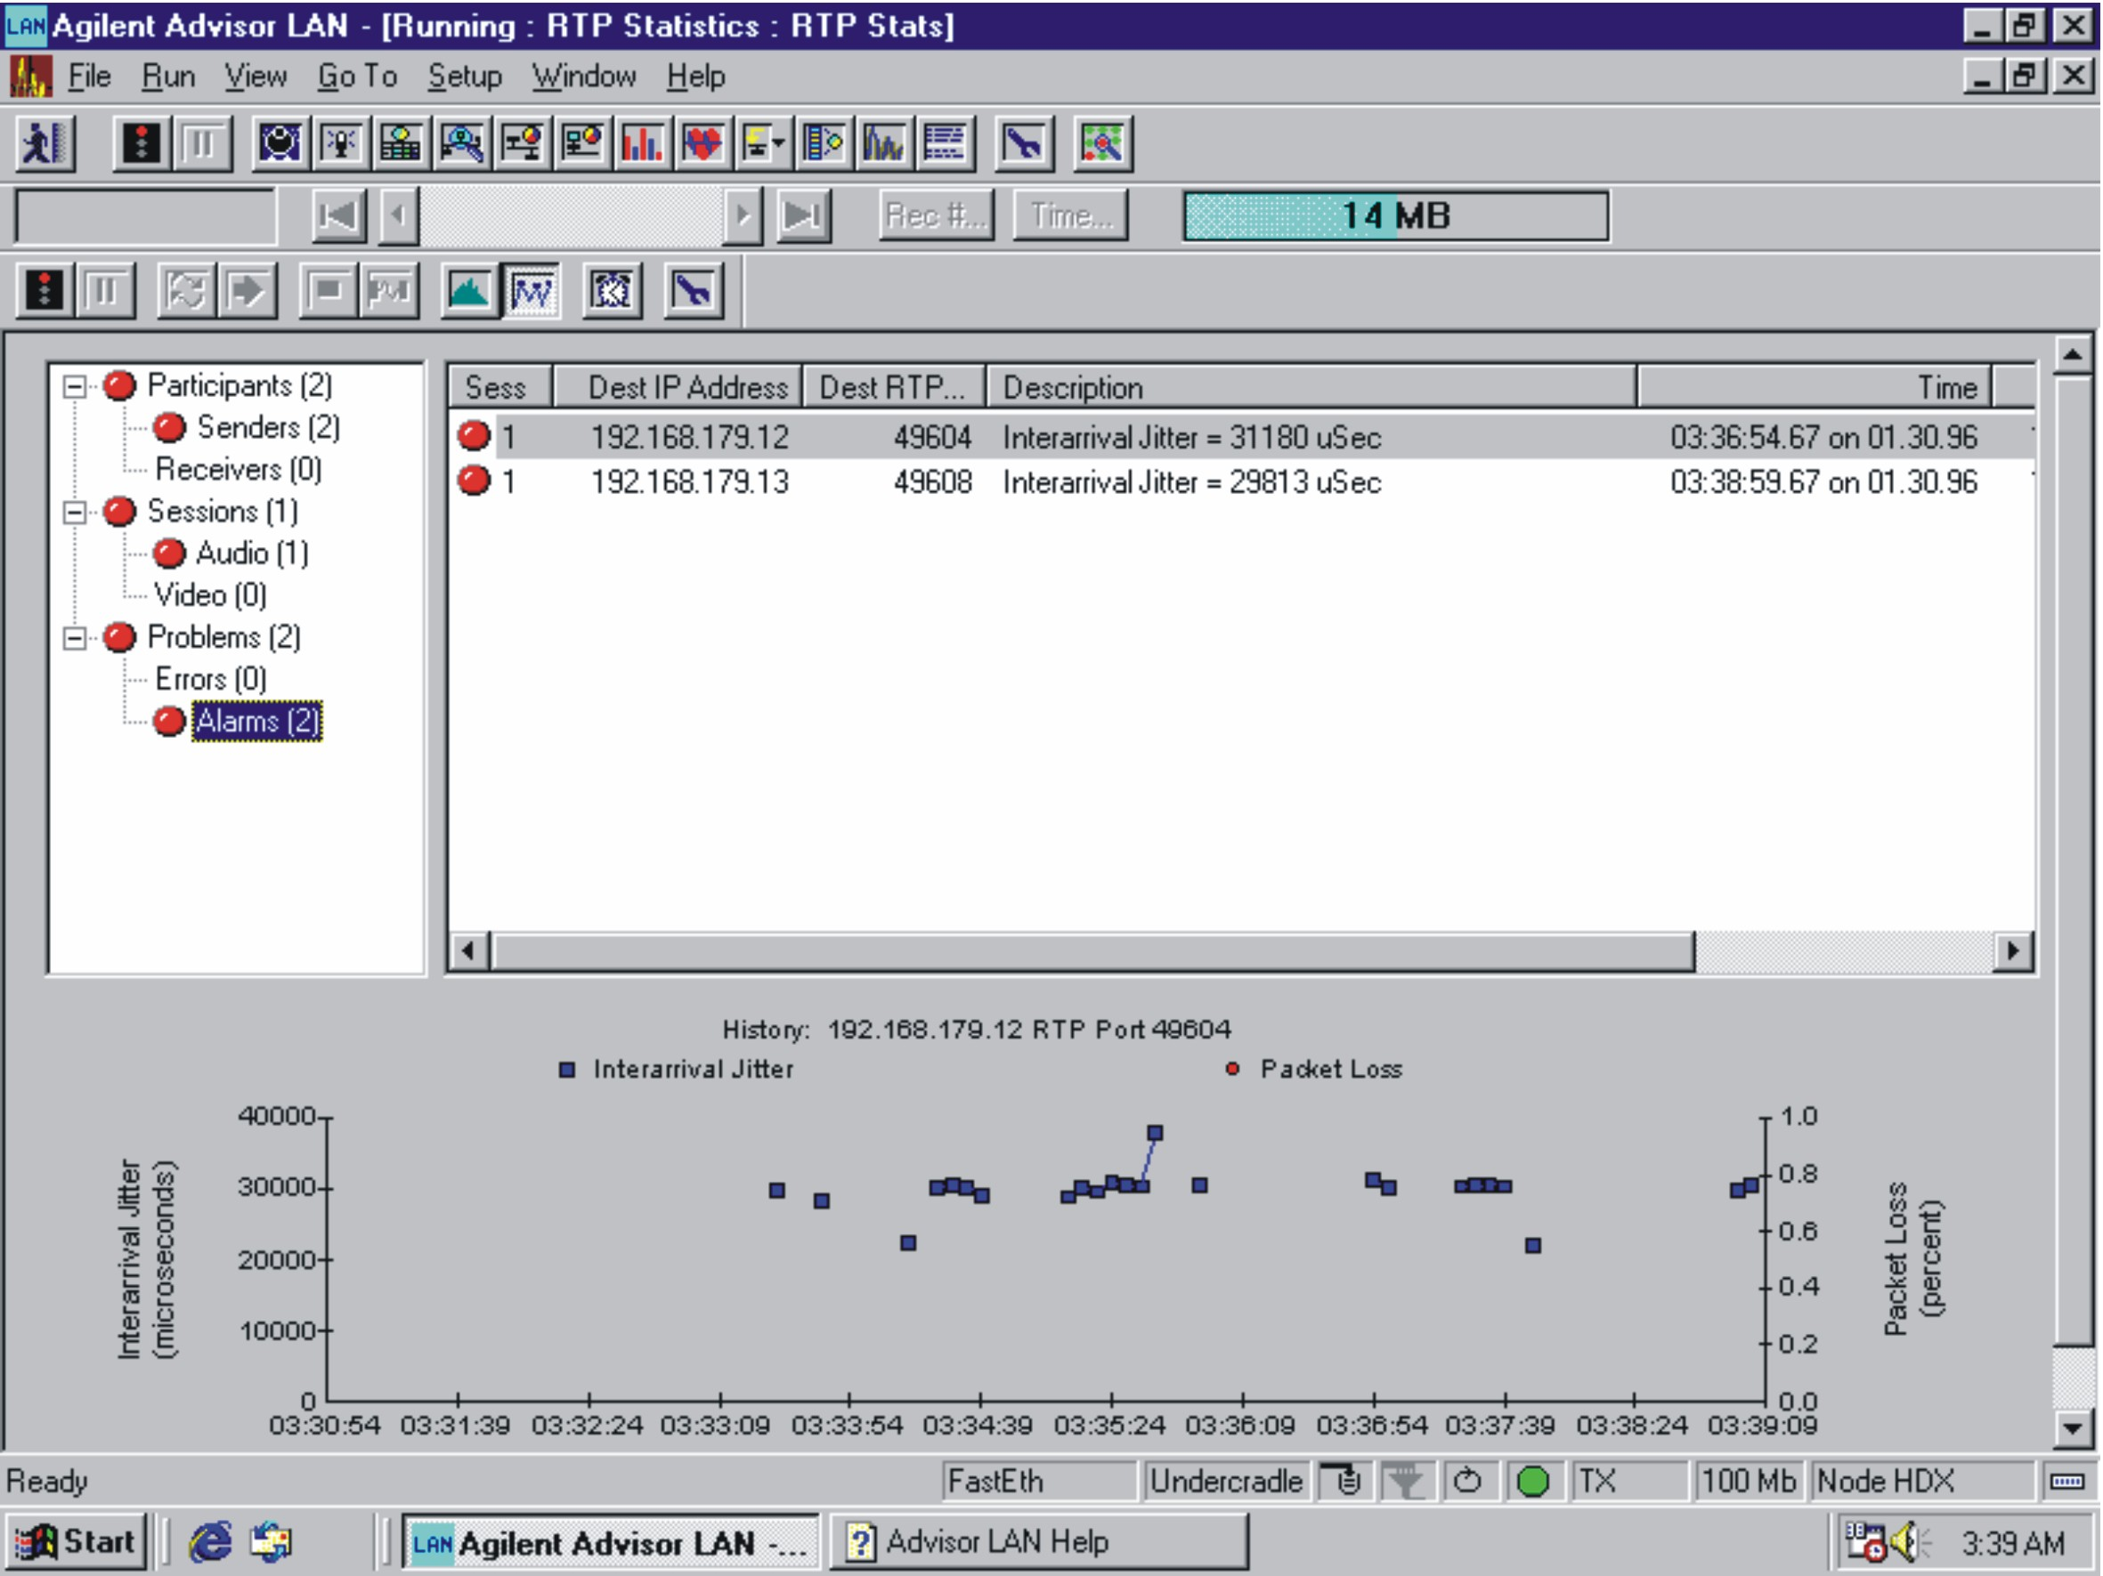

Fig.11 Time-correlated RTP packets jitter and loss

Sl.11 Vremenski korelirani varijacija kašnjenja i gubitak RTP paketa

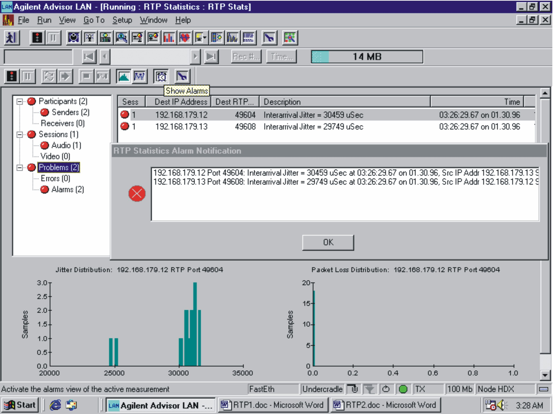
Fig.12 Probability density approximation of RTP packets jitter and loss
Sl.12 Aproksimacija gustoće vjerojatnosti varijacije kašnjenja i gubitka RTP paketa
In situations with diverse jitter sources and so diverse values, it is more useful to observe the approximations of the probability density functions of packet jitter and packet loss, as shown on Fig.12.

Measurements of Speech Perceptual Quality

Mjerenja perceptualne kvalitete govora
Finally, after testing at various levels of the protocol stack, RTP in particular, it is important to answer the following question:

How does packet jitter and loss manifest themselves at the end-to-end perceptual speech quality level? In other words, would acceptable quality at the RTP protocol level necessarily imply adequate voice quality (VQ) performance?
To answer this question, it is necessary to accomplish time-correlated VQ measurements. In this sense, we have tried the state-of-the-art PAMS, PSQM and PESQ methods [1], [2].
Fig.13 presents typical clarity test results for PSQM applied, which enable objective estimation of presence of distortions caused by delay, noise etc. The higher the score, the more degraded the signal.
In this case, we firstly send one or more test signals to ensure convergence of jitter suppression buffers and so eliminate their potential instability as dominantly affecting the tests, Only after that, every 16 milliseconds, we send the actual clarity test reference speech sample through the system and correlate it with its returning (distorted) form, see Fig.14. As it can be seen, clarity tests results can be poor even though the RTP protocol jitter and packet loss were not found to be too bad. However, we found out that worse RTP protocol test results for sure result in poor VQ performance!

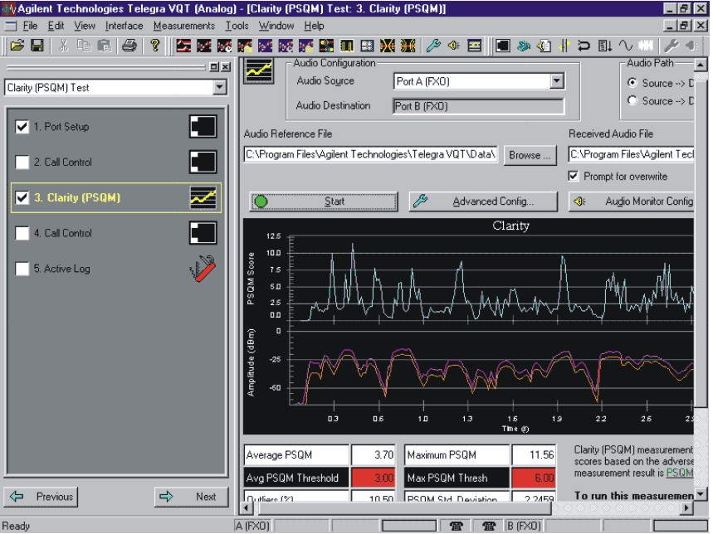
Fig.13 Clarity test results
Sl.13 Rezultati ispitivanja jasnoće

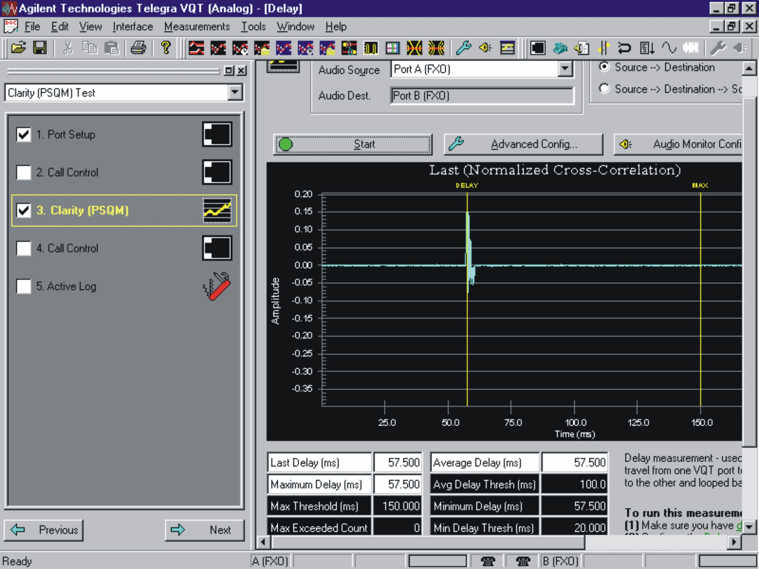

Fig.14 Delay test results
Sl. 15 Rezultati ispitivanja kašnjenja
We accomplished delay measurements throughout the whole circuit under test by using a single instrument with the remote loop back. It was necessary to ensure that the length of the test signal was at least two to three times longer than the expected delay. In addition, it is necessary to eliminate the impact of jitter compensating buffers.
We also made echo measurements as well as of the Perceived-Annoyance-Caused-by-Echo (PACE) [1], Fig.15.
Finally, impulse response (IR) of the system has been measured to enable prediction of how well would the voice signal be transported, as it determines the system transfer function in the range of 0-4 kHz. So for example, as presented at Fig.16, the IR delay has not passed over the threshold, and the last measured delay value is 57.5 ms (supposed that jitter buffers have already converged).

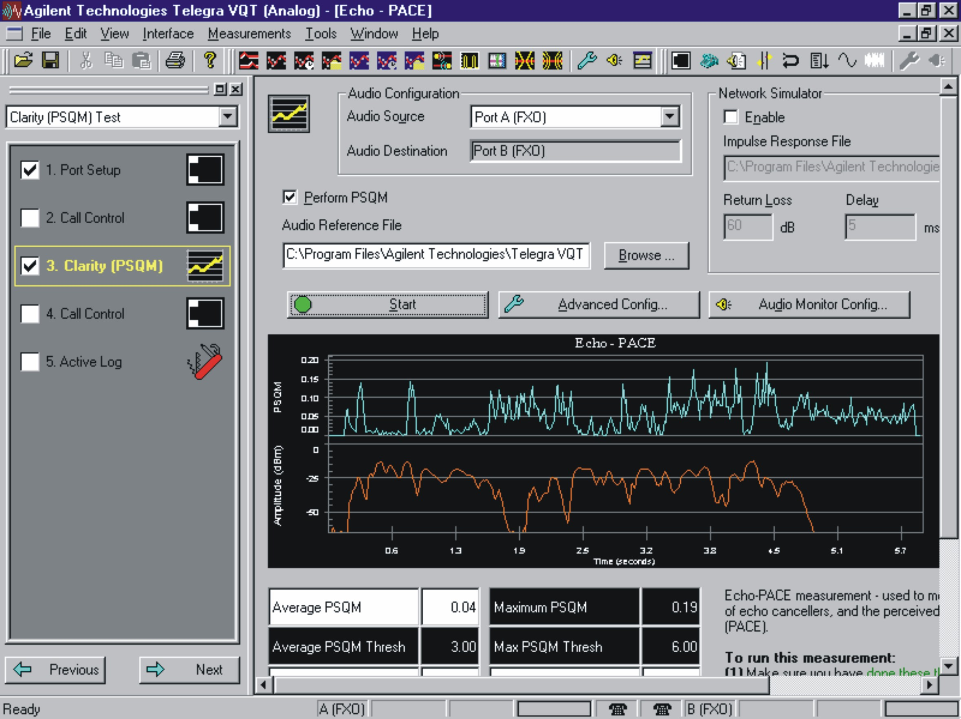
Fig.15 Echo PACE test results
Sl. 15 Rezultati ispitivanja perceptualne nelagode koju izaziva odjek

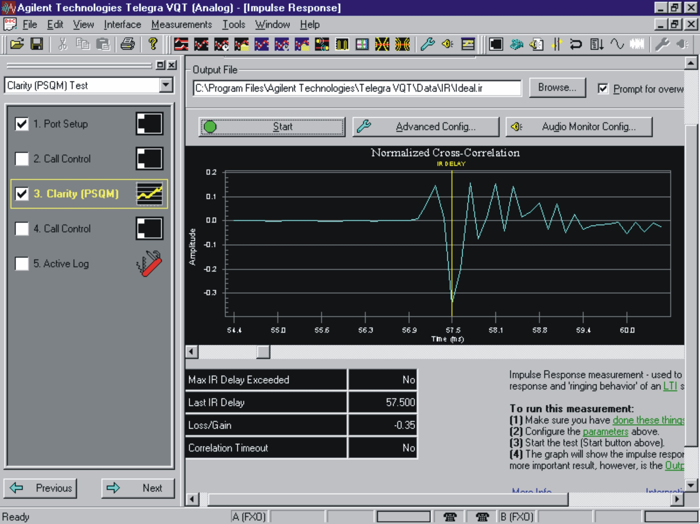
Fig.16 Impulse response measurement results
Sl.16 Rezultati mjerenja impulsnog odziva

III. Conclusion

Zaključak
We have proposed and demonstrated a VoIP QoS test procedure based on correlated protocol analysis (IP/TCP-UDP/RTP) and perceptual speech quality measurements. It has been shown how this concept can be used as an integral QoS criterion during the installation, commissioning and maintenance of VoIP networks.

References
Literatura
[1] Agilent Technologies, Application Note 1320, "Troubleshooting VoIP Signaling, Isolate Signaling and Performance Problems by Decodnig H.323 Traffic", 2000.



[2] Malden Electronics Ltd., "PAMS – A perceptual Analysis/Measurement System", 1998.
[3] The International Engineering Consortium, "Voice and Fax over Internet Protocol", Web Proforum Tutorials, 1999.
[4] The International Engineering Consortium, "Internet Telephony, Web Proforum Tutorials", 1998.
[5] ITU-T H.323, "Packet based multimedia communications systems", International Telecommunication Union Recommendations, 1998.
[6] Schulzrinne, S. Casner, R. Frederick, V. Jacobson, "RTP: A Transport Protocol for Real-Time Applications", Request for Comments (Proposed Standard) 1889, Internet Engineering Task Force, January 1996.

Rukopis primljen: 3. 11. 2006.

