1

.

Water dynamics and physical characteristics of hydromorphic soils in southern Bačka

Saša Pekeč¹
Boris Vrbek²
Saša Orlović¹
Dalibor Ballian³

¹University of Novi Sad
Institute of Lowland Forestry and Environment
Antona Čehova 13, 21000 Novi Sad, Serbia

²Department of Ecology
Forest Research Institute, Jastrebarsko
Cvjetno naselje 41, 10450 Jastrebarsko, Croatia

³University of Sarajevo
Faculty of Forestry, Sarajevo
Zagrebačka 20, 71000 Sarajevo, Bosnia and Herzegovina

Correspondence:
Saša Pekeč
University of Novi Sad
Institute of Lowland Forestry and Environment
Antona Čehova 13, 21000 Novi Sad, Serbia
E-mail: pekecs@uns.ac.rs

RUNNING TITLE
S. Pekeč et al.
Water dynamics and physical characteristics of hydromorphic soils in southern Bačka

Received December 12, 2012.

2

Abstract

Background and Purpose: The study presents basic types of hydromorphic soils in a protected area of middle part of the Danube alluvial plain in Vojvodina. The Danube is the largest river in the Republic of Serbia. This is the first river which itself created an alluvial plain through the Pannonian plain.

Due to the mild decrease of river bed slope and lateral erosion, which is a characteristic of lowland rivers, it formed a large dry alluvial plain. It was formed during the Holocene by alternating action of fluvial, erosion and accumulation processes.

Materials and Methods: In this study, the following classes of hydromorphic soils in the protected area of alluvial plain of the river Danube were studied: undeveloped hydromorphic soils (fluvisol), semigley soils (humofluvisol) and gley soils (humogley and eugley). Four soil types were examined within the hydromorphic order of soils: fluvisol, humofluvisol, humogley and eugley. The measurements of groundwater level and of the water level of the Danube river were carried out twice a month during the growing season in the period of two years. The distance of piezometers from the Danube was also measured. By each piezometer, apedological profile was established. Its external and internal morphology was described and soil samples were collected for laboratory testing. Laboratory examination of soil included analyses according to standard pedological methods.

Results: The most important characteristics of the soils are presented in this study. The

hydrological and physical characteristics are particularly described, especially the dynamics of

groundwater during the growing period in two years, granulometric composition,

differential porosity and Darcy’s coefficient. The average groundwater level related to

the soil surface varied in fluvisol from 258 to 301 cm, in humofluvisol from 234 to 260 cm, in humogley from 142 to 167 cm, and eugley from 38 to 51 cm beneath soil surface. The amplitude of the groundwater level variation varied from 94 to 120 cm in fluvisol, 138 - 256 cm in humofluvisol, 105-134 cm in humogley and 43-55 cm in eugley. There was high correlation
between groundwater level and the water level of the river Danube.

Key words: groundwater, granulometric composition, differential porosity, Darcy’s coefficient, Danube River

Introdution

The Danube is the second longest river in Europe after Volga. It is notable for being classified as an international waterway. The river originates in the Black Forest in Germany as much smaller Brigach and Breg rivers which join at the German town Donaueschingen. From there , the river is known as the Danube and flows southeastward for a distance of some 2850 km (1771 miles), passing through four Central and Eastern European capitals before emptying into the Black Sea via the Danube Delta in Romania and Ukraine. Known in history as one of the long-standing frontiers of the Roman Empire, the river flows through, or acts as part of, the borders of ten countries: Germany (7.5%), Austria (10.3%), Slovakia (5.8%), Hungary (11.7%), Croatia (4.5%), Serbia (10.3%), Bulgaria (5.2%), Moldova (1.6%), Ukraine (3.8%) and Romania (28.9%) (the percentages reflect the proportion of the total Danube basin area). The Danube, as the largest river in the Republic of Serbia, is the first river which itself created a river plain through the Pannonian plain. Due to the mild decrease of river bed slope and lateral erosion, which is characteristic of lowland rivers, it formed a large dry alluvial plain (1). The plain was formed during the Holocene by alternating action of fluvial, erosion and accumulation processes (2). From hydrological point of view, it is double-layered environment, with sediments of the Quaternary period, which is represented by sandy-gravel and sandy deposits, as well as by loess deposits. These formations, according to Josipović (3), are characterized by considerable moisture, capillarity, water permeability and water yield. In the valleys of big rivers like the Danube there are soils formed by fluvial sedimentation, i.e. soils formed on alluvial deposits. In spite of the fact that flooded areas of rivers differ among each other, there is similarity in cross- and longitudinal section according to the origin and regularity of sedimentation of suspended material. Coarse particles are precipitated near the bank while finer material is situated further from the bank. Research of this area contributed to alluvial plain partitioning according to morphological forms. Thus, according to dependence on deposit sedimentation intensity in inundation, three genetic zones could be discriminated: coastal, central and pre-terrace (4). These zones are characterized by specific relief, hydrology and vegetation according to Pekeč (5). The coastal part of alluvial plain contains mostly poorly developed hydromorphic soils with more than 2 m of groundwater level variations, with defined micro relief (bents, depressions). The altitude of the area is relatively high and covered with grass vegetation. The central part is lower, with semiglay soils covered with meadow and forest vegetation. The ground water level varies from 1 to 2 m. The pre-terrace part of alluvial plain is characterized by the class of gley soils, forest and swamp vegetation, with groundwater level variations of less than 1 m according to Pekeč (5).
4

Along large rivers, the embankments are usually built in order to protect from flooding waters. In a protected part of alluvial plain, hydrological conditions are considerably changed and soil evolution is not limited by fluvial sedimentation. The soil in the protected area is too humid for the influence of groundwater. In this work, we studied the following classes of hydromorphic soils in the protected area of the river Danube alluvial plain: undeveloped hydromorphic soils (fluvisol), semigley soils (humofluvisol) and gley soils (humogley and eugley), according to Škorić et al. (6). These soils belong to the group of hydromorphic soils (Gleysols according to WRB, 2006). In all four soil types, gleic horizon with the signs and symptoms of secondary oxidation (Gso) was observed, which pointed to alternate in moist and dry phase within the soil profile, while gleic horizon with the signs and symptoms of permanent reduction was observed in humogley and eugley soil (Gr). That proved that the soil pores were regularly saturated with groundwater according to Nešić et al. (7).

Materials and methods

The object of research was located in southern Bačka, in a protected part of the the Danube alluvial plain. The research area extended between 45015’46.6’’ and 45013’10.2’’ latitude, 19031’56.7’’ and 19058’10.5’’ longitude. Altitude in the part of the field where the research was done ranged from 72.00 m above sea level to 78.50 m above sea level. The area covered by this examination was approximately 15 000 ha.

Table 1
Soil types and terrain characteristics.

Type of soil Altitude
(m.a.s.)
Distance from the bank of the river Danube (m)

Fluvisol 75.50 3312.0
Humofluvisol 74.20 2026.0
Humogley 73.55 1916.0
Eugley 73.00 4161.0

The entire area was covered by a network of piezometers. For each type of hydromorphic soil that differed in the altitude a.s.l., the piezometers were set in order to measure groundwater levels. The groundwater level measurements were carried out twice a month during the growing season in the period of two years, as well as measurements of the water level of the Danube River. The distance of piezometers from the Danube was also measured. In the vicinity of each piezometer, a pedological profile was opened, its external and internal morphology was described and soil samples were collected for laboratory tests. Laboratory examination of soil included the following analyses according to standard pedological methods:

− Determination of soil texture according to International B-pipette method

with preparation in Sodium-pyrophosphate, (8)

5

− Total porosity (%) calculated using the values of specific and volume mass of soil, (8)
− Moisture retention at a pressure of 0.33 bar using Porous –plate, (9)

− Moisture retention at a pressure of 6.25 and 15 bar using Pressure membranes, (9);

− Differential porosity was determined from the difference of total porosity and moisture retention under different pressures; (8)
− Soil water permeability, i.e. Darcy's coefficient,
(8).

Results and discussion

According to the content of granulometric fractions in examined soils (Fig. 1), it could be perceived that fluvisol contained the largest share of coarse sand (34.45%), while a significantly lower percentage of this fraction was found in humofluvisol, humogley and eugley (1.46 to 3.80 %). The content of fine sand ranged from 44.95 to 59.98%. It was slightly higher in humofluvisol and humogley. Silt fraction ranged from 7.39 to 32.77%, with the highest percentage in humofluvisol and eugley, while the presence of clay was the highest in humogley and eugley (19.42 to 18.49%).

Figure 1. Granulometric composition in different types of hydromorphic soil.
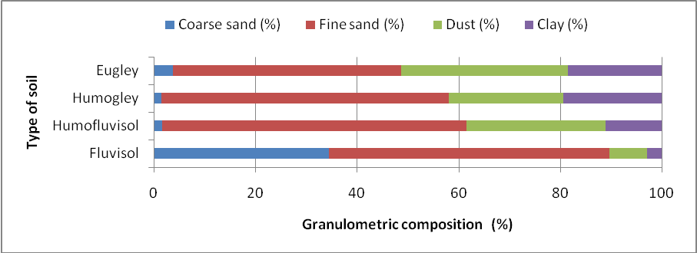

Differential porosity in those soils (Fig 2) varied depending on size distribution. The highest content of large pores was in fluvisol (62.61%) and humofluvisol (31.13%). Humofluvisol and humogley contained the highest percentage of medium pores (36.87 and 33.18%). The proportion of small and fine pores decreased from fluvisol to eugley, and the largest proportion was on eugley (57.28%) and humogley (53.08%).

6

Figure 2. Differential porosity in different types of hydromorphic soil.
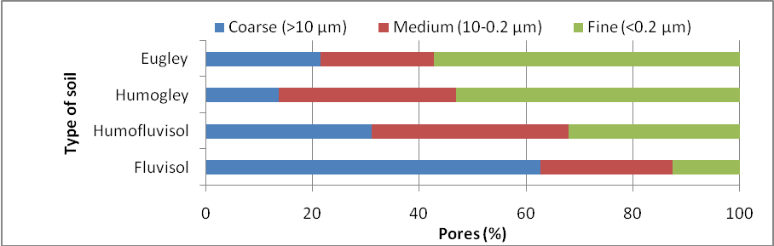

Vertical water permeability (Fig. 3) was a result of granulometric content and differential porosity of the examined soils. Vertical water permeability decreased from fluvisol to eugley. Fluvisol had water permeability equal to 0.0075 cm/sec. Other soil types had lower water permeability: in humofluvisol it was 0.0009 cm/sec, in humogley 0.0005 cm/sec and in eugley 0.0004 cm/sec.

Figure 3. Darcy’s coefficient-vertical permeability in different types of hydromorphic soil.
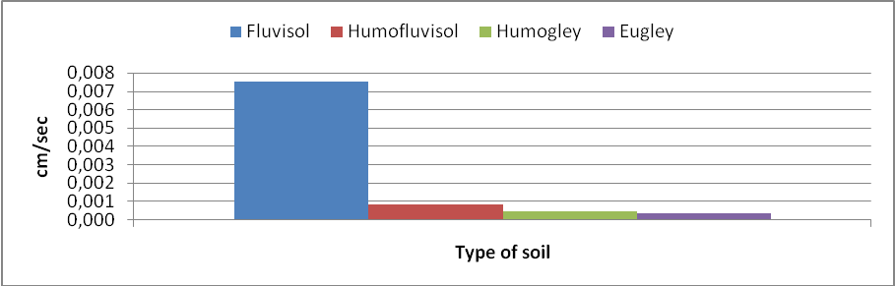

Upon analysis of groundwater dynamics in the surveyed hydromorphic soils, it was observed that (Fig. 4) groundwater level ranged in depth from 210-304 cm in fluvisol soil type during 2006, with an average value of 258 cm and the oscillation of 94 cm, while in 2007 the groundwater level was lower than 240-360 cm, with greater oscillations that amounted to 120 cm during the growing season.

FiFigure 4. Dynamics of groundwater in fluvisol.

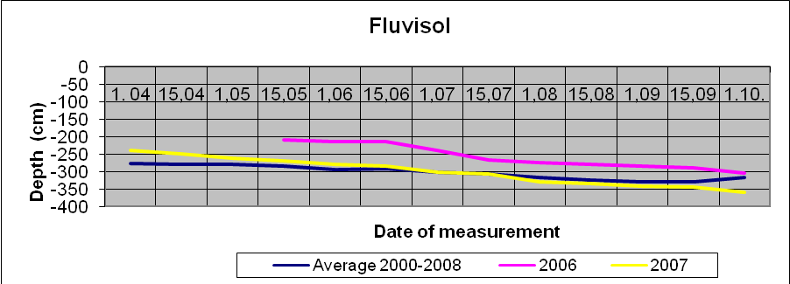7

Concerning the groundwater dynamics of humofluvisol soil (Fig. 5), it can be concluded that groundwater level was in 2006 in the range of 147-285 cm, with the oscillation of 138 cm, while in 2007 it was below the range of 120-385 cm and with increased oscillation of 265 cm during the growth period.

Figure 5. Dynamics of groundwater in humofluvisol.
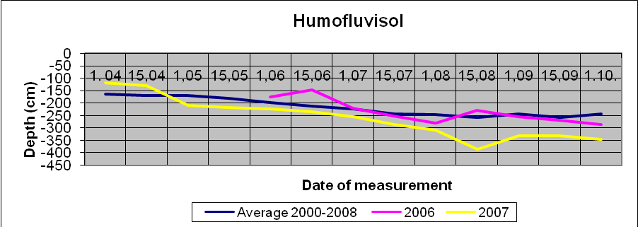

In humogley soil (Fig. 6), groundwater level ranged at a depth of 70-175 cm, with maximum variation of 105 cm in 2006, while in 2007 it ranged from 90 to 224 cm with an increased oscillation compared to the previous year (134 cm).

Figure 6. Dynamics of groundwater in humogley.
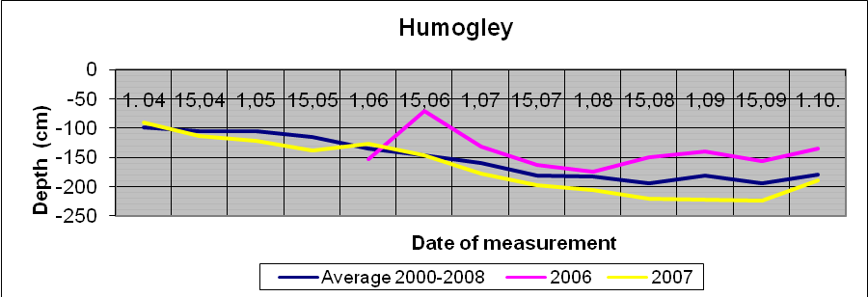

According to the dynamics of groundwater in eugley (Fig. 7), groundwater level in 2006 ranged only 5-60 cm in depth, and oscillations were 55 cm, while in 2007 it was slightly lower and ranged from 25 to 68 cm, with the oscillations of 43 cm.

8

Figure 7. Dynamics of groundwater in eugley.
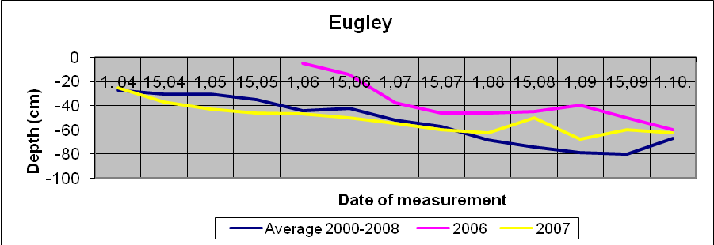

Table 2
Correlation between the water level of the Danube River and groundwater level.

Noof profiles Soil type Distance from the shore (m)
Coefficient r year 2006
Coefficient r year 2007

1/06 Fluvisol 3312.00 0.88 0.11
2/06 Humofluvisol 2026.00 0.96 0.21
3/06 Humogley 1916.00 0.67 0.12
4/06 Eugley 4161.00 0.78 0.21

Considering the granulometric composition of the basic types of hydromorphic soil (Fig. 1), it could be observed that coarse and fine sand, or total sand, predominated in fluvisol and humofluvisol fractions of soil, while silt and clay, or total clay, were predominant in humogley and eugley. The content of granulometric fractions of some soil types varied proportionally with differential porosity (Fig. 2). Large pores prevailed in humofluvisol and fluvisol , and small and fine pores in humogley and eugley. Based on granulometric characteristics and differential porosity, the examined soils differ in water permeability as a resultant of two previous soil characteristics (10). Thus, fluvisol soil expressed high water permeability (Fig. 3), considerably higher than in other soils; the permeability decreased from humofluvisol through humogley to eugley where water permeability was the lowest. Different physical properties of these soils are in concordance with findings of Pekeč et al. (11).
Given the geographic distribution of the examined soils and in relation to the Danube river bed and a variety of terrain elevation levels of investigated soils, the area along the river could be divided into coastal part with fluvisol, central part with humofluvisol, and pre-terrace part with humogley and eugley; where the terrain dropped from coastal to pre-terrace part, we found different groundwater dynamics (Fig. 4-7). Groundwater level was the lowest in fluvisol soil, then in humofluvisol and humogley, while the highest level of groundwater was measured in eugley. Small depth of groundwater and its physical properties are similar to results for eugley soil in a protected part of the Middle Danube (10). It is also noticeable

that the level of groundwater during the growing season decreased in all soils; groundwater level was higher in 2006 compared to 2007 year. The average level of groundwater obtained from measurements for the 2000-2008 period showed that the mean value of groundwater level was ??? in relation to the year when measurements were performed.
Certain level of correlation between groundwater levels and the gleyification degree of loess in southern Backa was found by Živković et al. (13). They also found a certain periodicity of groundwater movement during the year. In the area of southern Backa, groundwater level rises from November and reaches maximum in the period from March to April, keeping the level till the end of June, while in July it declines (13). This was confirmed by our results, particularly by groundwater in fluvisol (Fig 4), while in other soils (Fig 5,6,7) the level of groundwater was constantly decreasing till October with some minor fluctuations.
It should be borne in mind that the water-air properties of soil and thus the hydrological regime are the function of physical properties of a given area: (14), (15) and (16).
Marković (17) stated that the soil water regime in riparian zones, especially its central and parts close to banks, is mainly determined by the groundwater regime and not by atmospheric precipitation.
Bugarski (18), according to Orlović et al. (19), identified three zones considering the intensity of mutual influence of water levels and groundwater:
- Direct impact zone of the Danube on the level of groundwater (width 700-800 m);

- The transition zone (width 1500 m);

- Negligible impact zone (from 2200 m away from the river.)

However, this study shows a high degree of correlation between water levels of the Danube River and groundwater levels in all types of soil situated over 2200 m from the coast in the first year of research (2006). The correlation coefficient varied from 0.67 to
0.96 in 2006, and became weaker in 2007 when it ranged from 0.11 to 0.21 (Table 2). These results could be related to the Danube water level, as it was extremely high during 2006, but much lower in 2007.
Bugarski (18) indicated that, groundwater is in the region of Vojvodina the most important supplier of soil water, especially during the growing season. Recorded amplitudes between the lowest and highest water levels measured for many years by water measuring station in Novi Sad, as one of the most representative in the Middle Danube region, amount to approximately 912 cm. Based on these facts, the conclusions could be drawn also about the considerable variation of groundwater level in the alluvial plain of the Danube (19). Our results show that multiannual

10

average value of groundwater level in the 2000-2008 period in all tested soils varied between the values of groundwater level in 2006 that was high and a much lower level in 2007.

Conclusions

According to granulometric fraction analysis, the largest share of coarse sand was found in fluvisol, silt content increased in humofluvisol and eugley, while a share of clay was most pronounced in humogley and eugley. The porosity of these soils varied depending on soil texture. Vertical water permeability decreased from fluvisol to eugley. Fluvisol water permeability was more pronounced than in other soil types that have much lower water permeability.

Analyzing the dynamics of groundwater in hydromorphic soils examined in 2006, it can be concluded that groundwater level in fluvisol soil type had an average value of 258 cm and the oscillation of 94 cm, soil average groundwater level in humofluvisol was 234 cm with the oscillation of 138 cm, and average groundwater level in humogley soil was 142 cm, fluctuating 105 cm at maximum. In eugley soil, average groundwater level was only 38 cm deep, and the oscillation was 55 cm.

During 2007, groundwater level was significantly lower as the average depth of fluvisol was 301 cm with great oscillation, which was 120 cm during the growing season, while the humofluvisol groundwater level was 260 cm with 268 cm fluctuations. Groundwater level in humogley had an average value of 167 cm with increased oscillation compared to the previous year (134 cm), while in eugley the average water level was 51 cm, with the oscillations of 43 cm.

It is important to stress that the level of groundwater during the growing season decreased in all soils, as the level of groundwater was higher in 2006 in relation to 2007, while the oscillations of ground water increased during 2007. Higher correlation coefficient between the water level of the river Danube and groundwater level was recorded during high water in 2006 (0.67 to 0.96) than in 2007 when the water level was lower (0.11 to 0.21). The average level of groundwater obtained from the measurements in the 2000-2008 period showed the mean value of groundwater level in relation to the years when those measurements were performed.

11

Acknowledgement: This paper was realized as part of the project "Studying Climate Change and Its Influence on the Environment: Impacts, Adaptation and Mitigation" (Project No. III43007) financed by the Ministry of Education and Science of the Republic of Serbia within the framework of integrated and interdisciplinary research.

References

1. ŽIVKOVIĆ B, NEJGEBAUER V , TANASIJEVIĆ Đ, MILJKOVIĆ N, STOJKOVIĆ L, DREZGIĆ P 1972 Soils of Vojvodina. Institute for Agricultural Research, p 682

2. MARKOVIĆ S B 1996 Water regime of groundwater in the Yugoslav part of Banat, (M.Sc thesis) Faculty of Science, Institute of Geography, p 1-82

3. JOSIPOVIĆ J 1985 Basic hidrogeological characteristics of Vojvodina, the Provincial
Annual fund water, Water of Vojvodina, No 13, The Regional Water Fund, Novi Sad

4. ŠUMAKOV V 1959 Preliminary report on soil conditions in the bottomlands of the river Sava in the region of Sremska Mitrovica and principles of classification of land bottomland. Poplar 11: 917-930

5. PEKEČ S 2010 Pedological and hydrological characteristics of protected part of alluvial plain in Middle Danube Basin, (PhD Thesis), Faculty of Agriculture, Novi Sad, p 221

6. ŠKORIĆ A, FILIPOVSKI G, ĆIRIĆ M 1985 Classification of Yugoslav soils. Academy of Science and Art, Department of Natural Sciences: 76

7. NEŠIĆ LJ, PEKEČ S, IVANIŠEVIĆ P, BELIĆ M 2010 Infuence of groundwater on hydromorphic soils in a protected area of alluvial plain in middle part of Danube basin, Marc Morell (ed), Conference on Water Observation and Information System for Decision support, Balwois 2010, 25-29 May 2010., Balkan Institute for Water and Environment - IB2E, Ohrid, p 1-7

8. BOŠNJAK Đ, DRAGOVIĆ S, HADŽIĆ V, BABOVIĆ V, KOSTIĆ N, BURLICA Č, ĐOROVIĆ M, PEJKOVIĆ M, MIHAJLOVIĆ T D, STOJANOVIĆ S, VASIĆ G, STRIČEVIĆ R, GAJIĆ B, POPOVIĆ V, ŠEKULARAC G, NEŠIĆ L J, BELIĆ B, ĐORĐEVIĆ A, PEJIĆ B, MAKSIMOVIĆ L, KARAGIĆ Đ, LALIĆ B, ARSENIĆ I 1997 Methods of investigation and determination of physical soil properties. Yugoslav Society of Soil: 1-278

9. RICHARDS L A 1948 Porous plate apparatus for measuring moisture retention and transmission by soil. Soil Science 66:105-110

10. PEKEČ S, IVANIŠEVIĆ P, ORLOVIĆ S, BELIĆ M, NEŠIĆ L J, KNEŽEVIĆ M 2009b Physical characteristic of hydromorphic soils in a protected part of alluvial plains of central Danube basin. Soil and Plant 58( 3): 197-204

11. PEKEČ S, IVANIŠEVIĆ P, BELIĆ M, NEŠIĆ L J, KNEŽEVIĆ M 2009a Types of hidromorphic soils in protected area of alluvial plain if middle part of Danube basin. In: P Sekulić (ed), Book of Abstracts, 12th Congress of Society of Soil Science in Serbia "Status and perspectives of soil protection, management and use“. Society of Soil Science in Serbia, p 142

12. PEKEČ S, BELIĆ M, NEŠIĆ L J, ORLOVIĆ S, IVANIŠEVIĆ P 2011 Water physical properties of eugley in a protected part of alluvial plains of the central Danube Basin. African Journal of Agricultural Research 6 (7): 1717-1725

13. ŽIVKOVIĆ B, DRAGOVIĆ S, HADŽIĆ V 1967 The correlation between the amount of groundwater levels and the degree of gley loess of the northern part of southern Bačka, a special imprint of the fifth volume, Proceedings of the Institute for Agricultural Research, Institute for Agricultural Research, Novi Sad.

14. ZAJDELJMAN A 1987 Amelioration of soil, Moscow University Publishing, Moscow, p 304

15. VUČIĆ N 1987 Water, air and soil thermal regime. Academy of Sciences and Arts, Book VII Works, Department of Natural Science 1: 320

16. VASILEVA D 1978: Mutual relations of groundwater and water of the Danube and the consequences of these relations. Waterpower engineering 55: 12-17

17. MARKOVIĆ S B 2000 Paleogeography of the Quaternary in the Vojvodina, (PhD thesis), Faculty of Science, Novi Sad.

18. ORLOVIĆ S, TOMOVIĆ Z, IVANIŠEVIĆ P, VLATKOVIĆ S, GALIĆ Z, MARKOVIĆ S, PEJANOVIĆ R 2006 Possibilities of afforestation in the province, V. Živadinović (ed.) Proceedings of "Forestation in order to implement spatial planning and development of Agriculture, Forestry and Water Management of Republic of Serbia”, Association of Forestry Engineers and Technicians, Novi Sad, p 98-106

19. BUGARSKI D 1999 Danube river; Monography, Water of Srem, Vojvodina Regional
Geographical Studies, University of Novi Sad, Faculty of Science, Institute of Geography, Novi Sad, p 32-47

14

