Accepted: 09.10.2013. Professional paper
Reviewed: 04.11.2013. UDK 331.1::656.1

Elements of construction design in road traffic safety in rural areas

Konstruktivni elementi ergonomijskih značajki u sigurnosti cestovnog prometa ruralnih krajeva

Sarajko Baksa
Međimurje University of Applied Sciences in Čakovec
B.J.Jelačića 22a, 40000 Čakovec, Croatia
e-mail: sarajko_baksa@yahoo.com

Abstract: Ergonomic construction structure of road design is of extreme importance for the safety of road traffic, especially in rural areas, where construction design requirements have to be in line with traditional road routes. Because of that and the particularities of unclassified roads and so called dirt roads, that often intersect important traffic routs, the problem of ergonomic safety is even more prominent. The scope of this paper will include the analysis of ergonomic visibility of an incoming motorcycle by a driver entering the main traffic route from an unclassified road. The motorcycle has been chosen for this study because of its extremely slim frontal silhouette and generally higher speed than the speed limit. We will present the visibility zones and driver eye sight zones, and establish the technical – design and biological – anthropometric limitations of vehicles and drivers with an aim of increasing the road traffic safety.

Key words: anthropometry, construction ergonomics, roads, visibility zones

Sažetak: Ergonomijska konstrukcijska struktura dizajna prometnica od iznimnog je značaja za sigurnost cestovnog prometa, poglavito u okružju ruralnih područja, gdje su zahtjevi za konstrukcijskim značajkama podređeni temeljnim tradicionalnim pravcima rasprostiranja prometnica. Glede toga i specifičnostima u vidu nerazvrstanih prometnica i tzv. poljskih putova koji nerijetko presjecaju važnije prometne pravce, problematika ergonomijske sigurnosti još više dolazi do izražaja. Unutar rada analizirat će se ergonomska preglednost vozača koji se iz nerazvrstane prometnice uključuje na glavni prometni tok i nadolazećeg mu motocikla, koji je u svrhu studije odabran glede svoje iznimno male frontalne siluete i načelno veće brzine kretanja od maksimalno dozvoljene. Predočit će se vidne zone i zone pogleda vozača, te znanstveno utvrditi tehničko-konstrukcijska i biološko-antropometrijska ograničenja vozila i vozača u funkciji povećanja sigurnosti cestovnog prometa.

Ključne riječi: antropometrija, konstrukcijska ergonomija, prometnice, vidne zone

- Introduction

Design elements of ergonomic characteristics are of crucial importance when analyzing possible accidents within traffic routes with regard to the visibility zones and driver’s control and steering reactions to visual stimuli. The chosen operating elements for determining the ergonomic characteristics of road traffic safety in this study were the motorcycle Honda VTR 1000F, Figure 1, car Mazda 5, Figure 2, and road in a rural area, Figure 3.
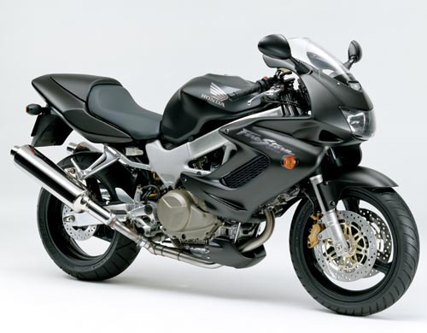 | 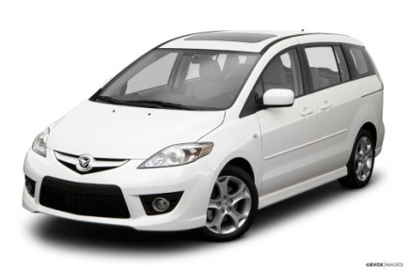 | 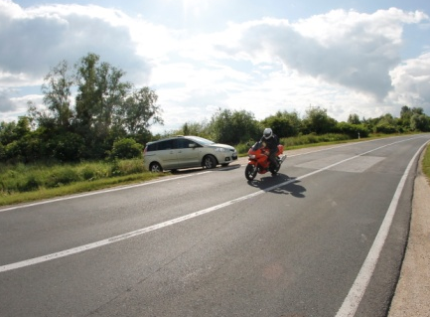
Fig. 1. Honda VTR 1000F. | Fig. 2. Mazda 5. | Fig. 3. Frame of analyzed road traffic flow.
- Biological Anthropometry

Knowing the dimensions of the body and some body segments of the driver and their biomechanical action characteristics is the basis of the approach to designing virtual 3D character models. The choice of ergonomic anthropometric measures varies depending on an entire series of factors – first of all depending on the form of the interior of the car driver’s working environment and the functions of individual elements within the working zone. It is therefore necessary to consider also which body parts will be in direct contact with these elements, then to define those parts that are in the close vicinity, or come only occasionally into contact. There are numerous and different sources of anthropometric data that are in principle divided into static, kinematic, and dynamic anthropometric measures (Mijović et al., 2001., Maver et al., 1976.).
Determining the anthropometric measures for every individual separately using the conventional method is complex and time-consuming. The introduction of new computer-aided 3D methods allows fast and accurate determination of all the important body dimensions in order to adjust the workplace and ambient dimensions to the anthropometric values of the driver (Tomić et al., 2005.). Consequently, software “ErSABA” (ERgonomy SArajko BAksa) was applied, which uses the input data such as body height, weight and gender, as well as the necessary work precision and working postures to determine twenty-two characteristic anthropometric values for the seating and standing working postures of male and female examinees, figure 4 and 5 (Baksa et al., 2002.).

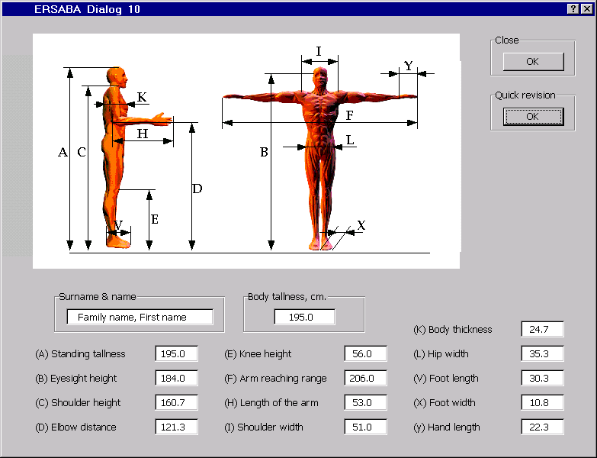 | 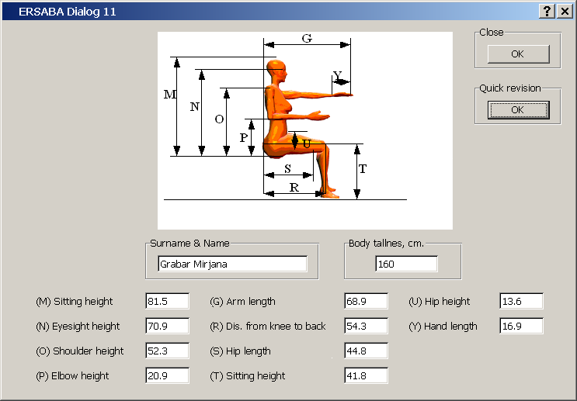
Fig. 4. Screen review of characteristic anthropometric measures for standing position. | Fig. 5. Screen presentation of program ERSABA for sitting working position.

- Physiological Vision Field Anatomy

Car drivers, as traffic participants, express their necessary visual capabilities by recognizing complex structures of horizontal and vertical signalling systems, identifying their distinct forms and colours, observing the movement of vehicles of other traffic participants, resulting eventually in the necessary speed and precision in reacting to the elements of the dynamic traffic environment, based on visual observation. The drivers have to have extremely good visual capabilities, which is decisive for adequate coordination of movements, fast response, and accuracy of performance. The driver’s workplace belongs to the closed type with small working area layout and the sitting body posture, so that for adequate design of the workplace, apart from the static and dynamic anthropometric values that refer to the kinematic characteristics of the drivers, the arrangement of work elements is important which provides the necessary level of visual control in performing the working process (Tomić et al., 2005.).
Anatomic eye structure allows the transfer of the standard line of vision as the so-called monocular or binocular vision. The presentation of the anatomic possibilities of the visual system in transferring the standard line of vision by transversal and sagital rotation of the eye and eyes is shown in figures 6 and 7. The limit of the vision of the right eye for monocular vision in transversal plane, figure 6, is from 94 to 104⁰ to the right from the standard line of vision, whereas to the left it is 62⁰. The same values refer also to the left eye. Monocular vision expresses only anatomic possibilities of the eye. In working systems, the visual control is realized by double vision. In transversal plane the vision limit realized by means of double vision is ± 62⁰, within which comfortable eye rotation is ± 15⁰.
In the sagital plane, figure 7, compared to the standard line of vision, the limit of the upper field of vision is 50⁰, and the limit of the lower field of vision is 70⁰. Comfortable rotation of the eyes in the sagital plane according to the standard line of vision is about 30⁰ and within these limits the colours are distinguished. In designing the workplaces the normal line of vision is used to express the fields of vision in the sagital plane. The standard line of vision of 0⁰ is a horizontal line of vision realized in the vertical position of the head. Natural or normal line of vision for the standing working position is lowered by 10⁰ from the standard line of vision, whereas for the sitting position it is lowered by 15⁰ below the standard line of vision (Jurum-Kipke et al., 2008.).

Fig. 6. Transversal visual axes and field of vision. | Fig. 7. Sagital visual axes and field of vision.

- Research results

Research results are undoubtedly showing, Figure 8, that the frontal view of the motorcycle VTR 1000F is extremely small and therefore it is extremely hard to notice it while entering the road, on which the aforementioned motorcycle is traveling, at a right angle, Figure 8a, which is additionally made harder by the speed of the motorcycle which in our study amounted to 100 km/h. The aforementioned speed exceeds the 80 km/h speed limit on that part of the road, but since motorcycle drivers on the concerned road often drive above the speed limit, this research was also conducted with increased speed.
Figure 8b is showing the application of the ergonomic solution with a purpose of increasing visibility for the Mazda 5 driver. If the design solution in the form of an additional window pane would not be implemented, the motorcycle from our research, considering the angle of approach in relation to the characteristic driver’s visibility zones, would be hidden during a short time interval, which could make the driver falsely conclude that the main road is clear and that he/she can join the traffic, which would have catastrophic consequences, but these additional window panes enable the driver to have the necessary visibility of the traffic surroundings, Figure 8c.

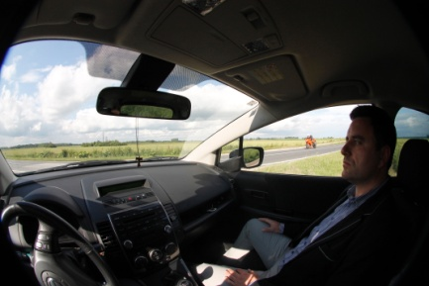 | 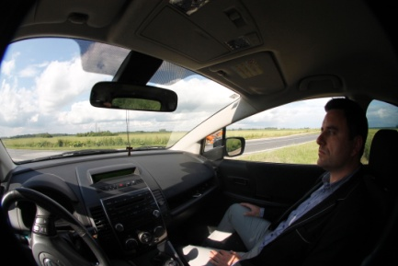 | 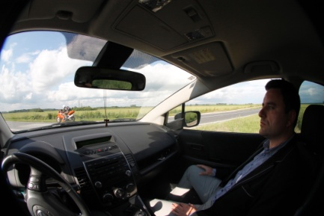
a) | b) | c)
Fig. 8. Image sequence of motorcycle approaching towards the motor vehicle.

- Conclusion

Design characteristics of roads are of great significance for traffic safety, especially within rural areas where often a large number of local and unclassified dirt roads connects to the county and regional roads, where poor visibility of intersections often result in traffic accidents.
The results of biometric anthropology and anthropometry and CAD methods can be used to determine visibility zones and all the activities which are performed during operating a motor vehicle, which enables a production of 2D and 3D computer humanoid models in interaction with the operating environment.
Virtual 3D humanoid models are without a doubt, besides biomechanics and biological anthropometry, an important part of the motor vehicle design process, which was experimentally proven in this paper.
Because of its minivan construction and the design solution of the forward edges of the side windows at the driver and the passenger side from the point of view of ergonomics and safety connected to driver visibility, the tested personal vehicle has proven to meet the required characteristics. This research has established that if a solid surface would be used instead of the existing solution that uses a glass surface that connects the windshield glass with the front side windows, driver visibility would diminish considerably.

References

1. | Baksa S., Skoko M., Baksa I. (2002): ErSABA 4.2. – Computer Software for Automatic Determination of Human Anthropometric Measures, 13th Congress of the European Anthropological Association, Zagreb, 2002.
2. | Jurum-Kipke J., Hozjan D., Baksa S. (2008): Cognitive Scientific Virtualization in the Function of Traffic Safety, Sigurnost 50 (1) (2008), Zagreb, UDK 614.8, ISSN 0350 – 6886, 1-7.
3. | Maver H., Rudan P., Tarbuk D. (1976): Praktikum biološke antropologije, Ergonomske metode, Antropologijska biblioteka, Zagreb, 1976.
4. | Mijović, B.; Ujević, D. & Baksa, S. (2001). Visualization of Anthropometric Measures of Workers in Computer 3D Modeling of Work Place. Collegium Antropologicum, 25., 56., (2001), 639-650.
5. | Tomić, D. ; Muftić, O. & Baksa, S. (2005) Computer 3D Spectral Analysis of Human Movements, CAES 2005, International Ergonomics Conference, Sinay, J., pp. 1-12, Košice, Slovakia, May, 2005, IEA & SEA, Slovakia.

