Marija Katić, M.A.
University of Dubrovnik

TRENDS IN THE CROATIAN LABOUR MARKET

UDK / UDC: 331.5(517)
JEL klasifikacija / JEL classification: J21
Prethodno priopćenje / Preliminary communication
Primljeno / Received: 7. ožujka 2006. / March 7, 2006
Prihvaćeno za tisak / Accepted for publishing: 20. lipnja 2006. / June 20, 2006

Abstract
In this paper, the main characteristics the Croatian labour market will be analysed – employment and participation rates, as well as unemployment and its structure. We will compare Croatian indicators to the other Central and Eastern European countries. Although unemployment indicators are not exceeding the range of the other transition countries indicators, Croatian ones are higher than the average. Transition process combined with the war created the deep recession in Croatia. Consequently, employment contracted transforming partly in inactivity and partly in unemployment. In this paper, we will use Blanchard’s adjustment ratio to examine what was the primer form of transformation, whether inactivity or unemployment. Now, after fifteen years of transition, the Croatian labour market is still not performing well and it is troubled by low participation and employment rates and, at the same time, with high unemployment rates. Through the educational structure of employment and unemployment, we will see whether there is connection between educational attainment and job-finding.
Keywords: Croatian labour market, Blanchard’s adjustment ratio, unemployment

1. INTRODUCTION
The process of transformation from centrally planned to market economy brought a deep structural change that had the strong impact on the labour market in Croatia, as in all of the transitional countries. The beginning of transition in Croatia coincidenced with the War of Independence and that created an even deeper crisis in the economy. Even after almost fifteen years of transition, the Croatian labour market is still not performing very well if we consider low unemployment rates, high participation and employment rates as indicators of a good labour market performance. On a contrary, Croatia is experiencing low participation rates, low employment and high unemployment rates, especially long-term unemployment.
In the analysis, two sources of data are used: data from the Croatian Employment Service (CES) register and the data from the Labour Force Survey (LFS) based on the criteria by International Labour Organisation (ILO) and conducted by the Croatian Bureau of Statistics (CBS). There is discrepancy between two sets of data due to different methodologies used in processing information. The data from the register will be used in analysing the situation in Croatia since they provide longer time series and the data from LFS will be used in comparisons with the other countries, as these are internationally comparable. We will compare Croatia to other European transition countries, whose economies experienced a similar situation to that of Croatia. Most of these countries already joined the European Union (Czech Republic, Estonia, Hungary, Latvia, Lithuania, Poland, Slovakia and Slovenia), while Bulgaria and Romania are in the same position as Croatia – waiting for accession. Comparing the Croatian labour market to other countries, we will point out some of the main economical problems of Croatia.
The paper is organised as follows: In the part two some main features of the transition will be emphasised. In the third part employment, its main characteristics and participation rates will be analysed. Part 4 will analyse unemployment, with the emphasis on the long term and youth unemployment. The following fifth part will analyse the educational structure of employment and unemployment and the paper will finish with the concluding remarks.

2. TRANSITION AND LABOUR MARKET IN CROATIA 1990 – 1996
In the pre-transitional period, full employment, overstaffing and excess demand for labour were the main characteristics across the labour markets of the former centrally planned economies. Open unemployment did not exist and it was illegal, with the exception of the former Yugoslavia (and therefore, Croatia) where there were some schemes to help unemployed workers. Employment was mostly concentrated in the industrial sector, again with the exception of Croatia and Slovenia, which were the only countries with more than fifty percent of working force employed in the service sector.
The main characteristic of the transition process is deep structural change throughout the entire economy. In the early phase of transition, all the countries, including Croatia, experienced a decline in productivity what had a strong impact on the labour markets. Demand for labour decreased and consequently employment too. Nesporova (1999, p.6) argues that the “delay before the effects on employment were felt was due to the enterprises being at first reluctant to dismiss redundant workers, assuming that the economic recession would be a short-term crisis”.
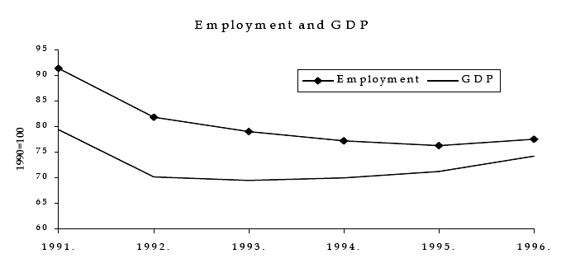
Source: Vujčić, 1998
Figure 1. Employment and GDP in Croatia
The output in Croatia had the typical U-pattern as in most other transition countries. The difference lies in the fact that Croatia, along with Bulgaria, experienced one of the strongest recessions among the selected group of countries. The conflicts in the region, which in Croatia resulted in the Croatian War of Independence in the early stage of transition, provides an explanation for such a serious situation and recession deeper than it would have otherwise been.

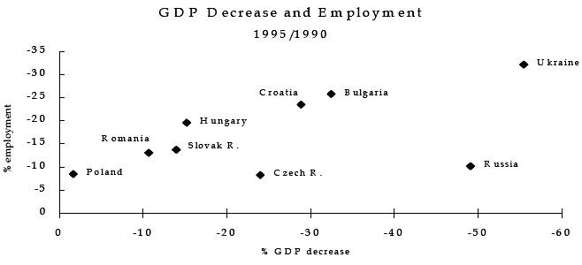
Source: Vujčić, 1998
Figure 2. GDP Decrease and Employment in Transition Countries
After the initial output fall which cumulatively amounted to almost 35% in the period 1991-1993, GDP in Croatia started to recover in the 1994 but employment continued to fall until 1997 as productivity began to grow. By the end of 1996 employment declined by approximately 540,000 workers (34% of the employment in 1989). Rutkowsky (2003) emphasises that Croatia responded to the shocks largely through employment reductions rather than through wages (Table 1), i.e. firms in Croatia tried to raise unit productivity through employment cuts and not through wage cuts. When GDP (productivity) started to grow in 1994, wages were following productivity while, at the same time, employment was continuing its contraction.
Table 1.
Employment and GDP per Capita
 | 1990 | 1991 | 1992 | 1993 | 1994 | 1995 | 1996 | 1997
Employment (000) | 1513.6 | 1314.7 | 1159 | 1108.4 | 1061.5 | 1026.8 | 1028 | 1004
GDP per capita at market prices (USD) | 5195.3 | 4023.1 | 2291 | 2349.2 | 3137.2 | 4028.9 | 4422 | 4398
Growth rate (%) | - | -21.1 | -11.7 | -8.0 | 5.9 | 6.8 | 5.9 | 6.8
Real gross wage (1994=100) | - | - | - | - | 100.0 | 127.8 | 142.9 | 155.3
Source: LABORSTA; Croatian Chamber of Commerce: http://hgk.biznet.hr/hgk/fileovi/577.pdf; CBS, Statistical yearbook, 2004; Wages: http://www.unece.org/stats/trends/ch5/5.12.xls
Nesporova (2001) argues that employment primarily transformed into economic inactivity and declines in the participation rates of the population aged 15 to 64 were visible across all the transition countries with only Slovenia keeping the rate above 70%. In Croatia, participation rate fell from 77% in 1990 to less than 60% in 1998. The second major way of employment transformation is to the unemployment. Table 2 shows us that all the countries had the same trend of increasing unemployment rates. Previously countries with practically zero unemployment (except Croatia and Slovenia) reached the double-digit unemployment rates. In 1996, the worst situation among the selected group of countries was in Croatia where registered unemployment rate reached over 16%. The rates were also high in Slovenia (13.9%), Bulgaria and Slovakia where the rate amounted 12.5% and 12.6% respectively. A better performance, surprisingly, can be seen in Romania (6.6%).

Table 2.
Registered Unemployment Rates in Transition Countries 1989 - 1996
 | 1990 | 1991 | 1992 | 1993 | 1994 | 1995 | 1996
Bulgaria | 1.7 | 11.1 | 15.3 | 16.4 | 12.8 | 11.1 | 12.5
Croatia | 8.2 | 14.9 | 15.3 | 14.8 | 14.5 | 14.5 | 16.4
Czech Republic | 0.7 | 4.1 | 2.6 | 3.5 | 3.2 | 2.9 | 3.5
Estonia | - | 0.1 | 1.7 | 1.9 | 2.2 | - | -
Hungary | 1.7 | 8.5 | 12.3 | 12.1 | 10.4 | 12.0 | 10.7
Latvia | - | - | 2.3 | 5.8 | 6.5 | 6.6 | 7.2
Lithuania | - | 0.3 | 3.5 | 3.5 | 0.5 | 7.3 | 6.2
Poland | 6.5 | 11.8 | 13.6 | 16.4 | 16.0 | 14.9 | 13.2
Romania | - | 3.0 | 8.2 | 10.4 | 10.9 | 9.5 | 6.6
Slovakia | - | 6.6 | 11.4 | 12.9 | 14.4 | 13.8 | 12.6
Slovenia | 4.7 | 8.2 | 11.5 | 14.4 | 14.4 | 13.9 | 13.9
Source:LABORSTA
Blanchard (1997) suggests that it is typical for many transition economies that much of decrease in employment translated into a decrease in participation (i.e., similar as Nesporova (2001), he suggests increase in inactivity). To illustrate this, he computed the following formula:
$$ΔP=ΔN+ΔU+ΔO$$
where P is population of working age, N is employment, U is unemployment, O is non-participation and Δ denotes the change of the variable in the selected period. Furthermore, if we consider the ratio
$$χ=\frac{ΔU}{ΔP−ΔN}$$
a value of 1 for $χ$ indicates that the entire adjustment was through unemployment rather than participation and a value of 0 that entire adjustment went through participation. Table shows the value of $χ$ for some transition countries.
It is necessary to stress that there is a big problem with the data about the population in Croatia in the 1990s considering the turbulent time and great migrations of population, within and out of the country. In order to calculate adjustment ratio for Croatia, I used the change in the estimated mid-year population as a proxy of a change in working age population.
Table 3.
Adjustment Ratios in Selected Transition Countries
 | Bulgaria | Croatia | Czech Republic | Hungary | Poland | Slovakia
$$χ$$ | 0.75 | 0.38 | 0.27 | 0.41 | 0.85 | 0.66
Source: Bulgaria, Czech Republic, Hungary and Slovakia for 1994: Blanchard (1997); Croatia: own calculations for the period 1990 -1997
From the Table 3, we can see that in Bulgaria, Poland and Slovakia adjustment in the first year of transition was mainly through unemployment while in Croatia, Czech Republic and Hungary adjustment went mainly through participation. This means that workers in Croatia have chosen inactivity, usually in a form of early retirement, rather than unemployment. Due to the lack of data on population during that time, it is difficult to estimate the participation rates for the period 1990-1997 to support this thesis.
From the Table 4. we can see how unemployment in Croatia changed comparing to employment. Whilst in 1989 the number of unemployed was more than ten times lower than the number of employed workers, that figure was only three times lower in 1997. The number of employed decreased for 510 thousands (for 30%), the number of unemployed increased for 117 thousands (almost doubled from 1989), what suggests that most of the people transferred into inactivity often motivated by early retirement opportunities (there has been a large number of demobilised men who retired after coming home from the war).
Table 4.
Unemployment as a Percentage of Employment in Croatia
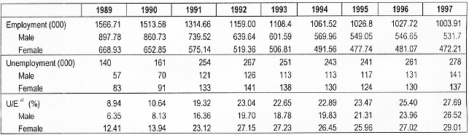
Source: LABORSTA; own calculation
$a$- Unemployment to employment ratio

3. PARTICIPATION AND EMPLOYMENT RATES
As already mentioned, the transition process, from the labour market standpoint, resulted with the decline in the employment up to 1996, but the question is what happened after and where is Croatia now. In the following nine year period, from 1996 to 2004, working age population increased by more than 500 thousands (17%) and employment relatively stabilised variating around 1,550,000 (variating $±$3 to 4%) with no radical declines or increases (Table 5).

Table 5.
Key Labour Market Indicators
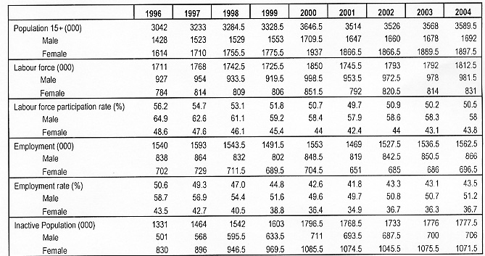
Source: CBS, Statistical reports – LFS, various years
Note: For the period after 1998 I have calculated an average of semi-annual data

Participation rate was declining from 56.2% in 1996 to 49.7% in 2001, mainly because of faster increase in working age population than in labour force. Afterwards participation rate started to increase gradually and in 2004 amounted 50.5%. In other words, approximately half of working age population either works or at least is willing to work but unable to find a job. Even though there is constantly higher number of a female inactive in the period 1996 - 2004, the change in number of inactive males was much higher – increase of 41% comparing to 29% raise in female inactivity. From the Table 5 we can also see that female participation rates are relatively unstable, compared to those for males.
Comparing to the some other countries in the region (Figure 3) we can see that Bulgaria and Hungary constantly have a lower participation rates, in 15-64 age group, than Croatia. Rutkowski (2003) argues that the low level of overall participation reflects a poor availability of job opportunities in Croatia. He computed a job creation rate of 3.5% in 2001 what was rather low comparing to Bulgaria (7%) or Lithuania (10%). This means that Croatia, expressed as a proportion of total employment, creates only 3.5% of new jobs and it needs at least to double this rate to achieve the level that other transition already have. Although Šošić (2004) estimated job creation rate to be 8.7%, this is still very low. The decreasing levels of participation are also connected with the “discouraged worker” effect where people leave the labour market after unsuccessful job search in belief that there are no jobs for them. Furthermore, the possibility of early retirement for older workers also contributed to the increase of inactivity.

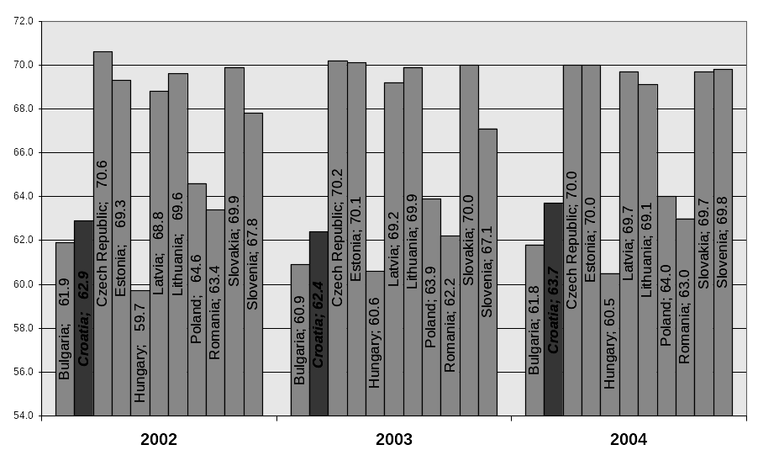
Source: EUROSTAT; Croatia: Labour Force Survey
Figure 3. Participation Rates in Transition Countries for the Age Group 15-64 (%)

Another characteristic of the Croatian labour market is the low employment-to-population ratio (Table 5). Only 43% of the working age population is actually employed in Croatia. While working age population was increasing since 1996, employment was relatively stable what entails a low-level labour resources utilisation. Among the female population, the situation is even more severe, only 36.7% of working age women works. Comparing employment rates in the selected group of countries, we can see that again Bulgaria is the only one that had a lower share of population employed than Croatia. A similar situation to that in Croatia can be found in Hungary and Poland where employment-to-population ratio is around 54 – 55%. Czech Republic and Slovenia are leading with this perspective with 55% working age population employed.
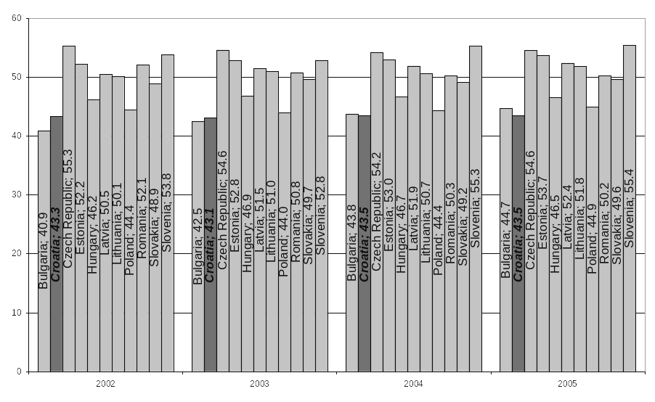
Source: EUROSTAT - average of quarterly rates for every year; CBS, Statistical report 2003; Own calculation
Note: for 2005 the average is for the first three quarters of the year;
Figure 4. Employment Rates In Transition Countries (%)

It is noticeable that there is a big difference between the employment rate in 15-64 age group (62.3%) and the rate for overall population over 15 years (43.5%) in Croatia what implies a low levels of employment over 65 years due to the mandatory retirement at that age, or also a large number of people over 65.
It is necessary to stress the divergent movements in the overall employment. On one side the number persons in paid employment in legal entities irrespective of the type of ownership declined by almost one-fifth (from 1,303,000 in 1991 to 1,088,000 in 2003) and on the other side, the number of self-employed almost doubled (from 129,000 in 1991 to 242,000 in 2003).
Another “product” of the declining registered employment that created high unemployment, is the expansion of employment in the informal or shadow economy. Schneider (2004) defines shadow economy as all market-based legal production of goods and services deliberately concealed from the authorities usually in order to avoid the payment of taxes and social contributions. He estimated the size of the Croatian shadow economy to be 35.4% of official GDP in 2002/03. From the Figure 5 we can see that Croatia is constantly having very large estimated shadow economy, along with Bulgaria, Estonia, Latvia and Romania. Such a large size of shadow economy could be associated to large contribution burden on wages in Croatia, i.e., to large labour costs. Calculating, I have computed the tax wedge of 39% on average Croatian wage, which is not significantly different from the other transition countries but it is still high. To avoid this high labour costs, employers hire workers in shadow economy.

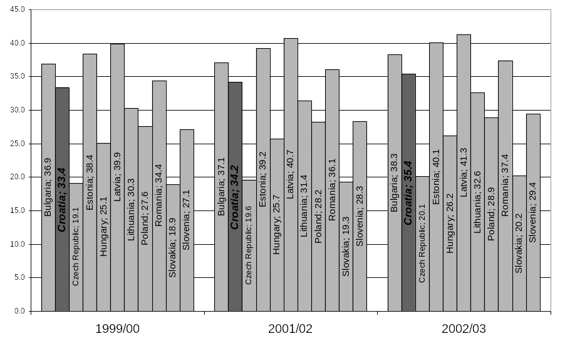
Source: Schneider (2004)
Figure 5. The Size of Shadow Economy in Transition Countries

4. UNEMPLOYMENT
Unemployment is the key issue in the Croatian economy. According to the Croatian Employment Service, the number of unemployed and overall unemployment rate was increasing until 2003 (Figure 6). In the period from 1996 to 2003 registered number of unemployed increased almost by 50% (Table 6). The revival of the economic activity in the second half of 90s (GDP increased by 6% in 1996 and by 6.5% in 1997) was not accompanied by higher employment but on the contrary, employment stagnated and unemployment continued to increase significantly and by the year 2002 registered unemployment rate was 22.3%. Notwithstanding the declining trend in unemployment for the last two years, the unemployment rate is still very high, 18% in 2004.

Source: CES, www.hzz.hr
Figure 6. Evolution of the Registered Unemployment Rate in Croatia (%)

The restructuring of enterprises caused an accelerating inflow of newly unemployed since reducing the number of employed became necessary for many firms in order to survive in new circumstances of a market economy. This was especially important for privatised firms, which were commonly overstaffed previously. Inflow to registered unemployment was constantly higher than outflow since 1995, though in 2003 this situation changed (Table 6).

Table 6.
Inflow and Outflow from Unemployment
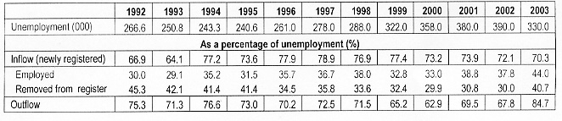
Source: Own calculation based on CBS Statistical yearbook 2004

The number of unemployed according Labour Force Survey (LFS) is lower than the registered unemployment and therefore, there is a substantial difference in the unemployment rates from two sources (even to 5% difference). The reason for such a big difference is that it was necessary to register as unemployed in order to be eligible for most social transfers and benefits. Therefore, many people registered as unemployed to receive financial support from the Employment Service. In the first half of 2001, LFS recorded almost 170 thousand people registered at CES who, according to international criteria, were not considered unemployed, mostly because they were not actively looking for a job or they did not accept offered jobs. Even 60 thousand of them stated that they were working what implies their involvement in the informal economy. Reform of the labour market institutions in the period 2001-2003 meant that the CES register actually was used for social rights administration and not for its primary objective – as an employment agency. After 2003 there were some efforts to divide the administration of social rights from that concerned with benefits related to unemployment status.

Table 7.
Unemployment Indicators Comparison of LFS and Employment Register Data
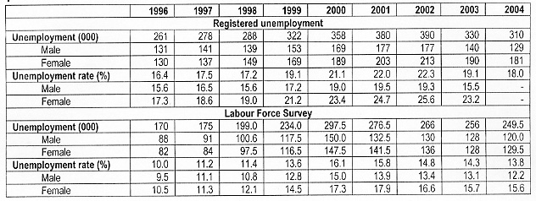
Source: LABORSTA; CBS, Statistical reports, various years;

In 2004, Croatian unemployment rate, according to LFS, was 13.8% with only Poland and Slovakia having higher rate of 19% and 18%, respectively. Even though it is almost 15 years since the beginning of transition, the high unemployment rates are still usual in all transitional countries and Croatia, Poland, Slovakia and Bulgaria kept the double-digit unemployment rates (Figure 7) of while Czech Republic, Estonia, Hungary, Romania and Slovenia succeeded in keeping it below 10%. The low rate in Romania is actually very surprising but it can be associated to the agrarian structure of the economy, which is, in turn, connected to the high rates of employment and low unemployment (Biondić et al., 2002).

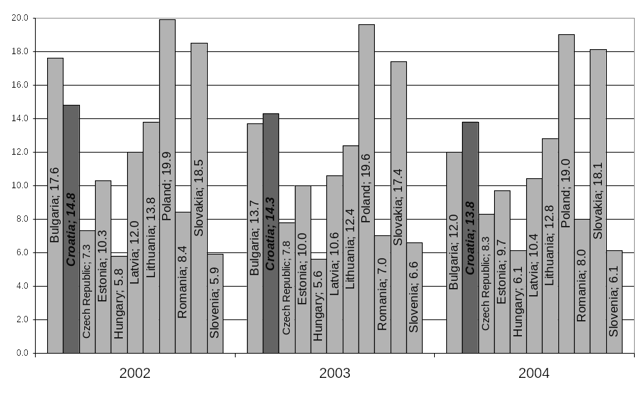
Source: LABORSTA
Figure 7. Unemployment Rates in Selected Transition Countries (%)
Male and female unemployment rates are diverging as time passes according to both sources. As was the case with participation rates, female unemployment rates are also less stable than male unemployment rates. While in 1996 the difference between gender unemployment rates was one (LFS) to two (CES register) percentage points, in 2003 the difference was much higher – 2.7 (LFS) and 7.7 (CES register) percentage points (Table 7). The female unemployment rate grew faster than male unemployment rate especially according to the CES register. Part of the explanation for such a situation is the fact that women had more incentives than men to register as unemployed (even though inactive) in order to be eligible for maternity leave.

4.1. Long Term Unemployment
Besides the high overall unemployment rate, one of the main characteristics of the Croatian labour market is long-term unemployment (unemployment longer than a year). Long-term unemployment is a particularly delicate problem for society because people who are long-term unemployed are faced with greater probability of poverty. More than half of the unemployed in Croatia (55%) are looking for a job for more than a year and even 40% is unemployed for more than two years. While in 1990 only 10.6% of unemployed were looking for a job more than three years, in 2004 that figure increased to 30% of workers looking for a job for the same time. Although there is a larger share of long-term unemployment among female unemployed population (58%), the share of 52.2% among males is also considerably high (Table 8).

Table 8.
Long Term Unemployment as a Share of Total Unemployment in Croatia (%)
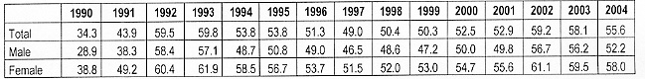
Source: CES

The problem of long-term unemployment is not a unique characteristic of the Croatian labour market; it is a problem of all of the transitional countries. There are notably high shares of unemployed workers who are without the job for more than a year all across these countries. According to the Labour Force Survey, Slovakia, Bulgaria and Romania are even having the larger share of long-term unemployed than Croatia (on average, 68%, 60% and 58% respectively). Slovenia is doing better than Croatia, but also with more than a half (51%) unemployed workers looking for a job longer than a year (Figure 8).
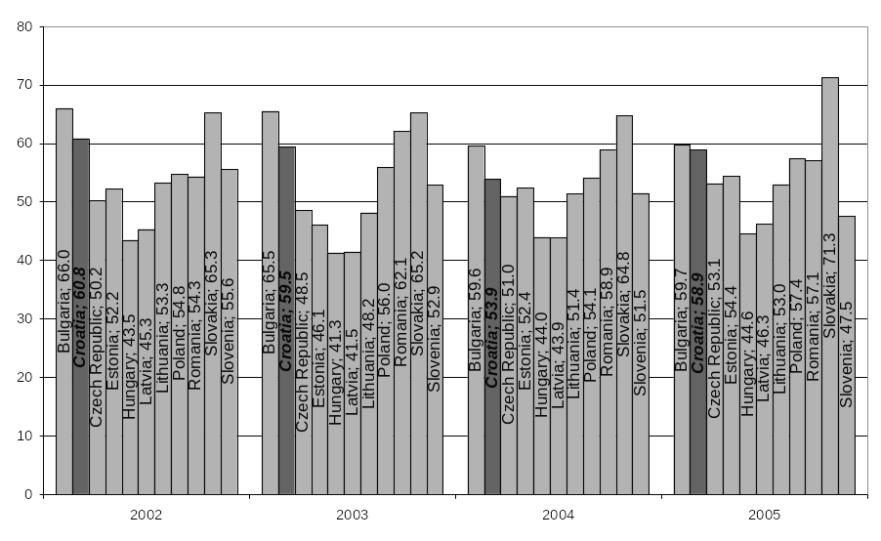
Source: EUROSTAT - average of quarterly rates for every year; CBS, Statistical report 2003; Own calculation
Note: For 2005 the average is for the first three quarters of the year;
Figure 8. Long-Term Unemployment as a Share of Total Unemployment in Selected Transition Countries (%)
If we look at the Table 9, we can see that workers older than 50, both males and females, are the most affected by the long-term unemployment. Considerably high share of prime age women are also without the job for more than a year, 63.3%.

Table 9.
Long-term Unemployment as a Share of Total Unemployment by Age Groups (%)
 | Total | Male | Female
15 and over | 54.1 | 50.9 | 56.8
15-24 | 39.5 | 38.6 | 40.4
25-49 | 58.7 | 52.7 | 63.3
50 and over | 65.1 | 69.4 | 60.2
Source: EUROSTAT, second half of 2004

Long-term unemployment often indicates that there are groups of workers with minimal chance of re-employment. It might be that they are disadvantaged because of their age, as we have already seen that the highest share of long term unemployed is among older workers. Furthermore, they might be disadvantaged due to their skills or educational attainment. Figure 9 suggests that the group of workers with only primary or lower secondary education is the most affected by long-term unemployment comparing to higher education than that. However, shadow economy is considered to be mostly concentrated in those sectors where workers are not required high qualifications (construction or catering) so this figures could be much lower in reality than the register shows.
Source: CES yearbook, various years
Figure 9. Long-term Unemployment by Educational Attainment (%)
Empirical evidence by Micevska (2004) suggests that there is a particularly strong association between the shadow economy and long-tem unemployment rate. The effect of the shadow economy in increasing long-term unemployment seems to be twice as high as the effect in increasing overall employment. This result could be due to the tendency of long-term unemployed to engage occasionally in informal activities.

4.2 Unemployment by Age Group
Although young people of age 15–24 are having the lowest share of long-term unemployment, in transitional countries they are often the group the most affected by unemployment. High youth unemployment rates often indicate a rigid labour market what is connected to difficulties of dismissing workers and indirectly hiring new workers and creating additional job opportunities. Young people, more and more, decide to prolong their education to avoid the unemployment and job finding process. In 1998, about half of the population between 15 and 24 years of age were in education, while that share had increased to 58% in 2003.
The unemployment rate tends to decline with higher age range, reaching the lowest level in the ‘over 50 years’ group (Table 10). If we consider prime age workers in Croatia (aged 25-49), unemployment rate is considerably lower than in the case of 15-24 age group and it amounts 11.5% and for the older workers it is “only” 8%. The same trend is across all the countries with Poland and Slovakia followed by Croatia and Bulgaria having the highest rate of unemployment among prime-age and older workers.
Table 10.
Unemployment Rates by Age Groups in 2005 (%)
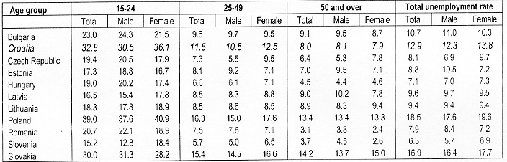
Source: EUROSTAT, average of quarter unemployment rates in a first half of 2005
Considering youth unemployment, in Croatia almost one-third of young people (aged 15 to 24) are unemployed - 32.8%. The only country where situation is even worse is Poland where 39% of young people are jobless. Somewhat similar situation as in Croatia is in Slovakia with 30% of youth unemployment rate, following Bulgaria 27% and Romania 21.9%. Slovenia and Latvia have the lowest youth unemployment rates among the group but still very high (15.2% and 16.5% respectively). From the Table 10 we can see that female youth unemployment in Croatia is the second highest among the selected countries, 36% of active female population between 15 to 24 years of age is unemployed. High youth unemployment often indicates that there are some barriers to the entry in to the employment.
As we have already seen, youth unemployment is in all of the selected countries higher than the national average and Figure 10 presents the relationship between those two values. Youth to total unemployment rate ratio is the highest in Hungary, followed by Romania where the youth unemployment rates are almost three times larger than average national rates. This implies very low levels of unemployment in other age groups in these countries. The countries with otherwise the highest rates of unemployment are having this ratio lower, so Croatian youth unemployment exceeds average 2.5 times. The lower value of this ratio implies somewhat higher unemployment rates among other age groups.

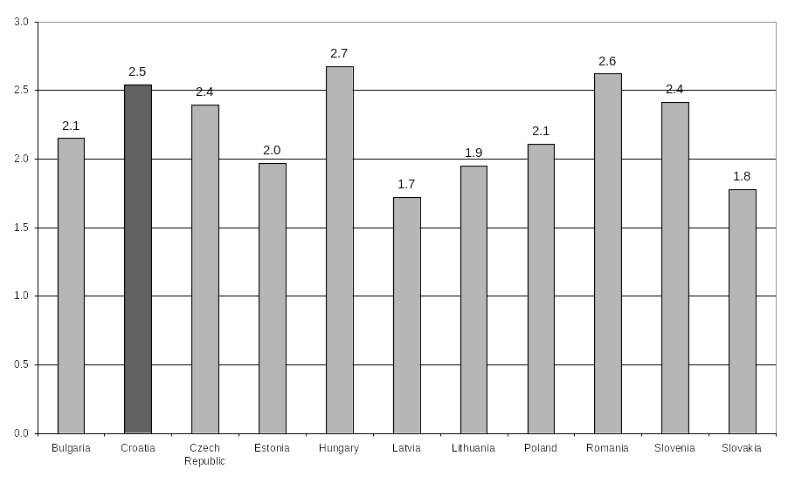
Source: Own calculation based on EUROSTAT data
Figure 10. Youth Unemployment Rate to Total Unemployment Rate in 2005

5. THE EDUCATIONAL STRUCTURE OF EMPLOYMENT AND UNEMPLOYMENT
In the whole period after 1980, there have been improvements in the educational structure of employment in Croatia, which comes because of employing young educated people but also because of the further education and training of already employed people. Bejaković (2003) analysed the structure of employment in the period from 1981 to 1996. In the relatively short-term period of fifteen years, the structure of employed improved significantly. In 1981 almost one-fifth of employed was without even primary level education and another fifth had only primary school – all together about 40%. The situation changed by 1996, where the workers with pre-primary and primary level of education were making about 30% of employment and that decreasing trend continued and whereas in 2004 there was only 22% of those workers in employment. The share of workers with high school education, which was less than 50% at the beginning of 80s, increased over the years and in 2004 they are making the majority of the employed, almost 60% (Table 11). A significant increase is in the share of workers with tertiary education (university diploma, Msc diploma or PhD). In 1981 they where making about 12% of employed workers and in 2004 more than 18%. From the gender perspective, we can see that among female employment there is larger share of women with high level of education and larger share of primary educated women than is the case among men.
Table 11.
The Structure of Employment in 2004
 | Total |  | Male |  | Female
 | 000 | % | 000 | % | 000 | %
Total | 1542 | 100 | 854 | 100 | 689 | 100
Pre-primary, primary and lower secondary education - levels 0-2 | 340 | 22.0 | 169 | 19.8 | 171 | 24.8
Upper secondary and post-secondary non-tertiary education - levels 3-4 | 918 | 59.5 | 546 | 63.9 | 373 | 54.1
Tertiary education - levels 5-6 | 284 | 18.4 | 139 | 16.3 | 145 | 21
Source: EUROSTAT, second half of 2004
According to Employment Service (Table 12) in 2003, 15% of the vacancies reported were requiring university degree and 5% non-university college degree. In three years selected, needs for workers with so high education, expressed in vacancies reported, and vacancies requiring university (or higher) diploma filled were constantly rising. Based on the current evolution and reported needs for workers we can expect further improvements in educational structure in employment.
Table 12.
Vacancies
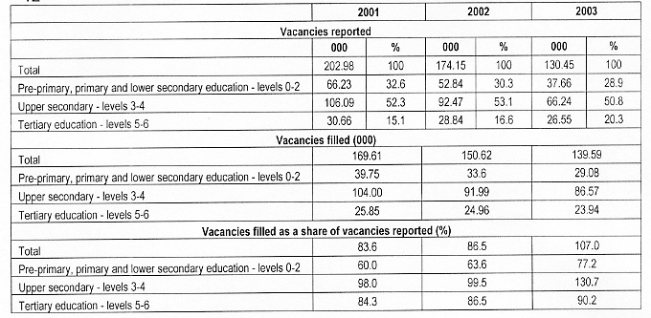
Source: CES, Yearbook, various years
Comparing Croatia to the other countries (Table 13), we can see that the share of workers with low educational level in employment is one of the highest, only Romania has higher. Another characteristic arising is that, along Romania, Croatia is country that has low share of tertiary education in the employment, even lower than primary education.
Table 13.
Educational Structure of Employment, 2004
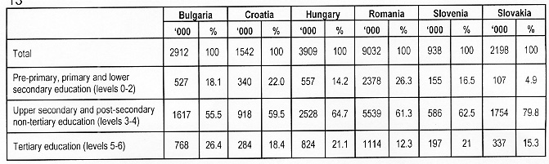
Source: EUROSTAT, last quarter 2004
If we now consider unemployment and its structure, we can see that the situation is almost the same in both cases of male and female population (Table 14). The highest share of unemployed is having high school education, followed by the workers with pre-primary and primary school. Finally, the lowest share in unemployment is that of the highly educated workers. The level of education is very important determinant in the process of finding a job. According to the Croatian Employment Service register, workers with university degree were leading in employment process during 2004 with the accession rate of 38.5%. They were followed by the workers with college non-university degree (35.7%) while the lowest job-finding rate was for the workers with primary school only (18.3%) and for workers without any school at all (8.8%).
Table 14.
Educational Structure of Unemployment, 2004
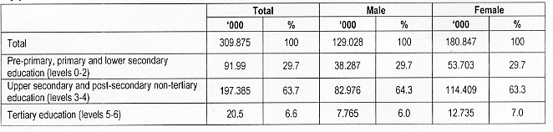
Source: CES
We have seen that the share of workers with tertiary education is the lowest in overall unemployment. Moreover, unemployment rates are also low –from the Table 15 we can see that unemployment rates were consistently lower for workers with university or even higher-level diplomas, they were constantly below 10%. On the other hand, unemployment rates for workers with lower educational levels than that reached double-digits and in 2003 they were almost 17%.
Table 15.
Unemployment Rates by Educational Attainment
 | 1998 | 1999 | 2000 | 2001 | 2002 | 2003
Pre-primary, primary and lower secondary education - levels 0-2 | 12.3 | 12.2 | 18.7 | 16.2 | 16.6 | 16.9
Upper secondary and post-secondary non-tertiary education - levels 3-4 | 13.5 | 15.0 | 19.3 | 18.4 | 17.4 | 16.7
Tertiary education - levels 5-6 | 5.2 | 8.4 | 11.3 | 7.6 | 9.4 | 8.4
Source: CBS, Statistical reports – LFS, various years

CONCLUSION
After analysing the Croatian labour market, we have seen that during the last fifteen years since the independence of Croatia and the beginning of transition, it has not been performing well and the situation is not changing still. Participation rates are very low in Croatia, only 50.5% of people over 15 years of age are active. Participation has been decreasing and our calculations using Blanchard’s adjustment ratio of 0.38 suggest that the most of the adjustment process during the transition period 1990-1997, while employment was decreasing, was through lower participation rather than higher unemployment. This implies that, while employment was decreasing, the majority of those who left employment transferred to inactivity (often encouraged by early retirement benefits) rather than becoming unemployed. On the other hand, while formal employment declined, the informal economy in Croatia grew to account for approximately a third of the official GDP, which is amongst the highest shares in transition countries. Furthermore, this decrease in employment rates, indicates that only 43.5% of population older than 15 is actually employed. At the same time unemployment rate increased to 18% according to CES or 13.8% according to LFS what is in either case very high and among the highest in transition countries. An especially large part of unemployed is unemployed for more than a year: one out of two unemployed is long-term unemployed. Another pronounced problem is high youth unemployment with one-third of those young people willing and available for work currently unemployed. We have to bear in mind that even though the unemployment rates are high this might not be the realistic situation considering widespread and large shadow economy.
Comparing the labour markets of Croatia to the other countries in the Central and Eastern Europe, which also went through transition, indicators suggest that the situation is more severe in Croatia than in most other Central and Eastern European countries. The problem in Croatia is low job creation; lower than in other countries, what results in low levels of job opportunities what especially affects the new enterers in the labour market. The war and the crisis afterwards contributed to the worse performance of the labour than it would have otherwise been. However, that is only the small part of the explanation for the labour market stagnation.
Overall, indicators show the bad labour market performance in Croatia. Although they are not exceeding the range in which other transition countries’ indicators are, that does not mean that unemployment is not a serious social and political problem. For example, unemployed and especially long-term unemployed are the group of people exposed to the increased risk of poverty what again affects the overall standard in the country. Therefore, decreasing unemployment and improving labour market performance should be a priority of policy makers in Croatia.

REFERENCES
Adnett, N. (1996) European Labour Markets: Analysis and Policy, London, Longman
Aghion, P. and Howitt, P. (1994) ‘Growth and unemployment’, Review of economic studies, Vol. 61, pp. 477-494
Basu, S., Estrin, S. and Svejnar, J. (2004) ‘Employment Determination in Eterprises under Communism and in Transition: Evidence from Central Europe’, IZA Discussion Paper No. 1370
Bejaković, P. and Gotovac, V. (2003) ‘(Ne)zaposlenost u Republici Hrvatskoj’, Pridruživanje Hrvatske Europskoj uniji: izazovi ekonomske i pravne prilagodbe, Institut za javne financije: Zaklada Friedrich Ebert, Chapter 9, pp. 193-212
Blanchard, O. (1997) The Economics of Post-Communust Transition, Claredon Press, Oxford
Botrić, V. (2003) ‘Regional differences in unemployment: the case of Croatia’, ERSA conference papers ersa03p25, European Regional Science Association
Cazes, S. (2002) ‘Do labour market institutions matter in transition economies? An analysis of labour market flexibility in the late nineties’, International Institute for Labour Studies, Discussion Paper No. 140
Cazes, S. and Nesporova, A. (2004) ‘Labour market in transition: balancing flexibility and security in Central and Eastern Europe’, Geneva: International Labour Organisation
CBS various years, Statistical Reports, Zagreb: Croatian Bureau of Statistics
CBS (2004) Statistical Yearbook, Zagreb: Croatian Bureau of Statistics
CES various years, Yearbook, Zagreb: Croatian Employment Service
Cvitković, A. (2003) ‘Socijalno partnerstvo i tržište rada’, Financijska teorija i praksa, 27 (4) str. 481-494
Crnković-Pozaić, S. (2002) ‘Nezaposleni koji rade: Radnici i poduzetnici iz sjene’, Financijska teorija i praksa, 26 (1), pp. 301-316
Junankar, P.N. and Madsen, B. (2004) ‘Unemployment in the OECD: Models and Mysteries’, IZA Discussion Paper No. 1168, June
Micevska, M. (2004) ‘Unemployment and Labour Market Rigdities in South-east Europe’, Global Development Network Southeast Europe, Research area: Enterprise Development and Labour Markets, June
Nesporova, A. (1999) ‘Employment and Labour Market Policies in Transition Economics’, Employment Strategy Department, International Labour Office, Geneva
Nesporova, A. (2001) ‘Unemployment in the transition economies’, Employment Strategy Department, International Labour Office, Geneva
Nickell, S., Nunziata, L. and Ochel, W. (2005) ‘Unemployment in the OECD since the 1960s. What do we know?’, Economic Journal, 115(January) 1-27
OECD (1990) Employment Outlook, Paris: OECD
Rutkowsky, J. (2003) ‘Does Strict Employment Protection Discourage Job Creation? Evidence from Croatia’, Washington: World Bank, mimeo
Saint-Paul, G. (2004) ‘Why Are European Countries Diverging in Their Unemployment Experience?’ IZA Discussion Paper, No. 1066 (March)
Schneider, F. (2004) ‘The Size of the Shadow Economies of 145 Countries all over the World’, IZA Discussion Paper No. 1431
Šošić, V. (2004) ‘Regulation and Flexibility of the Croatian Labour Market’, Global Development Network Southeast Europe, Research area: Enterprise Development and Labour Markets, June
Šošić, V. (2005) ‘Siromaštvo i politike na tržištu rada u Hrvatskoj’, Financijska teorija i praksa, 29 (1), 75-94
Vujčić, B. (1998) ‘Structural Changes in Employment: Where We Are, How We Got There and Where Are We Going To?’, CNB Working Paper, Zagreb: Croatian National Bank

Marija Katić, mag.
Sveučilište u Dubrovniku

KRETANJA NA TRŽIŠTU RADA U HRVATSKOJ

Sažetak
U ovom će se radu analizirati glavne karakteristike hrvatskog tržišta rada – zaposlenost, stope participacije, nezaposlenost te njena struktura. Usporedit će se hrvatski pokazatelji s pokazateljima zemalja srednje i istočne Europe. Iako pokazatelji nezaposlenosti ne premašuju opseg pokazatelja drugih tranzicijskih zemalja, hrvatski su znatno viši od prosjeka. Tranzicijski proces u kombinaciji s ratom uzrokovao je veliku recesiju u Hrvatskoj, a kao posljedica, zaposlenost se smanjila te djelomično preinačila u neaktivnost, a djelomično u nezaposlenost. U ovom radu koristit će se Blanchardov omjer prilagodbe kako bi se ispitalo koji je bio primarni oblik transformacije, neaktivnost ili nezaposlenost. Ni petnaest godina nakon početka tranzicije hrvatsko tržište rada još nije uspješno; opterećeno je s niskom stopom zaposlenosti te isto vrijeme s visokom stopom nezaposlenosti. Pokazatelji obrazovne strukture zaposlenosti i nezaposlenosti pokazat će nam postoji li veza između obrazovanja i pronalaženja posla.
Ključne riječi: hrvatsko tržište rada, Blanchardov omjer prilagodbe, nezaposlenost
JEL klasifikacija: J21

Micevska (2004) used econometric models in order to examine the relationships between labour market institutions and various aspects of unemployment (overall, male, female and long-term unemployment). Data on 37 countries were included in the analysis (24 OECD countries, 6 CEE countries and 7 SEE countries), mostly referring to the end of 1990s.

