Paediatr Croat 2007;51: ZNANSTVENI PREGLED
SCIENTIFIC REVIEW

UDK 616.8

NEURONAL MIGRATION AND CORTICAL MIGRATORY DISORDERS
IVICA KOSTOVIĆ¹, NATAŠA JOVANOV-MILOŠEVIĆ^{1, 2}, ZDRAVKO PETANJEK^{1, 3}

¹ Department of Neuroscience, Croatian Institute for Brain Research, School of Medicine, University of Zagreb, Šalata 12, 10000 Zagreb, Croatia
² Department of Medical Biology, School of Medicine, University of Zagreb, Šalata 3, 10000 Zagreb, Croatia
³ Department of Anatomy, School of Medicine, University of Zagreb, Šalata 11, 10000 Zagreb, Croatia

Acknowledgements: This work was supported by grants 108-1081870-1876 (I.K.) and 108-1081870-1932 (Z.P.) from the Croatian Ministry of Science, Education & Sport.

Correspondence to:
Zdravko Petanjek
Department of Neuroscience, Croatian Institute for Brain Research
School of Medicine, University of Zagreb
Šalata 12, 10000 Zagreb, Croatia
Tel: 385-1-4596-801
Fax: 385-1-4596-942
E-mail: zpetanjek@net.hr

I. Kostović, N. Jovanov-Milošević, Z. Petanjek. Neuronal migration and cortical migratory disorders. Paediatr Croat 2007;51:

In this review we outline the neurobiological basis for classification of cortical migratory disorders. Neurons of the human cortex are born in the ventricular and subventricular zone and migrate for a long distance to reach their final point of destination in the cortex, using two types of migratory routes and mechanisms: (1) radial migration along radial glia and (2) tangential, presumably “neurophilic” migration. The process of migration is complex and may be disturbed by various genetic and extrinsic factors. The disturbances of proliferation in the ventricular zone result in major malformations such as schizencephaly, while the failure of onset of migration results in periventricular nodular heterotopia with characteristic abnormalities in magnetic resonance imaging (MRI) and with genetic aberration in the background (FILAMIN1 gene mutation). The typical migratory disorder is lissencephaly type I caused by defect of ongoing migration. The lissencephaly type I is currently included in agyria-pachigyria band spectrum disorders. This group of disorders is caused by mutations of LIS1 and DCX (XLIS) gene mutations associated with Miller-Dieker syndrome, Lennox-Gastaut syndrome and epilepsy. The defects of late phases of migration cause lissencephaly type II, cobblestone complex, which is associated with Walker-Warburg syndrome, macrocephaly, retinal malformation, muscle-eye-brain disease and Fukuyama congenital muscular dystrophy. Zellweger syndrome is morphologically characterized by polymicrogyria and biochemically by defects of the mitochondrial desaturation pathway. The disorders with later migration failure show abnormal MRI restricted to the cortex. Another migratory disorder, focal cortical dysplasia, is a frequent cause of drug resistant epilepsy. An especially helpful diagnostic tool for migratory disorders is high resolution (3T) MRI. Genetic testing together with detailed MRI of migratory disorders opens new perspectives for early detection and improved treatment of migratory disorders.

Descriptors:

INTRODUCTION

Developmental brain disorders are major causes of neurological, behavioral and cognitive impairment in children (1). Neuronal migration disorders can be defined as a distinct entity of developmental disorders, which is characterized by defective neuronal migration and intrauterine onset of occurrence leading to cortical dysgenesis (2-4). In order to explain the pathogenesis of migratory disorders, we have to study migration as a crucial neurogenetic process and its relation to other neurogenetic processes (proliferation, neuronal differentiation, axonal growth, and synaptogenesis). The starting premise is the fact that all neurons are born in the ventricular and subventricular zone deep in the telencephalic wall, and then migrate towards the cerebral surface, forming cortical layers (5). Neuronal migrations are most extensive in the forebrain of higher vertebrates, such as bony fishes, birds and mammals. This is especially expressed in humans, where neurons travel very long distances (6).
The classical migratory route, where immature neurons move from the ventricular zone orthogonal to the pial surface and are guided to their final position by radial glial fiber system, was described for more than a century ago. In the last decade growing evidence has shown that this classic concept of radial migration of principal, prospective projection (pyramidal) excitatory glutamatergic cortical neurons should be expanded with tangentional migration used by GABA-ergic (gama-aminobutyric acid) neurons. Inhibitory GABA-ergic neurons, which mostly correspond to cortical interneurons, are born in the local-specific region of the ventral (basal) telencephalon, named ganglionic eminence (GE), and afterwards migrate parallel to the pial surface to all parts of the cerebral cortex, including the most distant, dorsal part of the telencephalic vesicle.
Abnormalities of neuronal migration may occur at any point of the complex migratory path. In the developing human brain, abnormalities of neuronal migration are considered as early gestational events induced by genetic factors, teratogens or infections, resulting in large-massive malformations (i.e., pachygyria, lissencephaly, and polymicrogyria) (2-4). However, new findings about abnormalities of neuronal migration in the human telencephalon provide some evidence that, beside these major malformations, moderate migration disturbances might play a role in some psychiatric and neurological disorders, such as epilepsy, schizophrenia and autism, or might be responsible for some deflection in normal behavior, such as developmental delays, learning disabilities, perceptual disturbance and motor incoordination (7). Focal and microscopic subtle lesions found in some psychiatric and neurological states could produce fine disorganization of the cortical circuitry, and we believe, are preferentially caused by lesions of migration of distinct interneuron subpopulations (8-13).
The aim of this review is to examine how current knowledge about migration can be used for classification of migratory disorders and how these cortical dysplasias might be identified using combined neuroimaging, neurogenomic and classical clinical examinations.

NEURONAL MIGRATION IN THE TELENCEPHALON OF THE HUMAN FETUS

To describe modes of neuronal migration (14-19) it is important to define: (a) the telencephalon and its longitudinal zones (20); (b) and to classify neuronal types in the cerebral cortex (21-26).
The telencephalon comprises a complex set of structures that derive from the most anterior region of the neural tube, the prosencephalon (27-29). The developing telencephalon has two major regions: the dorsal part is the pallium (roof), and ventral is the subpallium (base). The proliferative zones of the pallium (ventricular and subventricular zones) give rise to the cerebral cortex, including the hippocampus, whereas the proliferative zone of the subpallium, GE, gives rise to the basal ganglia and septal nuclei (Figure 1A). Specification of the regional dorsal-ventral identity in the telencephalon is based on the division of the embryonic telencephalon into molecularly distinct progenitor domains (30).
As in the other parts of the nervous system, two major types of neurons are produced in proliferative layers of the telencephalon (5, 27, 29): principal – projection neurons (pyramidal neurons), and neurons of the local circuit, interneurons. In the cerebral cortex these two major neuronal types are exclusively connected to two major neurotransmitters; projection neurons are excitatory glutamatergic, while interneurons synthesize GABA, which in the mature brain functions primarily as an inhibitory neurotransmitter (31, 32).

A. Radial migration

For a long time it was thought that neurons which come to populate the six-layered cerebral cortex are exclusively born deep within the developing brain in the dorsal (pallium) ventricular and subventricular zones that outline the lateral ventricle, at a position that is strictly below their final cortical destination (5). Newly postmitotic neurons must migrate a distance of hundreds of cell-bodies to reach their correct position within the cerebral cortex. They obtain bipolar morphology (Figure 1, 2A, B) and appear largely to migrate orthogonal to the surface of the brain, guided by radially oriented glial fibers (gliophilic migration) that transverse the whole thickness of the telencephalon (33). During development, the radial glia scaffold provides the physical link between the ventricular surface (the proliferative zones) and the pial surface, acting as guides by which immature neurons migrate to reach their final destination. The organization of the radial “glia” explains how the immense population of neurons that constitute the human cerebral cortex is generated from progenitors lining the cerebral ventricle and then distributed to the appropriate layers of distinctive cytoarchitectonic areas (Figure 1, 2A, B). This leads to “radial unit hypothesis”, which implies that the ependymal layer of the embryonic cerebral ventricle consists of proliferative units that provide a genetically controlled proto-map of prospective cortical cytoarchitectonic areas. The output of the proliferative units is translated via glial guides to the expanding cortex in the form of ontogenetic columns. The radial unit model provides a framework for understanding how neurons find their proper position and are specified correctly in the extremely complex cortical network (34, 35).
With exception of the cortical layer I (36), the first-born neurons come to reside in the deepest layers of the cortical plate, while the last-born neurons come to reside in the most superficial layers, indicating that the cortex is established in an inside-out fashion (5). Neurons completing migration appear to require a stop signal (presumably extracellular protein reelin), which appears to be provided by the earliest born, the Cajal-Retzius cells, that are located in the most superficial marginal zone, the prospective cortical layer I. The termination of neuronal migration is accompanied by detachment from the glial substrate and is followed by the outgrowth of neuronal processes.
Classical studies, as well as modern retroviral lineage analyses, concur in the point that projection glutamatergic neurons, in all species examined, originate in the ventricular and subventricular zones of dorsal telencephalon (5, 18, 37), where the radial glia also seem to be neuronal precursors and not only a cellular guide for neuronal migration (35, 38, 39). The intensive production of projection neurons in the dorsal telencephalon of the human fetus starts at around the 6th post-conceptual week (pcw), decreases after the 16 pcw and finishes between 20-26 pcw. Radial migration proceeds accordingly by the same developmental schedule (27, 29).
The major steps of radial migration for principal cortical neurons can be summarized as follows (see numbers on Figure 2B): (a) “detachment from proliferative cells” - proliferation of neurons from radial glial cells (1), and assimilating the migratory (bipolar) morphology (2); (b) “attachment” to (3) and crawl accompanied by radial glia (4) - newly born neurons have to turn in the correct migratory direction and establish proper neuron-glia molecular recognition; (c) “detachment” from radial glia (5) – neurons have to receive at the proper time and in the proper position the stop signal to be situated in their proper final position and to continue with differentiation (6). A defect in any of these key steps of radial migration may lead to cortical dysplasia (Figure 2C, D).

B. Tangentional migration

All hippocampal and almost all cortical GABA-ergic interneurons in lower mammals are generated distant to their final destination in the specific region of the telencephalon, the ganglionic eminence (GE) (40, 41). These neurons migrate tangentially to their target cortical regions, mostly through lower intermediate zone and upper subventricular zone (19, 42). In addition to this major stream of migrating cells, another stream is present in the upper part of the marginal zone where it forms the subpial granular layer (36). Also, individual tangentionally migrating neurons could be seen in all developing telencephalic layers.
By tangentional migration (Figure 1A), which is neurophilic in nature (33, 43-45), prospective interneurons move parallel to the surface of the brain, along axons and cell bodies of other neurons, also passing between other numerous growing axons and breaking through regional boundaries, traveling a more distant route than radially migrating neurons (Figure 2). When they reach their designated region, they enter into the overlying cortex. It seems that proper positioning and specification of interneurons requires much more developmental cellular events than in the case of projection neurons (46). In addition, it seems that: (a) significant production of interneurons in the human brain continues for a much longer period (after 30 pcw) than for projection neurons (up to 20 pcw) (27, 29), and that (b) there is much more diversity among interneurons (24-26). Both of these facts greatly increase the vulnerability of interneuron migration.
According to L e t i n i ć e t a l. (6) migration of interneurons in humans is somewhat different than in rodents. During the early fetal period of human development (8-12 pcw) cortical interneurons are exclusively produced in the GE, whereas later (12-16/20 pcw) interneurons seem to be produced in the dorsal (pallium) ventricular/subventricular zone. However, although born in the dorsal telencephalon, these neurons are not guided by radial glial fibers (as projection neurons born there). Massive production of GABA-ergic interneurons in the dorsal proliferative zones seems to be present only in primates, and especially prominent in humans. However, neurogenesis in the dorsal proliferative zone stops in the human brain around midgestation, whereas proliferation in the GE continues (6, 47), as presented by the tangentionally migrating cells seen in the stream leaving GE after midgestation (48). This suggests that in the human fetal brain intensive production of interneurons and their migration to the cortex may continue even after 30 pcw, that is at least one month later than the major phase of proliferation and migration of principal glutamatergic neurons.
Recent evidence suggests that spatial and temporal origins distinguish between major neurochemically and morphologically defined interneuron subtypes and this contributes to the remarkable diversity of their differentiation fate (41, 49, 50). Distinct subgroups of cortical interneurons appear to have distinct places of origin in different parts of the GE (medial, lateral, caudal, septal), as well as the specific subgroups of interneurons which are produced in the dorsal (cortical) proliferative zones. It is also possible that proliferation of different interneuron subgroups occurs during a specific time window and that specific interneuronal subpopulations use different and specific routes of tangentional migration to reach their final target in the cerebral cortex (51).
In conclusion, we propose that disturbances of migration of interneurons occur in humans more frequently than expected, due to the very complex migratory mechanism and prolonged period of development, which also means a prolonged period of vulnerability.

Developmental periods and migratory phases in classification of migratory disorders

Due to the discovery of many causative genes and gene products, modern classification of migratory disorders becomes very complex (see B a r k o v i c h e t a l. 2005)(1). However, basic principles of previous classification (major phases of cortical development) are used as a framework for the current classification (1-4, 52-58).
The purpose of this review was to illustrate the significance of developmental data for the study of migratory disorders and not to give an elaborate account of all migratory disorders (59-61). Therefore, in this review we have consulted simplified classification presented in table 1. With the help of data in different columns of table 1, it is possible to identify major “migration syndromes” and expand knowledge throughout other classifications (1).

Characteristic migration syndromes

A. Abnormalities of proliferation and onset of migration
a. Schizencephaly

Schizencephaly (cleft brain) consists of a unilateral or bilateral full thickness cleft of the cerebral hemispheres with communication between the ventricle and extra-axial subarachnoid spaces (4, 53, 54). This may appear as a wide cleft (open lipped) or a narrow groove (closed lipped) that is typically lined by gray matter polymicrogyria. Schizencephaly can be due to regional absence of proliferation of neurons and glia, local failure of induction of neuronal migration or focal ischemic necrosis with destruction of the radial glial fibers during early gestation (Figure 2B indicated by numbers 1-3). Schizencephaly is usually sporadic, but familial occurrence has been reported. Several sporadic patients and two siblings of both genders with open-lipped schizencephaly have been described to have mutations in the homeobox gene EMX2. Experimental data showed that EMX2 is expressed in the cortical ventricular zone of mammals and is involved in cell fate determination, but has adverse consequences for radial glial development, neuronal migration, cortical plate formation and cerebral cortical area development.

b. Periventricular nodular heterotopia

Periventricular nodular heterotopia (PNH) (Figure 2C, D, see part indicated by a, and figure 3A), which is often bilateral, consists of confluent nodules of gray matter located along the lateral ventricles (2-4, 53, 54). Most patients with PNH have epileptic seizures without additional neurological abnormalities, but the spectrum of clinical presentations is wide. In many patients, PNH is associated with extremely mild or no symptoms, whereas in others there may be mild mental retardation, epilepsy, psychiatric symptoms or other systemic features. There is a good association between PNH and seizures, which commonly consist of mixed partial or tonic-clonic seizures, with the majority of symptoms present in the second or third decade of life. Removal of the heterotopic cortex, if possible, may lead to seizure relief. However, not all patients with PNH have epilepsy. MRI of relatives of patients who have diagnosed PNH and epilepsy, or patients which performed brain MRI for other reasons, occasionally demonstrates PNH, even in the absence of a history of seizures. Additionally, the vast majority of individuals with PNH have normal intelligence, with many of them holding high-level professional employment. Interestingly, there may be an increased risk of psychiatric disorders and stroke in early adulthood among patients with PNH, and non-neurological features may predominate the clinical picture, including persistent ductus arteriousus, congenital strabismus, and gastrointestinal motility defects.
The pathological and radiographic defect in the brains of patients with PNH is a striking collection of neurons that line the lateral ventricle (Figure 2C, 3A), suggesting that there is an inability of some neurons to initiate migration away from their place of birth in the ventricular zone, or inappropriately migrate backwards towards the ventricular surface. On tissue examination, the periventricular nodules contain well-differentiated cortical neurons in the subependymal zone and functional MRI studies suggest that PNH can also be functionally integrated into neural circuits. This suggests that neurons that have failed to migrate have retained the information that allows them to assemble in functionally active aggregates and to participate in integrated networks. In addition to the heterotopic collection of neurons, there is a normal-appearing outer cortex, suggesting that other neurons are able to migrate normally.
PNH occurs much more frequently in women as X-linked bilateral PNH. Bilateral PNH is associated with prenatal lethality in almost all men and a 50% recurrence risk in the female offspring of affected women. Almost 100% of families with X-linked bilateral PNH and about 20% of sporadic patients harbor mutations of the FILAMIN1 (FLN1) gene. FLN1 protein was first identified in white blood cells, where it is required for migration, formation of filopodia, chemotaxis, cell morphology, and platelet aggregation. The normal role of the FLN1 protein is in neuron migration onset, transducing ligand-receptor binding to actin necessary for motility. It seems that FLN1 is required for transition of immature neurons from multipolar into bipolar morphology that allows radial migration (62).

B. Defects of ongoing migration
a. Type I lissencephaly

Lissencephaly is widely used term to describe “smooth” brain disorders (Figure 3C,F). It covers a broad spectrum of disorders characterized by absence of gyri (agyria), or decreased convolutions (pachygyria) and variable heterotopic “gray” bands (2-4, 53, 54).
In lissencephaly, the cortex histologically consists of four layers (from pia to ventricle) (Figure 2D see part indicated by b): (1) below the pia is a molecular layer, followed by a thin (2) pyramidal layer (undeveloped and displaced layers V and VI), then cell-sparse layer (3), and finally, a thick inner cell layer (4) presumably consisting of neurons, which did not completed migration (63). Molecular genetic studies have shown that there are both autosomal and X-linked lissencephaly due to the mutations in LIS1 and DCX genes respectively. In both groups defective genes cause impairment of migration through abnormal production of microtubule associated protein (MAP1). In autosomal mutation of gene LIS1 (locus is 17p13.3, subunit of PAFAH1B1), while in X-linked form of type I lissencephaly gene DCX (XLIS) is abnormal (locus Xq22.3-23). It is interesting that genetic mutations are found in only 40% of all patients with lissencephaly as revealed by large screening groups (56). This fact, together with findings of a wide spectrum of relatively mild forms of subcortical band heterotopias (Figure 2C, see part indicated by b) indicated that other, unidentified genes are involved in agyria-pachygyria-band spectrum disorders. MRI studies are essential for further understanding of migratory disorders and real incidents of these abnormalities in the brain (see below paragraph on MR). As one example of the importance of MRI serves finding of distribution of abnormalities in rostral-caudal axis of the cerebrum: it was shown that mutations of LIS1 predominantly affect the posterior (parietal-occipital regions of the cortex), while mutations of DCX predominantly affect the frontal cortical regions. In other words, MRI of abnormalities may help to predict and distinguish different etiologies.

b. Subcortical band heterotopia

Subcortical band heterotopia (SBH) is a malformation where a thin layer of white matter separates the cortex from a prominent heterotopic band of gray matter (2-4, 53, 54) (Figure 3B). From the point of developmental interaction between migratory neurons and the subplate zone during the second trimester of gestation the most interesting malformation is SBH (subcortical laminar heterotopia), which gives an MR image of double cortex (Figure 2C,D, see part indicated by b, Figure 3B). In SBH the cortex may appear normal and heterotopic band (lamina, layer of misplaced neurons) is located in the white matter, beneath the cortex. It is very likely that this “band” is composed of late arriving neurons, which were arrested at the interface between the fetal white matter and subplate zone due to the disruption of cellular interaction in the subplate (Figure 2B, see part indicted by 4). We point out that at the end of the second trimester the subplate zone is the thickest fetal layer, thicker than the adult cortex, and this enlarged migratory trajectory may be impassable for neurons with an abnormal migratory cytoskeleton (MAP1). In accordance with this possibility is the fact that in X-linked lissencephaly and SBH there is a predominance of frontal distribution, where the subplate zone is the thickest of all cortices. Lissencephaly and SBH are now included in agyria-pachygyria-band spectrum disorders.

C. Defects of migration stopping and premature arrest of migrating neurons
a. Cobblestone complex (lissencephaly type II) and associated syndromes

Cobblestone lissencephaly is part of the complex of symptoms constituting Walker-Warburg syndrome, muscle-eye-brain disease and Fukuyama muscular dystrophy (2-4, 53, 54). Patients with cobblestone lissencephaly often display mental retardation and epilepsy, defects in eye and muscle development (nonprogressive congenital muscular dystrophy). In cobblestone lissencephaly, the cortical surface has a roughened appearance like “cobblestones” and lacks gyri and sulci. The similarities in the phenotype between these three disorders suggest a common underlying pathogenesis. The “cobblestoning” appears due to a defect in neuronal migration stopping (Figure 2B, see part indicated by 5 and 6). The hetrotopic neurons in these disorders migrate beyond the marginal zone, prospective layer I, into the leptomeninges, through gaps in the external basement membrane penetrating the pia where they present as follicular heterotopias (Figure 2C, D, see part indicated by c).
Walker-Warburg syndrome (WWS) includes severe cobblestone complex and retinal and other eye abnormalities, as well as congenital muscular dystrophy. The cobblestone cortex is thickened (7–10 mm), except in a complex with hydrocephalus; there are diffuse agyria, diffuse white matter changes, and often irregular laminar heterotopia beneath the cortex. There is significant midline-hemisphere cerebellar hypoplasia. Eye involvement includes retinal nonattachment or detachment or more mild retinal and optic nerve hypoplasia.
Muscle-eye-brain disease (MEB) consists of cobblestone complex, retinal and other eye abnormalities including a glial pre-retinal membrane, and myopathy. The cortex shows frontal pachygyria and less severe gyral abnormalities in the occipital region. The cerebellum is less involved than in WWS, and the midline may be hypoplastic, but hemispheres are usually normal. The MEB gene has been mapped in a Finnish population to chromosome 1p34-p32.
Fukuyama congenital muscular dystrophy (FCMD) is the second most common form of inherited congenital muscular dystrophy in the Japanese. There is progressive facial and limb weakness with delayed motor development, congenital and progressive joint contractures and elevated serum muscle enzymes. Brain involvement includes cobblestone complex that is less severe than Walker-Warburg syndrome or muscle-eye-brain disease, with minor or no eye abnormalities. Autosomal recessive mutation of the gene FCMD, which encodes a extracellular matrix molecule called fukutin affects its expression in developing layer I of the cortex, resulting in lack of presentation of the stop-signal for migrating neurons.

D. Focal cortical dysplasia

Focal cortical dysplasia (FCD) was first described in patients who were treated surgically for drug resistant epilepsy (53). Initial neuropathological findings indicated cortical dyslamination, ectopic neurons and presence of cytomegalic neurons and balloon cells. Modern protocols for pre-surgical evaluation of epileptogenic focus include high resolution MR scans. Local disturbance of any phase of migration and cortical organization may cause FCD. Due to its clinical importance, a new classification of FCD was proposed (64, 65). Basically there are two major groups of focal cortical dysplasias:
1. In the first group are mild cortical dysplasia (MCD) and FCD 1A: cortical architecture is abnormal but there are not abnormal or dysplastic neurons (architectural dysplasia). In MCD microscopically ectopic neurons may be found adjacent to or in layer I or outside layer I and changes are too discrete to be clearly visible by MRI. In group FCD 1A isolated architectural abnormalities were found without abnormal neurons.
2. The second group may be further divided into 3 types of FCD, and in all, abnormal neurons were seen:
- FCD 1B is cytoarchitectural dysplasia with giant (neurofilament-enriched) neurons or immature but not dysmorphic neurons.
- FCD 2A beside cytoarchitectural abnormalities, dysmorphic neurons are present but without balloon cells.
- FCD 2B (Taylor type dysplasia) shows cytoarchitectural abnormalities with dysmorphic neurons and balloon cells.
FCD is distinct among migratory neuronal disorders due to the demonstrated physiology of identified neurons in tissue slices obtained from patient after epilepsy surgery. Physiological recordings have shown that GABA_{A}-receptor mediated inhibition is substantially altered in addition to striking reduction of GABA-transporter expression (65). This shows that migratory dysplasia which involves the abnormal position of interneurons may also have abnormal synaptic functions.

E. Late stage migration and post-migratory defects
a. Other focal cerebral cortical dysplasias

Other focal cerebral cortical dysplasias are usually not properly classified and the neuropathological and MRI features are not clearly defined as in drug-resistant epilepsy. They may result from focal migration disruptions occurring late during neuronal migration, apparently continuing with derangement of cortical formation.

b. Polymicrogyria

In polymicrogyria (PMG) neurons are organized abnormally to produce multiple small gyri (Figure 3D,E). Two histological patterns of PMG are recognized (2-4, 53, 54). First, a “four-layered” cortex which comprises: a molecular layer, an organized outer layer, a cell sparse layer, and a disorganized inner layer. Second, completely disorganized “unlayered” microgyri will appear due to premature migration arrest. These malformations also appear to be connected to aberrant migration of interneurons from the GE and cortical laminar necrosis. Diffuse PMG involves widespread areas of cortex and is most likely to have epigenetic causes (Figure 3D), such as intrauterine infection or toxic exposure producing encephalopathy, though some causes may be genetic. Focal patterns of PMG (Figure 3E) and transmission within families suggest several causative genes.
Zellweger syndrome is characterized by a cortical dysplasia resembling polymicrogyria of cerebral and cerebellar cortex, sometimes with pachygyria around the Sylvian fissure, and focal subcortical and subependymal heterotopias. It is thought to arise from errors of peroxisomal metabolic function, the primary abnormality proposed in Zellweger syndrome is a defect in the mitochondrial desaturation pathway.

Neuroimaging of migratory disorders

Application of modern neuroimaging techniques, especially MRI has opened a new era in research of migratory disorders and malformations of cortical development (55, 57, 66-72). Neuroimaging has shown that there are many cortical developmental migratory disorders that do not have fatal consequences and therefore are rarely seen by pathologists. Neuroimaging allows segregation of patients into coherent groups and, in combination with characteristic abnormal phenotype of genetic tests, makes possible identification of candidate genes, reveals molecular biological mechanisms and provides for a new interpretation of associated clinical syndromes. Nowadays, identification of these subtle imaging variations requires high-resolution imaging where 3T MR has become the diagnostic standard, especially when one is dealing with drug resistant epilepsy. Radiological classification is in accordance with classification of cortical abnormalities based on disturbance of different developmental phases of migration of neurons (Table 1, see radial migration chapter above).
The peak time of disturbance of migration is the later part of the first and the second trimester. Absence of gyrification (lissencephaly) and aberrantly formed gyri are the most common structural signs of migration disorders, while hypoplasia or agenesis of the corpus callosum often accompanies these disorders. Seizures are the most often dominant early clinical sign of disorders of migration.
Malformations that are associated with failures in production (proliferation) of neurons and glia in fetal ventricular-subventricular zone (Table 1), may led to schizencephaly and other large abnormalities. The main radiological (MR) characteristic is that these abnormalities extend from the ventricle to the cortical surface. Magnetic resonance spectroscopy (MRS), best performed on stronger (3T) MR devices, shows reduced N-acetyl aspartate (NAA) indicated by reduced NAA:kreatin ratio. This reduction is caused by the smaller quantity of mature neurons and both the white matter and the cortex may show abnormal signal intensity, especially on T2-weighted images with fluid-attenuated inversion recovery (FLAIR sequences). The border between the white matter and the cortex is changed when compared with the normal cortex.
The second group of abnormalities (Table 1) that are secondary to migration arrest-failure, usually show gray matter intensity situated anywhere in the white matter. High-resolution MR (3T) is essential for demonstrations of abnormal layers of arrested neurons and to distinguish them from normal cortical structure. The smooth cortical surface of the lissencephalic cerebrum is easily recognizable on MR images. The pachygyria can be determined by standard morphometry. Bands of neurons extend radially from the pia inwards as in cobblestone malformation. The border between the cortex and white matter shows a saw-tooth like appearance.
The third group of disorders of neuronal migration (Table 1) reflects the failure of later migration of neurons, with consequences for cortical organization (laminar and radial organization, dendritic development and development of connections). This group of disorders differs from proliferative-migratory disorders in that that the abnormal image is restricted to the cortex. The cortex may be thicker than normal, the white matter-cortex junction is irregular and the MRI signal of the cortex may be abnormal (57).
MRI features of cobblestone lissencephaly may be difficult to distinguish from those of polymicrogyria. There is a thickened cortical gray matter with a knobby cobblestone surface and few or absent sulci. Some areas appear as pachygyria with a smooth surface. Bands of “white matter” that are composed of glial-fibrous tissue interrupt the gray matter. There are often small cerebellar cysts and white matter neuronal heterotopia. Hydrocephalus may be present when marked thinning of the cortex is present.
Radiographically polymicrogyria is recognized by multiple small gyri with shallow sulci and white-matter interdigitation giving the cortex a roughened appearance. Thick MR sections can give the appearance of pachygyria because signal intensities are averaged and microgyri are missed, so that images constructed at <4 mm intervals may be necessary to detect polymicrogyria. The surface of the brain may be variably smooth, when the outer molecular layer fuses over the microsulci, or may be irregular.
High resolution MRI (minimally 3T) is today the gold standard in visualization of focal cortical dysplasias. MR protocols are essential for preoperative diagnosis and sensitivity of MRI ranges between 60-98% (64). FCD shows a variety of features that are not specific, but are important factors in indication for surgery. The following features were described: local cortical thickening, blurring gray matter-white matter interface, signal changes in the underlying white matter usually with increased signal on T2-weighted images. It should be noted that infants have incomplete myelination and therefore it is difficult to delineate the border between the white and gray matter.
REFERENCES

1. Barkovich AJ, Kuzniecky RI, Jackson GD, Guerrini R, Dobyns WB. A developmental and genetic classification for malformations of cortical development. Neurology 2005;65:1873-87.
2. Gleeson JG. Neuronal migration disorders. Ment Retard Dev Disabil Res Rev 2001;7:167-71.
3. Gressens P. Pathogenesis of migration disorders. Curr Opin Neurol 2006;19:135-40.
4. Ross ME, Walsh CA. Human brain malformations and their lessons for neuronal migration. Annu Rev Neurosci 2001;24:1041-70.
5. Rakic P. A century of progress in corticoneurogenesis: from silver impregnation to genetic engineering. Cereb Cortex 2006;16(suppl 1):i3-17.
6. Letinić K, Zoncu R, Rakic P. Origin of GABAergic neurons in the human neocortex. Nature 2002;417:645-9.
7. Sarnat HB. Disturbances of late neuronal migrations in the perinatal period. Am J Dis Child 1987;141:969-80.
8. Bielau H, Steiner J, Mawrin C, Trubner K, Brisch R, Meyer-Lotz G, Brodhun M, Dobrowolny H, Baumann B, Gos T, Bernstein HG, Bogerts B. Dysregulation of GABAergic neurotransmission in mood disorders: a postmortem study. Ann N Y Acad Sci 2007;1096:157-69.
9. Di Cristo G. Development of cortical GABAergic circuits and its implications for neurodevelopmental disorders. Clin Genet 2007;72:1-8.
10. Levitt P. Disruption of interneuron development. Epilepsia 2005;46(suppl 7):22-8.
11. Levitt P, Eagleson KL, Powell EM. Regulation of neocortical interneuron development and the implications for neurodevelopmental disorders. Trends Neurosci 2004;27:400-6.
12. Lewis DA, Hashimoto T. Deciphering the disease process of schizophrenia: the contribution of cortical GABA neurons. Int Rev Neurobiol 2007;78:109-31.
13. Woo NH, Lu B. Regulation of cortical interneurons by neurotrophins: from development to cognitive disorders. Neuroscientist 2006;12:43-56.
14. Kriegstein AR, Noctor SC. Patterns of neuronal migration in the embryonic cortex. Trends Neurosci 2004;27:392-9.
15. Hatten ME. Central nervous system neuronal migration. Annu Rev Neurosci 1999;22:511-39.
16. Hatten ME. New directions in neuronal migration. Science 2002;297:1660-3.
17. Nadarajah B, Parnavelas JG. Modes of neuronal migration in the developing cerebral cortex. Nat Rev Neurosci 2002;3:423-32.
18. Parnavelas JG, Alifragis P, Nadarajah B. The origin and migration of cortical neurons. Prog Brain Res 2002;136:73-80.
19. Marin O, Rubenstein JL. Cell migration in the forebrain. Annu Rev Neurosci 2003;26:441-83.
20. Rubenstein JL, Rakic P. Genetic control of cortical development. Cereb Cortex 1999;9:521-3.
21. DeFelipe J, Farinas I. The pyramidal neuron of the cerebral cortex: morphological and chemical characteristics of the synaptic inputs. Prog Neurobiol 1992;39:563-607.
22. Braak H, Braak E. Golgi preparations as a tool in neuropathology with particular reference to investigations of the human telencephalic cortex. Prog Neurobiol 1985;25:93-139.
23. Nieuwenhuys R. The neocortex. An overview of its evolutionary development, structural organization and synaptology. Anat Embryol (Berl) 1994;190:307-37.
24. Freund TF, Buzsaki G. Interneurons of the hippocampus. Hippocampus 1996;6:347-470.
25. Markram H, Toledo-Rodriguez M, Wang Y, Gupta A, Silberberg G, Wu C. Interneurons of the neocortical inhibitory system. Nat Rev Neurosci 2004;5:793-807.
26. Monyer H, Markram H. Interneuron Diversity series: Molecular and genetic tools to study GABAergic interneuron diversity and function. Trends Neurosci 2004;27:90-7.
27. Kostović I. Zentralnervensystem. In: Hinrichsen KV, ed. Humanembryiologie. Berlin: Springer-Verlag, 1990:382-448.
28. Puelles L, Rubenstein JL. Forebrain gene expression domains and the evolving prosomeric model. Trends Neurosci 2003;26:469-76.
29. Sidman RL, Rakic P. Development of the human central nervous system. In: Hayamaker W, Adams RD, eds. Histology and histopathology of the nervous system. Springfield: Thomas 1982:3-138.
30. Schuurmans C, Guillemot F. Molecular mechanisms underlying cell fate specification in the developing telencephalon. Curr Opin Neurobiol 2002;12:26-34.
31. Cossart R, Petanjek Z, Dumitriu D, Hirsch JC, Ben-Ari Y, Esclapez M, Bernard C. Interneurons targeting similar layers receive synaptic inputs with similar kinetics. Hippocampus 2006;16:408-20.
32. McCormick DA. GABA as an inhibitory neurotransmitter in human cerebral cortex. J Neurophysiol 1989;62:1018-27.
33. Metin C, Baudoin JP, Rakic S, Parnavelas JG. Cell and molecular mechanisms involved in the migration of cortical interneurons. Eur J Neurosci 2006;23:894-900.
34. Rakic P. Specification of cerebral cortical areas. Science 1988;241:170-6.
35. Noctor SC, Flint AC, Weissman TA, Dammerman RS, Kriegstein AR. Neurons derived from radial glial cells establish radial units in neocortex. Nature 2001;409:714-20.
36. Zecevic N, Rakic P. Development of layer I neurons in the primate cerebral cortex. J Neurosci 2001;21:5607-19.
37. Noctor SC, Martinez-Cerdeno V, Ivic L, Kriegstein AR. Cortical neurons arise in symmetric and asymmetric division zones and migrate through specific phases. Nat Neurosci 2004;7:136-44.
38. Noctor SC, Flint AC, Weissman TA, Wong WS, Clinton BK, Kriegstein AR. Dividing precursor cells of the embryonic cortical ventricular zone have morphological and molecular characteristics of radial glia. J Neurosci 2002;22:3161-73.
39. Hevner RF. From radial glia to pyramidal-projection neuron: transcription factor cascades in cerebral cortex development. Mol Neurobiol 2006;33:33-50.
40. Anderson SA, Kaznowski CE, Horn C, Rubenstein JL, McConnell SK. Distinct origins of neocortical projection neurons and interneurons in vivo. Cereb Cortex 2002;12:702-9.
41. Wonders CP, Anderson SA. The origin and specification of cortical interneurons. Nat Rev Neurosci 2006;7:687-96.
42. Nadarajah B, Alifragis P, Wong RO, Parnavelas JG. Neuronal migration in the developing cerebral cortex: observations based on real-time imaging. Cereb Cortex 2003;13:607-11.
43. Heng JI, Moonen G, Nguyen L. Neurotransmitters regulate cell migration in the telencephalon. Eur J Neurosci 2007;26:537-46.
44. Jovanov-Milošević N, Benjak V, Kostović I. Transient cellular structures in developing corpus callosum of the human brain. Coll Antropol 2006;30:375-81.
45. Crandall JE, McCarthy DM, Araki KY, Sims JR, Ren JQ, Bhide PG. Dopamine receptor activation modulates GABA neuron migration from the basal forebrain to the cerebral cortex. J Neurosci 2007;27:3813-22.
46. Powell EM, Campbell DB, Stanwood GD, Davis C, Noebels JL, Levitt P. Genetic disruption of cortical interneuron development causes region- and GABA cell type-specific deficits, epilepsy, and behavioral dysfunction. J Neurosci 2003;23:622-31.
47. Letinić K, Kostović I. Transient fetal structure, the gangliothalamic body, connects telencephalic germinal zone with all thalamic regions in the developing human brain. J Comp Neurol 1997;384:373-95.
48. Dujmović A, Esclapez M, Petanjek Z. Tangentional migration in the human telencephalon during midestation: A Golgi study. Neurolo Croat 2007;56(suppl 2):120.
49. Nery S, Fishell G, Corbin JG. The caudal ganglionic eminence is a source of distinct cortical and subcortical cell populations. Nat Neurosci 2002;5:1279-87.
50. Xu Q, Cobos I, De La Cruz E, Rubenstein JL, Anderson SA. Origins of cortical interneuron subtypes. J Neurosci 2004;24:2612-22.
51. Ang ES, Jr., Haydar TF, Gluncic V, Rakic P. Four-dimensional migratory coordinates of GABAergic interneurons in the developing mouse cortex. J Neurosci 2003;23:5805-15.
52. Gressens P, Mesples B, Sahir N, Marret S, Sola A. Environmental factors and disturbances of brain development. Semin Neonatol 2001;6:185-94.
53. Guerrini R, Filippi T. Neuronal migration disorders, genetics, and epileptogenesis. J Child Neurol 2005;20:287-99.
54. Guerrini R, Marini C. Genetic malformations of cortical development. Exp Brain Res 2006;173:322-33.
55. Barkovich AJ, Kuzniecky RI, Dobyns WB. Radiologic classification of malformations of cortical development. Curr Opin Neurol 2001;14:145-9.
56. Francis F, Meyer G, Fallet-Bianco C, Moreno S, Kappeler C, Socorro AC, Tuy FP, Beldjord C, Chelly J. Human disorders of cortical development: from past to present. Eur J Neurosci 2006;23:877-93.
57. Barkovich AJ. Pediatric neuroimaging. 4. ed. Philadelphia: Lippincott Williams & Wilkins, 2005.
58. Sarnat HB, Flores-Sarnat L. Etiological classification of CNS malformations: integration of molecular genetic and morphological criteria. Epileptic Disord 2003;5(suppl 2):S35-43.
59. Graham DI, Lantos PL. Greenfield’s neuropathology. 7. ed. London: Arnold, 2002.
60. Krušlin B. Prirođene nakaznosti središnjeg živčanog sustava kao patomorfološki problem. PhD thesis. Zagreb: Medicinski fakultet Sveučilišta u Zagrebu, 1995.
61. Volpe JJ. Neurology of the Newborn. 4. ed. Philadephia: WB Saunders, 2001.
62. LoTurco JJ, Bai J. The multipolar stage and disruptions in neuronal migration. Trends Neurosci 2006;29:407-13.
63. Jellinger K, Rett A. Agyria-pachygyria (lissencephaly syndrome). Neuropadiatrie 1976;7:66-91.
64. Bast T, Ramantani G, Seitz A, Rating D. Focal cortical dysplasia: prevalence, clinical presentation and epilepsy in children and adults. Acta Neurol Scand 2006;113:72-81.
65. Calcagnotto ME, Paredes MF, Tihan T, Barbaro NM, Baraban SC. Dysfunction of synaptic inhibition in epilepsy associated with focal cortical dysplasia. J Neurosci 2005;25:9649-57.
66. Glenn OA, Barkovich AJ. Magnetic resonance imaging of the fetal brain and spine: an increasingly important tool in prenatal diagnosis, part 1. AJNR Am J Neuroradiol 2006;27:1604-11.
67. Gressens P, Luton D. Fetal MRI: obstetrical and neurological perspectives. Pediatr Radiol 2004;34:682-4.
68. Judaš M, Radoš M, Jovanov-Milošević N, Hrabač P, Štern-Padovan R, Kostović I. Structural, immunocytochemical, and MR imaging properties of periventricular crossroads of growing cortical pathways in preterm infants. AJNR Am J Neuroradiol 2005;26:2671-84.
69. Kostović I, Judaš M, Radoš M, Hrabač P. Laminar organization of the human fetal cerebrum revealed by histochemical markers and magnetic resonance imaging. Cereb Cortex 2002;12:536-44.
70. Kostović I, Judaš M, Škrablin-Kučić S, Štern-Padovan R, Radoš M. In vivo MR imaging of transient subplate zone in the human fetal telencephalon. Soc Neurosci Abstr Atlanta USA 2006;9610.
71. Radoš M, Judaš M, Kostović I. In vitro MRI of brain development. Eur J Radiol 2006;57:187-98.
72. Lim CC, Yin H, Loh NK, Chua VG, Hui F, Barkovich AJ. Malformations of cortical development: high-resolution MR and diffusion tensor imaging of fiber tracts at 3T. AJNR Am J Neuroradiol 2005;26:61-4.

Figure 1. (A) Schematic drawings of migratory routes of cortical neurons in the dorsal telencephalon (pallium) of a human fetus aged 14 post-conceptual week (pcw) show the coronal section at the level of ganglionic eminence (GE), thalamus (Th), hypothalamus (Hyp), caudate nucleus (S), putamen (P) and corpus callosum (CC). Excitatory projection (pyramidal) neurons obtain bipolar morphology and migrate orthogonal to the surface of the brain, guided by glial cells (radial migration). The radial migratory route is showed by dashed arrows. Majority of hippocampal and cortical inhibitory GABA-ergic interneurons migrate tangentially to their target cortical regions, mostly through the lower intermediate zone (iz) and upper subventricular zone (svz). The tangentional migration route is showed by filled lines. (B) Microphotography of the section through the whole thickness of the dorsal telencephalon of a human fetus at 10 pcw, impregnated by Golgi method. Bipolar migrating, prospective projection neurons are mostly impregnated in proliferative vz and svz. Numerous radial glial fibers can be seen extending from the ventricle to the pia, as well as numerous prospective projection pyramidal neurons at the beginning of the differentiation process in the cortical plate (CP). Marginal zone (MZ).
Slika 1. (A) Shematizirani prikaz putova migracije kortikalnih neurona u dorzalnom telencefalonu (palium) čovjekova fetusa u 14. tjednu gestacije, na frontalnom presjeku u razini gdje su vidljivi ganglijski brežuljak (GE), talamus (Th), hipotalamus (Hyp), nucleus kaudatus (S), putamen (P) i korpus kalozum (CC). Ekscitacijski projekcijski (piramidni) neuroni imaju bipolarnu morfologiju i migriraju okomito na površinu mozga uz radijalno usmjerena glijalna vlakna (radijalna migracija). Smjer radijalne migracije prikazan je isprekidanim linijama. Većina hipokampalnih i kortikalnih inhibicijskih GABA-ergičkih interneurona migrira tangencijalno do ciljnog područja, najvećim dijelom kroz donji dio intermedijarne (iz) i gornji dio subventrikularne zone (svz). Smjer tangencijalne migracije prikazan je punim linijama. Unipolarni neuroni, budući interneuroni, kreću se paralelno s površinom mozga i moraju prijeći mnogo veću udaljenost nego radijalno migrirajući neuroni. (B) Mikrofotograija rezova impregniranih Golgi metodom kroz cijelu stjenku dorzalnog telencefaloma u 10. tjednu gestacije. Bipolarno migrirajući, budući projekcijski neuroni najviše su impregnirani u proliferativnim vz i svz. Primjetni su brojni izdanci radijalne glije koji se protežu od komore do meke moždane ovojnice, a u kortikalnoj ploči vidljivi su i brojni budući projekcijski piramidni neuroni na početku procesa diferencijacije. Marginalna zona (mz).

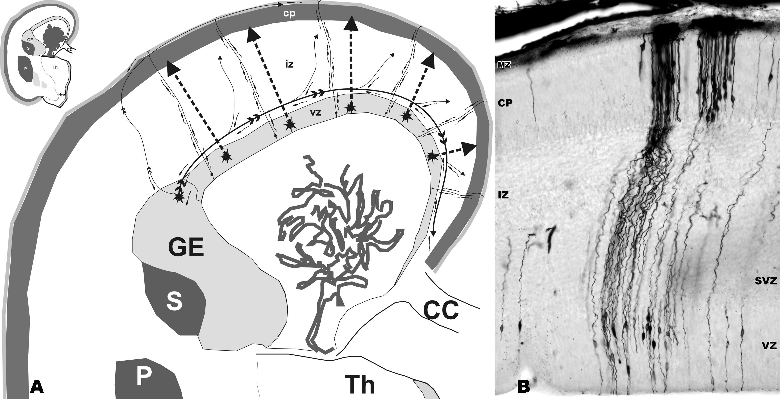

Figure 2. (A) Microphotography of a human telencephalic wall of a fetus in 10 pcw impregnated by Golgi method. Note bipolar radially oriented cells in the ventricular zone (vz) that begin the migration process, radial glia that extend processes from the pial to the ventricular surface (arrows) and immature prospective projection neurons in the cortical plate (cp), just finishing migration and starting with dendrite differentiation. (B) Schematic drawings of cellular events during the process of migration (for description see text). (C) Schematic drawings of the telencephalic wall and (D) enlargement of the superficial part including the cortex (layers I-VI) and underlying white matter (WM) show the consequences of disturbed migration: (a) abnormalities of proliferation and migration onset defect can result in periventricular heterotopia, (b) disturbances of ongoing migration can lead to subcortical heterotopia (“double” cortex), (c) abnormalities in migration stopping can be seen as heterotopic neurons in the marginal zone (mz), below the pia, or even breaking through. Here we show the situation where only fine structural disorganization (attenuated layers II and III) is present.
Slika 2. (A) Mikrofotografija stijenke telencefalona čovjekova fetusa u 10. tjednu gestacije impregnirana Golgi metodom. Obratite pozornost na bipolarne radijalno orijentirane stanice u ventrikularnoj zoni (vz) koje započinju s migracijom, radijalnu gliju koja svoje nastavke proteže od meningealne do ventrikularne površine (strjelice) i buduće projekcijske neurone u kortikalnoj zoni (cp), koji su tek započeli s dendritičkom diferencijacijom. (B) Shematizirani prikaz staničnih događanja tijekom procesa migracije (za opis vidi tekst). (C) Shematizirani prikaz stijenke telencefalona u cjelini i (D) povećan površinski dio koji uključuje koru (slojevi I.-VI., zasjenjeno) s pripadajućim dijelom bijele tvari (WM); prikazane su posljedice narušene migracije. Neispunjeni znakovi prikazuju normalno smještene neurone, a crno ispunjeni znakovi prikazuju neurone koji se nalaze u pogrješnom sloju. (a) Nepravilnosti proliferacije i započinjanja migracije koje mogu dovesti do periventrikularne heterotopije; (b) Nepravilnosti u tijeku migracije koje mogu dovesti do subkortikalne heterotopije (dvostruki korteks); (c) Nepravilnosti u stadiju zaustavljanja migracije mogu dovesti do heterotopije neurona u marginalnoj zoni. Ovdje je prikazan slučaj kod kojeg je došlo samo do fine strukturne dezorganizacije kore mozga (stanjeni slojevi II. i III.). U svim situacijama prikazanim ovdje poremećaj organizacije kore velikog mozga može biti u rasponu od vrlo blagih do oblika s potpunom laminarnom dezorganizacijom.

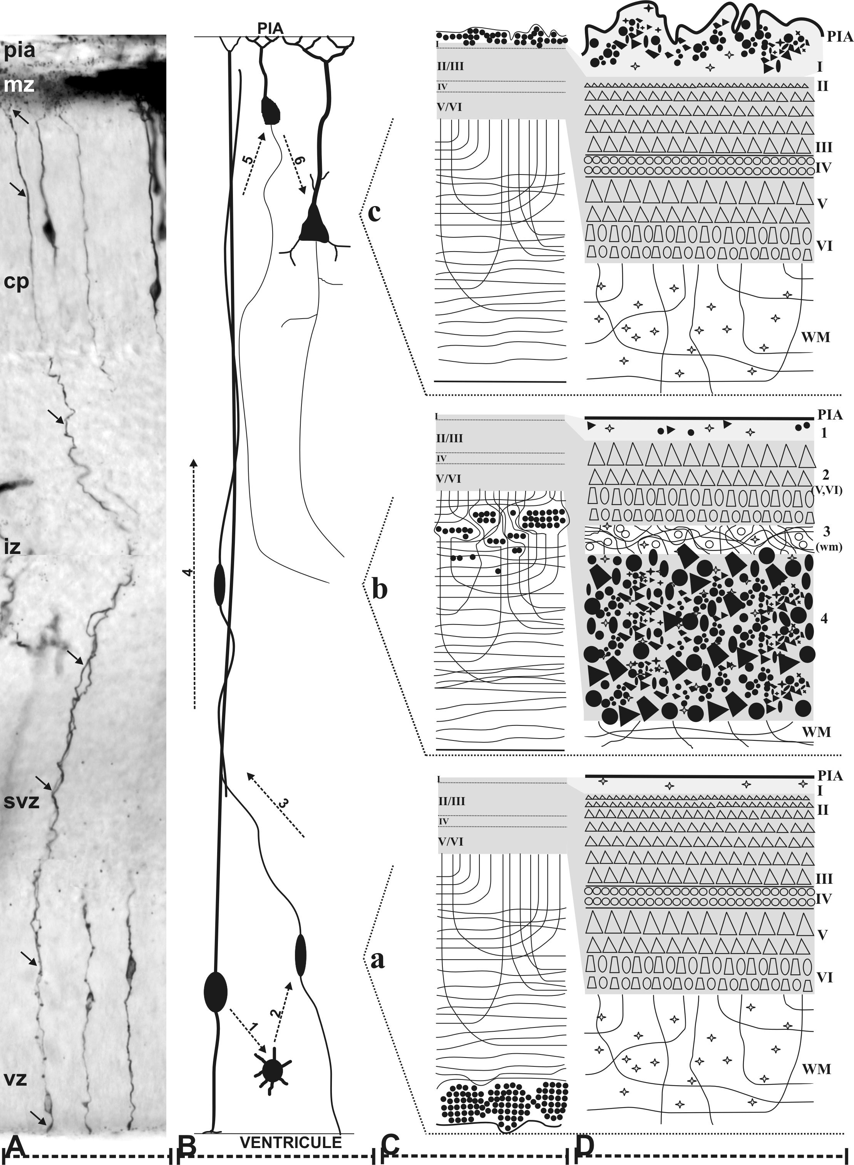

Figure 3. (A) In periventricular heterotopia abnormal nodules of heterotopic neurons (grey filled outlines) are observed lining the cerebral ventricles, with no other abnormalities in brain architecture. (B) In the subcortical laminar heterotopia a second band of grey matter (band heterotopia) is situated underneath the white matter (grey filled outlines). (C) In agyria (lissencephaly) the surface of the brain is completely smooth, the cortex is thickened and the ventricles are enlarged. (D) Diffuse polymicrogyria of the newborn human. (E) Focal polymicrogyria in the region of the cingular gyrus (asterix) as accidental finding during autopsy (CC - corpus callosum). (F) Normal human fetal brain (18 pcw) before gyrification, shown here to demonstrate gross morphology of telencephalon in lissencephaly.
Slika 3. (A) Kod periventrikularne heterotopije abnormalni čvorići heterotopnih neurona (iscrtano sivom bojom) okružuju moždane komore. (B) Kod subkortikalne laminarne heterotopije, sekundarni plašt sive tvari (”band” heterotopija) odvojen je s bijelom tvari od kore velikog mozga (iscrtano sivom bojom). (C) U agiriji (lizencefaliji) površina mozga potpuno je glatka, korteks je zadebljan i komore povećane. (D) Difuzna polimikrogirija kod novorođenčeta. (F) Fokalna polimikrogirija u području cingularne vijuge (zvjezdice) kao slučajan nalaz kod obdukcije (CC – corpus callosum). (F) Normalni fetalni mozak u 18. tjednu gestacije, prije razvoja vijuga, iskorišten je ovdje za prikaz vanjske morfologije telencefalona kod lizencefalije.

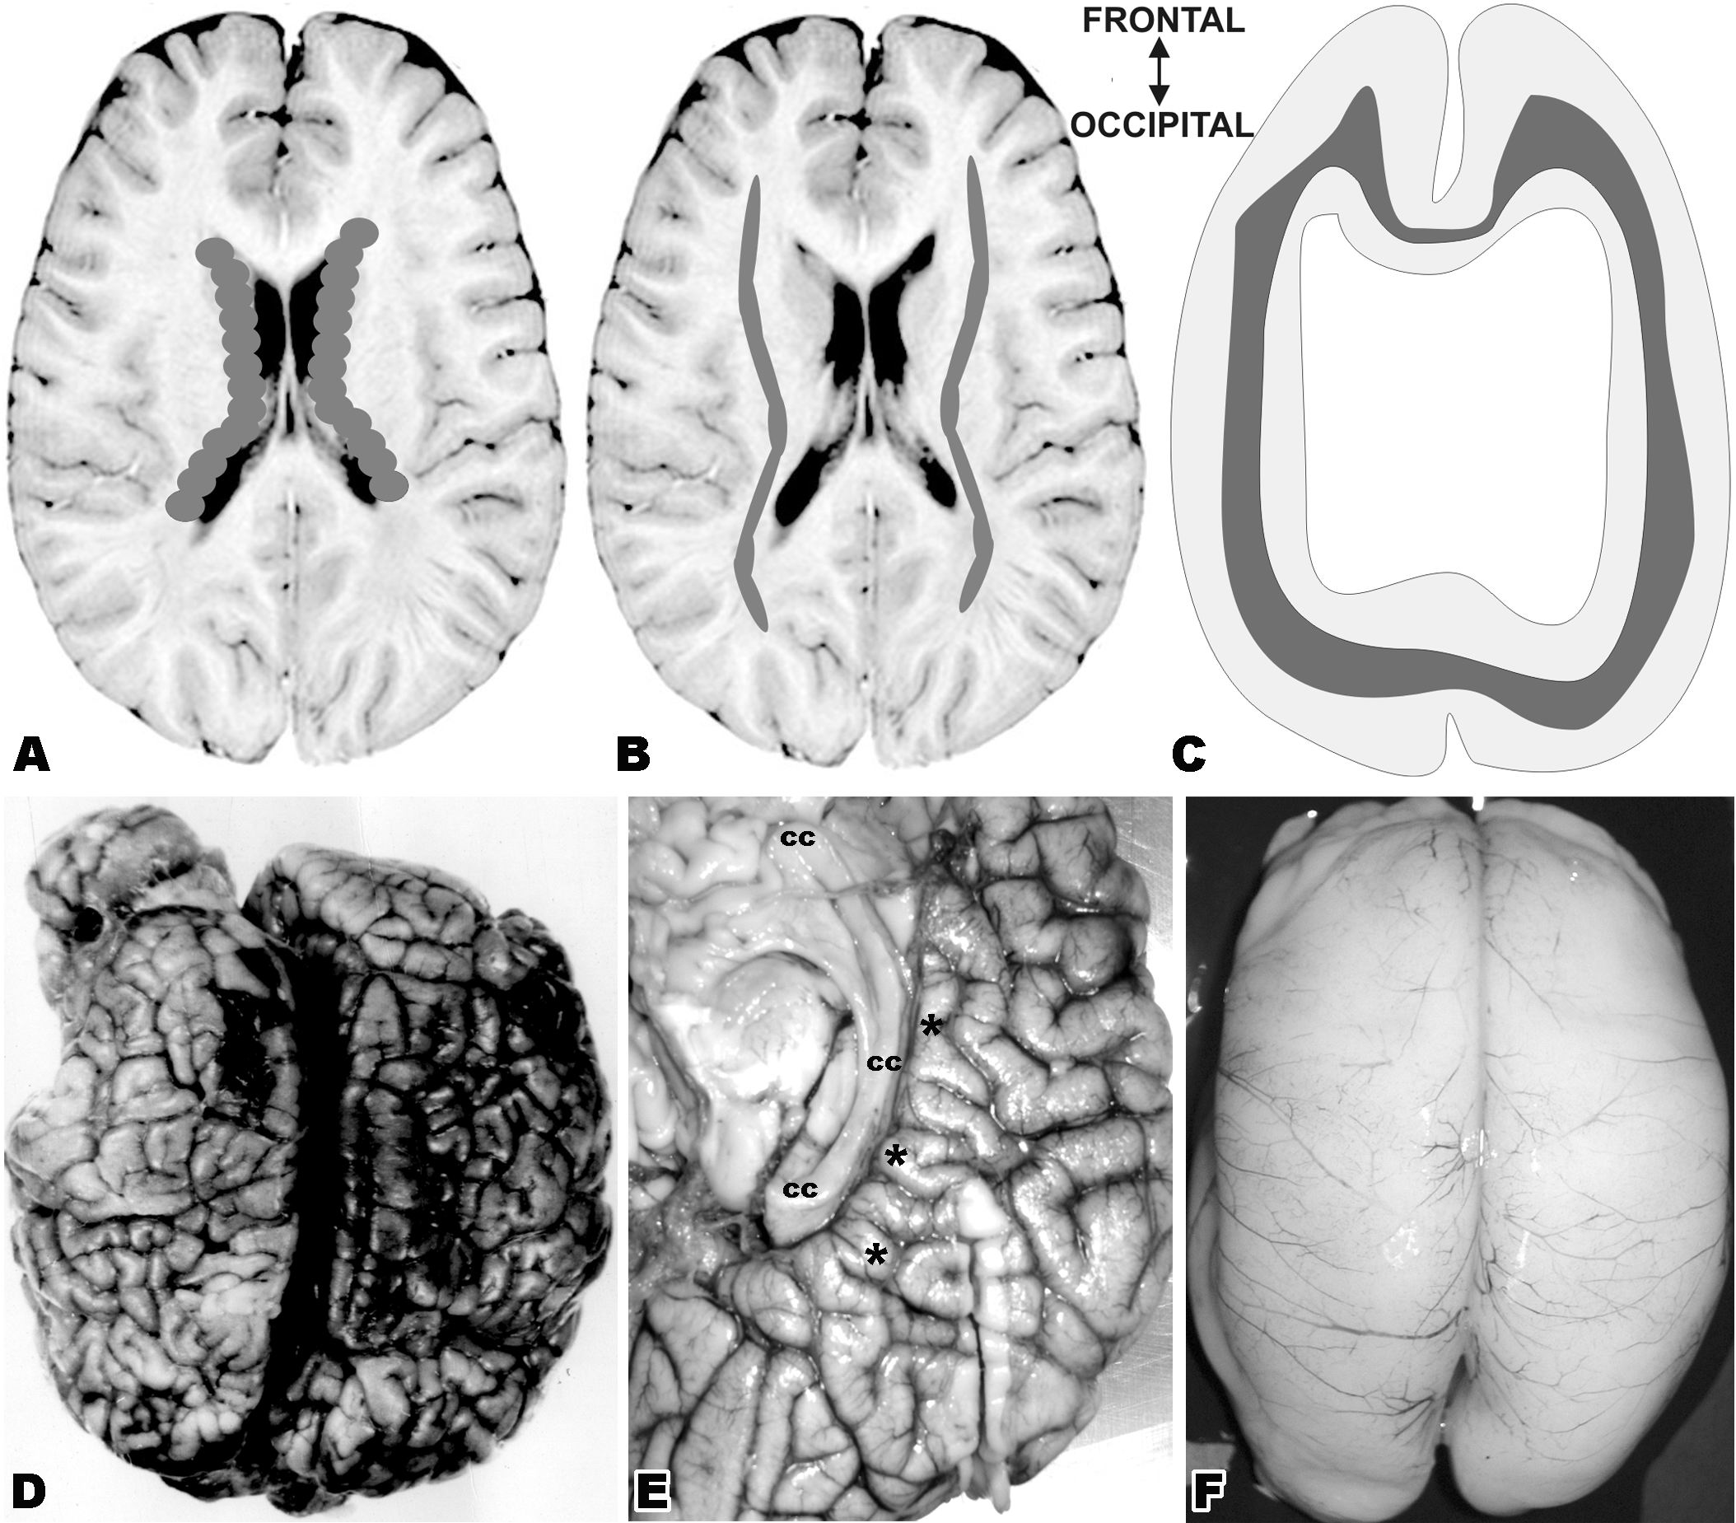

Table 1. Classification of neuronal migration disorders
Tablica 1. Klasifikacija poremećaja migracije

Disturbed phase of neuronal migration | Morphological  manifestation (examples) | MRI findings  and topology | Vulnerability window | Candidate gene and protein product | Neurological consequences & Clinical manifestation
Abnormalities of proliferation of neuronal and radial glia cells, (cell fate determination defect) | Schizencephaly-split brain  (uni- or bilateral clefts with e.g. thick microgyric cortex or pachygyria, large heterotopias, predominantly frontal areas) | -abnormal MRI intensities extend from ventricles to the cortex | -3 month of gestation | -Homeobox genes, EMX2 | -prominent cognitive disturbances  -frontal motor disturbances  -seizures
Defect of onset of migration | Bilateral periventricular (subependymal) nodular heterotopia (collections of neurons in white matter) | -collection of neurons that line the lateral ventricle | -not later than midgestation  (20 post-conceptual week) | -Xq28, FILAMIN1, (FLN1), actin-binding phosphoprotein | -average intelligence  -seizures as dominant clinical feature
Agyria-pachygyria-band spectrum disorders
Defect of ongoing migration (incomplete neuronal migration from ventricular neuroepitelium) | Classical lissencephaly (type I) -classical isolated lissencephaly sequence (ILS)  -brain smooth as in 12 post-conceptual week, poorly developed layers, but they are present, in addition to heterotopic layer.  Subcortical “band” neuronal hetrotopia (SBH) | -smooth cortical surface  -gray matter MR intensity in white matter  -predominance in posterior regions of cortex | -not later than 3-4 month of gestation | -17p13.3, gene LIS1, subunit of PAFAH1B1 and Xq22.3-23, gene DCX (XLIS), protein dublecortin  -associated with MAPs | -severe mental retardation, subtle facial deformation, epilepsy, other neurological abnormalities
 |  |  |  | -autosomal dominant deletion in 17p13.3 and a ring chromosome | -Miller-Dieker syndrome (MDS)  -severe lissencephaly with profound mental and physical disabilities, characteristic faces
 | Pachygyria similar features to isolated lissencephaly but less pronounced, presence of few unusually broad gyri, | -abnormally thick cortex,(morph-ometry may be required) | -not later than 3-4 month of gestation | -autosomal recessive inheritance | -similar to lissencephaly but less severe
Defect of ongoing neuronal migration (presumably disrupted interaction subplate and migrating neurons) | X-linked lissencephaly (XLIST)/Double cortex/ | -MR bands of gray matter outside of cortex  -predominance in frontal lobe | -not later than mid-gestation (20 post-conceptual week) | -locus Xq22.3-23, gene DCX (XLIS), protein dublecortin  associated with MAPs and 17p13.3, gene LIS1, subunit of PAFAH1B1 | -moderate mental retardation with epilepsy, often associated with Lennox-Gastaut syndrome  -paucity of movement, behavioral problems, epilepsy,  hypotonia to hypertonia
OTHER NEURONAL HETEROTOPIAS
Defect of ongoing neuronal migration | Other neuronal heterotopias (NH)  -isolated focal or diffuse NH |  |  | -autosomal recessive  inheritance  -in fetal alcohol syndrome | -moderate mental retardation with epilepsy, often associated with Lennox-Gastaut syndrome  -incidental autopsy findings
Premature arrest of migration | Unlayered “nonclassic” polymicrogyria with heterotopic neurons arranged in columns |  |  | -autosomal recessive mutation  -impairment of peroxisomal function | -characteristic for Zellweger syndrome
“COBBELSTONE” COMPLEX SYNDROMES
Defect of neuron migration stop signal | Lissencephaly type II Cobblestone complex  -clusters and circular arrays of neurons separated by glia and vascular elements without any lamination | -bends of large heterotopic clusters of neurons extending from pial surface | -no later than 3-4 month of gestation | -9q34.1, FKRP gene | -Walker-Warburg syndrome,  macrocephaly, retinal malformations, CMD
 |  |  |  | -1p32-34, POMT1 gene | -Muscle-eye-brain disease
 |  |  |  | -9q31, FCMD gene encodes ECM-fukutin) | -Fukuyama congenital muscular dystrophy (FCMD)
FOCAL CORTICAL DYSPLASIAS
Local disturbances of any phase of migration and cortical organization | Focal cortical dysplasia (FCD):  architectural dysplasias:  -Mild cortical dysplasia (MCD) (microscopic heterotopia)  -FCD 1A-isolated abnormalities-normal neurons | -difficult to see by MRI | -any time during migration from 8-26 post-conceptual week and even at later phases of cortical development (non genetic etiology) | -both genetic and non genetic etiology  -reduction in GABA-ergic interneuron density (altered  GABA_{A}-receptor mediated inhibition )  -reduction in GABA-transporter expression | -common cause of medically refractory epilepsy in children (intractable focal epilepsy, drug-resistant epilepsy)  -described also as neurological entity after lobectomy  - neurological symptoms usually begin in first few years  -may be associated with febrile seizures and status epilepticus
 | CYTOARCHITECTURAL dysplasias:  -FCD1B -altered laminations and giant neurons  -FCD2A -dysmorphic neurons  -FCD2B - Taylor type-balloon cells | -focal cortical thickening (morphometry required)  -blurring of gray-white matter junction
Disturbance of later phases of migration followed by cortical organizational events derangement | Other focal cerebrocortical disgenesis  a) “brain warts”, verrucose dysplasia  b) neuronal hetrotopia with astrocytes | “thick” cortical plate with neuronal heterotopias  “MRI-macrogyria” | -5 month of gestation and later | -autosomal recessive mutation  -encephalo-clastic process  -maldevelopmental varieties  -intoxication  -infections  -invasions, etc. | -seizures, hemiparesis, mental retardation to dyslexia, focal myoclonus, hemianopia etc.  -may cause drug resistant epilepsy
Probably post-migration defect | Polymicrogyria  -great number of small plication on the cortical surface, festoon like gyri or glandular formation  -Layered, “classic”, four layered cortex | -abnormal images restricted to the cortex | -5 month of gestation and later |  | -generalized weakness, severe hypotonia, severe recurrent seizures  -Zellweger cerebro-hepato-renal syndrome

