INTERACTIVE SCHEDULING SYSTEM

Peter Bubeník*, Dariusz Plinta**

Received: 6. 7. 2004. Preliminary communication
Accepted: 12. 7. 2005. UDC: 338.3

This paper deals with the discussion on the use of simulation techniques for work order scheduling on the factory floor level of production and contains a description of the program electronic planning board with simulation elements for Finite Capacity Scheduling. The ability to implement simulation effectively for factory scheduling is dependent upon the availability of shop floor data and the response time for the evaluation process.

1. INTRODUCTION

Shop floor scheduling is an important task in managing production systems. Complex decisions must be made which impact on global objectives such as meeting delivery due dates and minimizing the inventory of cost.

Attempting to consider all of the variables, which determine the effectiveness of a particular schedule is highly interrelated and has not been possible in most manufacturing operations.

In the case of manufacturing cost increases, there are major productivity improvements to be achieved by making the production scheduling for the process more effective.
The quality of a production schedule involves many, sometimes conflicting, objectives. While maximizing throughput is certainly an important consideration, an ideal schedule will also have the following characteristics:

- Delivery due dates are met.
- Inventory costs are maintained at acceptable levels.
- Equipment, personnel and other limited resources are well utilized and have balanced workloads.
- Adaptations can be made quickly in the event of an unexpected change (equipment failure, raw material shortage, etc.).

Production planning and scheduling play a key role in helping management achieve its goals in this ever changing and competitive environment. The primary objectives of production planning and scheduling in modern manufacturing environment are as follows:

- Producing what has been planned and promised on time.
- Minimizing the work in process.
- Minimizing the inventory of finished goods.
- Maximizing the utilization of capital assets and other resources.
- Increasing throughput by reducing time constraints.
- Minimizing the cost of production.

2. SCHEDULING TECHNIQUES

It is difficult to optimise a schedule over all these characteristics in practice. From most production schedules one is chosen for emphasis depending on current production objectives. Generally, a trade off must be made to reach a balance among the objectives. In practice, production scheduling is done in many ways.

The most common methods of scheduling are purely manual techniques. In the most straightforward form, the department foreman, or the machine operator, selects the job to run next from those jobs waiting in front of the machine. The criteria used in these circumstances often reflect the evaluation measures and may not reflect the overall business objectives. Job status control boards also use visual layout schedules.

A more analytical approach to scheduling is sequencing by dispatching rules. This method uses rules, which prioritise the jobs waiting for processing. The effectiveness of the schedule may vary widely depending on the particular rule selected, the type of production facility, and the mix of jobs to be produced. It is difficult to predict the performance of dispatching rules by traditional methods. They are also limited in scope as to what they consider and are often hard to implement on the shop floor.

Managers have historically disliked having to wait a long time for analysis. With the computing capabilities and graphics constructs that are now available, managers can not only get a quick response to the analysis of work order scheduling or work order release, but can also receive the information in an easily understandable form. Major advances in databases technologies have been made and the computer is now a common sight on the shop floor. These improvements make the access and manipulation of data for factory control a real possibility.

MRP II (Manufacturing Resource Planning) expanded the scope of MRP to consider many other facets of production facility management. In addition to sophisticated factory accounting capabilities, modules for capacity planning and shop floor data collection were also provided.

These techniques are effective for longer term scheduling and order launching, but lack the detail necessary for effective day-to-day production scheduling. ERP (Enterprise Resource Planning) has emerged as an extension of MRPII, with the ability to integrate a company’s manufacturing processes with financial transactions and FCS (Finite Capacity Scheduling).

Figure 1. ERP – Post MRP Finite Scheduling
3. WHAT IS FCS (FINITE CAPACITY SCHEDULING)?

Traditional MRPII assumes infinity capacity and simply gives notification when resources are over-utilized. Plans must then be manually balanced using feedback from the capacity planning function.

FCS technology on the other hand provides true constrained privatisation for master planning. This means that schedules recommended by FCS optimise the finite available of capacity (Figure 2).

The FCS software is a powerful suite of programs that apply these principles to any manufacturing business. FCS identifies the critical and non-critical resources for optimised scheduling. FCS provides the optimised pacing of production by finitely forward-scheduling the critical resources according to the OPT (Optimalization Production Technology) principles and the management prioritisation policy.

FCS synchronies view production by backward scheduling the non-constraining parts of the manufacturing environment. It ensures the release of materials to the floor at the proper time to meet the needs of the schedule for critical constraining areas while maintaining a lean inventory.

Figure 2. The FCP Planning Process

By implementing the FCS system in plants, the following quantifiable real benefits could be achieved:

Table 1. Potential benefits of Finite Capacity Scheduling (FCS)

Benefit | Improvement potential
Delivery performance | 10-20 %
Work in process reduction | 20-25 %
Setup time reduction | Up to 50 %
Machine utilization | 15-25 %
Reduction in idleness | 15-20 %
Maintenance crew utilization | 10-15 %

4. DESIGN AND WORKING WITH THE SCHEDULING SYSTEM

In the demand division Dopravné pásy, MATADOR, a.s. has designed electronic planning board “PlanDP”. Data of order (customer, order number, batch size, due date) are downloaded from the MRPII system into PlanDP and all the information on product operations (processing times, set-up time) are held in the Plan DP database.

Figure 3. Production Planning Process

The production planning process has two layers (Figure 3). The top layer represents long-range scheduling or traditional production planning and control. At this layer, forecasters estimate the capacity and resources needs based on estimated sales or orders for relatively large time frame (information loaded from the MRP II system).
The second layer represents detailed or operational scheduling. Here the time frame is in the order of hours to several days and hours. Exact sequencing is determined for each machine. The scheduler concentrates most of his/her effort on this layer.

PlanDP can be used as a graphical MPS (Master Production Schedule) where orders are loaded with product information to PlanDP, which provides a finite schedule. This step is performed repeatedly until the schedule meets a prescription objective. These objectives may be handed down from management, such as minimizing production costs and short lead times.

The heart and soul of design of FCS is the sequencer. The sequencer is essentially an electronic planning board where resources and the operations scheduled for processing on each resource are displayed.

At the bottom half of the screen, the sequence overview displays each resource and the operations scheduled on them in an easy-to-read Gant format. Above the sequence overview individual resource windows with colourful icons are used to represent the loaded operations.

Sequencer process (Figure 4):
- System loading orders with the product information (number of orders, quantity, bill of materials, due date, technologies).
- System sequencing orders according to type of production technologies, due date.
- Making batches from orders by minimizing the amount of set up time.
- Forwarding jobs and all batches on time line for each machine, when the machine is not busy, jobs waiting.
- System analysing objectives (meeting due date, minimum amount of set up time, work in process, lead time).
- If a schedule does not meet a prescription objective, it is possible to unload jobs and change a sequence; operators change batches, variants of technologies and enter actual operation times.
- When a schedule is ready to be released, FCS offers the basic alternatives of the printed reports available.
- New orders added, back to step 1.

Figure 4. Model PLANDP

The system has been written in the Visual Basic Application for MS Excel environment (Figure 5). The planning board has three sections.

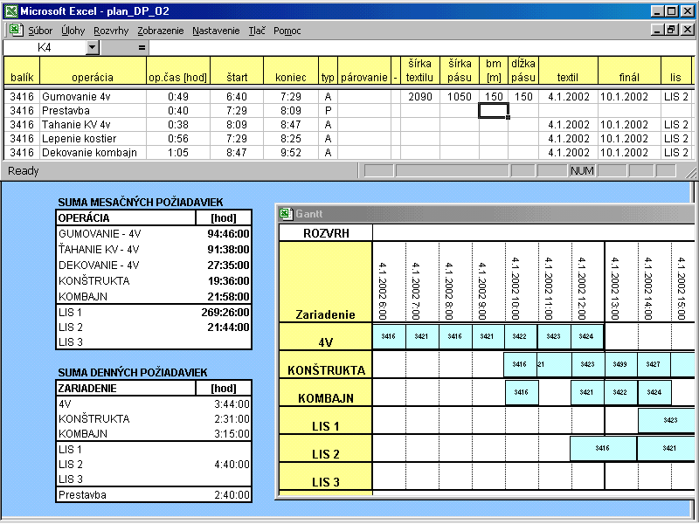

Figure 5. Planning board PLAN DP
On the top is detailed operational scheduling. Here the number of order, name of machine, name of operation, start time and end time of each operation can be found. On the left half of the screen, the Master Production Schedule displays each resource monthly. On the right half of the screen, the sequence overview displays each resource on the Gant chart format.

The electronic planning board enables a feasible schedule to be made the existing schedule to be revised by the basic scheduling rules of LIFO (Last-In-First-Out), FIFO (First-In-First-Out). The dispatcher using simulations looks for the best production schedule in the real manufacturing process.

5. CONCLUSION

The interactive scheduling systems, which have been presented to generate a feasible schedule and to revise the existing schedule, enable a schedule to very quickly identify the critical and non-critical resources.

The Dispatcher has the interactive tools for effective and timely planning of changes on the shop floor. The effectiveness of the proposed concept has been tested in the real manufacturing process.

Manufacturing has undergone a significant change over the last decade and will continue to change in the foreseeable future. Some of the changes are as follows:
- System reduces the number of delay orders and shortens lead-time by a better mix of orders.
- Many variants of sequencing allow due dates to be met
- Lead times are minimized by decreasing the amount of set up time.
- Demands to deliver just in time minimize the work in process and reduce costs.

With the implementation of PLAN DP the following results were reached:
Table 2. Results achieved by the use of PLAN DP

Results | Original stage | New stage
Shortening of time on arbitration of shop plan by production | Calculation of abusive capacities was inexact and longwinded | Calculation of capacities is possible every time
Reducing the rate of default supplies | Breach of delivery schedules | Reducing the rate of default supplies
Early planning of preparation inputs to producing | Lag of orders on the score of missing inputs | Preplanned inputs according to schedule of delivery order to customer
Actual recovery of line | By estimation | Real number
Fast creation of daily production plan for production lines | MRP II did not provide, daily plan, was arbitrary realized by planner | Creation of daily plan according to need also in case of any change in production

REFERENCES

- Basl J.: Podnikové informačné systémy, Grada, 2002,
- Bubeník, P.: Finálne kapacitné plánovanie výroby v podmienkach zákazkovej výroby Dopravné pásy MATADOR, a.s., Produktivita 3/2002,
- Grant, H.: Production scheduling using simulation technology, Factor Inc., USA.
- Gregor, M. - Košturiak, J. - Mičieta, B. - Bubeník, P. - Ružička, J.: Dynamické plánovanie výroby, EDIS, Žilina, 2000, ISBN 80-7100-607-6.
- Krišťák, J. - Košturiak, J. - Varady, M.: Theory of Constraints – Teória obmedzení. 1.vyd. Jozef Blaha Žilina 1999,
- Plinta D.: Modelling and Simulation of Production Process in Condition of Group Working Machine Elements; Industrial Engineering and Increasing of Productivity, 11-12.11.1999 Belušské Slatiny, Słovakia 1999.
- Ulrych, Z. – Horváth, G. - Votava, V.: Využití simulace v podnikové logistice, 33rd Spring International Conference - Modelling and Simulation of Systems MOSIS99, Rožnov pod Radhoštěm, April 27 - 29, 1999.
- Ulrych Z.; Votava V.: Využití simulace pro ověřování průchodnosti zakázek výrobou, 6. ročník mezinárodního semináře MOPP 2003, ZČU Plzeň, 1/2003.

INTERAKTIVNI SUSTAV ZA ODREĐIVANJE RASPOREDA PROIZVODNJE

Sažetak

U ovom se radu analizira uporaba simulacijskih tehnika za određivanje rasporeda radnih aktivnosti na razini proizvodnog pogona. Pritom se opisuje programsko rješenje elektroničkog sustava za planiranje, sa simulacijskim elementima određivanja konačnog rasporeda korištenja kapaciteta. Utvrđuje se da učinkovito korištenje simulacije za određivanje rasporeda proizvodnje ovisi o dostupnosti podataka iz same proizvodnje, te vremenu potrebnom za provedbu procesa evaluacije.

* Peter Bubeník, PhD, Department of Industrial Engineering, Žilina University , Moyzesova 20, 010 01 Žilina, Slovak Republic, Phone: +421 41 513 2719, Fax: +421 41 513 1501, E-mail: bubenik@kpi.utc.sk
** Dariusz Plinta, PhD, Bielsko-Biala University, Department of Industrial Engineering, 2 Willowa Street, 43-309 Bielsko-Biała, Poland, E-mail: dplinta@ath.bielsko.pl

