Paediatr Croat 2008;52 KLINIČKA ZAPAŽANJA
CLINICAL OBSERVATIONS

STRUČNI ČLANAK PROFESSIONAL PAPER

UDK 616-036.1

CHRONIC DISEASES IN CHILDREN AND ADOLESCENTS – SOME PSYCHOLOGICAL CHARACTERISTICS

NADA POP-JORDANOVA, STOJKA FUSTIĆ, TATJANA ZORCEC*

* Pediatric Clinic, Faculty of Medicine, Skopje

Adresa za dopisivanje:
Prof. dr. sc. Nada Pop-Jordanova
Pediatric Clinic, Faculty of Medicine, Skopje
Tel: ++389 2 3147497
E-mail: npopjordanova@yahoo.co.uk

N. Pop-Jordanova, S. Fustic, T. Zorcec. Chronic diseases in children and adolescents - some psychological characteristics. Paediatr Croat 2008;52:

A significant number of children suffer from chronic diseases, which demand careful adjustment, and the coping and active role of all involved in the treatment. Psychological problems in this population are increased by the long duration of procedures, specific diet and low physical activity. In this study various psychometric instruments are used to evaluate the psychological characteristics of children and adolescents suffering from cystic fibrosis, juvenile rheumatoid arthritis, diabetes mellitus and cancer.
The obtained results are compared between groups as well as with a control. Children with cystic fibrosis and neuroticism appeared to be more aggressive, while those with juvenile rheumatoid arthritis and cancer more anxious and depressed in comparison with the control. The personality profiles in adolescents with cystic fibrosis and cancer is similar, showing Hs-D-Hy peaks. Manifest depression is found only in the group with cancer and occasionally in cystic fibrosis. The profiles for diabetics showed emotional instability as well as some psychopathological traits.
Generally, psychological functioning in all children is not so impaired. Multidisciplinary teamwork is needed to overcome the psychological problems that occur as well as to ensure good quality of life.

Descriptors: CHRONIC DISEASE - psychology; ADAPTATION, PSYCHOLOGICAL; CHILD PSYCHOLOGY

INTRODUCTION

The common opinion is that long-lasting illnesses and chronic diseases are associated with older people and not with children. However, a significant number (7.5-10%) of children actually suffer from chronic diseases (1).
There are many different types of chronic diseases. Some are present at birth, while others may develop at a later stage during infancy or childhood. While some children with chronic diseases may grow out of them later in life, most will not be able to lead normal lives in the absence of special care.
O ’ H a l l o r a n (2) used a set of criteria to define chronic conditions. He states that chronic conditions may:
- have a duration at least 6 months
- have a pattern of recurrence or deterioration
- have a poor prognosis
- produce consequences or sequels that impact on the individual’s quality of life.
In our country the main chronic diseases among children and adolescents are asthma, diabetes, cancer, cystic fibrosis and epilepsy. The exact incidence data are not yet available.
Chronic diseases in childhood are significant for several reasons: they threaten the child’s normal development, care can be extremely complex and require a combination of medical and other services, and finally, care is very costly over a long period of time. Consequently, the socioeconomic status of the family can influence the outcome of a chronic childhood illness. It is important that inadequately managed chronic disease can seriously affect the social, psychological and physical development of children. It is suggested that some children and adolescents with chronic conditions have higher risk for psychopathology than their healthy counterparts as well as an increased rate of emotional distress and maladjustment (3).
Although, many children in general are well adjusted psychosocially in peer relationships (4), a chronic disease is a stressor to which children and families must adapt. Anxiety often leads to a maladaptive pattern of parent-child interaction and child behavior problems, known as “vulnerable child syndrome”.
Conflicting results are obtained concerning the impact of a chronic disease on the behavior of children. One group of studies shows that chronically ill children are more at risk for psychiatric problems, social isolation and school problems than healthy children. On the other hand, other clinical studies show no differences, or even superior functioning in ill children compared with healthy ones. This conflicting outcome can be explained by the use of different assessment methods, as well as in the sources of information: the child, the parents or other observers.
School presents particular challenges both physically and socially. The physical environment may contribute to exacerbation of the chronic condition (dust, pollution, unfilled gas) and higher absenteeism. The social environment may include verbal abuse, less peer support, teacher’s insufficient knowledge for support, leading to lower academic achievement in chronically ill children.
In our previous studies we showed an alexithymia construct in adult patients with cancer, as well as some psychological characteristics in children with cystic fibrosis (5, 6).
The aim of this study was to evaluate the psychological characteristics of children and adolescents with different chronic illness (cystic fibrosis, juvenile rheumatoid arthritis, diabetes and cancer).

METHODS

The examined groups comprise: a) adolescents with cystic fibrosis (N = 25 mean age = 17.5 ± 2.6 years); b) with cancer (N=20, mean age=19.5±1.3 years) c) children with juvenile rheumatoid arthritis-JRA (N=15, mean age 8.5±0.56 years) and d) children with diabetes mellitus (N=9, mean age=12.5±1.5 years).
The diagnosis was done at least one year before the psychological assessment. The evaluation was performed when children were in the period of improved health condition, without severe pain, superinfection or metabolic imbalance.
We applied interviews for mothers and children, Child Behavior Checklist (CBCL) for children below 12 years, General Anxiety Scale (GAS), Eysenck Personality Questionnaire (EPQ) for children over 10 years, for adolescents and parents Minnesota Multiphase Personality Inventory (MMPI), Emotional Profile Index (PIE) as well as Beck Depression Questionnaire (BD) and Human Value Rank (HVR) (7-13).
The results obtained for EPQ and CBCL are compared with a control group (25 healthy children, mean age 12.5±0.98 years) as well as with patients diagnosed with neuroticism (N=25, mean age l2.8±1.5 years).

RESULTS

CBCL obtained from mothers showed a pretty “normal” profile for all ill children. On the Figure1 the CBCL results for ill boys are presented. Three aspects of behavioral problems are more expressed, aggression, moderate depression and hyperactivity, but still within normal T-scores (below 65 percentile).
On table1 the EPQ results obtained for different chronic conditions compared with the control are shown. As can be seen the statistical significance is obtained only in P scores for diabetic and neurotic children, as well as for N scores for diabetic and JRA children. In other words, ill children showed lower P scores in comparison with healthy children at the same age. For the neurotic traits, all chronically ill children showed lower scores than the control, except the group of “neurotic” patients, which presented higher N scores. The statistical evaluation used was t-test.
Results obtained for General Anxiety Scale (GAS) showed those children with JRA are more anxious than others, except the neurotic patients (Figure 2). The high anxiety can be related to the pain in JRA children and the reduction of movement in everyday life. From the Manual, accentuated anxiety is estimated if the score is over 15.
The MMPI is applied for adolescents (over 14 years,) with chronic diseases. In figure 3 the MMPI obtained for CF males and females are presented. The adolescents with cystic fibrosis showed a so called “neurotic” profile (Hs-D-Hy). The Hy- peak is more accentuated in girls. It is very important that the score for depression is not so high in both girls and boys. The group’s score obtained on BDI is 12.5 (below cutoff for manifested depression).
On figure 4 the MMPI obtained for parents of children with JRA is compared. This chronic disease is related with chronic pain in the joints, so the parents have to cope with this problem. Fathers showed a L-Hy-Pt profile, where Pt scores are higher than the Hy score, which corresponds to accentuated psychopathic traits. For mothers the obtained profile is under the T-scores but the Pt score is also the highest.
The MMPI obtained for adolescents with malignancies (leukemia, solid tumors, and lymphomas) is presented on Figure 5. Both, girls and boys showed a Hs-D-Hy profile, which corresponds to hypersensitivity and high neurotic tendencies, combined with depression. This profile correlates with the destabilization of the autonomic nervous system.
The Beck depression inventory (BDI) was also applied for cancer patients. The group’s results showed total scores of 14.66, which are under the cutoff for depression. However, in 8 patients the score on BDI was over 19 which corresponds to manifest depression.

On figure 6 the profiles for mothers and diabetic girls are shown. Apart from the high L-score, the profile for mothers is in the normal range. For diabetic girls peaks on Pd-Pa-Sc are present which correspond to emotional instability as well as possible psychopathic traits.
Results obtained for Emotional Profile Index (EPI) are compared between adolescents with CF and JRA (Figure 7). Both groups showed very similar emotional profiles, with accentuated impulsivity and depression. The fear is most accentuated in JRA adolescents in contrast to exploration. It can be related to chronic pain and insecurity about the future as well as with inappropriate movements.
It was also interesting to compare Human Values Rank obtained for different chronic conditions. As follows, figure 8 shows HVR concerning CF and diabetic adolescents.
For CF children health is the most important value, followed by love, friendship and the rest. It corresponds to the actual state of those patients. In the diabetic group the more important values are religion and friendship followed by money and happiness.

DISCUSSION AND CONCLUSION

Chronic illness presents different challenges at different life stages. In early childhood, illness is interpreted differently by the child from illness that appears during adolescence. Fantasies of abandonment, separation and fears about the various procedures that the child cannot understand are common in young children. For the adolescent, the impairment evokes concern about the future, perception of family life, body image and dependency on parents. The personality of the child prior to illness and the family relationship has a significant impact upon adjustment. The child with separation problems frequently manifests difficulties in coping with hospitalization, when a phobic child develops excessive fear of minor procedures. On the other hand, an adolescent who fights authority may see chronic illness as an opportunity to fight.
Depression could be a frequent and significant complication of chronic illness. Depression in children and adolescents is associated with significant impairment in social and family relationships as well as increased risk of suicide. It appears that the specific characteristics of the illness are important in determining if an ill child will develop psychological symptoms, but it is not clear which characteristics of the illness are most influential. One of the few consistent findings is that children with a brain-related illness have more psychological or behavioral disorders than children with other illnesses.
We have some adolescents with accentuated depression but with our support and medication we have solved the problem. For the diabetic group we found some psychopathic traits in the personality profiles.
In the case of pediatric patients, the researchers reported depression in 7% of the acute inpatients, in 23% of patients with orthopedic problems, in 13% of cardiological patients, 15% of the asthmatics and in 17% in cancer. The prevalence of depression in cystic fibrosis (CF) is 11.5%, in diabetes 5% and 20-25% in inflammatory bowel disease (14-17). In this context insecure attachment and impaired ability to regulate the affect during a child’s early years is identified as a key link to depression. Attachment difficulties lead to negative self-schemata, negative affects and impaired ability to regulate affects, putting the individual at risk for depression in the presence of environmental stressors (18).
Concerning the illness as a stressor that precipitates depression, the parameters such as the severity of illness, course and medication are very important.
C o r b o z e t a l. (19) showed a connection between the severity of the illness and the degree of the psycho-reactive disturbance in children with CF. Most CF children suffered from neurotic or psychosomatic symptoms. In our study the obtained results correspond to accentuated anxiety and oppositional behavior.
On the other hand some authors (20-26) have found that children and adolescents with chronic conditions are not at higher risk for psychopathology than their healthy counterparts, although they may be more vulnerable. Similarly, chronically ill children and adolescents in our study did not differ too much more than healthy children of the same age. S t u b e r (27) showed the parents of seriously ill children to be more severely affected than children, possibly because they had a better appreciation at the time of the true danger posed by the illness and the treatment. Similar results are presented in the study of A s h k a n i (28). In our study some of the parents showed psychopathic traits, the others depressive reactions, but generally we obtained very close collaboration concerning the treatment procedures as well as the attitude toward the mental health of children.
In a UK study (29) adolescents with cancer were no more anxious or depressed than the control adolescent population. Nevertheless, a substantial minority of patients and controls had elevated anxiety or depression scores. In the same example, mothers were the most anxious family members. Based on the psychometric results obtained we agree with these findings.
The meta-analytic Review (30) concerned the problems of youths with arthritis showed the increased risk for overall adjustment problems and internalizing symptoms but not for externalizing symptoms or poor self-concept. H u y g e n e t a l (3) reported that self-esteem, perceived competence and body image in patients with JRA were as positive as they were in healthy participants. There were no differences between ill and healthy youngsters with respect to the incidence of psychopathology. In our study JRA children were below adolescence, so they did not manifest serious psychological problems. In contrast to the children, both parents, especially fathers showed accentuated psychopathological traits on MMPI.
We can conclude generally that children and adolescents with chronic illness in our study appeared to be well adjusted to the diseases and did not manifest major mental problems. In very rare cases some depressive reaction, opposite behavior and aggression were noticed.
The impact of a chronic disease on children and families is related less to the specific diagnosis than to disability profile and family functioning. Prognosis, predictability, the threat to life or to cognitive, social and physical development, the fears from medical and surgical interventions and the functional limitations have a major impact.
One positive approach to chronic illness is to consider the factors that enable most children and families to cope as well as they can. Warning signs of distress in children include problems at school or in social relationships, low self-esteem, helplessness/hopeless and denial, as well as a poor compliance with treatment. Most frequent psychological problems appeared to be anxiety, depression, oppositional behavior and aggression.
Interventions, which are beneficial, include family therapy, supportive counseling or biofeedback modalities. Our experience with peripheral and central biofeedback treatment is very encouraging (31, 32). Multidisciplinary teamwork can improve the care, quality of life and prognosis for both children and their families.

REFERENCES

1. Isaacs D, Sewell J. Children with chronic conditions. MJA 2003;179(5):235-6.
2. AIHW: Britt H, Miller C, Knox S, Charles J, Valenti L, Pan Y, Henderson J, Bayram C, O’Halloran J, Ng A 2004. General practice activity in Australia 2003-2004.
3. Huygen ACJ, Kuis W, Sinnema G, Psychological, behavioral, and social adjustment in children and adolescents with juvenile chronic arthritis. Ann Rheum Dis 2000;59:276-82.
4. LeBovidge JS, Lavigne JV, Miller ML. Adjustment to chronic arthritis of childhood: the roles of illness-related stress and attitude toward illness. J Pediatr Psychol 2005;30(3):273-86
5. Pop-Jordanova N, Alexithymia and cancer. Jpn J Psychosom Med 1997;37:585-8.
6. Pop-Jordanova N, Fustic S, Zorcec T, Psychological aspects of cystic fibrosis in children. Paediatr Croat 2001;45:111-5.
7. Achenbach TM. Manual for the child behavior checklist (4-18) and 1991 Profile, Burlington, VT: University of Vermont, Department of Psychiatry, 1991.
8. Eysenck HJ, Eysenck SBJ. Manual of the Eysenck personality questionnaire, London, Holder and Stroughton, 1975.
9 Miklos Biro, Praktikum za primenu i interpretaciju MMPI, Savez drustava psihologa Srbije, Beograd, 1981.
10. Baskovac-Milinkovic A., Bele-Potocnik Z, PIE, Profil indeks emocija, Manual, Ljubljana, Zavod za produktivnost dela, Centar za psihodijagnosticka sredstva, 1983.
11. Beck A., Steer RA. The Beck depression inventory manual, San Antonio. Psychological Corp., 1987.
12. Sarason IG, Johnson JH, Siegel JM. Assessing the impact of life changes: development of the life experiences survey. J Consult Clin Psychol 1978;46:932-46.
13. Pogacnik VLV. Human values test. Manual, Ljubljana, Zavod za produktivnost dela, Centar za psihodijagnosticka sredstva, 1988.
14. Kashani JH, Hakami M, Depression in children and adolescents with malignancy. Can J Psychiatry 1982;27:474-7.
15. Kashani JH, Lababidi Z, Jones RS, Depression in children and adolescents with cardiovascular symptomatology: the significance of chest pain. J Am Acad Child Adolesc Psychiatry 1982;21:187-9.
16. Kashani JH, Barbero GJ, Bolander FD. Depression in hospitalized pediatric patients. J Am Acad Child Adolesc Psychiatry 1981;20:123-34.
17. Kashani JH, Venzke R, Millar EA. Depression in children admitted to hospital for orthopedic procedures. Br J Psychiatry 1981;138:21-5.
18. Huygen ACJ, Kuis W, Sinnema G, Psychological, behavioral, and social adjustment in children and adolescents with juvenile chronic arthritis. Ann Rheum Dis 2000;59:276-82.
19. Corboz R, Schenker R, Bachmann P, Psychology, psychopathology and social problems of children with cystic fibrosis. Helv Paediatr Acta 1980;35(5):477-88.
20. Orr DP, Weller SC, Satterwhite B et al. Psychosocial implications of chronic illness in adolescence. J Pediatr 1984;104:152-7.
21. Wasserman AL, Thompson EI, William JA et al. The psychological status of survivors of childhood/adolescent Hodgkin’s disease. AJDC 1987;141:626-31.
22. Cappelli M, McGrath PJ, Heick CE et al. Chronic disease and its impact: the adolescent’s perspective. J Adolesc Health Care 1989;10: 283-8.
23. Kellerman L, Zeltzer L, Ellenberg L et al. Psychological effects of illness in adolescence. I: Anxiety, self-esteem, and perception of control, J Pediatr 1980;97:126-31.
24. Zeltzer L, Kellerman J, Ellenberg L et al. Psychological effects of illness in adolescence. II. Impact of illness in adolescents-crucial issues and coping styles. J Pediatr 1980;97:132-8.
25. Antony KK, Gil KM, Schanberg LE. Brief Report: parental perceptions of child vulnerability in children with chronic illness. Journal of Pediatric Psychology, 2003,28:185-90.
26. Allen R, Newman SP, Souhami RL, Anxiety and depression in adolescent cancer: findings in patients and parents at the time of diagnosis. European Journal of Cancer 1997;33:1250-5.
27. Stuber ML, Psychiatric sequelae in seriously ill children and their families. Psychiatr Clin North Am, 1996;19:481-93.
28. Ashkani H, Dehbozorgi R, Tahamtan A, Depression among parents of children with chronic and disabling disease, IJMS, 2004;29:90-3.
29. Isaacs D and Sewell JR, Children with chronic conditions. MJA, 2003:179:235-6.
30. LeBovidge JS, Lavigne JV, Donenberg GR, Miller ML, Psychological adjustment of children and adolescents with chronic arthritis: a meta-analytic review, Journal of Pediatric Psychology, 2003;28:29-30.
31. Pop-Jordanova N, Biofeedback, Kultura, 2008.
32. Pop-Jordanova N, Biofeedback modalities for children and adolescents, Chapter V. In: New Research on Biofeedback. Nova Biomedical Books, New York 2007.

S a ž e t a k

KRONIČNE BOLESTI U DJECE I ADOLESCENATA – NEKE PSIHOLOŠKE KARAKTERISTIKE

N. Pop-Jordanova, S. Fustić, T. Zorcec

Broj kroničnih oboljenja u djece prilično je velik, i to zahtijeva aktivnu ulogu i prilagodbu svih uključenih u tijeku liječenja. Dugotrajnost procedura, specifične dijete i fizička aktivnost povećavaju psihološke probleme te populacije. U ovoj studiji služili smo se različitim psihometrijskim instrumentima radi evaluacije psiholočkih karakteristika djece i adolescenata koji obolijevaju od cistične fibroze, juvenilnog reumatoidnog artritisa, dijabetesa mellitusa i raka.
Dobiveni rezultati su uspoređivani međusobno kao i s kontrolnom skupinom. Djeca sa cističnom fibrozom i ona s neurotičnim manifestacijama su agresivnija, dok su djeca s juvenilnim reumatoidnim artritisom i rakom anksioznija i depresivnija od kontrolne skupine. Profili osobnosti u adolescenata sa cističnom fibrozom i rakom imaju slične karakteristike, pokazujući Hs-D-Hy pikove. Manifestna depresija je nađena samo u skupini s rakom i rjeđe kod djece sa cističnom fibrozom. Profili dijabetičara pokazuju emocionalnu nestabilnost kao i neke psihopatološke crte.
Općenito uzevši, psihološko funkcioniranje bolesne djece nije mnogo poremećeno. Multidisciplinarni timski rad je nužan, da bi se prebrodili određeni psihološki problemi i da bi se osigurala dobra kakvoća života.

Deskriptori: KRONIČNA BOLEST - psihologija; PSIHOLOŠKA ADAPTACIJA; DJEČJA PSIHOLOGIJA

Primljeno/Recieved: 12. 12. 2007.
Prihvaćeno/Accepted: 23. 6. 2008.

Figure 1: CBCL obtained for different diseases
Slika 1: Rezultati CBCL-a dobiveni kod različitih skupina bolesnika

Table I: EPQ obtained for chronically ill children
Tablica I: EPQ rezultati kod kronično bolesne djece

Condition/Stanje | P | E | N | L
Control/Kontrola | 11.87±6.23 | 13.16±5.75 | 13.84±5.31 | 12.64±4.62
CF/CF | 6.67±2.9 | 15.91±2.54 | 11.67±4.23 | 15±3.81
JRA/JRA | 9.6±2.8 | 11.9±3.3 | 10.8±3.1* | 14.5±3.9
Diabetes/Dijabetes | 7.5±1.5** | 15.5±4.5 | 8±2** | 12±5
Neuroticism/Neuroticizam | 5.16±3.1** | 14.16±1.7 | 16±3.6 | 12.6±4.1

* p< 0.05
** p< 0.01
P- psychopathological traits/psihopatološke crte, E- extraversion/ekstraverzija, N- neurotic tendencies/neurotične tendencije, L-lie scale/skala laganja, CF-cystic fibrosis/cistična fibroza, JRA-juvenile rheumatoid arthritis/juvenilni reumatoidni artritis

Figure 2: Results for General Anxiety Scale
Slika 2: Rezultati za opću skalu anksioznosti

CF-cystic fibrosis/cistična fibroza, JRA-juvenile rheumatoid arthritis/juvenilni reumatoidni artritis

Figure 3: MMPI for girls and boys with CF
Slika 3: MMPI profili za djevojčice i dječake sa CF-om

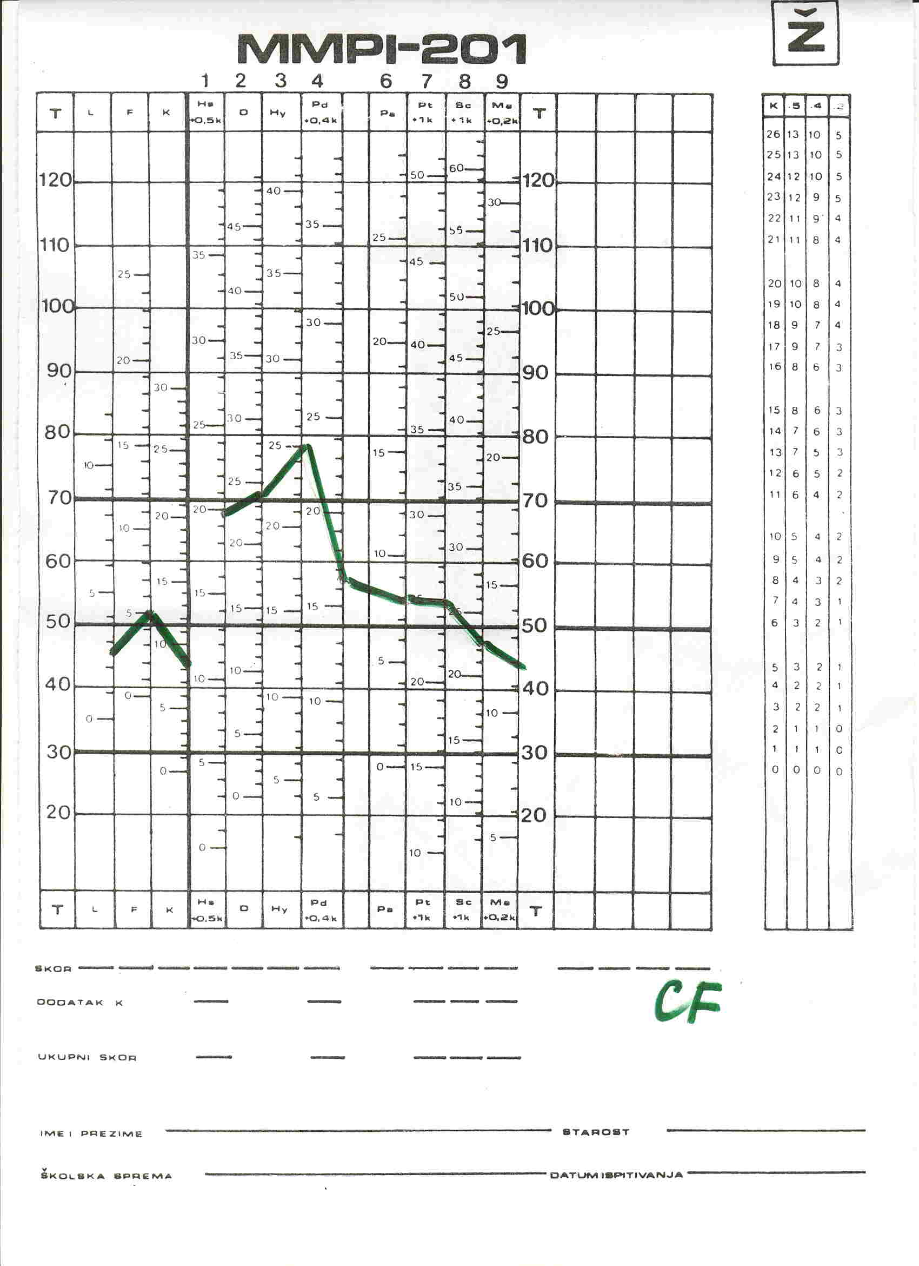
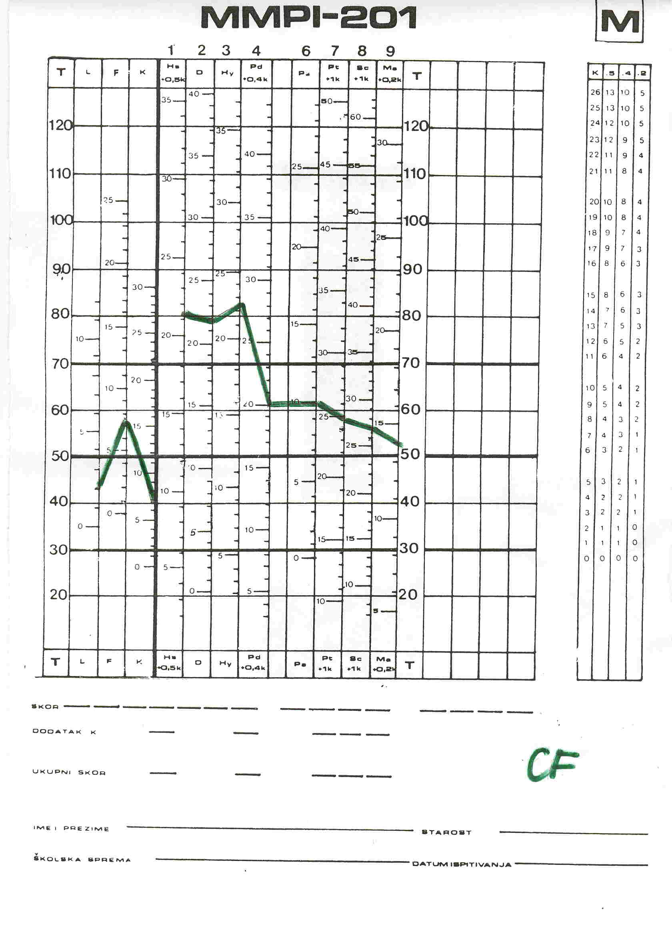

Figure 4: MMPI for parents of girls and boys with JRA.
Slika 4: MMPI profili za roditelje djevojčica i dječaka s JRA-om.

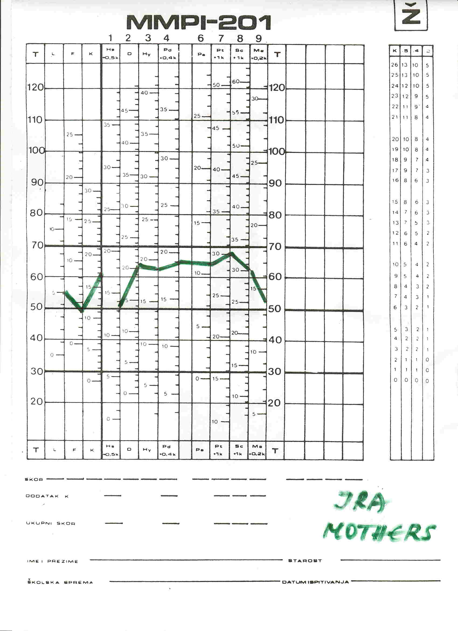
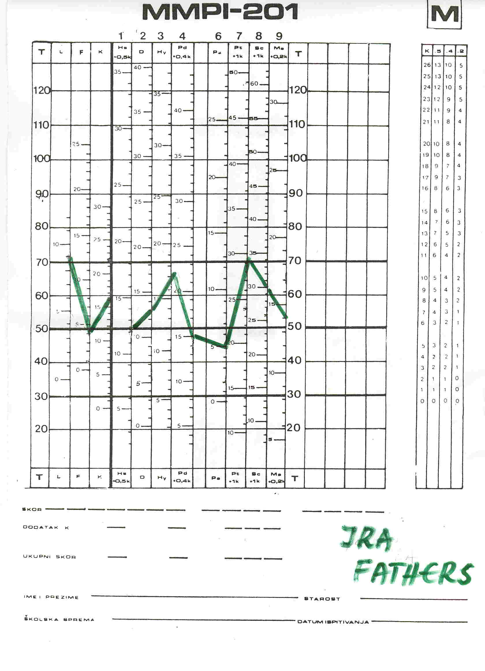

Figure 5 MMPI for boys and girls with cancer.
Slika 5: MMPI profili dječaka i djevojčica s rakom

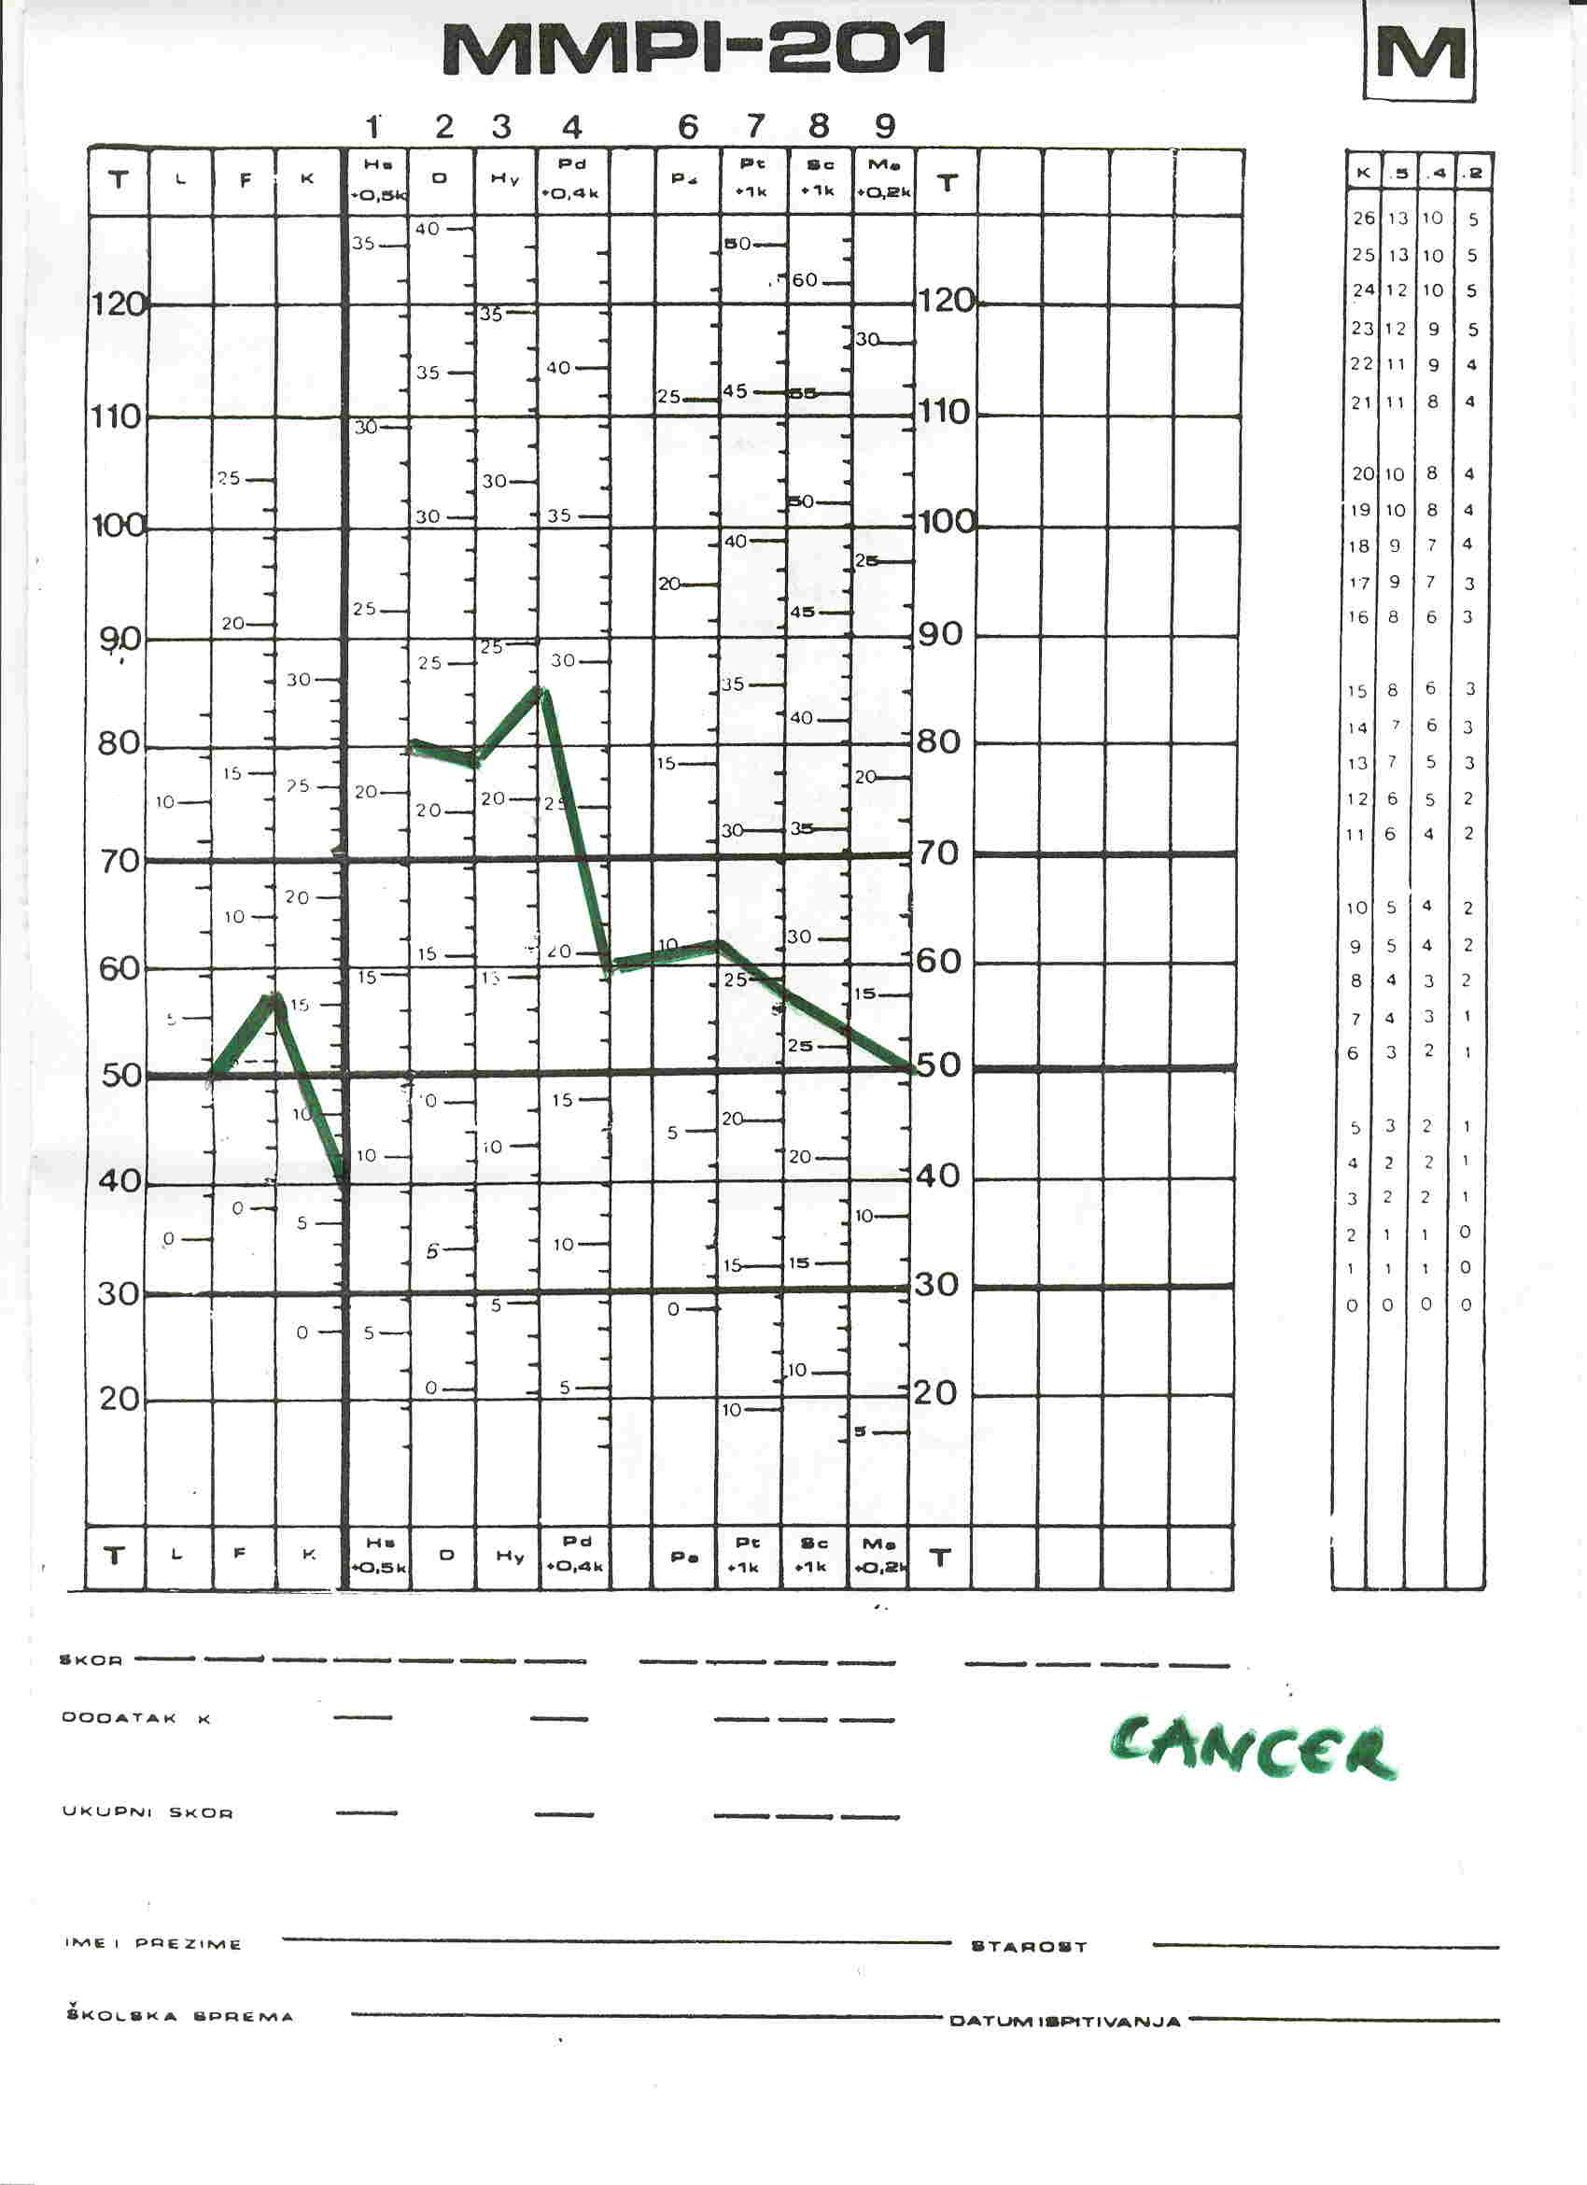
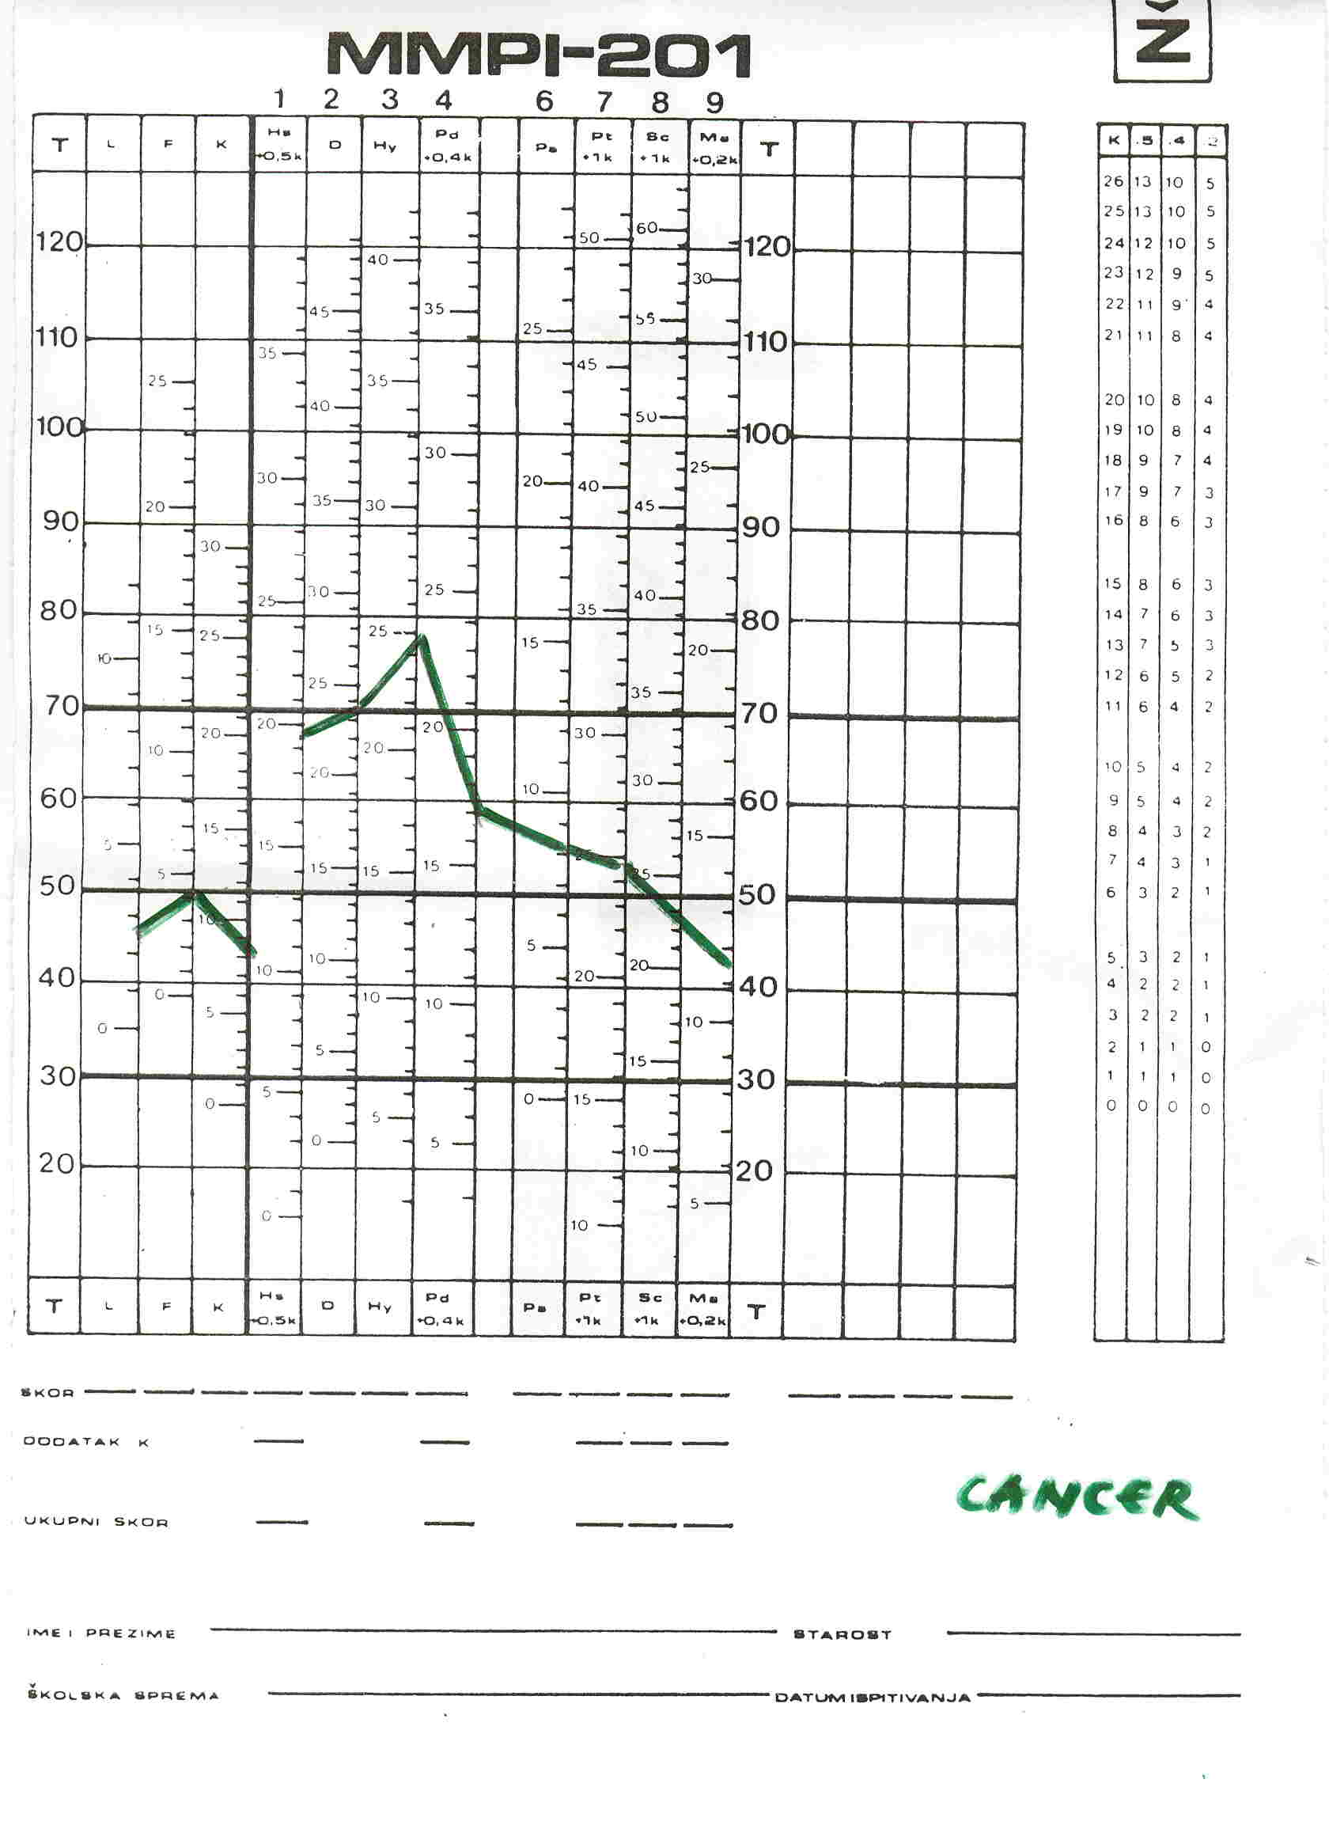

Figure 6: MMPI profiles obtained for mothers and diabetic girls
Slika 6: MMPI profili majki i djevojčica s dijabetesom
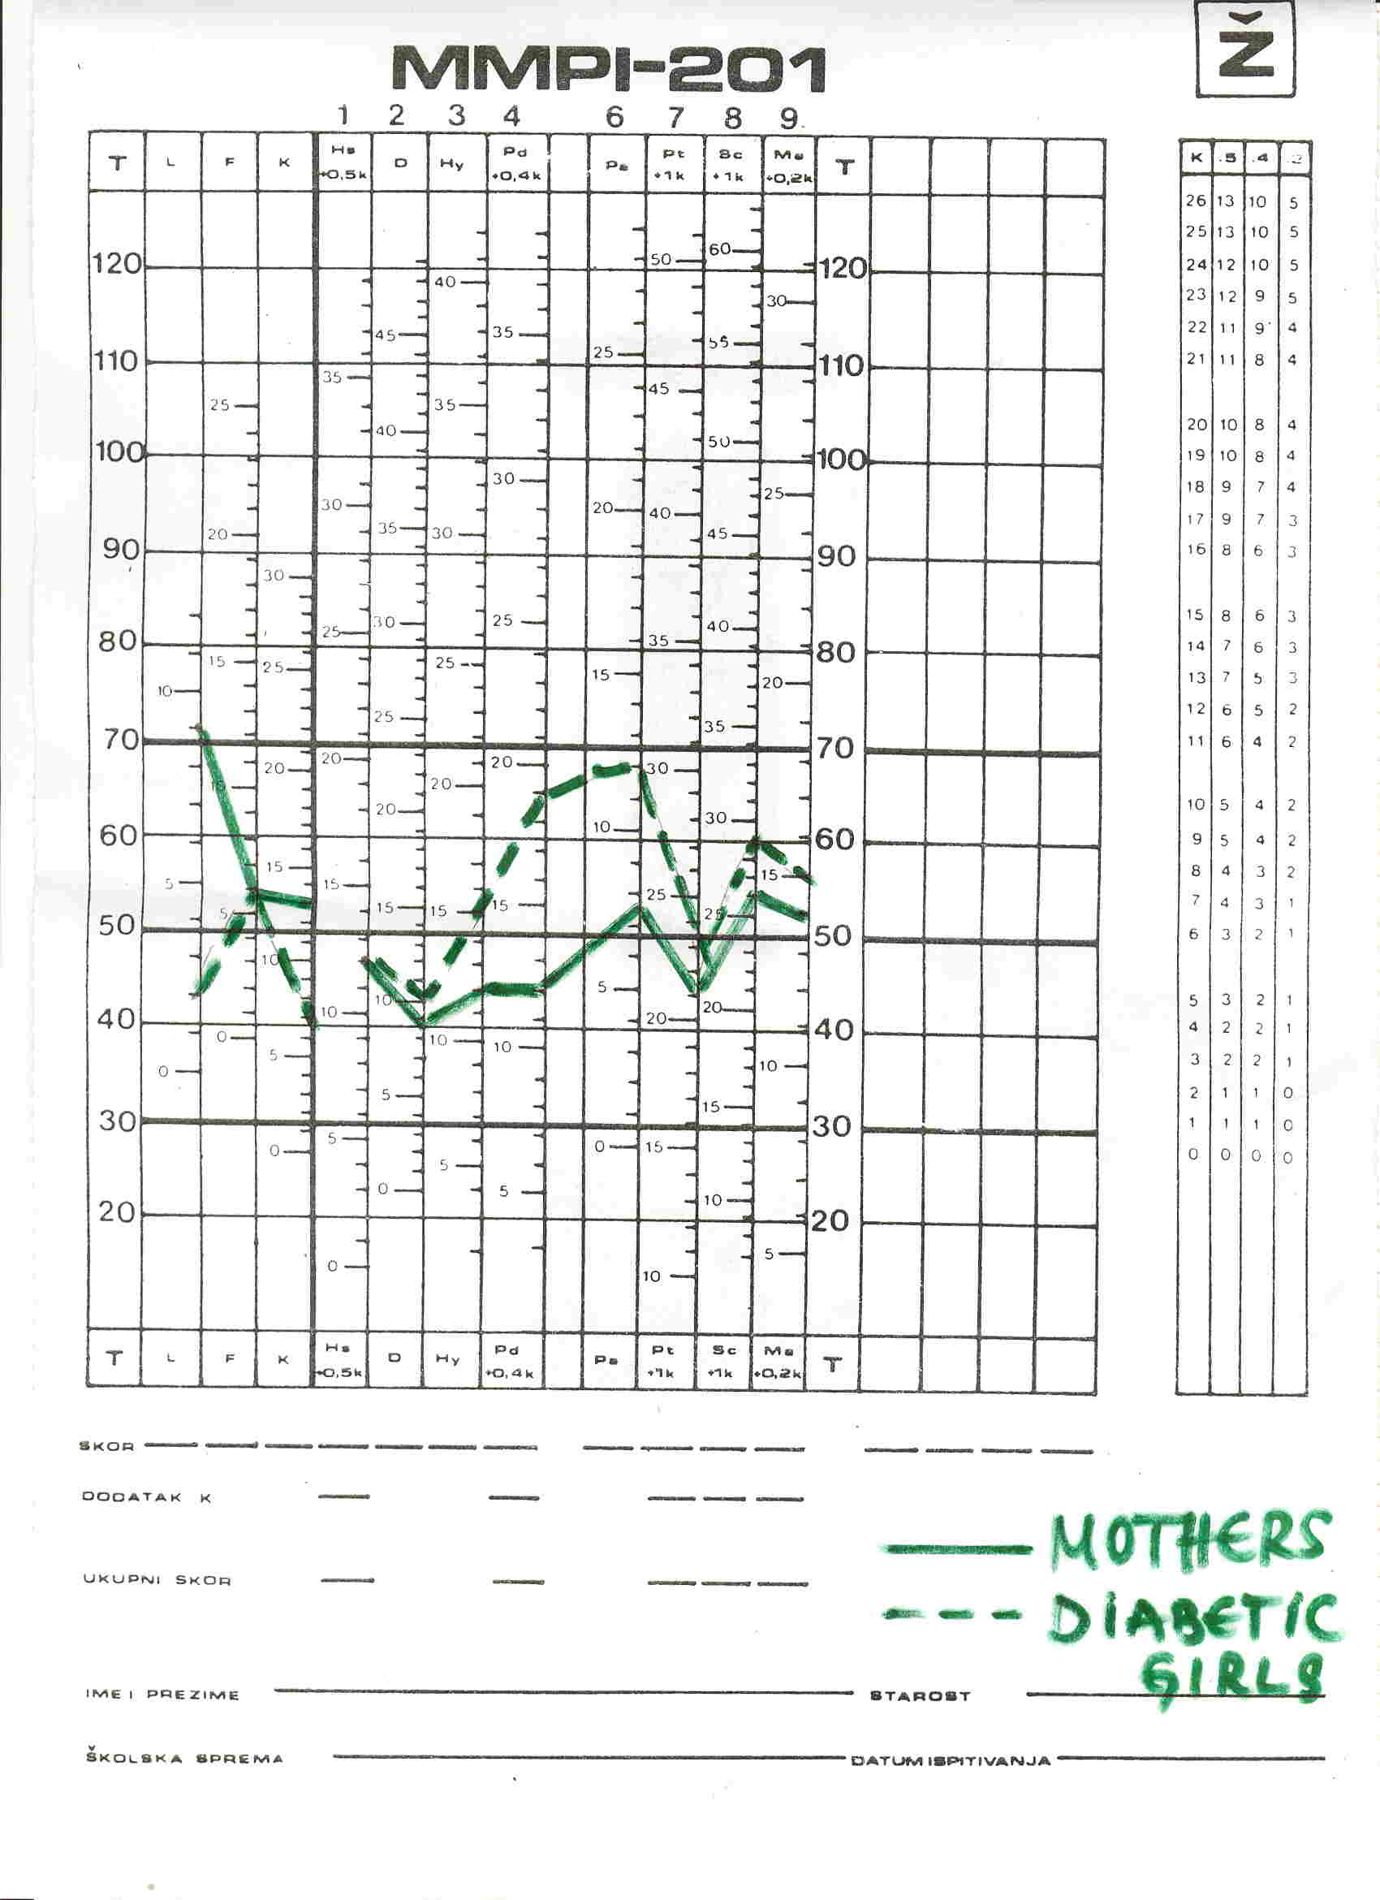

Mothers/Majke
Girls/djevojčice

Figure 7: EPI for CF and JRA adolescents
Slika 7: EPI kod CF-a i JRA-a adolescenata

JRA-juvenile rheumatoid arthritis/juvenilni reumatoidni arthritis, CF-cystic fibrosis/cistična fibroza

Figure 8: Human Value Rank for CF and diabetic children
Slika 8: Lista vrijednosti kod djece sa cističnom fibrozom i dijabetesom

CF |  | Diabetes/Dijabetes
 | 1
health/zdravlje →  → | 2 | ← religion/religija
 |  | ← friendship/prijateljstvo
 | 3
 |  | ← money/novac
 | 4
 |  | ← happiness/sreća
 | 5
love/ljubav → |  | ← love/ljubav
friendship/prijateljstvo → | 6 | ← health/zdravlje
rest/freedom/odmor/sloboda →

 | 7
happiness/sreća → |  | ← freedom/sloboda
 | 8
happiness with parents/sreća s roditeljima → |  | ← beauty/sloboda
wisdom/mudrost → | 9
money/novac → |  | ← food/hrana
beauty/ljepota → | 10 | ← security/sigurnost
food/hrana →

 | 11 | ← comfort life/udoban život
religion/religija →

 | 12 | ← novelties/novine
novelties/security/novine/sigurnost →

professional success/profesionalni uspjeh → | 13 | ← respectability/poštovanje
power/moć →

comfort life/udoban život → | 14 | ← power/moć
 | 15 | ← professional success/profesionalni uspjeh
 | 16 | ← wisdom/mudrost
 | 17 | ← rest/odmor
 | 18 | ← happiness with parents/sreća s roditeljima

