Dr Rebeka Mesarić Žabčić

RURAL TOURISM AND ENTERPRISES: THE EXAMPLE OF MEĐIMURJE COUNTY

ABSTRACT:
This paper analyses the current rural tourism offer in Međimurje County. It also indicates how certain holdings have focused on preserving rural traditions in order to develop small enterprises. The aim of the paper is to examine the quality of rural tourism in Međimurje County, to ascertain in which parts of the county there are facilities and holdings given over to rural tourism, where wine trails are located, and what other attractions rural tourism in Međimurje County has to offer. The paper will also examine whether any difficulties exist regarding legal regulation and whether these difficulties could obstruct the development of rural tourism in the county, and which regulations on registering facilities/holdings are in effect. It is also the intention of this paper to examine and conclude in what ways rural tourism has tried to unify and revive the relatively well organised county of Međimurje.
It is argued that neighbouring Slovenia has had a positive impact on the development of rural tourism in Međimurje, as have the ideas and experiences of emigrants returning from Austria, Switzerland, and Germany, where this type of tourism has been popular for many years. Individual rural holdings, the presentation of traditions through folk customs and old crafts, the region’s traditional produce, and the fact that the level of environmental protection is very high and that the River Mura has been proclaimed a protected area all provide further incentives at both the individual and local government level to invest in such businesses.

KEY WORDS: rural tourism, Međimurje County, rural tourism facilities, wine trail, folk customs and crafts

1. INTRODUCTION
The difficulties in which mass tourism found itself at the end of the 20th century resulted from the emergence of its opposite in the shape of what is known as selective tourism. One of the most widespread forms of selective tourism today is undoubtedly rural tourism.
The area researched in this paper is the county of Međimurje, a predominantly agricultural and low-lying region situated between the rivers Drava and Mura in the north-west of the Republic of Croatia. Originally, rural tourism developed in Međimurje as a result of the independent initiatives of local individuals. However, it started to expand significantly in the mid-1990s when this form of tourism started to spread into Međimurje from neighbouring Slovenia. Another factor in its spread was the return of large numbers of migrant workers from Međimurje who had been working temporarily in Austria, Germany and Switzerland, and who returned home with the intention of investing in their home county. Given that it provides opportunities to make decent profits, raise the standard of living, and slow down rural depopulation in Međimurje, rural tourism has started being used to revitalise the area.
Međimurje has a large number of farms that are particular to the region, and at the same time has rich traditions in gastronomy, customs and crafts. The local environment has also been preserved to a high level. This paper, for the first time, will attempt to set out and integrate the geographical area and its existing material and cultural wealth in order to promote the existing tourism offer and raise it to a higher level.
At the same time, besides the above-mentioned traditions, the Međimurje region also has a healthy climate, excellent leisure opportunities, and good road connections with the rest of the Republic of Croatia and neighbouring states, all of which have been important factors in the continuing development of rural tourism in the county. The paper can also be seen, in part, as an attempt to draw attention to rural tourism in the most northern part of our beautiful country.
2. LITERATURE SURVEY
Experts have still not agreed upon a single definition for agritourism, rural tourism or village tourism, even though there has been one world congress and two European ones on the subject which have tried to standardise definitions. For the purpose of this work, certain definitions have been preferred, though this is not intended to diminish the validity of others.
A general definition of rural tourism found on the internet defines it as a broad concept that can be applied to any tourism in rural areas, and which encompasses various activities (hunting, fishing, nature parks, winter tourism, village tourism, ecotourism, health and culture). At the same time, rural tourism need not be restricted to a source of additional income but can also be a full-time professional activity (https://www.ruralis.hr).
In addition, the notion of rural tourism includes a variety of other terms such as ecotourism, countryside tourism, agritourism, village tourism, farmhouse tourism, farm tourism, eco-rural tourism, and so on. It can be concluded, however, that rural tourism is based upon the rural economy and the utilisation of the countryside in the context of what can be offered to tourists. Situated outside urban settlements or tourist centres, it is devoid of the features of mass tourism. The emergence of new tourist destinations has encouraged the development of such continental tourism. The cornerstones are represented by smallholders who depend on agriculture for their livelihoods, and who offer any surpluses through the new sales channel provided by tourism. It is important to note that the additional income created by rural tourism can be realised in one’s own yard with the active participation of the whole family. Besides the sale of produce, income can be earned through providing accommodation, food and other activities (feeding domestic animals, grape-picking, helping with the harvest, selling wine, distilling brandy, horse riding, etc.) Rural tourism also involves aspects of sustainable tourism, aspects which do not damage the environment, and which also encourage ecological agricultural production.
Vukonić and Čavlek (2001) in their dictionary of tourism define rural tourism as a form of tourism that involves the temporary stay of tourists in a rural environment which offers the visitor, besides fresh air and natural surroundings, a variety of activities connected with rural life, such as grape and fruit-picking, gathering the hay, tending cattle etc, as well as festivals, carnival and other events. Tourists can stay in this rural environment, as today enterprises that cater for tourists offer accommodation in the form of rooms or even cottages which can be rented either through an agency or directly.
According to the definition of the Council of Europe, rural tourism involves tourism in a rural environment that offers all the activities that can be carried out in that environment. The most important features of such tourism are the peaceful surroundings, the absence of noise, a well preserved environment, interaction with the local people, sampling the local cuisine, and getting to know the rural way of life. The growth of rural tourism is based upon sustainable development and the revitalisation of existing facilities and heritage and gearing them towards tourism. At the same time, this form of tourism, as opposed to more well-known forms, has no need to build extra facilities, as, on the contrary it is able to meet challenges in the best way using existing structures.
This work focuses on Međimurje County, which is situated in the northern part of the Republic of Croatia between the rivers Mura and Drava. To the north, the county borders Hungary, to the west Slovenia, to the south Varaždin County, and to the south-east Koprivnica-Križevci County. Lower Međimurje is flat in character, while the upper part is hilly.
Rural tourism in Međimurje grew out of the available accommodation, the promotion of the traditions and heritage of the region, the connection between tradition and culture, and also the traditional village way of life. Ten years ago, it began to develop intensively in Međimurje, or Upper Međimurje to be more precise. An important influence on the spread of rural tourism in Međimurje County was that of neighbouring Slovenia, but also the ideas and experiences of returning guest workers from Austria, Germany and Switzerland where this form of tourism had existed for many years.
Smallholdings have played a key role in the maintenance of existing traditions through farmhouses, local and national customs and the knowledge that has been handed down from generation to generation. In addition, the environment is well-preserved and the River Mura has been proclaimed a protected area. All these factors have helped orientate both individuals and the county as a whole towards this form of investment.
In Međimurje County, rural tourism is connected with agricultural land and the countryside, and encompasses activities related to the rural economy, hunting, fishing, culture, gastronomy, health, uncovering one’s roots, sport and recreation, green and other types of tourism (wine routes, tours, hikes and walks).
The hypotheses and investigations underlying this work have the following aims: to establish the existing facilities devoted to rural tourism in Međimurje, the influence of the cuisine of the region on this form of tourism, what other elements the rural tourism offer contains, the folk customs of the region that have had an impact on the growth of rural tourism, and the importance of the wine routes. An additional aim is to research and establish which old houses have been renovated and preserved for rural tourism, and also the significance of family smallholdings and organic food in the growth of this kind of tourism in the region.
3. METHOD OF WORK AND METHODOLOGICAL OBSERVATIONS
The research project consisted of the following stages:
1. the collection and analysis of existing documentation on rural tourism in Međimurje County;
2. field work, which was carried out between 1-15 June 2007, including visits to facilities and farms used in rural tourism;
3. the writing-up of conclusions based on the results obtained in the research.
At the same time, in order to ensure the quality of the work, the following methods were employed: data analysis based on the consultation of the existing geographical literature, data processing, comparison with data and information taken from secondary sources, cartographic analysis and analysis of diagrams. Maps of Međimurje County were also used, as well as photographs and internet pages. In addition, interviews were conducted with experts involved in tourism in the Međimurje region.

4. RESULTS AND DISCUSSION
4.1. Rural tourism facilities in Međimurje County
When discussing rural tourism, it should be borne in mind that this form of tourism does not require new land as existing buildings are used, and natural materials are employed for their maintenance and renovation. In addition, traditional architecture and respect for the environment are adhered to in the building of new structures in rural areas whether they are designed for living in or for tourism. However, in rural tourism, the spirit of the region is not achieved solely by the beauty of the countryside or its historical significance but also by the character of the people, their customs, their cuisine, the visual appearance of the environment and how it has been maintained, as well as other factors.
The only place that has so far been registered for rural tourism is Goričanec in Sveti Martin na Muri. Located in the picturesque surroundings of the River Mura, it has a restaurant that seats 280 guests and a terrace that can accommodate 1,500 people. With its authentic Međimurje home cooking and its recreation facilities (tennis courts, a riding school, five-a-side football pitches, angling, bungalows and a ferry across the Mura), Goričanec is particularly popular for family and business gatherings, as well as for training for sportsmen and sportswomen from Croatia and neighbouring Slovenia.
Due to the large amount of legal requirements and regulations that need to be fulfilled, besides Goričanec no other establishments have so far been brought into the rural tourism system, though several are involved in the initial preparatory stages. These establishments are also involved in a variety of other activities such as farming. The establishments are: ‘Potrti Kotač’ and ‘Jastreb’ in Jurovčak, ‘Mala Hiža’ and ‘Hozjan’ in Mačkovec, and ‘Štefova Klet’ and ‘K Jeleni’ in Gornja Dubrava.
The ‘Potrti Kotač’ establishment is situated on the Međimurje wine route. It is an old vine-dresser’s hut that offers home cooking in the rustic surroundings of the Međimurje hills, vineyards and forests. It seats 150 while the summer terrace accommodates a further 80 visitors. Close to the building, there are several luxurious bungalows, which located among the flowers, chestnuts, vineyards and hills evoke images of refuge and peace. The building and its surroundings have been transformed into a small family folk museum whose collection tells the story of every nook and cranny of the house and estate. The ‘Jastreb’ restaurant is situated in the immediate vicinity of ‘Potrti Kotač’, and besides the main building there are several items of historical interest such as a steam locomotive that dates back to 1887, a threshing machine from 1936 and an enormous barrel that can hold 11,000 litres, a symbol of the viticultural character of the region and which is located in a pleasant space for dining and relaxation. Being just 5 kilometres outside Čakovec, ‘Mala Hiža’ is a very popular place with locals. With its rich menu based on traditional home cooking, including game dishes, its excellent wines and recreational facilities (tennis courts), it is worth waiting if a reservation has not been made in advance. ‘Hozjan’ is only a few hundred metres from ‘Mala Hiža’ and because of its large seating capacity it is very popular for wedding receptions. In ‘Štefova Klet’, on their first visit, guests receive an ‘identity card’ from the Gregorinčić family which entitles them to special offers on subsequent visits. The restaurant is located among hills, fields and vineyards, and is designed to hold wedding receptions, and business and family gatherings. Overnight accommodation is available, and it offers excellent wines and culinary specialities from Međimurje. ‘K Jeleni’ is situated not far from ‘Štefova Klet’ among hills and vineyards. Besides its excellent home cooking and homemade wine, live music is provided at weekends. Figure 4 shows rural tourism locations in Međimurje County

4.2. Međimurje cuisine as one of the offers of rural tourism
Fieldwork and visits to the places and families that are engaged in rural tourism reveal that an important role in rural tourism is played by the excellent wines and regional dishes that can be found in restaurants. Međimurje cuisine is characterised by simple but tasty dishes. The elements that give Međimurje cuisine its particular character are corn flour, potatoes, pickled cabbage, grits, a cheese known as turoš, and cream. A popular method of preparing food is known as pretepeni (cooked in sour cream, milk and flour). Dishes prepared in this way include soup, potatoes and cucumber. As far as meat dishes are concerned, the most common dishes are poultry and pork (well-known pork specialities are meso s tiblice (a preserved ham dish) and pork dripping). The region’s soups are hearty and generally based on meat and milk, but also vegetables and pulses such as cucumber, green beans, peas, beans, grits and so on. The salads are normally dressed with black pumpkin oil or less commonly with pork dripping, and are usually seasonal. Pickling is still done in the traditional way, for example cabbage, gherkins, peppers, beetroot, as is the making of preserves such as plum jam, stewed fruit, etc. Bread is made with corn, rye, barley or a mixture of these ingredients, and is served with virtually every meal. By far the most well-known cakes and desserts are Međimurje cheese-cake; štrukli (a boiled pastry dish) made from courgettes, cabbage or poppy seed; walnut loaf; poppy-seed cake; honey biscuits; corn cakes and strudels.
4.3. Other tourist attractions connected with rural tourism and folk customs
Reminders of the past and the nation’s heritage (clothes, masks, customs, fairs and food) draw in increasing numbers of tourists each year. Interviews with staff of the Međimurje County Tourism Association reveal how tourists who visit Međimurje are particularly enthusiastic about the natural beauty of the region, organised hunting trips, excursions on the ferry across the River Mura, Procinkolov (a Međimurje and Hungarian festival which is held each year in Čakovec from 1-2 August), Međimurje carnival, grape-picking in Štrigova and Železna Gora, apple-picking in Pušćine, wine-tasting in the cellars of Upper Međimurje, horse riding, and tours of local monuments known as pilovi.
The rural tourism attractions on offer are completed by spas. The village of Vučkovec is home to the Sveti Martin spa, which on 20 July 2007 became the largest bathing facility in continental Croatia. The excellent thermal waters with their high level of minerals were known as far back as 1911. The spa is located on the Međimurje Wine Trail, and together with the spa there is a restaurant which offers a wide selection of homemade dishes and drinks. There are also eight single and double bedrooms, inside and outside pools with hydromassage and air massage facilities, saunas and hand massage salons.
Although skiing is still in the initial stages of development in Međimurje, there are already 2 ski lifts and several slopes for skiing and sledging in the villages of Železna Gora, Prekopa and Jurovčak for lovers of these sports.
Hunting tourism with 600 km² of hunting grounds attracts thousands of hunters, particularly from Italy, Austria and Germany, and is a major source of income. Hunting is a key element in the economy of Međimurje and there are a thousand registered hunters who are involved in gamekeeping and the protection, raising and hunting of wild animals. All these hunters are members of the Zeleni Međimurja club. The game in Međimurje includes pheasant, hare, deer, partridge and wild duck.
Angling can be found along the Mura and Drava. The most fished-for species are pike, catfish, carp and roach.
Local customs can be seen in the way that the houses are built, in the regional costumes, wedding ceremonies, songs, music and dance.
Traditional female dress emphasises female beauty. Women used to wear caps to show that they were married, their shoulders were covered with richly decorated shawls and on their feet they wore boots. Male costume consisted of woollen shirts and trousers, while on their heads the men wore hats. Over their shirts, they would wear a waistcoat. However, many of the old trades no longer exist, which is mainly due to the general trend of modernisation, but also the rapid development of small enterprises in Međimurje. Nevertheless, handmade wicker baskets and various other objects made from willow or corn husk can still be found. An important role in the promotion of rural tourism in Međimurje is also played by local music, song and dance. Thanks to the cultural and arts societies that offer a wide array of cultural programmes throughout the year, Međimurje folk songs have been preserved, among the most well-known of which would be Međimurje malo (‘Little Međimurje’), together with traditional folk dances. Two other well-known folk songs from Međimurje would be Cvetnjak Horvatske (‘The Flower Garden of Croatia’) and Zemlja između voda (‘The Land between the Waters’).
The watercourses, vineyards and rural way of life are the reasons why many tourists come here. Croatian and especially foreign visitors are impressed by the beauty of the region, the excellent wines, the terrific local cuisine, with its specialities, and the warm welcome extended by the hosts. Međimurje County Tourism Association staff are quick to emphasise that the feedback that has reached them so far has been exclusively positive, and that all of the above-mentioned features point to the continued development of rural tourism in Međimurje.
4.4. Other types of tourism: the wine trail and the ‘wine paradise’ of north-west Croatia
Viticulture has traditionally been the main economic activity in Međimurje. Vines were being cultivated in Upper Međimurje (around Štrigova, Sveti Urban and Železna Gora) as early as the 15th century when the noble Zrinski family earned most of their income from wine-making in the region (Dugački, 1936; Movčan, 1995). In terms of vineyards, Međimurje is one of the richest regions in Croatia. The area of Upper Međimurje is covered with vineyards with excellent autochthonous and foreign grapes, especially white grapes, such as kraljevina, moslavec, white graševina, yellow muscat, ranjski reisling, pinot blanc, pinot gris, sauvignon, traminac, etc. Wines from Međimurje are quite full, with a crispness and array of bouquets and colours. In better years with plenty of sun and hard frosts, ice wine is produced from frozen late-season grapes, which finds Međimurje viticulturalists a place among the best vintners in Croatia.
Because of the vineyards, some of the most important rural tourism attractions in Međimurje are the wine trails. In 1999, the Međimurje County Tourism Association established a wine trail through Upper Međimurje which in places, depending on where it passes through, actually changes its name. The wine trail project is connected with the efforts to develop rural tourism and organic agriculture in the county of Međimurje. Upper Međimurje is a hilly region in the north-west of Međimurje (highest point Mohokos at 344 metres), covered with forests, fields and meadows on the northern slopes and approximately 1,100 hectares of vineyards on the southern and south-eastern slopes, most of which are under private ownership, although about 140 hectares are owned by the firm Agromeđimurje. At present, approximately 60 vineyards produce wine under the appellation control system, of which around ten have been granted ‘quality wine status’, which is what gives Međimurje viticulture the reputation of being one of the best in Croatia.
According to the Institute for Tourism in Zagreb, the Međimurje Wine Trail is “of great national importance, and is not only one of the most significant tourist attractions in Međimurje but also in the whole of Croatia” (Kušen, 2003).
Along the wine trail, there are around twenty quality establishments for wine-tasting where various award-winning, mainly white, wines can be sampled. Failure to try one of these Međimurje wines in one of these establishments while driving along the Međimurje Wine Trail would be a major oversight. The well-known wines of the Međimurje slopes that are worth sampling include moslavac, graševina, rizling rajnski, pinot bijeli, pinot sivi, chardonnay, silvanac zeleni, traminac, sauvignon, muškat žuti or bijeli, ice wine (izbor bobica and ledene berbe), and the sparkling wine known as pjenušac.
The Međimurje Wine Trail has a very attractive itinerary featuring interesting establishments (places with special licences and Međimurje Wine Trail stamps of approval, wine-tasting premises, wine shops and so on), cultural and nature tourism attractions, together with the necessary tourism facilities. The Međimurje Wine Trail is marked with sign-posts and welcome signs (this year, brown signs, which signal places of interest for tourists, are in the process of being put up), its main routes passing through the villages of Lopatinec, Železna Gora, Štrigova and Sveti Urban.
In the last ten years or so, Međimurje winemakers have successfully improved the quality of their product and a process is underway to further improve the product of the most successful producers through the creation of wine-tasting establishments and wine shops, in other words augmenting the rural tourism offer. Such wine establishments have been divided into three categories: P – wine selling (represented by one grape); D – wine selling and tasting (two grapes), and K – wine selling and tasting in special wine-tasting establishments (three grapes).
Wine selling (P) covers wines with appellation control kept in cellars. The following is a list of family businesses that sell wine in this manner, together with their addresses: the Horvat family, Sveti Urban 279; the Trstenjak family, Banfi 31; Vladimir Knehtl, Sveti Urban 82; the Novak family, Banfi 202; Mirko Vlašić, Železna Gora 80; Dragutin Munđar, Frkanovec; the Holcinger family, Vukanovec 3; Avgust Bobnjar, Robadje 130; Dvanajščak-Kozol, Dragoslavec 81; Bojan Štampar, Sveti Urban 2; the Hažić family, Jurovčak 72.
Wine selling and tasting (D) are carried out by: the Lebar-Židov family, Železna Gora (quality wines); the Belović family, Železna Gora 2b (quality wines); Josip Zadravec, Sveti Urban 103d; Alojz Novak, Sveti Urban 70 (quality wines); the Jambrović family, I.G. Kovačića 112, Lopatinec (quality sparkling wines).
Wine-tasting and wine shops (K) are divided into three categories. The first category covers excellently laid-out establishments selling quality wines and with well-conducted wine-tasting. The following establishments fall under this category: Vinska Kuća Lovrec, Sveti Urban 133; Vinska Hiža Cmrečnjak, Sveti Urban 273; Vinoteka i kušaonica Terbotz, Železna Gora 113. The second category consists of pleasantly laid-out establishments with excellent wines and well-conducted wine-tasting. This category includes the following establishments: Branimir Jakopić, Železna Gora 92; Vinogradarstvo Čanadi, Železna Gora 115; Vinotoč Kunčić, Banfi 125; Vinska Kuća Obitelji Turk, Vučetinec 107b; Matanović-Provin, Sveti Urban 130; Vinarija Agromeđimurje, Štrigova bb.
A large part of the sale of wines with appellation control takes place through wine cellars and small farms, which is good for the development of the economy, self-employment and the development of the county.
The wine trail also covers other places of interest for tourists such as a tour of ‘Agromeđimurja’ winemakers in Štrigovi, the Mađerkin Breg beauty spot, rural structures of cultural interest such as traditional cottages, vine-dressers’ huts, cellars dug from sandstone (without any walls or support), and old wooden wine-presses. In addition, every year on May 24th-25th, there is a wine festival known as the Urban Open Cellars Festival. Other attractions include the Sveti Martin spa in Vučkovec, the Terbotz wine manor with its wine-tasting facilities, wine shop, collection of wines and excellent restaurant. There is also the ‘Potrti Kotač’ restaurant in Jurovčak, which is laid out in the rural style and has slopes for sledging and skiing, together with a ski-lift. The Trstenjak family ethnographic collection is located nearby in Marof, and the most northerly point in Croatia is situated in Svet Martin na Muri. There is also Mohokos, the highest point in Međimurje as well as hill trails (the Međimurje and Železna Gora hill trails). There is a tennis academy in Brezje, the ‘Venera’ five-a-side football pitch in Lopatinac, clay-pigeon shooting in Vukanovec, hunting for small game, the protected area around the River Mura, and angling. Given the above, it is clear to see the extent to which tourism in Međimurje is based upon the traditions and culture of the Međimurje village. The preservation of the indigenous village way of life and the development of tourism in this region has been carried out in a way that is both up-to-date and well-thought-out, but which is in accordance with the International Council on Monuments and Sites’ Charter on Cultural Tourism. This is because tourism does not destroy culture but, on the contrary, makes it viable not only in a passive sense but also in an active one, as the preservation of cultural forms opens up economic opportunities.
Since the opening of the Međimurje Wine Trail, the project has been greeted with a stream of positive reactions, the most significant of which is undoubtedly an increased interest on the part of small farms in renovating buildings in order to cater for the needs of tourists. The other positive reaction has been the increase in the number of visitors to the Međimurje Wine Trail. However, the rate of progress in realising projects is unsatisfactory, which is due to the limited funds available. A second factor is the very strict criteria set by the Međimurje Wine Trail Council which have to be met in order to be included on the trail, as the emphasis is on quality rather than quantity.
The Međimurje Wine Trail project has so far been successful, and it is hoped that its development will continue in the coming years. It is planned to complete the system of brown tourism road signs, publish a promotional brochure and map, open a museum of wine, train those employed on the Međimurje Wine Trail in order to raise the quality of service and facilities used, and to encourage enterprises to become involved in the rural tourism system and in the promotional and marketing campaigns of the Međimurje Wine Trail.
It is particularly significant for rural tourism in Međimurje that the establishments on the Međimurje Wine Trail are open the whole year round, and that the opening times in virtually all of these places are flexible, and arrangements can be made in advance.
The prime-mover and main investor in the Međimurje Wine Trail (signposting, renovation, etc) is the Međimurje County Tourist Association and its body that runs the trail so efficiently, the Međimurje Wine Trail Council. Each spring, the Hortus Croatiae association of winegrowers and vintners organises a wine festival and open cellar days known as the ‘Urban’ festival, which is named after Saint Urban the patron saint of winegrowers.
From the overall work of the Međimurje County Tourist Association and existing resources, it can be clearly seen that tourism in this region is founded upon the rural way of life. Besides the wine trail and rural tourism establishments, there is also the cuisine which is based upon traditional food, connected to the organic agriculture present in the region.

4.5. Examples of the renovation of old houses for the purpose of rural tourism
Ten years ago, due to a combination of tradition and culture, the awareness of returning emigrants, available capital and the desire to realise a big profit on investments, but also the traditional rural way of life, the intensive renovation of old houses, known as kleti, began, and rural tourism in Međimurje started to develop. Nejašmić (1991) emphasises that the preconditions for rural tourism are laid down by the preservation of traditional surroundings and awareness of the importance of protecting the natural and cultural environment. It has already been underlined how the development and spread of rural tourism in Međimurje County was positively influenced by neighbouring Slovenia, but also Austria and Germany, where this form of tourism had been in existence for many years. In addition, there was the orientation of individual farms towards the preservation of existing traditional resources, the renovation of typical rural properties while maintaining their authenticity, the nurturing of folk customs and traditional crafts, the fact that the environment had been well preserved, and also the proclamation of the River Mura as a protected area. All these factors helped influence returning emigrants and the County authorities to invest.
The ‘modernisation’ and renovation of old houses for the purpose of rural tourism is a recent development in Međimurje. In part, this is a consequence of the return from abroad of people originally from Međimurje (see figures 1 and 2). The results of the research and surveys indicate that of the total number of people returning, 6 individuals or 2.9% have invested in this new form of tertiary activity. All rural tourism buildings are located in Upper Međimurje.

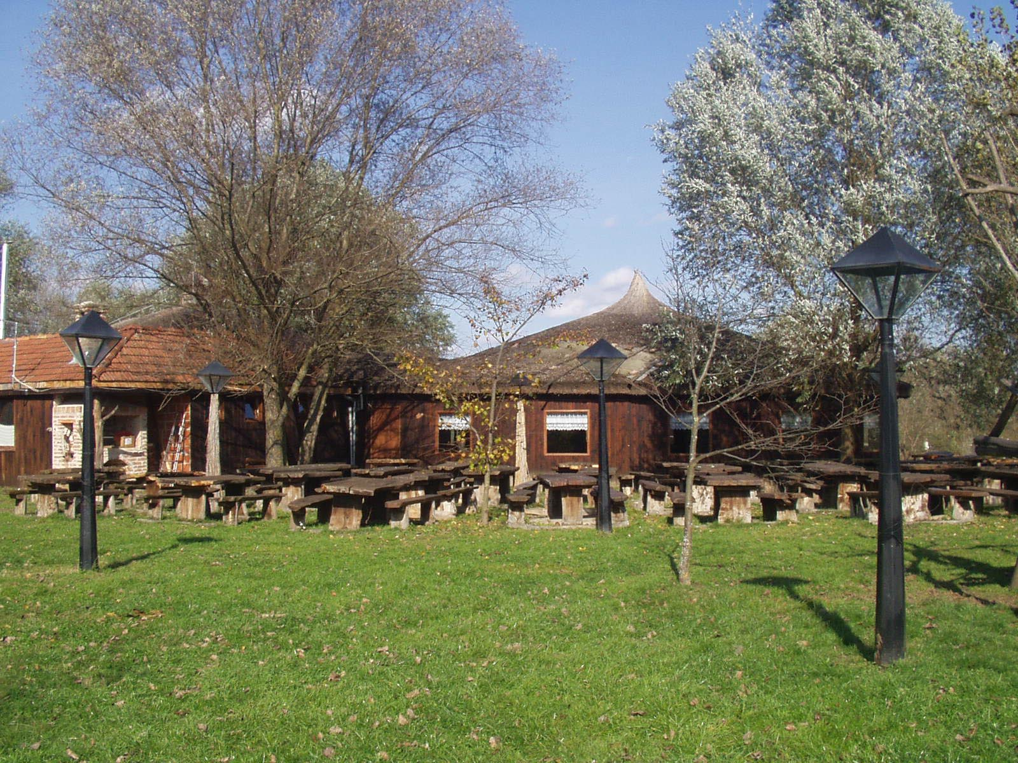
Figure 1. Example of a rural tourism buildings in Sveti Martin na Muri
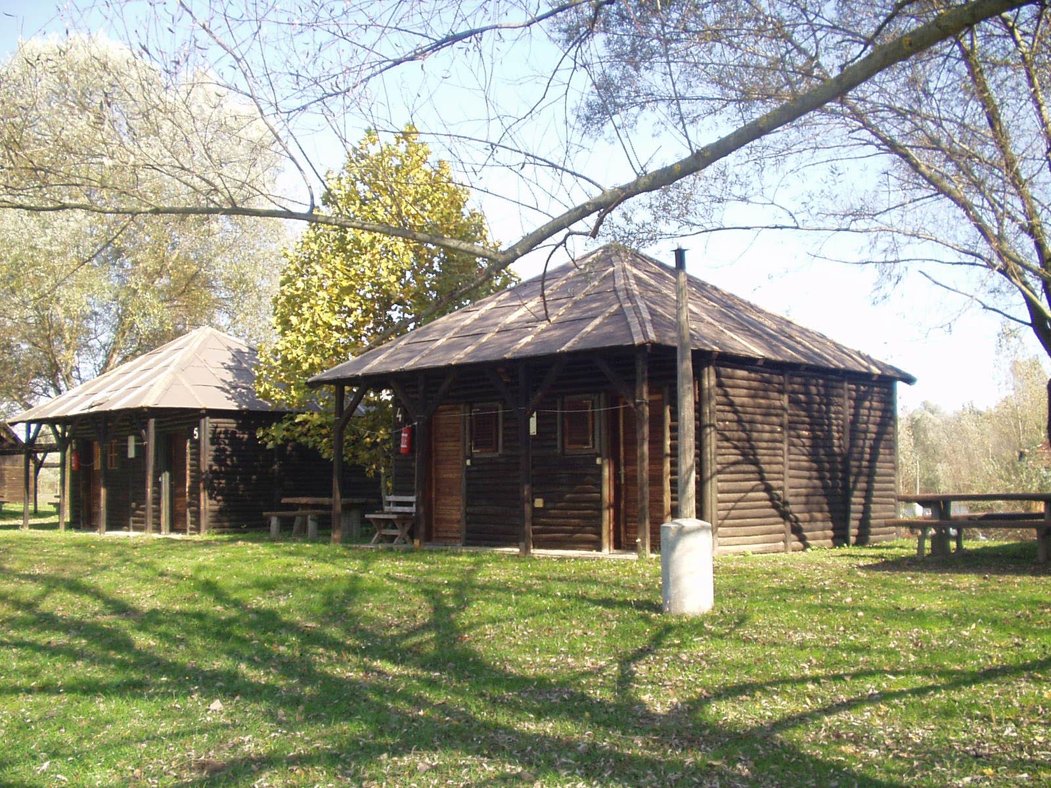
Figure 2. An example of rural tourism buildings in Sveti Martin na Muri (bungalows for renting)
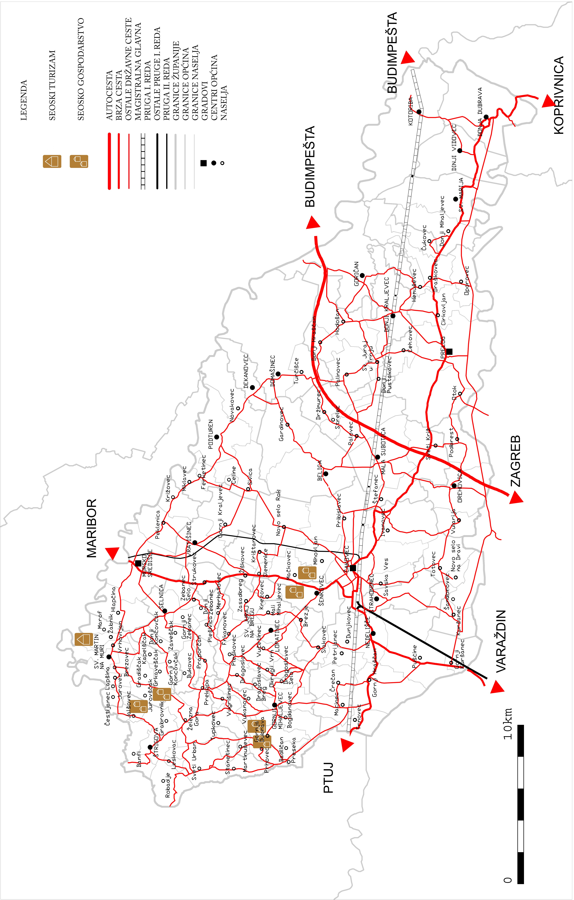
Figure 4. The location of rural tourism facilities in the county of Međimurje
The benefits of the development of rural tourism in Međimurje County can be seen in the expansion of the existing tourism offer and the increase in the tourism trade in the spring and autumn months. It can also be seen in the way Međimurje has joined the ranks of other Croatian counties and countries following this trend in world tourism, and in the opportunity that is presented to earn greater income from tourism. At the same time, it has helped preserve folk customs and traditional crafts and the unique socio-cultural characteristics of the Međimurje region, as well as top-quality traditional rural products and agricultural produce.
4.6. Small-scale agriculture in the context of rural tourism and the production of organic produce
The conditions for agricultural produce and the accompanying food industry in Međimurje vary according to the solvency and quality of the land in question. In the past, agriculture was one of the most important factors for subsistence in Međimurje. Substantial sub-division of the land and smallholdings with a large number of owners have adversely affected present-day agricultural production. This traditionally agricultural region has a large amount of arable land that produces quality organic agriculture produce. It also has developed infrastructure, the necessary climatic conditions and relatively good quality land, all of which indicate that favourable preconditions exist for a better assessment of the role of agriculture in the overall economy of the county. The area of Lower Međimurje has favourable conditions for agriculture, as has the Pleistocene plain and low-lying parts of the upper part of the region. Although it is hard to generalise, it is preferable that the best areas be given over to production that ensures the best return per unit: fruit, vegetables, ornamental plants and so on. According to figures from the Međimurje County Chamber of Trades and Crafts, in 2002 the largest part of the agricultural sector comprised small farms which, according to the figures, reached almost 21,000 in number and accounted for 37,000 hectares of land, which on average represented 1.75 hectares per farm. In total, agricultural land covers 495.4 km² or 67.9% of the total surface area of the county. Although it is envisaged that existing farmland will continue to be used for agricultural purposes, it is foreseen that there will be specific changes in the way that agricultural land is used, such as in terms of expansion and fallow land, although not to the same extent as in previous changes. In order to understand the significance of the process it is necessary to explain the reasons that lie behind these changes.
It has already been mentioned how agriculture has always been one of the main factors in everyday subsistence in Međimurje. The population worked on smallholdings, but when there were a number of male offspring this led to problems concerning the inheritance of the land. Magdalenić (1994) emphasises that before the start of denationalisation, the number of smallholdings in Međimurje was higher than the national average but they were markedly smaller in size. Because of agricultural surpluses, excessive land division, smallholdings with a large number of owners, a lack of agricultural equipment and insufficient mechanisation, and also ceilings on agricultural production, the sixties and seventies of the last century witnessed the departure of many inhabitants of Lower Međimurje, where agriculture was more prevalent, in order to work abroad. In short, in the last century, this traditionally agricultural region where almost 95% of the land was cultivable (in Croatia the figure was just under two-thirds), due to insufficient development and low production levels was not able to sustain its population.
5. CONCLUSIONS AND IMPLICATIONS
The importance of rural tourism revolves around the interaction between agricultural production, traditional produce, the preservation of the cultural and historical heritage of the countryside and the traditions, cuisine and services that can be presented through tourism. The fact that 92% of the land in the Republic of Croatia can be considered as rural underlines the importance of this form of tourism for the country. The inhabitants of Međimurje were looking for extra sources of income and given their traditional orientation towards agriculture the development of tourism presented itself as the logical choice. Additional positive influences were to be found in the examples of neighbouring Slovenia, Austria and Germany where this form of tourism had developed earlier. Moreover, this trend occurred at the same time as demand in tourism started to change, which helped to orientate rural communities towards the development of tourism. At present, all rural tourism locations are situated in Upper Međimurje. Rural tourism, however, endeavours to unite and revive the relatively well organised area of Međimurje County through its comprehensive offer to tourists, emphasising the centrality of the environment as its basic resource and attraction in the development of such tourism.
Rural tourism in Međimurje County is able to meet the expectations of tourists, create extra income, employment and business opportunities for the local population, and provide support for other economic activities. Consequently, in the future attention needs to be paid to preserving individual smallholdings and existing rural traditions as well as to the tourism activities necessary for the development of rural tourism.
There are still difficulties concerning rules and regulations, which to a certain extent hinder the development of rural tourism in Međimurje County. It would be a positive development if in the near future effective laws could be drawn up in the field of rural policy to enable the faster registration of buildings and businesses involved in rural tourism.
So far, those small businesses in Međimurje County that are oriented towards developing rural tourism have been very successful. The process is progressing well, and could act as a model of rural tourism development in other Croatian regions.
The direction of future research in rural tourism in the area of Međimurje County should move towards establishing the number of rural households that are willing and able to set up this type of small-sized enterprise but who have been discouraged from doing so by the bureaucracy involved. In addition, it would be worthwhile researching whether or not there are opportunities for developing rural tourism in Lower Međimurje and what the key factors involved in doing so would be. At the same time, it would also be worthwhile for any new research to examine other issues involved such as the local community, obtaining financial support from local government, and so on.
Geographical marketing is also important in developing rural tourism in Međimurje County and in this respect the following idea could be of assistance: "... forget the words rural tourism and just offer guests your way of life, your way of speaking, your customs, your homemade produce, your wine, your emotions and your spirit, and the heritage passed down from your grandparents …".
BIBLIOGRAPHY
Dugački, Z. (1936). Međimurje - zemlja i stanovništvo - Čakovec.
Kušen, E. (1992). Seoski turizam te arhitektura sela i seoskog gospodarstva, u: knjizi "Hrvatski farmer", Globus, Zagreb, 363-382.
Kušen E. (2003). Sustav obilježavanja i interpretacije turističkih atrakcija Međimurske županije, Zagreb.
Kušen, E. (2002). Turistička atrakcijska osnova, Institut za turizam, Zagreb.
Magdalenić, I. (1994). Novije promjene u gospodarstvu Županije međimurske.- Sociologija sela, br. 3-4 (125-126), str. 175-190, Zagreb.
Mesarić Žabčić, R. (2004). Seoski turizam u Međimurju, Hrvatska revija br. 1, str. 103-107, Matica Hrvatska.
Mesarić Žabčić, R. (2005). Utjecaj migracija na transformaciju naselja Međimurja, Doktorska disertacija.
Movčan, I. (1995). Vizija razvoja turizma i ekološke stabilizacije Međimurja, Čakovec.
Nejašmić, I. (1991). Depopulacija u Hrvatskoj, korijeni, stanje, izgledi", Globus, Zagreb.
Vukonić, B., Čavlek, N. (2001). ur. Rječnik turizma, Masmedija, Zagreb.
Strategija razvoja hrvatskog turizma do 2010. godine i Mogućnosti razvoja ruralnog turizma na: http://www.ape.hr/plani_slicice/Studija_turistickih_mogucnosti.pdf
http://www.toplicesvetimartin.hr
http://www.seoski-turizam.net
http://www.ruralis.hr
http://www.ruralis.hr/hr/agroturizam2.html
http://www.tzm.hr

Dr. Rebeka Mesarić Žabčić,Institute for Migration and Ethnic Studies, Trg S. Radića 3, Zagreb, tel 6111-563, e-mail: rebeka.mesaric@zg.t-com.hr
In order to construct new buildings or adapt existing ones for the purpose of rural tourism on agricultural land, it is necessary to obtain a location permit, planning documentation and a building licence.
For more, see: Mesarić Žabčić, 2005.

