Lidija Petrić i Davorka Mikulić

The Role of Cultural Tourism in the Process of Urban Regeneration

Abstract:

The global economic crisis has devastated manufacturing industry and created structural unemployment problems that have been most evident in the urban environments. At the same time, an enormous population growth has forced cities to face many ecological, spatial and social problems. Therefore cities have to consider new models of development that could help them regenerate and diversify their economies. Development strategies have increasingly identified cultural and creative industries as key growth sectors in the process of urban and regional regeneration. Moreover, tourism is seen as their complementary industry in a way that it helps transforming cultural resources (e.g. culture in general) into tourism products. Culture and tourism have growingly been promoted together as part of a broader strategy of diversification of local economies.
The purpose of this article is to throw some light on and discuss the role that development of tourism and culture could play within the context of urban regeneration strategy. To this end some best practices will be discussed and recommendations related to policy measures proposed.

Key words: urbanisation, urban regeneration, tourism, culture

Urbanisation and urban degradation

The process of urban development and urbanisation is as old as civilisation itself. The first urban settlements had been founded in the fertile valley of the rivers of Eufrat and Tigris four thousand years B.C. Whole history of urban development shows that most of the cities have developed predominantly due to the reasons of defence but with economy being deeply embedded from their very beginning. However cities hadn't grown rapidly till the beginning of the industrial revolution. Hence, at the beginning of the16 th century there had been only 6 cities with more than 100,000 inhabitants in Europe (Paris was the biggest with 225,000 inhabitants); in 1700 there were 13 such cities while in 1800, 21 cities had more than

100,000 inhabitants (London was the biggest one with the population of 861,000) (Šimunović, 2007: 35).
Industrial revolution had produced strong urbanisation. Due to the rise of industrial production (economy of scale), technical progress in all the areas of human life and society including novelties in the construction engineering, there was an enormous rise of both the number and the size of the cities. The growth of urbanisation rate was 39 % in the 1980-ties, 45 % in 1994, and 48 % in 2002. According to the UN prognosis, till 2025 the urbanisation rate will exceed 60% (Šimunović, 2007: 46).
Because of the ever rising rate of urbanisation, many cities (especially the Mediterranean ones) are characterised by unplanned and illegal urban expansion, unstable and heterogeneous spatial patterns of land use, lack of infrastructure and services. As a consequence there is a wide urban degradation that could be evident in terms of:
- Formation of distressed urban areas and pockets of deprivation due to social and economic exclusion;
- Underutilisation of urban infrastructure in the centre and overburdened infrastructures in the periphery;
- Transformation of the shape of urban fabric, blurring city limits and fragmenting the city space with infrastructure networks;
- Housing and public services poorly adapted to special needs;
- Creation of mono–functional districts, separation between dwelling and workplace, generating traffic congestion and pollution;
- Unsustainable consumption of land resources and agricultural space;
- Environmental degradation taking the form of deteriorating air quality, rising noise levels, loss of open space, and increased vulnerability of natural and man-made amenities. (PAP/RAC, 2004).

Apart from the problems of urban degradation in the spatial and environmental area caused by the ever rising rate of population growth, even more important are the economic problems related to the processes of globalisation and decentralisation. Namely, many cities have been hit particularly hard by economic and social transitions which have devastated manufacturing industry and created structural unemployment problems. Therefore the cities need to attract new and growing activities which will provide jobs and assist the physical regeneration of inner city zones (Law, 2002: 49). To many cities tourism seems to be one of the most desirable activities for urban regeneration, as the basis for its development (arts, heritage, and events) already exists.

Urban regeneration and tourism

Urban regeneration was first formalised in the U.S.A. in the 1960s, when relocation of marine activities triggered the total abandonment of large territories, which have become harbour derelict lands. Municipalities have often reassigned these empty urban lands to central business type of activities as in Baltimore, Boston and New Orleans. Baltimore was one of the first cities to successfully regenerate its waterfront and as a consequence became exemplary to the rest of the world (Law, 2002: 45-46)

Inner Harbour in Baltimore
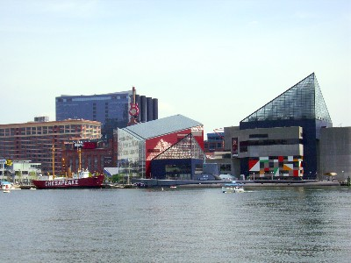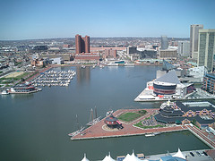
Source: http://images.google.hr/images?hl=hr&q=Inner%20Harbour%20in%20Baltimore&um=1&ie=UTF-8&sa=N&tab=wi; accessed on March 14th, 2009

In the 1980’s, a second phase was launched, on the London Docklands, and then in Barcelona. Later, in the 1990’s, urban regeneration was launched in many urban areas, often densely populated, functionally heterogeneous, but facing many urban malfunctions. Opportunities for urban regeneration interventions may be abundant particularly in cities with:
- Degraded and overpopulated city centres needing complex urban renewal and redevelopment,
- Under–utilized urban land on potentially most valuable locations (waterfront and harbour areas) necessitating increased land-use efficiency through the initiation of land recycling, in–fill development and re–development of underutilised waterfront area,
- Declined or abandoned industrial or military areas as a result of economic restructuring and global de–industrialization making necessary the promotion of local economic development based on restructuring and privatisation, the attraction of foreign investments and transfer of technology,
- Peripheral, illegally built residential areas of poor standard demanding efficient infrastructure and open spaces (PAP/RAC, 2004: 7)

Why should a city adopt tourism as a strategy for its regeneration?
There is a number of reasons, as listed below:
- Most of the cities already have different resources that might serve as tourist attractions (museums, historical buildings and sites, traditional events etc.);
- Tourism requires costly investments into physical infrastructure but most of it has benefits for the local community and business sector as well;
- Engaging in activities related to tourism and promoting them elsewhere will raise the profile and visibility of the city which will then be of assistance to those engaged in its economic promotion;
- The overall rise of economic activities that are directly and indirectly connected with tourism ;
- Many of the functions which could be expanded at least because of the desire to attract tourist, such as culture and sport, will help persuade potential residents, such as business professionals and executives, that the city is a good place to live and work in;
- The regeneration of the city zones and monuments and the arrival of new visitors will also increase civic pride.

Scheme 1 The strategy of urban tourism
Source: after Law, C.M., Urban Tourism, the Visitor Economy and the Growth of the Large Cities, Continuum, London, New York, 2002, pp. 50

Although there are those who favour manufacturing industry instead of tourism as a development strategy, one cannot neglect global trends of tertiary sector development within which tourism seems to be one of the most important activities. What exactly constitutes urban tourism? There can be a number of activities and motivations. Though varying by destinations and attractions, these could be visiting friends, business/convention, outdoor recreation, entertaining and sightseeing, shopping and education. The tourist city thus embraces all of the above functions and their resources (Paskaleva-Shapira, 2001). However, most of these activities could be considered under the common concept of culture. Tourism and cultural policies have become more integrated into economic development strategies and the definitions of both ’culture’ and ’tourism’ have widened to facilitate the new economic role assigned to them.

The relationship between culture and tourism in the process of urban regeneration - the new concepts of urban development

Until relatively recently, the development of tourism and culture was relatively independent. The number of ’cultural tourists’ was small, and tourist consumption of cultural facilities during their travels tended to be incidental to the main function of cultural institutions of serving the needs of the local population. Cultural institutions also tended to be elitist in outlook, and saw visitors as an unwanted diversion from their main job of conserving or producing cultural goods. Today, however, museums and other cultural institutions are throwing open their doors to visitors and actively competing with other leisure attractions for their custom and expenditure. As the basic forces driving the expansion of tourism and cultural consumption are so similar, it is not surprising that mass tourism and mass cultural consumption have coincided in the late 20th century (Richards, 1996).

However, the dilemma what exactly is culture and what its connection with tourism might be, has been discussed among scientist on a continuous basis. Thus Williams (Richards, ed.1996; 59) identifies three broad categories of modern usage of the term culture: (1) as a general process of intellectual, spiritual and aesthetic development; (2) as indicative of a particular ’way of life’; and (3) as the works and practices of intellectual and artistic activity. Over the time, there has been a shift in meanings attached to the word in general usage, away from the former and towards the latter two categories. Two basic uses of the term ’culture’ can therefore currently be identified in the academic literature: culture as process and culture as product. Culture as process is transformed through tourism into culture as product.
Many policy makers have recently argued that certain changes in the economy are exerting a significant influence on the position of art and culture in the society. These changes include „globalisation, digitalization, the rise of the 'knowledge' worker, the boom in intellectual property, changes in leisure consumption“. As Tepper (2002; 159, in Tomić-Koludrović, Petrić, 2005; 13) said, "Art and culture are now heralded as engines of economic growth and development", particularly when it comes to tourism development. The increasing emphasis on the commercialization and the economic value of the arts and culture coincided with the use of the term ’cultural industries’ to define this sector (Cunnigham, S.; http://test.eprints.qut.edu.au/588/1/cunningham_from.pdf, accessed on March 23rd, 2009).

Cultural industries refer to "all forms of activity associated with what is traditionally understood as art and popular culture, including the live performance and singular artistic production, together with the recorded and reproduced productions in the audio and visual media" (Wynne , 1992:1).

The usage of cultural industries in the process of urban regeneration through tourism has been discussed by different scientists. Hence Bianchini (as seen in Richards, ed., 1996: 80) argues that there are two particular categories of European cities where cultural tourism is a primary objective of cultural policy. The first of these is ’declining cities’ that have used cultural policy to support strategies for the diversification of their economic base and the reconstruction of their image. The aim was to attract new investment and to generate physical and environmental renewal through service industries expansion (Glasgow, Sheffield, Liverpool, Birmingham, Hamburg, Bochum, Rotterdam, Lille, and Genoa). Other category of cities where cultural tourism is particularly important is so called 'cultural capitals'. These are cities which are recognized as major cultural centres but have had to invest heavily in cultural infrastructure just the same because of competition from other European cities (London, Edinburgh, Paris, Copenhagen, Amsterdam, Berlin and Rome). In any case culture is increasingly being viewed as an important and often integral part of regeneration strategies, rather than a mere add-on feature or appendage, and community needs are starting to be prioritised in cultural planning (Smith, 2004: 20).
In parallel with the term „cultural industries“, few other terms such as „creative cities“, „creative economies“ and „creative industries“ have also been recently in use, with the term "creative" as the focal concept (Smith, 2003; Pratt, 2008).
One of the many definitions of creativity is that this is a process helping us to achieve our cultural dreams. It is certainly the engine of the “new economy” (Varbanova, 2006: 9).
Some of the most significant changes in city design were the result of the transformation from pre-industrial to industrial phase of the economy in the late 19th century and then, to post-industrial phase from the late 1980s and 1990s inducing progress in the social sphere and introducing the new phenomenon of the transforming cities - “creative industries”. (Gligorijević, 2006: 19). The official definition of the term was “those industries which have their origin in individual creativity, skill and talent and which have a potential for wealth and job creation through the generation and exploration of intellectual property” (DCMS, 2005). According to British classification the sectors belonging to this group are: advertising, architecture, the art and antiques market, crafts, design, designer fashion, film and video, interactive leisure software, music, the performing arts, publishing, software and computer games, television and radio, all of them being growingly recognized as the important factors of a tourist destination's attractiveness.
In the post-industrial period cities are centres of the global economy with key words ‘networks’ and ‘flows’: capital, information, goods and services, people and ideas. “Cities provide opportunities and interactions which can solve their own problems by themselves and improve the quality of life of the whole region” (Landry, 2000; in Gligorijević, 2006:21).
The concept of “creative city” is a relatively new phenomenon, stressing that the human capital is the core, not the infrastructure or the architecture of the place. This is a dynamic concept, focusing on creativity, community development and culture as main indicators for having a vibrant, lively and comfortable city, sustainable and flourishing for future generations. (Varbanova, 2006: 9). UNESCO's Creative Cities Network created within Global Alliance for Cultural Diversity defines „creative cities“ as „cities that share experience, know-how, skills training and technology“ or in other words "cities that support other cities“ (http://portal.unesco.org/culture/en/ev.php._URL_ID=28053&URL_DO=DO_TOPIC&URL_SECTION=201.htm, accessed on March 15th, 2009).
What the crucial conditions are for a city to become creative is not so simple to define: to have creative citizens, organizations, artists, groups, designers or leaders, or all of these? (Gligorijević, 2006: 22). Landry (2000; in Gligorijević, 2006:22) claims that creativity of the city relates to managing, planning, economy, social inclusion, culture and local identity, providing the strategic basics for such an environment.
An outstanding example of the creative development and exceptional achievements of a region and a city under strong management is the Basque capital, Bilbao. The rehabilitation process, from drawing up redevelopment strategy to implementation, was the result of cooperation and partnership of local, regional, and national leaderships (Ibidem). Bilbao used culture as a tool or a catalyst for regeneration initiatives, a phenomenon that has also been well-documented (see e.g. Wynne, 1992; Parkinson and Bianchini, 1993; Richards, 1996; Evans, 2001). Two phases could be identified in the urban regeneration process in Bilbao. During the first on, in the early 1990s, there was a strong emphasis on physical regeneration and some of the most important projects were carried out, such as the clean up of the estuary, the move of the port towards the sea, freeing up key central inner-city areas, and the construction of the underground system. This was also a period when Bilbao Metrópoli 30 (BM30) was created. This was a public–private association that was charged with city marketing and monitoring the progress of the Strategic Plan for the Revitalization of Metropolitan Bilbao. In 1992 an urban regeneration company was established, Bilbao Ría 2000. This was a public multi-level partnership of the main institutional bodies, from central to local government, responsible for the main regeneration projects. During the second phase, from the late 1990s to the early 2000s, this strategy for the regeneration of Bilbao gave way to a much more fragmented and market-driven orientation, with more emphasis being placed on resources such as city marketing or attracting world-renowned architects. Starting from the Guggenheim Museum, which was inaugurated in 1997, large-scale urban regeneration schemes have been promoted by public administrations: the restoration of a former shipyard area in a central inner-city area, residential towers, a new airport and a new Exhibition Fair amongst others. (Gonzάlez, 2006: 844).

Guggenheim museum - Bilbao Port of Bilbao

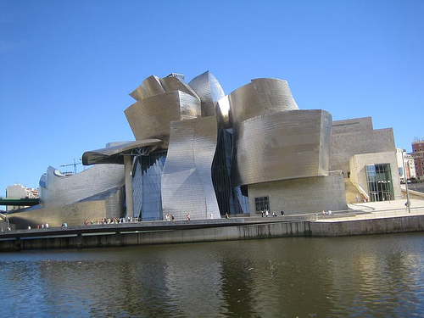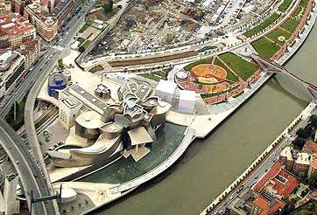
http://images.google.hr/images?hl=hr&q=Bilbao&btnG=Pretra%C5%BEi+slike&gbv=2&aq=f&oq= (accessed on April, 8 th, 2009)

The new Strategic Plan has shifted towards a qualitative approach to regeneration and the need to invest in knowledge and values as a more effective long-term strategy ‘to promote Bilbao internationally as a world-class city’. (BM30, 2005: 5, in Gonzάlez, 2006: 844). This new regeneration process run by the BM30 has been based on links between knowledge society and the process of 'glocalization'. It is oriented towards external economic competitive policy with strong respect for the cultural identity of the Basque country.
Although some might think that the above explained project might have done even better, the data presented by Plaza (2008) prove that it has made quite a success as far as tourism growth and the city's new tourism image are concerned:
- The Guggenheim Museum has played the key role in the city regeneration process; in the period from 1997 when it was opened till 2006, the number of visitors has increased from 259,234 to 1,008,774 respectively;
- The number of tourists in the province of Biscay whose capital is the city of Bilbao has grown from approx. 8,000 visitors in 1980-ties to almost 90,000 visitors; it realized 740,905 overnight stays in 2006;
- In the period from 1995 to 2005 the hotel and restaurant sector in metropolitan Bilbao gained almost 4,000 new employees, partly due to the GMB;
- The main sector that encompassed the change in employment structure in metropolitan Bilbao, the increase in jobs in knowledge intensive business services represents almost 34 % of the overall employment growth from 1995 to 2005 (Plaza, 2008).
Another approach to urban regeneration is through "cultural districts" and/or "cultural quarters". Wynne (1992: 19) describes a "cultural quarter" as being "that geographical area which contains the highest concentration of cultural and entertainment facilities in a city or town", but might include lots of other facilities such as eating and drinking establishments, entertainment facilities, retail outlets as well as other cultural venues. Smith (1992) stresses that it is of the utmost importance for any project of cultural regeneration that cultural developments are integrated into mixed-use districts designated also for offices, residential, hotel, catering, retail and recreation use rather than constructing isolated arts centres or cultural landmarks which fail to generate further economic and social benefits for the local communities. Such concentrations of different resources enable the highest visitor satisfaction and augment the value of a tourist product.
Cultural-tourist quarter is generally narrower concept than cultural-tourist cluster. Cluster makes „a group of specialised local networks through which goods, services and knowledge are exchanged“ (Law, 2002). Participants within the group are at the same time competing and cooperating. Though Michael Porter (1998) has initiated an interest for cluster research, a number of researchers used tourism as an example of an activity that proves the competitive and cooperative nature of a cluster (Maitland, 2002; Petrić, Mrnjavac, 2002; Hjalager, 2000). Russo (2001: 27-42) was one of those who analysed whether a cultural cluster could be identified in a typical tourist heritage destination and if it could be useful for the urban sustainability achievement. He stresses that the rate of tourism growth should be adjusted to the overall local economy development in order to enhance synergy between them. To this end he proposes several principles:
- The cultural tourism value chain has to be cosidered as a whole;
- Spatial dispersion of tourism benefits should be balanced by creating "cultural cluster";
- Model aims at maximizing positive effects of tourism on other sectors of urban economy;
- It is an instrument of development of a high value added sector;
- It is aimed at optimising quality rather than maximizing quantity;
- It is integral and based on a long-term approach;
- It is based on cooperation and partnership.

Partnership and co-operation between key stakeholders in the process of urban regeneration through cultural tourism

International initiatives

As competition between neighbouring cities and regions for tourist business increases, many cooperative ventures are being formed by local governments in different countries, who do not see each other as an immediate competitive threat. Transnational cooperation in the development of cultural tourism has also been promoted by a number of initiatives from the European Commission. An example of such a development is the Art Cities in Europe network which started as an initiative of the Federation of European Cities' Tourist Offices (FECTO) aiming to promote culturally motivated tourism and to establish an accessible international centralised booking infrastructure for cultural events (such as exhibitions, festivals, ballets and operas). In Croatia two cities, Split and Zagreb, are currently members of this network.
(http://www.artcities.de/content/ACE2003/en/x2city/frame_karte.html, accessed on March 17th, 2009)
Another important initiative as far as cultural urban tourism development is concerned, is 'The Cultural Capital of Europe' initiative, launched already in 1991 under the name of the European Cities of Culture. It was renamed in 1999 and is now financed through the Culture 2000 Programme. The European Parliament and Council of the EU established a Community Action for the event from 2005 to 2019 recognizing the importance of the event in strengthening local and regional identity and fostering European integration, as well as providing more tangible social and economic benefits for host cities, including development of tourism and culture. (http://ec.europa.eu/culture/our-programmes-and-actions/doc443_en.htm, accessed on March 17th, 2009)

Local level partnership in the urban tourism development

Public participation and partnerships are key elements in any process of contemporary urban planning and management. Therefore, a process of urban regeneration should be based on mobilising local communities and their key actors to share and contribute to a collective effort of improving urban areas. In many of the Mediterranean countries this would start evidently from the co-operation of different actors and stakeholders, such as public sector agencies, local authorities, regional and national agencies responsible for physical planning and urban management, as well as the residents and local community. It is widely recognised that a broader range of actors is essential in such complex undertakings, such as entrepreneurs, professional and business associations, Non Governmental Organisations, etc. Such partnerships, in the context of an urban regeneration process, could:
• provide a clear picture of a city’s characteristics, problems, prospects and needs;
• form a shared vision for the city;
• identify common needs and priorities for urban regeneration;
• promote commitment to the implementation of the project;
• generate necessary funding for project implementation and follow up (PAP/RAC, 2004)

The importance of establishing partnerships is widely recognised, especially public-private ones, as a means of securing realistic sources of urban regeneration funding, but also providing new ideas, more efficiency and entrepreneurial spirit. When talking about partnership and cooperation between tourism and culture in the process of urban regeneration, it must be stressed that in spite of a shared wish to develop culture and cultural tourism, however, there is often a lack of coordination between the different policy levels, and frequent disagreement about how policies should be implemented. Participation in cultural tourism is also strongly related to possession of cultural capital. In the case of tourism, however, the direct economic cost of participation, and the opportunity costs involved in time spent travelling, means that cultural tourism requires a higher level of investment than many other forms of cultural consumption.
The main areas of cooperation between cultural and tourism sector include:
- visitor managing in small history sites, museums and galleries, theatres and concerts;
- development of activity/places such as cultural concert halls, exhibitions, museums and art galleries or sport facilities and organized events,
- development of leisure settings such as ancient buildings and monuments, harbours, historical street pattern, parks and green areas, or ecclesiastical buildings,
- enhancement of socio-cultural features as folklore, friendliness, language, liveliness and ambience of the place, local customs and security,
- development of joint marketing efforts between cultural and tourism sector in the city aiming at branding the city.

The following scheme describes the potential relations within a cultural sector and between cultural sector and its surroundings.

Scheme 2. Cooperation of key stakeholders in a tourist city

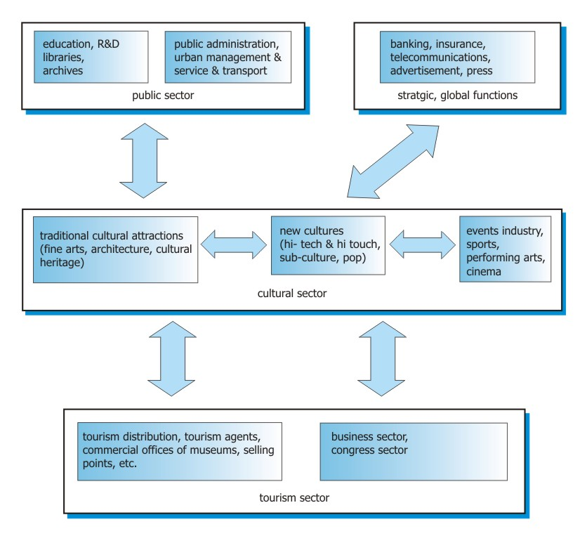
Source: According to: Russo, A. P., 2001. pp. 32.

In the middle of the scheme there is a chain representing intra - sectoral relationships between stakeholders in the cultural sector. Cooperation and the coordination process could be established between different areas of cultural supply, such as heritage sites, performances and visual art, creative industries etc. The combinations and relations between these areas can vary. For example, new technologies (audio-visual ones) are used for interpreting art and heritage attractions as a part of traditional cultural sightseeing programme. Furthermore traditional attractions can be used as attractive locations for congresses and meetings. Hi-touch industries could support highly attractive markets for MICE tourism (for example fashion, music, fairs, design and software could be very useful in development of new and highly specialised «niches»).
Other group of relations is represented by vertical connections between suppliers, producers and consumers at any level of the local cultural production value chain (from inputs such as education and research, through administration to distribution within and outside traditional channels).
The third group of networks deals with the diagonal partnership between cultural industry and other strategic sectors. The main objective of such partnership, from the perspective of the local entrepreneurs is to reach global market or to diversify their production adapting them to the local conditions (Russo, 2001; adapted by Mikulić, 2008; 50-51)
Modern information system can help communication and trust between the cluster stakeholders. Creation of a functional network is a main strategic challenge for any destination management and marketing organisation. Apparently there is a whole range of activities and processes where tourism and other key stakeholders especially those from cultural sector can cooperate. In order to enhance their cooperation and through it achieve better valorisation of cultural resources it is important to:
- Educate all the relevant stakeholders on cultural tourism issues so as to enhance their knowledge on the opportunity of making money out of cultural resources;
- Adjust cultural policy to the overall economic policy of a city and foster its implementation through public-private partnership, strategic alliances, cultural tourism development fund establishment etc.;
- Create teams of experts who would help destination managers in creating and managing cultural tourism products (such as urban environment expert group, cultural heritage expert group, marketing/promotion group of experts etc.).

Instead of conclusion:

Cities have recently faced many problems related to the ever growing trend of urbanisation rate causing environmental, spatial and social degradation. At the same time global economic crisis has devastated manufacturing industry and created structural unemployment problems. Therefore the cities need to attract new and growing activities which will provide jobs and assist their physical regeneration. To many of them 'marriage between tourism and culture' seems to be an ideal solution for future regeneration process. Not so long time ago culture has been looked upon as a set of activities focused exclusively at the group of privileged people. However, life has 'dethroned' it and showed that it is sustainable only if it serves to people and not vice versa. This is the reason why tourism has been so warmly welcomed as a new 'industry' that could help utilising culture and thus help in regenerating stumbling cities. Hence, new concepts and models of development connecting tourism and culture appeared, such as creative industries, creative cities, cultural industries and so on. What is common to all of them is that they put focus on creativity, imagination, cooperation and partnership, with the last two concepts being continuously stressed as the preconditions for the creativity to come to life. Croatian recent practice confirms that the potential of none of these concepts has been fully recognized yet. Therefore, many of Croatian tourist cities with plenty of exquisite cultural resources (Split, Trogir, Dubrovnik, Šibenik, Zadar) have not utilised them adequately, neither for the needs of the locals nor for the needs of tourists who come to visit them. These resources have not been transformed into cultural products. Many of them simply exist and very few attempts to restore them, re-imagine and re-brand them, to interpret and present them in a new way have been noticed so far. Unfortunately, most of our dilemmas as far as the utilisation of cultural resources is concerned, is the issue of working hours. This is, with no doubts, also one of the important issues but far from being the crucial one. In the situation when new opportunities for development have to be found and used, as the old ones are continuously loosing their importance, Croatian cities can't miss the opportunity to become the 'real cultural tourism destinations'. This is not only the question of "how much tourism we want" but "if not tourism, culture and other creative/cultural industries... what else do we have"?

Literature:

- Cunningham, S., From Cultural to Creative Industries: Theory, Industry, and Policy Implications; http://test.eprints.qut.edu.au/588/1/cunningham_from.pdf, accessed on March, 23rd, 2009
- DCMS (2005), “Creative Industries” Section, (UK Government) Department for Culture, Media and Sport ; http://www.culture.gov.uk/what_we_do/creative_industries/ (accessed on March 15th. 2009)
- Evans, Graeme (2001), Cultural Planning: An Urban Renaissance? London:Routledge.
- Bianchini and M. Parkinson (eds), Cultural Policy and Urban Regeneration - The West European Experience, Manchester-New York: Manchester University Press
- Gligorijević, Ž. (2006), Forces and Trends Shaping the Contemporary City: The Creative Sector in Creative Cities. In Švob-Đokić, N. (Ed.) Cultural Transitions in South-eastern Europe. The Creative City: Crossing Vision and New Realities in the Region: collection of papers from the course, Dubrovnik, 2006. Institute for International Relations, Zagreb, pp. 22.
- Gonzάlez, S. (2006), Scalar Narratives in Bilbao: A Cultural Politics of Scales Approach to the Study of Urban policy, International Journal of Urban and Regional Research, 30 (4), 836-857
- Hjalager, A. M., Tourism destinations and the concept of industrial districts, 2000, Tourism and Hospitality Research 2(3), 199–213
- http://images.google.hr/images?hl=hr&q=Inner%20Harbour%20in%20Baltimore&um=1&ie=UTF-8&sa=N&tab=wi; accessed on March 14th, 2009
- http://images.google.hr/images?hl=hr&q=Bilbao&btnG=Pretra%C5%BEi+slike&gbv=2&aq=f&oq= (accessed on April, 8 th, 2009)
- Landry, C. (1999), From Barriers to Bridges: Re-imagining Croatian Cultural Policy. Report of a European Panel of Examiners, Strasbourg: Council for Cultural Co-operation, Council of Europe
- Landry, C. (2000), The Creative City: A Toolkit for Urban Innovations, Comedia, Earthscan, London
- Law, C. M., (2002), Urban Tourism - The Visitor Economy and the Growth of Large Cities, Continuum, London and New York,
- Maitland, R, (2002), Stvaranje uspješne suradnje u urbanim turističkim destinacijama: primjer Cambridga, Turizam, 50 (3), str. 295-304
- Paskaleva-Shapira, K., (2001) Innovative partnerships for Sustainable Urban Tourism; Framework Approach and the European Experience, 'Creating and Managing Growth in Travel and Tourism’ TTRA European Conference, Stockholm, Sweden, April 2001; http://bibemp2.us.es/turismo/turismonet1/economia%20del%20turismo/turismo%20de%20ciudades/innovative%20patnerships%20for%20sustanaible%20urban%20tourism%20europe%20experience.pdf; accessed on march 20th 2009.
- Petrić, L., Mrnjavac, Ž. (2003), Turistička destinacija kao lokalno ukorijenjen sustav, Turizam, 51 (4), 375-387
- Porter, M.E. (1998), Clusters and the New Economics of Competitiveness, Harvard Business review, Nov-Dec, 77-90, prema Maitland, R., op.cit., 2002., str. 296.
- Plaza, B. (2008), On Some Challenges and Conditions for the Guggenheim Museum Bilbao to be an Effective Economic Re-activator, International Journal of Urban and Regional Research, Vol. 32 (2), 506-17
- Pratt, A.C. (2008): Creative cities: the cultural industries and the creative class, Geografiska Annaler: Series B, Human Geography 90 (2): 107–117.
- Priority Actions Programme / Regional Activity Centre, (2004), Guidelines for Urban regeneration in the Mediterranean Region, Split
- Richards, G., ed. (1996) Cultural Tourism in Europe, CABI, Wallingford
- Russo, A. P., (2001), Cultural Clusters and Tourism Development: the Challenge of Venice. In: Jelinčić, D.A. (Ed.) Culture: A Driving Force for Urban Tourism – Applications of Experiences to Countries in Transition. Proceedings of the 1st international seminar on Culture. Dubrovnik, 18-19 May 2001. Institute for International Relations, Zagreb, 27-42
- Smith, M. K. (2003), Issues in Cultural tourism Studies, Routledge , Taylor and Francis Group London and New York
- Šimunović, I., (2007) , Urbana ekonomika, petnaest tema o gradu, Školska knjiga Zagreb
- Tomić-Koludrović, I., Petrić, M. (2005), Creative Industries In Transition: Towards a Creative Economy? in Švob-Đokić, N. (ed.) The Emerging Creative Industries in Southeastern Europe, Zagreb, Institut za međunarodne odnose, pp.13.
- UNESCO Creative city Network: http://portal.unesco.org/culture/en/ev.php._URL_ID=28053&URL_DO=DO_TOPIC&URL_SECTION=201.htm, accessed on March 15th, 2009)
- Varbanova, L. (2006), Our Creative Cities Online. In Švob-Đokić, N. (Ed.) Cultural Transitions in Southeastern Europe. The Creative City: Crossing Vision and New Realities in the Region: collection of papers from the course, Dubrovnik, 2006. Institute for International Relations, Zagreb, pp. 9.
- Wynne, D. (1992), The Culture Industry; The Arts in Urban Regeneration, Aldershot: Avebury

