Salih Katircioglu∗ UDK 339.727.22:338.1(560)
Original scientific paper
Izvorni znanstveni rad

FOREIGN DIRECT INVESTMENT AND ECONOMIC GROWTH IN TURKEY: AN EMPIRICAL INVESTIGATION BY THE BOUNDS TEST FOR CO-INTEGRATION AND CAUSALITY TESTS

ABSTRACT

This paper empirically investigates the level relationship and the direction of causality between net foreign direct investment (FDI) inflows and economic growth in Turkey by using the bounds test for co-integration and Granger causality tests. Results suggest that both variables are in long-run equilibrium relationship only when FDI is dependent variable under the ARDL (auto-regressive distributed lag) modeling approach. Final investigation in the paper is that economic expansion in Turkey stimulates expansion in net FDI inflows.

JEL: C22; C51; F43.

Key Words: FDI, Economic Growth, Bounds Test, Granger Causality, Turkey.

1. Introduction

The theoretical and empirical literature on the relationship between FDI and economic growth is quite extensive. FDI is often seen as an important catalyst for economic growth (Le and Suruga, 2005). Majority of empirical studies focuses on the effect of FDI on economic growth. Thus, the causal link from FDI to growth has been popular in the relevant literature. However, as also mentioned by Chakkaborty and Basu (2002), the causal link from economic growth to FDI and feedback relationship between FDI and economic growth deserves further attention. So, the direction of the relationship between FDI and economic growth needs to be further emphasized, because, FDI related spillover of knowledge promotes economic growth and economic growth in turn attracts more FDI (Chakkaborty and Basu, 2002).

Empirical studies in the literature investigated the FDI – growth nexus such as Le and Suruga (2005), Durham (2004), Borensztein et al. (1998) and Balasubramanyam et al. (1996). They generally confirmed the possibility of positive impact of FDI on economic growth through some mechanisms such as technology upgrading progress, human capital, absorptive capacity of the host country, and trade policy adopted by the host country. In these studies authors suggest that FDI can have positive but indirect impact on economic growth where they generally studied panel of countries. On the other hand, Le and Suruga (2005) suggest that FDI, public capital and private investment play important roles in promoting economic growth in the case of India. They also found that excessive spending in public capital expenditure can hinder the beneficial effects of FDI.

This article investigates long-run equilibrium relationship and the direction of causal link between FDI and economic growth for Turkey, which has a developing economy, strategic geographical location, and about 8,800 USD per capita income (GDP) in current prices (World Bank, 2009). Turkey had a highly volatile economy in the history, but its economy has started to stabilize during a one party period since 2002. Exports and imports of goods and services constituted 22% and 27% of GDP respectively in 2007. Inflation is about 5.73% according to consumer prices.

Figure 1

Net FDI Inflows (in million USD prices) to Turkey during 1960-2006

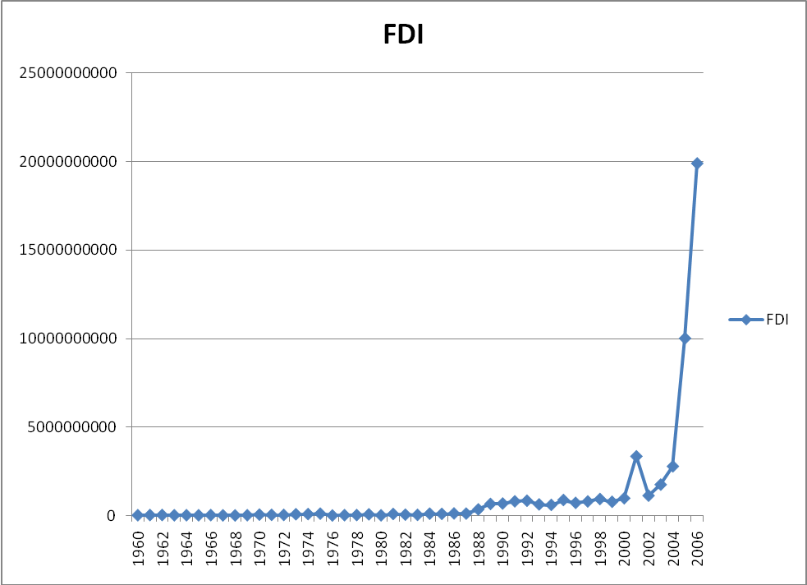
Source: Word Bank, 2009.

FDI inflows also showed a tremendous increase in the Turkish economy after 2002 as a result of successful economic policies of government as also can be seen from Figure 1. Net FDI inflows reached to a maximum of 22.19 million USD in the history, which consituted 3.38% of GDP in 2007. Thus, this study is important to identify empirical relationship between FDI and real income growth in the case of such developing country like Turkey.

The paper proceeds as follows. Section II defines data and methodology of the study. Section III provides results and discussions and the paper concludes with Section IV.

2. Data and Methodology

Data used in this paper are annual figures covering the period 1970 – 2005 and variables of the study are real gross domestic product (GDP) and net FDI inflows. Data are taken from World Bank Development Indicators (World Bank, 2009) and both variables are at 2000 constant US $ prices.

The Augmented Dickey-Fuller (ADF) and Phillips-Perron (PP) Unit Root Tests are employed to test the integration level and the possible co-integration among the variables (Dickey and Fuller 1981; Phillips and Perron 1988). The PP procedures, which compute a residual variance that is robust to auto-correlation, are applied to test for unit roots as an alternative to ADF unit root test.

To investigate a long-run relationship between each pair of variables under consideration, the bounds test for co-integration within ARDL (the autoregressive distributed lag) modeling approach was adopted in this study. This model was developed by Pesaran et al. (2001) and can be applied irrespective of the order of integration of the variables (irrespective of whether regressors are purely I (0), purely I (1) or mutually co-integrated). The ARDL modeling approach involves estimating the following error correction models:

$Δ\text{ln}Y_{t}=a_{0_{Y}}+\sum_{i=1}^{n}{b_{i_{Y}}Δ\text{ln}Y_{t−i}+\sum_{i=0}^{n}{c_{i_{Y}}Δ\text{ln}X_{t−i}+σ_{1_{Y}}\text{ln}Y_{t−1}+}}σ_{2_{Y}}\text{ln}X_{t−i}+ε_{1t}$ (1)

$Δ\text{ln}X_{t}=a_{0_{X}}+\sum_{i=1}^{n}{b_{i_{X}}Δ\text{ln}X_{t−i}+\sum_{i=0}^{n}{c_{i_{X}}Δ\text{ln}Y_{t−i}+ϖ_{1_{X}}\text{ln}X_{t−1}+}}ϖ_{2_{X}}\text{ln}Y_{t−i}+ε_{2t}$ (2)

In equations (1) and (2), ∆ is the difference operator, Y_{t} is the log of dependent variable, X_{t} is the log of independent variable and ε_{1t} and ε_{2t} are serially independent random errors with mean zero and finite covariance matrix.

Again in equations (1) and (2), the F-test is used for investigating a level (long-run) relationship between dependent variable and its regressors. In the case of a long-run relationship, the F-test indicates which variable should be normalized. In Equation (1), when Y is the dependent variable, the null hypothesis of no co-integration is H₀: σ_{1Y} = σ_{2Y} = 0 and the alternative hypothesis of co-integration is H₁: σ_{1Y} ≠ σ_{2Y} ≠ 0. On the other hand, in Equation (2), when X is the dependent variable, the null hypothesis of no co-integration is H₀: ϖ_{1Y} = ϖ_{2Y} = 0 and the alternative hypothesis of co-integration is H₁: ϖ_{1Y} ≠ ϖ_{2Y} ≠ 0.

In the presence of co-integration based on the bounds test, the Granger causality tests should be done under vector error correction model (VECM) when the variables under consideration are co-integrated. By doing so, the short-run deviations of series from their long-run equilibrium path are also captured by including an error correction term (See also Narayan and Smyth, 2004). On the other hand, in the absence of co-integration, then, the Granger causality tests should be done under vector autoregressive (VAR) model. The VAR model can be specified as equation (3) where Y is the dependent variable, and the VECM can be specified as equation (4) where X is the dependent variable:

$Δ\text{ln}Y_{t}=α_{0}+ϕ_{\text{11}}^{p}\left(L\right)Δ\text{ln}Y_{t}+ϕ_{\text{12}}^{q}\left(L\right)Δ\text{ln}X_{t}+μ_{1t}$ (3)

$Δ\text{ln}X_{t}=α_{1}+ϕ_{\text{21}}^{p}\left(L\right)Δ\text{ln}X_{t}+ϕ_{\text{22}}^{q}\left(L\right)Δ\text{ln}Y_{t}+δ{\text{ECT}}_{t−1}+μ_{2t}$ (4)

Where

$ϕ_{\text{ij}}^{p}\left(L\right)=\sum_{n=1}^{P_{\text{ij}}}{ϕ_{\text{ijn}}L^{1}}$ $ϕ_{\text{ij}}^{q}\left(L\right)=\sum_{n=1}^{Q_{\text{ij}}}{ϕ_{\text{ijn}}L^{1}}$
$ϕ_{\text{21}}^{p}\left(L\right)=\sum_{i=1}^{P_{\text{21}}}{ϕ_{\text{21},i}^{p}L^{i}}$ $ϕ_{\text{22}}^{p}\left(L\right)=\sum_{i=0}^{P_{\text{22}}}{ϕ_{\text{22},i}^{p}L^{i}}$

In equations (3) and (4), ∆ denotes the difference operator and L denotes the lag operator where, for example, (L)∆lnY_{t} = ∆lnY_{t-1}. ECT_{t-1} is the lagged error correction term derived from the long-run co-integration model. Finally, μ_{1t} and μ_{2t} are serially independent random errors with mean zero and finite covariance matrix. Finally, according to the VAR model for causality test, having statistically significant F value in equation (3) and according to VECM for causality test, having statistically significant both F and t ratios for ECT_{t-1} in equations (4) would be enough condition to have causation from X to Y and from Y to X respectively.

2. Empirical Results

Table 1 gives ADF and PP unit root test results for net FDI inflows and GDP. Real GDP is non-stationary both in ADF and PP tests at level but stationary at first difference, that is integrated of order one, I(1). PP test suggest that FDI variable is integrated of order zero, I (0). However, this is not justified by ADF test. PP test will be taken into consideration for FDI variable due to the fact that PP procedures compute a residual variance that is robust to auto-correlation and are applied to test for unit roots as an alternative to ADF unit root test.

Table 1.

ADF and PP Tests for Unit Root

Statistics (Levels) | ln y | Lag | ln FDI | lag
τ_{T} (ADF) | -2.92 | (0) | -3.30*** | (4)
τ_{μ} (ADF) | -0.62 | (0) | -0.58 | (4)
τ (ADF) | 5.75 | (0) | 1.19 | (2)
τ_{T} (PP) | -2.92 | (0) | -3.57** | (1)
τ_{μ} (PP) | -0.62 | (0) | -0.84 | (1)
τ (PP) | 6.16 | (1) | 1.11 | (13)
Statistics  (First Differences) | ∆ln y | Lag | ∆ln T | lag
τ_{T} (ADF) | -6.34* | (0) | -5.74* | (1)
τ_{μ} (ADF) | -6.43* | (0) | -5.65* | (1)
τ (ADF) | -1.22 | (2) | -2.26** | (3)
τ_{T} (PP) | -6.33* | (2) | -10.65* | (3)
τ_{μ} (PP) | -6.42* | (2) | -9.78* | (1)
τ (PP) | -3.78* | (4) | -9.67* | (1)
Note: y represents real gross domestic product; FDI is net inflows of foreign direct investment τ_{T} represents the most general model with a drift and trend; τ_{μ} is the model with a drift and without trend; τ is the most restricted model without a drift and trend. Numbers in brackets are lag lengths used in ADF test (as determined by AIC) to remove serial correlation in the residuals. When using PP test, numbers in brackets represent Newey-West Bandwith (as determined by Bartlett-Kernel).
*, ** and *** denote rejection of the null hypothesis at the 1%, 5% and 10% levels respectively.
Tests for unit roots have been carried out in E-VIEWS 5.1.

Now having the fact that FDI variable is stationary at level while real GDP is stationary at first difference for Turkey, long-run equilibrium relationship will be now investigated by using the bounds test for co-integration within ARDL modeling approach. Table 3 gives results of the bounds test for co-integration between net FDI inflows and real GDP for Turkey under three different scenarios as also suggested by Pesaran et al. (2001: 295-296), that are with restricted deterministic trends (F_{IV}), with unrestricted deterministic trends (F_{V}) and without deterministic trends (F_{III}). Intercepts in these scenarios are all unrestricted. Critical values for F and t statistics are presented in Table 2 as taken from Pesaran et al. (2001) to be used in this study.

Table 2.

Critical Values for ARDL Modeling Approach

 | 0.10 |  |  | 0.05 |  |  | 0.01
k = 2 | I (0) | I (1) |  | I (0) | I (1) |  | I (0) | I (1)
F_{IV} | 3.38 | 4.02 |  | 3.88 | 4.61 |  | 4.99 | 5.85
F_{V} | 4.19 | 5.06 |  | 4.87 | 5.85 |  | 6.34 | 7.52
F_{III} | 3.17 | 4.14 |  | 3.79 | 4.85 |  | 5.15 | 6.36
t_{V} | -3.13 | -3.63 |  | -3.41 | -3.95 |  | -3.96 | -4.53
t_{III} | -2.57 | -3.21 |  | -2.86 | -3.53 |  | -3.43 | -4.10
Source: Pesaran et al. (2001): pp. 300-301 for F-statistics and pp. 303-304 for t ratios.
Note: k is the number of regressors for dependent variable in ARDL models, F_{IV} represents the F statistic of the model with unrestricted intercept and restricted trend, F_{V} represents the F statistic of the model with unrestricted intercept and trend, and F_{III} represents the F statistic of the model with unrestricted intercept and no trend. t_{V} and t_{III} are the t ratios for testing σ_{1Y} = 0 in Equation (5) and ϖ_{1Y} = 0 in Equation (6) respectively with and without deterministic linear trend.

Results in Table 4 suggest that the application of the bounds F-test using ARDL modeling approach does not suggest the existence of a level relationship (long-run relationship) between real GDP and net FDI inflows when FDI is dependent variable since the null hypothesis of H₀: σ_{1Y} = σ_{2Y} = 0 is accepted. On the other hand, the bounds F-test suggest the existence of a level relationship between real GDP and net FDI inflows when real GDP is dependent variable since the null hypothesis of H₀: ϖ_{1Y} = ϖ_{2Y} = 0 is rejected according to F_{IV} scenario at 0.01 level. On the other hand, the results from the application of the bounds t-test in each ARDL model are less clear-cut and do not generally allow the imposition of the trend restrictions in the models since they are not statistically significant (See Pesaran et al., 2001: 312).

Table 3.

Bounds Test for Cointegration

 | With  Deterministic Trends |  |  |  | Without Deterministic Trend
Variables | F_{IV} | F_{V} | t_{V} |  | F_{III} | t_{III} | Conclusion
 |  |  |  |  |  |  | H₀
y and FDI
F_{y} (y / FDI) | 2.82ª | 2.28ª | -2.64ª |  | 1.41ª | -1.41ª | Accepted
F_{FDI} (FDI / y) | 4.20^{c} | 3.69ª | -2.18ª |  | 4.03^{b} | -1.95ª | Rejected
Note: Akaike Information Criterion (AIC) and Schwartz Criteria (SC) were used to select the number of lags required in the co-integration test. Both gave the same level of lag order, VAR= 1. F_{IV} represents the F statistic of the model with unrestricted intercept and restricted trend, F_{V} represents the F statistic of the model with unrestricted intercept and trend, and F_{III} represents the F statistic of the model with unrestricted intercept and no trend. t_{V} and t_{III} are the t ratios for testing σ_{1Y} = 0 in Equation (5) and ϖ_{1Y} = 0 in Equation (6) respectively with and without deterministic linear trend. ª indicates that the statistic lies below the lower bound, ^{b} that it falls within the lower and upper bounds, and ^{c} that it lies above the upper bound.

On the basis of the bounds test results for co-integration, the Granger causality tests require a VAR model in the case of (y / FDI) where real GDP is dependent variable and a VECM in the case of (FDI / y) where FDI is dependent variable. There are methods for lag length selection in the recent literature such as AIC (Akaike Information), SIC (Schwartz Information Criterion) and Hsiao’s (1979) sequential procedure (which combines Granger’s definition of causality and Akaike’s minimum final prediction error (FPE) criterion). However, due to the limited number of observations in this study, maximum lag is set to 3 and both VAR and VEC models were estimated for each lag length. Pindyck and Rubinheld (1991) also point out that it would be best to run the test for a few different lag structures and make sure that the results were not sensitive to the choice of lag length.

Table 4.

Granger Causality Tests

Lag Level | 1 |  | 2 |  | 3
Null Hypothesis | F – Stat | t_{ECTt-1} | F – Stat | t_{ECTt-1} | F – Stat | t_{ECTt-1} | Result
y and FDI
FDI does not Granger cause y | 0.10 | - | 0.08 | - | 0.29 | - | y ⇒ FDI
y does not Granger cause FDI | 6.44* | -2.81* | 3.68** | -2.49** | 2.96** | -2.85*
Note: 1. *, and ** significance at 1% and 5% levels respectively.

Results in Table 4 suggest unidirectional causation in the long-run that runs from real GDP growth to net FDI growth in the case of Turkey. Short-run causation from FDI to real GDP growth is not confirmed since F statistics in the VAR model in Table 4 are not statistically significant in any lag length where both F and t statistics in the VECM are statistically significant in all of the lag lengths as a long-run estimation. Therefore, there is strong evidence that a growth in real income stimulates a growth in net FDI flows to Turkey.

3. Conclusion

This paper empirically investigated long run equilibrium relationship between real GDP growth and net FDI growth by using the bounds test for co-integration in Turkey. Results suggest that these two variables are only co-integrated when net FDI inflows are dependent variable in the ARDL model. Furthermore, the results of causality test using VECM suggest unidirectional causation from real GDP growth to net FDI growth in Turkey. Thus, it is important to mention that economic expansion in Turkey stimulates net FDI inflows. The highly volatile Turkish economy has started to stabilize apart from 2000s once single party government period is experienced after long years of coalition parties’ governments. Having this opportunity, successful economic policies have been implemented in Turkey since then. Statistical figures also show that there is tremendous increase and improvement in bet FDI inflows to Turkey apart from 2000s. Thus, the results of this study have also shown that FDI growth in Turkey is stimulated by economic expansion. Having this major finding in the present study, a further research is recommended to be done on through which channels FDI is stimulated in the case of Turkey.

REFERENCES

Chakraborty, C. and Basu, P. (2002) Foreign direct investment and growth in
India: a co-integration approach, Applied Economics, 34, 1061 – 73.
Dickey, D. and Fuller, W.A. (1981) Likelihood ratio statistics for autoregressive
time series with a unit root, Econometrica, 49, 1057-72.
Hsiao, C. (1979) Causality in econometrics, Journal of Economic Dynamics and
Control, November, 321-46.
Le, M. V. and Suruga, T. (2005) Foreign direct investment, public expenditure
and economic growth: the empirical evidence for the period 1970-2001, Applied Economics Letters, 12, 45 – 49.
Narayan, P. K. and Smyth, R. (2004) The relationship between the real exchange
rate and balance of payments: empirical evidence for China from co-integration and causality testing, Applied Economic Letters, 11, 287 – 91.
Pesaran, M. H., Shin, Y. and Smith, R. J. (2001) Bounds testing approaches to the
analysis of level relationships, Journal of Applied Econometrics, 16, 289 – 326.
Phillips, P. C. B. and Perron, P. (1988) Testing for a unit root in time series
regression, Biometrica, 75, 335-46.
Pindyck, R. S. and D. L. Rubinfeld, (1991) Models and Economic Forecasts,
McGraw-Hill Inc.
World Bank (2009) World Development Indicators, CD-ROM database.

IZRAVNA STRANA ULAGANJA I GOSPODARSKI RAST U TURSKOJ: EMPIRIJSKO ISTRAŽIVANJE POMOĆU GRANIČNOG TESTA ZA KOINTEGRACIJU I TESTA KAUZALNOSTI

SAŽETAK

Rad empirijski istražuje razinu odnosa i smjer kauzalnosti između prihoda od izravnih stranih ulaganja (FDI) i gospodarskog rasta u Turskoj koristeći granični test za kointegraciju i Grangerov test kauzalnosti. Rezultati ukazuju na to da su obje varijable u dugotrajnom uravnoteženom odnosu samo kad su izravna strana ulaganja ovisna varijabla po ARDL (autoregresijski model s distribuiranim vremenskim pomakom) pristupu. Zaključak rada je da gospodarska ekspanzija u Turskoj stimulira ekspanziju neto priljeva od izravnih stranih ulaganja.

JEL: C22; C51; F43.
Ključne riječi: FDI (izravna strana ulaganja), gospodarski rast, granični test, Granger kauzalnost, Turska

 Associate Professor of Economics, Department of Banking and Finance, Eastern Mediterranean University, P.O. Box 95, Famagusta, North Cyprus,Via Mersin 10, Turkey, Tel: +90 392 630 2008, Fax: +90 392 630 2032, e-mail: salihk@emu.edu.tr Članak primljen u uredništvo: 10.5.2009.
PP approach allows for the presence of unknown forms of autocorrelation with a structural break in the time series and conditional heteroscedasticity in the error term.
For detailed information, please refer to Pesaran et al. (2001), pp. 295-296.

