Tina Jakaša UDK 65.01
Diana Bratić Original scientific paper
Fivos Iliopoulos Izvorni znanstveni rad

THE IMPACT OF CHANGING BUSINESS ENVIRONMENT ON RISK TYPES

ABSTRACT

The changes in business environment resulted in new types of risks in the electric power companies. Therefore, it is very important for electric power companies to identify risks and to find correlations between them on a regular basis, so as to protect and increase the company value. This paper proposes the following three hypothesises: H1 There are changes in types of risks in electric power companies in the course of the last decade. H2 There is a correlation between the intensity of market competition and the impact of the present types of risks. H3 There is a correlation between present types of risks in electric power companies. All theses were proven to be true. Moreover, we identified the most critical risks that the electric power companies are facing today, and have compared them with those of a decade ago. We explored the intensity of market competition and examined a relationship with different types of risks.

Keywords: Power Companies, Market competitive intensity, Changing business environment, Risk type

I. INTRODUCTION

A decade ago electrical power companies operated in a stable environment and held monopoly positions on the market. In 1990 the energy market opening has started by adopting the Directive to improve the transparency of gas and electricity prices charged to industrial end-users.
After a short while the first Directive for electricity was adopted in 1996, setting the rules for creating an internal electricity market. The initial goal was to open 33% of the electricity market by February 2003.
In 2003 the second Directive for electricity was adopted to stimulate the market opening defining a new threshold for market opening, 1st of July 2007 for all customers.
Liberalisation of electricity markets has resulted in dramatic change in business environment characterized by the following: changes in energy regulatory policies, introduction of competition and a subsequent loss in market share, increased customer demand; price volatility of electricity, fuel and CO₂ emissions; difficulties in securing fuel supply routes, changes in quota policies for CO₂ emissions, difficulties in securing adequate transmission facilities at acceptable prices etc.
Therefore, in order to achieve an effective risk management system in electrical power companies, it is a vital to understand these changes and to identify the most critical risks from aspect of business performance. Risk management protects and adds value to the organization and its stakeholders and it is a factor of business performance [1].
In this paper three hypothesis are proposed.
H1 There is a change of risk types in electrical power companies over a decade.
H2 There is a correlation between market competitive intensity and the impact of the present risk types.
H3 There is a correlation between present risk types in electrical power companies.
In order to tests these hypotheses, we used the results from the survey conducted in 1995 by Unipede and the results from our research completed in 2007.
The main goals of this paper are to examine the most important risks today for electricity industry as well as to identify the changes in risk types due to changes in business environment over the decade.

II. THE MOST CRITICAL RISKS A DECADE AGO IN THE ELECTRICAL POWER COMPANIES

Professional organization UNIPEDE (Union de producteur et distributeur d’Europe) was the professional association which represents the common interests of the electricity industry. The organization has been founded in 1925 in Paris. At the UNIPEDE level, Steering Committee in 1994 set up a Task force whose objectives were [2]:
- to create a framework that allows the collection and exchange of information on how Risk Management is being applied in the UNIPEDE member companies,
- to exchange experience,
- to stimulate the implementation of Risk Management.

Task force, together with Datamonitor from London conducted a survey in 1995 [2]. The survey included 133 companies in 45 countries. The final sample included 85 companies from 31 countries. Therefore the response rate was 61%. The results indicated the most critical risks for power companies at that time.
Respondents were asked to rank the three most critical risks of those listed. The results were analyzed using a weighted average. Percentage ranking was generated by summing the proportion of 1st place risks + proportion of 2nd place risks x 0,5 + proportion of 3rd place risks x 0,25.

Figure 1
The most critical risks in order of importance

31,7% of participants listed environmental risks among the top three most critical risks to their company’s viability and profitability followed by employee and public safety.
Political risk was considered also critical, especially by companies in countries which suffered increased legislative and market uncertainties on account of international political activity. Other significant risks include market competition and regulation risks placing business interruption risks as well as corporate image risks in management focus.

III. EMPIRIC RESEARCH OF RISK MANAGEMENT SYSTEM IN POWER COMPANIES

Basic Research Information
Research officially commenced in November 2006. The collection phase was completed in July 2007, and the data was processed using the software solution SPSS, version 15.0. Initial pattern included seventy-seven participants from Power Utilities, 21 of whom answered the questionnaire (response rate: 27.3%).
Datamonitor is the leading provider of online data and analytic platforms for key industrial sector. Its clients are five thousand of the world's leading companies. Croatian Power Utility is one of Datamonitor’s clients, it has access to its knowledge base. For the purpose of this research Datamonitor prepared a contact list according to defined criteria. In addition to primary data sources, secondary data sources were also used such as company news, company annual reports published on the Internet and in journals, as well as materials from professional organizations (ERGEG, Eurelectric etc.), other available researches and studies etc.
During the research, different scientific methods were used as following:
- a method using a questionnaire in which data, information, attitudes and opinions on the topic of the investigation were gathered about the investigated subjects [3],
- a statistical method by which phenomena are analyzed, indices are calculated, correlations are found etc., with the goal of determining their structure, characteristics and the patterns among the phenomena [4],
- a verification method, used to find arguments for verifying specific hypotheses and
- other methods such as methods for analysis and synthesis, inductive methods, descriptive methods etc.

The Research Sample
The research sample was chosen according to the following criteria:
- the number of company employees engaged in risk management,
- the size of the electrical company.

Table I represents geographical distribution of the power companies. Nine of them operate in countries of the European Union, two countries are candidates for EU membership or have applied for accession to the European Union (Croatia, Bosnia and Herzegovina), and two countries are not EU members (Switzerland and Norway) [5]

Table 1
Geographical distibution of the power companies in the final sample

Country | Total Number
Austria | 2
Bosnia and Herzegovina | 1
Finland | 1
France | 1
Croatia | 1
Ireland | 1
the Netherlands | 2
Norway | 4
Portugal | 1
Slovenia | 2
Sweden | 2
Switzerland | 3
Total | 21

In the preparation of contacts, it was taken into account that the target group should be the managers who manage risk in the companies and who have sufficient knowledge and access to information in this area in order to provide us with an accurate picture of risk management in electrical power companies. Of the total number of contacts (seventy-seven), thirty-one of them (or 36% of the research subjects) are risk managers in their companies, two of them lead risk management organizational units, four are risk managers at the corporate level, twenty-three are chief finance officers and the remaining twenty-six are engaged in operations related to risk (trade, supply etc.) or are part of general management.

Table 2
Functions of the participants interviewed in power companies

By analyzing final sample, as presented in Table II [5], we can conclude that eleven participants are closely related to risk management activities in their companies, which amounts to 52.4% of the total number. Four participants were risk managers in electrical companies. The others were related to business areas including trade, supply, finance, controlling, etc. and various managerial functions. The reason for this is the fact that risk management is at various stages of development in these companies. Companies that have developed risk management systems also have independent risk management units, while risk management in the other companies is a part of other business functions such as finance etc.
If we examine the sample from the aspect of company size, we can conclude that seven large companies (33.3%), one medium-large, five medium-sized, six medium-small and two small companies are represented [5].

Table 3
Number of employees in the power companies of the sample

IV. METHOD FOR DEVELOPING THE MARKET COMPETITIVE INTENSITY, MCI, FOR ELECTRICITY MARKETS

Market competitive intensity, MCI, for electricity markets was taken from Datamonitor to describe and evaluate the impact of business environment in terms of electricity market liberalization on electrical power companies [6]. The Datamonitor research was conducted on twenty European electricity markets. The goal of the research was to determine the degree of market openness on the electricity market. The research began in mid 2005 and lasted until mid 2006. In the first phase, the results of a hundred interviews of experts were collected and verified, and in the second phase the results were reviewed and classified.
The MCI is calculated using the following nine metrics (measurements):

- the effectiveness of the regulator,
- the ease of third-party access to the network,
- the effectiveness of balancing and data transfer,
- wholesale market fragmentation,
- retail market fragmentation,
- traded market maturity,
- access to market information and assistance,
- consumer representation,
- propensity to switch suppliers.

These metrics have been divided into three groups:
- market framework,
- supplier push and
- customer pull.

The professional interviewed was scored according to each of these nine metrics on a scale of 0 − 10. To calculate the overall score, i.e. the market competitive intensity index, the following two methods were employed:

- Simple additive measure – the score of each underlying factor is weighted by the importance of that factor. By adding together all the final index scores, the MCI is obtained:
$\text{MCI}=\sum_{i=1}^{9}{z_{i}}$. (2)

- The multiplicative measure – an alternative method to the additive measure, uses the multiplicative measure with the application of the following formula:
$\text{MCI}=\prod_{i=1}^{9}{z_{i}}$, $z={\text{xi}}^{\text{yi}}$. (3)
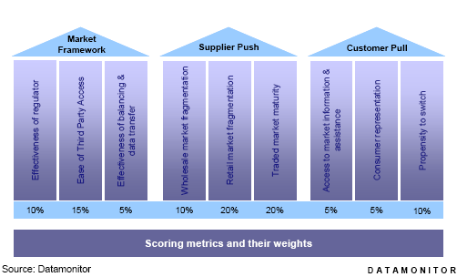

Figure 2 − Calculation of the MCI using nine weighted factors [6]

Figure 2 − Calculation of the MCI using nine weighted factors [6]

The results of the research indicate that the electricity market is the most developed in the United Kingdom, i.e. that there are a large number of competitors on the market. Regardless of the dynamics of the opening of markets in the European Union, according to which as of July 1, 2004, all customers except households can freely choose their electricity supplier, the degree of market openness is still low in the majority of the countries of the European Union, as evident from Figure 2.

Figure 3
Total MCI of electricity markets [6]
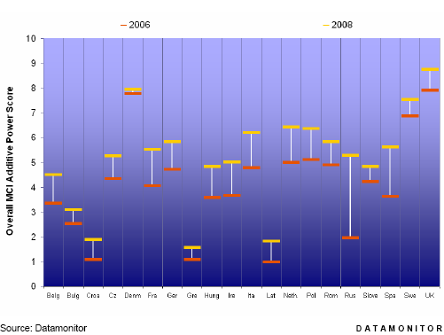

In Figure 3, the results for the year 2006 are presented in red and for the year 2008 in yellow. From the figure, it is evident that there are clusters around a score of 5, indicating that the countries of the European Union have nonetheless begun the process of opening the electricity markets. The highest scores were obtained by the United Kingdom, Sweden and Denmark. The total score of Sweden was greatly influenced by the existence of a very mature and liquid wholesale electricity market. Reasons for the slow opening of markets differ for each country but they all have monopolistic electrical power companies, disinterested customers and a dearth of knowledge concerning the process of changing suppliers [6].

V. DEFINITION OF RISK TYPES

In order to understand the results of analysis, it is necessary to define a few risk types.
Market risk: Risk of financial gain or loss due to exposure to fluctuations in market prices. The four standard market risks are: interest rate risk, or the risk that interest rates will change; currency risk, or the risk that foreign exchange rates will change; equity index risk, or the risk that stocks or other index prices will change; and commodity risk, or the risk that commodity prices (e.g., energy, emission rights, bio-fuels, metals) will change [7].
Credit risk: Risk of loss due to a counterparty defaulting on a contract or, more generally, risk due to uncertainty about a counterparty's ability or willingness to meet its obligations (contractual disputes and arbitration due to operational issues are usually covered in operational risk) [7].
(Commodity) price risk: the risk of prices rising above the projected or “trend” level, as a result of which the overall energy cost increases to an extent that compromises the user’s cash flow and/or profitability [8];
Load risk: the risk of consuming high volumes of energy at peak price times although the average market price may remain unchanged compared with the projected level, the unfavourable timings of peak periods may still result in significantly increased costs [8];
Volumetric risk: the risk of actual energy demand exceeding the projected, and previously secured, level, which often necessitates purchasing the volume shortfall at a higher price [8];
Balancing risk: the risk of the actual physical position differing from the position previously declared to the wholesale market operator, which in certain markets may result in heavy fines [8].
Currency risk: Risk caused by payments in foreign currency of fuel and electricity, etc. therefore this correlation was expected.
Most published papers analyze management of specific risk type and particularly electricity price risk. There are many papers discussed price risk volatility [9], commodity risk hedging [10, 11] or price movement [12]. Recent introduction of new holistic approach in risk management forced electrical companies to think about other risks beside commodity risk. The energy policy of European Commission, translated into energy directives, i.e. third package set down a number of goals e.g. reduction of carbon emission, increase of energy efficiency, increase of renewable resources etc. Consequently, new type of risks came into the focus of power utilities.

VI. RESULTS OF EMPIRICAL RESEARCH

Analysis of correlation between the MCI index and the impact of the most critical risks in electrical power companies
We examined all possible correlation between MCI and listed risks and found only one statistically significant.
Therefore, a comparison of the MCI index and impact of the commodity price risk (Qa) on electrical power company performance is presented in order for us to test the hypothesis that there is a correlation between the openness of electricity markets, i.e. market competitive intensity — MCI, and the impact of the present risks on business performance of electrical power companies.
Prior to comparison, it is necessary to test the normality of the index. From the following figure, we conclude that the distribution is normal, somewhat skewed to the right (skewness = -0,034) and relatively flat (kurtosis = −0,485).
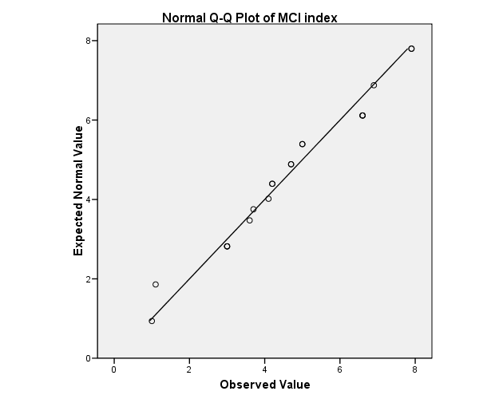

Figure 4 − Q-Q plot of MCI
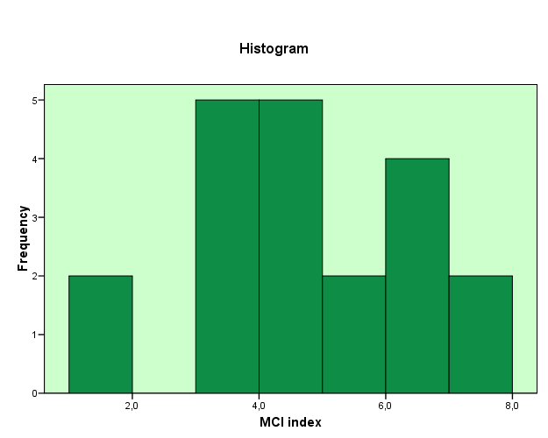

Figure 5 − Histogram of MCI

Table 4.

Correlation between market competitive inensity and impact of the commodity price risk

 |  | MCI index | Qa impact
MCI index | Pearson Correlation | 1 | -,524(*)
MCI index | Sig. (2-tailed) |  | ,021
MCI index | N | 20 | 19
Qa impact | Pearson Correlation | -,524(*) | 1
Qa impact | Sig. (2-tailed) | ,021
Qa impact | N | 19 | 20
* Correlation is significant at the 0.05 level (2-tailed).

Table 4. shows that there is a very strong correlation between the variables (correlation coefficient r=0,524, n=19). The correlation is negative meaning that variables move in different direction (when one variable increases, the other decreases, and vice versa). This was expected due to the definition of the impact of commodity price risk (1- very high, 5- very low). The level of significance is less than 0,05 indicating a statistically significant correlation.

We can interpret these results in a way that in the mature electricity markets the exposure to the commodity price risk is a higher due to the existence of reasonably well established and liquid wholesale market.

Analysis of importance and impact of the most critical risks in electrical power companies
We asked participants to asses the consequences for the company by using two criteria:
- importance (very important/not very important)
- impact (1-very high, 5- very low).

By analyzing risks in power utilities from aspect of risk importance we can conclude that today the most important risks for power companies are:
- environmental risk,
- interest rate risk,
- credit risk,
- legal/regulatory compliance risk.

Table 5
The impact of the most important risks for power companies today

Response
Frequency
Environmental risk
21
Interest rate risk
21
Credit risk
21
Legal/regulatory risk
21
Commodity price risk
20
Political risk
20
Interest currency risk
20
Network loss risk
20
Peak load risk
20
Fuel price risk
19
Volume risk
18
The most important risks

Moreover, we asked participants about the impact of different risk types on company performance. They could choose the mark from 1 (risk with very high impact) to 5 (very low impact).
The results show that risks with most impact on power company’s performance today are:
- commodity price risk,
- political risk,
- fuel price risk,
- legal/regulatory compliance risk.

Figure 6
The impact of the most important risks

By analyzing risks in electrical power companies from aspect of risk impact on company performance we can conclude that the biggest impact has the following risks:
- commodity price risk,
- political risk,
- fuel price risk and
- legal/regulatory compliance risk.

Credit risk has an average mark of 3 and is placed at his middle of the scale. All risks positioned left from credit risk (see Fig. 5) indicate very high and high impact on the company performance and risks positioned right from credit risk indicate low or very low impact.
Two participants are rated image risk as very important with medium impact on company performance.
To sum up the most important risk from both aspects importance and impact are:

- commodity price risk,
- political risk,
- fuel price risk,
- legal/regulatory compliance risk.
- volume risk and
- peak load risk.

Figure 7
Risk Map

Comparison of risk types over the decade
If we compare the results from Unipede survey and our research we can conclude that legal/regulatory risk was very critical for electrical power companies in the past decade and is still today. The energy market opening has started in 1990 by adopting the Directive 90/377/EEC to improve the transparency of gas and electricity prices charged to industrial end-users. Even then this risk was perceived as very critical for company performance. Ten years later, the market liberalisation is in different stages of development and therefore still in the focus of Power utilities.
In the past the operational risks were in focus. Today they are replaced by financial risks. Energy market opening caused volatility of wholesale electricity prices placing the commodity price risk in the management focus. Fuel price risk and volume price risk are related to these changes.
Political risk was and still is a very critical for company performance due to direct impact on business performance.

Analysis of correlation between the most critical risks in electrical power companies
We compared all type of risks listed in a questionnaire and we found some correlations. It is very important to examine those correlations to be able to decide which risks should be aggregated and which should be treated separately in order to define a good risk strategy. Analysis of correlation between different risk types was performed using Pearson method.
One participant emphasized the correlation between commodity price risk and peak load risk in the production area of Power Utility that was a driver to test this thesis.
Therefore, we performed an analysis of the correlation between the commodity price risk (Qa) and peak load risk (Qj). The results show that there is a strong correlation between the variables (correlation coefficient r=0,402, n=19). The correlation is positive, which means that both variables move in the same direction (when one variable increases, so does the other, and vice versa). The level of significance is greater than 0,05 due to a small sample size.

Table 6
Correlations between commodity price risk and peak load risk

 |  | Qj impact | Qa impact
Qj impact | Pearson Correlation | 1 | ,402
Qj impact | Sig. (2-tailed) |  | ,088
Qj impact | N | 20 | 19
Qa impact | Pearson Correlation | ,402 | 1
Qa impact | Sig. (2-tailed) | ,088
Qa impact | N | 19 | 20

As we inspected the possible correlations between commodity price risk (Qa) and volume risk (Qi) we found a statistically significant correlation. The peak load risk is caused by a higher consumption than expected in time of peak load. This fact increases the company costs and will increase the impact of commodity price risk.

Table 7
Correlations between commodity price risk andvolume risk

 |  | Qa impact | Qi impact
Qa impact | Pearson Correlation | 1 | ,679(**)
 | Sig. (2-tailed) |  | ,002
 | N | 20 | 18
Qi impact | Pearson Correlation | ,679(**) | 1
 | Sig. (2-tailed) | ,002
 | N | 18 | 18
** Correlation is significant at the 0.01 level (2-tailed).

The results show that there is a very strong correlation between the variables (correlation coefficient r=0,679, n=18). The correlation is positive, which means that both variables move in the same direction (when one variable increases, so does the other, and vice versa). The level of significance is lass than 0,05 indicating a statistically significant correlation. The volume risk is caused by exceeding in consumption so that electrical power companies have to buy more electricity in higher prices. When increasing the impact of volume risk we increase the impact of commodity price risk.

The commodity price risk includes other risks such as political or financial risks. The companies use various types of derivative instruments (forwards, futures and swaps) to hedge various financial risks, primarily interest rate risks, currency risks and electricity price risks.
Therefore, we are examining the correlations between commodity price risk, interest rate risk and interest currency risk.

Table 8
Correlations between commodity price risk and interest rate risk

 |  | Qa impact | Qe impact
Qa impact | Pearson Correlation | 1 | ,395
Qa impact | Sig. (2-tailed) |  | ,085
Qa impact | N | 20 | 20
Qe impact | Pearson Correlation | ,395 | 1
Qe impact | Sig. (2-tailed) | ,085
Qe impact | N | 20 | 21

The results show that there is a strong correlation between the variables (correlation coefficient r=0,395, n=20). The correlation is positive, which means that both variables move in the same direction (when one variable increases, so does the other, and vice versa). The level of significance is greater than 0,05 due to a small sample size.

Table 8. presents a correlation between commodity price risk (Qa) and interest currency risk (Qf).

Table 9
Correlations between commodity price risk and interest currency risk

 |  | Qa impact | Qf impact
Qa impact | Pearson Correlation | 1 | ,422
 | Sig. (2-tailed) |  | ,064
 | N | 20 | 20
Qf impact | Pearson Correlation | ,422 | 1
 | Sig. (2-tailed) | ,064
 | N | 20 | 20

The results show that there is a strong correlation between the variables (correlation coefficient r=0,422, n=20). The correlation is positive, which means that both variables move in the same direction (when one variable increases, so does the other, and vice versa).
The interest currency risk is caused by payments in foreign currency of fuel and electricity, etc. therefore this correlation was expected.
We can conclude that when examine a commodity risk one should also look at peak load risk, volume risk, interest rate risk and interest currency risks. Those risks are correlated and should be treated together.

CONCLUSION

The first step in risk management process is to identify company's main risks in terms of intensity and impact i.e. to design a risk map. This is the precondition for defining adequate risk strategies. The research results show that risk map has been changed over last decade. New risks related to electricity market liberalization appeared. New challenges presets following the fulfillment of third package in terms of risk management.
This work has demonstrated that there is a change of risk types over a decade due to a change of business environment. Furthermore, in this paper a following three hypothesises are proposed: H1 There is a change of risk types in electrical power companies over a decade. H2 There is a correlation between market competitive intensity and the impact of the present risk types. H3 There is a correlation between present risk types in electrical power companies.
In order to test these, we examine the most important risks today for electrical power companies and compared them to the most critical risks a decade ago, stated by Unipede research. According to this analysis we can conclude that legal/regulatory risk was a very critical risk and still is for electrical power companies due to market liberalisation process. Operational risks are replaced by financial risks, especially commodity price risk, credit risk, interest rate risks and interest currency risk. Those risks are in companies focus today. There is no change in importance of political risk over a decade. This risk is still a very critical for a company due to direct impact on business performance.
The most important risks today from both aspects importance and impact are: commodity price risk, political risk, fuel price risk, legal/regulatory compliance risk, volume risk and peak load risk.
The market competitive intensity was defined by a very specific metrics (MCI index) developed by Datamonitor in order to describe the changes in business environment. This metrics include three groups of issues: market framework, supplier push and customer pull. Based upon the previous analysis of the correlation between market competitive intensity and impact of the commodity price risk on company performance, we can conclude that there is a strong correlation between the variables that is statistically significant. This shows that in the mature electricity markets the exposure to the commodity price risk is a higher due to the existence of reasonably well established and liquid wholesale market.
Moreover, we examined the correlation between present risk types in electrical power companies and we found that there is a positive medium correlation, statistically significant between commodity price risk and volume risk meaning when increasing the impact of volume risk we increase the impact of commodity price risk. We also found a positive correlations between commodity price risk and interest rate risk as well as interest currency risk but not statistically significant. This was expected while commodity price risk includes other risks such as political or financial risks.
A company needs to define a risk strategy for all the risks identified. In order to do it we need to define which risk should be aggregated and treated together and which risk should be treated separately. Therefore it is very important to examine the correlation between them. So, when examine a commodity risk one should also look at peak load risk, volume risk, interest rate risk and interest currency risks. Those risks are correlated and should be treated together.
It is very important for electrical power companies to be aware of the change all changes in business environment and to identify risks on a regular basis in order to protect and increase the company value.

REFERENCES

Jakasa,T., Osmanagić Bedenik, N., Iliopoulos, F., Bratić, D., (2008), “The impact of risk management effectiveness on Power Utility performance”, 5th International Conference on the European Electricity Market, Lisbon, Portugal, May 2008: 1-6.
UNIPEDE, “At your own risk”, ref. 00300Ren9609, February 1996, Paris, France
Zelenika, R., (2000), Methodology and technology of writing a scientific or professional paper (in Croatian), (Rijeka, Faculty of Economics at University of Rijeka), p. 337.
Serdar, V., (1997), Statistics Book (in Croatian), (Zagreb, Školska knjiga), p.1.
Jakaša, T., (2007) Comparative analysis of Risk Management System in Power Utilities (in Croatian), Master Thesis, (Zagreb, Faculty of Economics at University of Zagreb)
Datamonitor, (2006), “Company Grafics: European Utilities Databook”, Datamonitor Plc., ref. code. DMEN0421, October 2006, London, United Kingdom, available only to the members
Eurelectric, (2007), “Risk management in electricity industry – White paper I – Overall perspective, Eurelectric, Datamonitor Plc., ref. code: 2007-030-0137, January 2007, London, United Kingdom, available only to the members
Datamonitor, (2002), “Risk management in Energy Supply”, Datamonitor Plc., ref. code: DMEN0193, May 2002, London, United Kingdom, available only to the members
Chan, K. F., Gray, P., van Campen, B., (2008), “A new approach to characterizing and forecasting electricity price volatility”, International Journal of Forecatsing, 24 (2008): 728-743.
Cartea, A., Villaplana, P., (2008), "Spot price modeling and the valuation of electricity forward contracts: The role of demand and capacity", Journal of banking and finance, 32 (2008): 2502-2519.
Higgs, H., Worthington, A., (2008), "Stochastic price modeling of high volatility, mean-reverting,spike-prone commodities: The Australian wholesale spot electricity market", Energy Economics, 30 (2008): 3172-3185.
Datamonitor, (2009), "PRICE GRAPHICS SERIES European Gas and Power Price Fundamentals: Q2 2009", Datamonitor Plc., ref. code: BFEN0399, May 2009, London, United Kingdom, available only to the members

Biographies

Tina Jakaša (b. 1974) received the undergraduate (4-year) from Faculty of Electrical Engineering and Computing at University of Zagreb and Master Degree in Economic Science from the Faculty of Economics and Business at the University of Zagreb (2003 and 2007).
Presently she is heading the Procurement and Sales Market Research Section at HEP Supply (2006-today).
Previously she has worked in HEP Distribution (1999-2006).
Her topics of research include electricity markets, electricity supply and risk management in Power Utilities.

Diana Bratić (b. 1973) received the undergraduate (4-year) from Faculty of Graphic Arts at University of Zagreb and Master Degree in Economic Science from the Faculty of Economics and Business at the University of Zagreb (2004 and 2008).
Presently she is assistant on Faculty of Graphic Arts, Department of Economics (2008-today).
Previously she was head for Croatia and Adria region in Targo Promotion Zagreb (2005-2008) .
Her topics of research include organisation, controlling, information in organisation, management infosystems and risk management.

Fivos S. Iliopoulos (b. 1977) received a first class undergraduate Business Administration (hons) degree from the University of Westminster, in London (UK), in 1998, and an MBA from the Bath School of Management (UK) in 2001.
Presently he is heading the sales department for south-eastern Europe at Datamonitor, offering a series of consultancy services for companies in the Energy, Consumer, Healthcare, and Financial Services industries in the region.
Previously, he was head of business development for energy for Datamonitor, focusing on a variety of issues affecting the European energy market, and specifically relating to the performance of utilities.

UTJECAJ PROMJENJIVE POSLOVNE OKOLINE NA VRSTE RIZIKA

SAŽETAK

Promjene u poslovnom okruženju uvele su novi tip rizika u poduzeća elektroprivrede. Zbog toga je za poduzeća elektroprivrede vrlo važno identificirati rizike i naći korelaciju među njima, te to činiti redovito kako bi se zaštitile i povećale vrijednost kompanije. U ovom se radu predlažu sljedeće tri hipoteze: H1 Postoje promjene u tipu rizika u poduzećima elektroprivrede tijekom zadnjih 10 godina. H2 Postoji korelacija između intenziteta tržišne konkurencije i utjecaja prisutnih/postojećih tipova rizika. H3 Postoji korelacija između postojećih tipova rizika u poduzećima elektroprivrede. Sve teze dokazane su kao istinite. Nadalje, identificirani su najkritičniji tipovi rizika danas s kojima se suočavaju poduzeća elektroprivrede, te uspoređeni s onima od prije deset godina. Istražen je intenzitet tržišne konkurencije, te ispitana povezanost s različitim tipovima rizika.

Ključne riječi: poduzeća elektroprivrede, intenzitet tržišne konkurencije, promjenjivost poslovnog okruženja, tip rizika

HEP Supply L.t.d., Zagreb, Croatia, Ulica grada Vukovara, nº 37, 10 000 Zagreb, Croatia, tina.jakasa@hep.hr
Faculty of Graphic Arts, Zagreb, Croatia, Getaldiceva 2, 10 000 Zagreb, Croatia, diana.bratic@grf.hr
Datamonitor Plc, London, United Kingdom, Mortimer Street, 37-41, 1250-283 London, UK Članak je primljen u uredništvo: 13.3.2009

