Title of the paper
  - Name Surname¹, Name Surname², Name Surname³, Name Surname⁴ and Name Surname⁵
¹ University, Faculty, Department, Street, Number, Zip Code, City, Country
² University, Faculty, Department, Street, Number, Zip Code, City, Country
³ University, Faculty, Department, Street, Number, Zip Code, City, Country
⁴ University, Faculty, Department, Street, Number, Zip Code, City, Country
⁵ University, Faculty, Department, Street, Number, Zip Code, City, Country
Corresponding author:  Name Surname  email@email.com  Received:  January 19, 2022  Accepted:  January 19, 2022  Published:  January 3, 2024  Citation:  Surname, N.; Surname, N.; Surname, N. et al.  Title of the paper.  Advances in Civil and Architectural Engineering, 2024, 15 (28), pp. 1-##.  https://doi.org/10.13167/2024.28.##  ADVANCES IN CIVIL AND ARCHITECTURAL ENGINEERING (ISSN 2975-3848)  Faculty of Civil Engineering and Architecture Osijek  Josip Juraj Strossmayer University of Osijek  Vladimira Preloga 3  31000 Osijek  CROATIA |  | Abstract:  The abstract should consist of and briefly present the motivation, research gap, problem, and purpose of the research, as well as the principal results and major conclusions. The abstract should be a single paragraph and follow the paper's style but without headings (i.e., 200-250 words). State the question addressed in a broad context and highlight the purpose of the study; briefly describe the main applied methodology; summarize the main findings; and indicate the main conclusions and interpretations of the results. The abstract should be an objective representation of the article, so it shouldn't contain results that are not presented and substantiated in the main text and should not exaggerate the main conclusions. An abstract is often presented separately from the paper, so it must be able to be understood in stand-alone form. For this reason, references should be avoided in the abstract. Also, non-standard or uncommon abbreviations should be avoided, but if essential, they must be defined at their first mention in the abstract itself. Immediately following the abstract, provide a maximum of five keywords (e.g., avoid "and" or "of"). Only abbreviations established in the field may be eligible for the keywords.  Keywords:  keyword1; keyword 2; keyword 3; keyword 4; keyword 5

Introduction
The introduction should briefly summarize the study's significance and set it in context. It should state the work's objective and relevance, as well as the precise hypotheses being tested. The present state of research on the topic should be thoroughly examined, with major publications noted. When required, please highlight problematic and diverse hypotheses. Finally, briefly summarize the work's principal goal and the most important conclusions. Keep the introduction simple enough for scientists who aren't working on the paper's topic to understand.
When developing and preparing for the ACAE Journal, you should remember to keep the following guidelines in mind:
- Please use the passive voice in the third person.
- Make use of the formatting styles that have been included in this template.
- Please use British English.
- Please use comma “,” as a decimal separator (e.g., 3,14; 1,41) and dot “.” as a digit grouping symbol (e.g., 1.234,56 €; 1.000.000,00 mil.).
- Please use ISO 80000 an international standard introducing the International System of Quantities (ISQ) and mathematical notation and symbols.

Methodology

Materials and methods
The methodology should be explained in sufficient detail for others to be able to duplicate and obtain the same results as presented in the paper. New procedures and protocols should be detailed, whereas well-established approaches should be given briefly and suitably cited. Provide the name and version of any software that was utilized, as well as whether or not the computer code was available. Any pre-registration codes should be included.

Figures

Single figures and graphs
After figures should be described and referenced in the text, they should be integrated into the main text. Figures must be numbered according to the sequence of their appearance in the text (Figure 1, Figure 2, etc.).
Figures must include a caption and a short explanatory title (please use the "Insert caption" option for adding a new figure number and title, as well as please use the style for the figure title). Figure text cannot be smaller than 10 points, and you must use the same text style as the template (i.e., Helvetica font, size 10 or 11 pt.). Authors are encouraged to create color figures. If the photo or figure is cited, please properly reference its source, as required, and described in the chapter References. When using licensed photographs, it's an advisable to consult the authors for permission before using them in the paper.
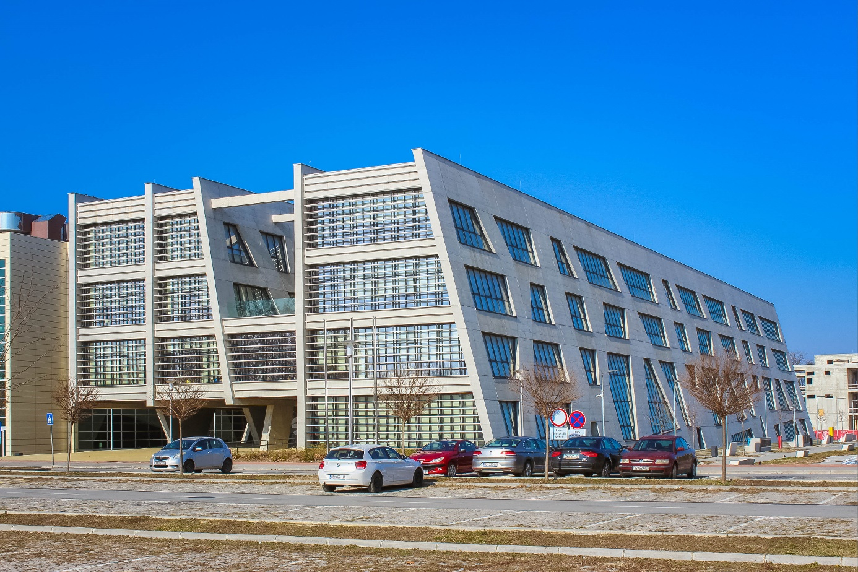
Figure 1. Title of the figure
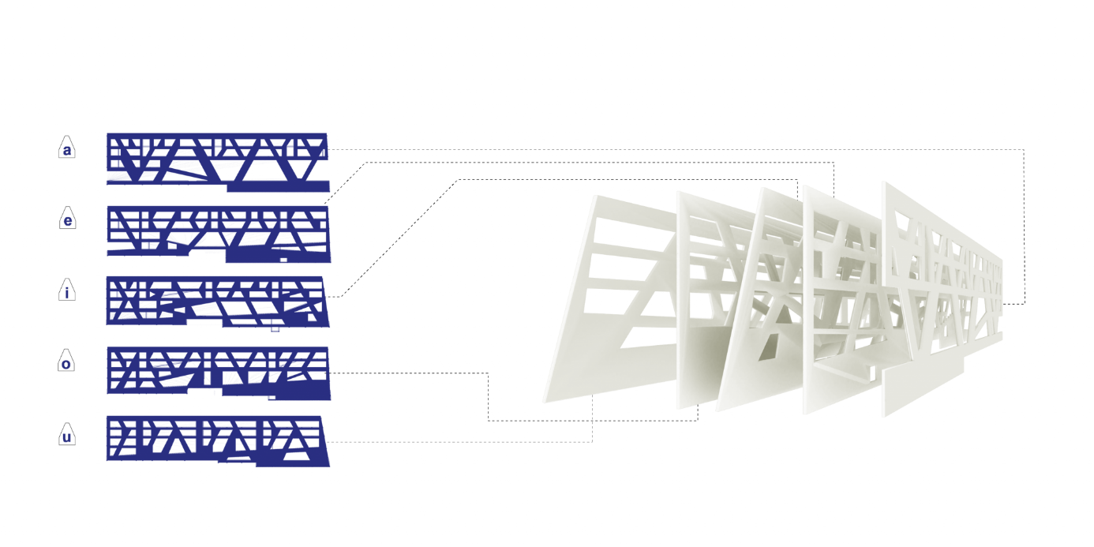
Figure 2. Title of the figure

Multiple figures and graphs
Please include sub-notations and explanations for multiple figures or graphs, as well as the references to the sub-noted figures (Figure 3 a); Figure 3 b)).
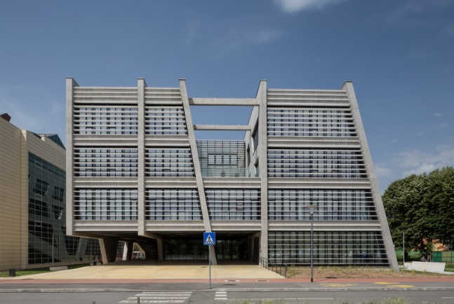 |  |  | 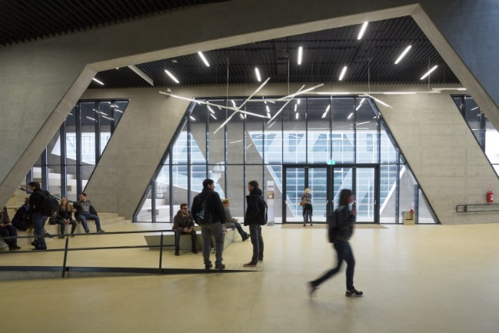
a) |  |  | b)
Figure 3. Title of the figure: a) description; b) description
In case of graphs, please use font Helvetica size 10 pt and preferably allow its formatting in the editing process, e.g., Figure 4.

Figure 4. Title of the graph

Tables
Tables should be referenced in the text in a logical order. A descriptive title above every table, and if numerical measurements are given, the units must be included in the column heading. Vertical rules should be avoided if possible. Text in the table can be smaller font size but not smaller than 9 pt. Please use table style “Grid Table 1 Light”, as shown in Table 1:
Table 1. Title of the table
Heading  (unit) | Heading |  | H_{i}
 | Sub-heading | Sub-heading

Equations
Equations should be structured using the equation option in insert bar. All equations should be explained in the text prior to mathematical expressions and they must be referenced Eq. (1).
$$P_{1}+\frac{1}{2}∙ρ∙v_{1}^{2}+ρ∙g∙h_{1}$$ | (1)
Please use the equation template: Insert → Equation → Equation template as in Eq. (2):
$$P_{2}+\frac{1}{2}∙ρ∙v_{2}^{2}+ρ∙g∙h_{2}$$ | (2)
Notations symbols used in the equations have to be defined in the text; e.g., ρ notates the fluid density; g acceleration due to gravity; P₁ pressure at elevation 1; v₁ velocity at elevation 1; h₁ height at elevation 1; P₂ pressure at elevation 2; v₂ velocity at elevation 2; h₂ height at elevation 2.
Please avoid equations and mathematical expressions in the text.
Please consistently implement ISO 80000 notations and symbols when structuring equations, e.g., variables such x, y, etc., and running numbers, such as i in x_{i}, as well as parameters a, b, etc. are printed in italic type, while mathematical constants and numbers are printed in upright type, e.g., e = 2,718218; π = 3,141592; as well as well-defined operators, e.g., div, δ in δx and each d in df/dx.

Results
Results should be clear and concise. The results should be presented numerically or graphically in the paper, but they should be well defined and discussed in the text in both cases.

Discussion
Please describe the relevance of the work's results in this chapter rather than repeat them. Extensive citations and discussion of published material should be avoided.

Conclusions
The main conclusions of the study may be presented in a short Conclusions section, which may stand alone or form a subsection of a Discussion or Results and Discussion section.

Appendices
If there is more than one appendix, they should be identified as A, B, etc.

Abbreviations
Please define and list all acronyms and abbreviations in alphabetical order if there are more than ten of them in the text.

Acknowledgments
Acknowledgements should be compiled in this section and should not be included on the title page, as a footnote to the title, or in any other way. Individuals who assisted with the research should be listed here (e.g., providing language help, writing assistance, proofreading the article, etc.).

References
The numbered reference citation style is the mandated referencing style for the ACAE journal, and please apply this referencing style correctly and consistently in your paper. Reference numbers have to be in square brackets, e.g., [1] and numbered in the order in which they appear in the text. A range of references can be cited; for example, [2-5] would quote references 2, 3, 4, and 5 simultaneously. Page number(s) can also be put into the citation if specific page number(s) are needed that are not listed in the reference list: for example, [4, p. 1] or [5, pp. 1-2]. For items with multiple authors, list up to four names in full; for items with more than four authors, list the first author plus "et al.“. Required bibliographic elements are given below for the most common types of reference citations, along with optional elements that should be used consistently. Examples of referencing authored books are shown in [1; 2]; unauthored books (books published by committee, agency, or group) [3]; chapter in an edited book [4]; journal article [5]; conference paper [6]; magazine or newspaper article with stated author [7] and if there is no stated author of the article [8]; online available data or webpage [9; 10]; master and doctoral thesis [11]; standards and norms [12].
ACAE journal has an Endnote template of referencing style, please contact the editors if you require the aforementioned template.

Important: if you use an automatic referencing tool, please covert citations into plain text before submitting your paper.

- Surname, N. Title of Work. Edition, City or Country of Publication: Publisher, Year of Publication.

e.g. Gu, X.; Jin, X.; Zhou, Y. Basic Principles of Concrete Structures. Germany: Springer Berlin Heidelberg, 2016. https://doi.org/10.1007/978-3-662-48565-1

- Surname, N.; Surname, N. Title of Work: Subtitle. Editions, City or Country of Publication: Publisher, Year of Publication. [In Language if the work is not in English]

e.g. Wietek, B. Beton – Stahlbeton – Faserbeton: Eigenschaften und Unterschiede. 1st Edition, Germany: Springer Vieweg Wiesbaden, 2019. https://doi.org/10.1007/978-3-658-27707-9 [In German]

- Title of Work. City or Country of Publication: Publisher; Year of Publication.

- Surname, N. Title of the chapter. In: Title of the book, Surname, N.; Surname, N. (eds.). City or Country of Publication: Publisher; Year of Publication, pp. startpage-endpage.

e.g. Schiegg, Y. Monitoring of corrosion in reinforced concrete structures. In: Corrosion in Reinforced Concrete Structures, Böhni, H. (ed.). England: Woodhead Publishing Limited; 2005, pp. 46-70.

- Surname, N. et al. Title of article. Journal Title, Year of Publication, Volume No. (Issue No.), pp. startpage-endpage or article number. https://doi.org/

e.g. Marović, I.; Hanak, T.; Plaum, S. Performance management in civil engineering: A systematic literature review. Advances in Civil and Architectural Engineering, 2022, 13 (24), pp. 47-58. https://doi.org/10.13167/2022.24.5

- Surname, N. Title of paper. In: Title of published proceedings, Surname, N.; Surname, N. (eds.). Date of the conference startday-endday Month Year, Location, Publisher; Year, pp. startpage-endpage.

e.g. Prieto, S. A.; García de Soto, B.; Adán, A. A Methodology to Monitor Construction Progress Using Autonomous Robots. In: Proceedings of the 37th International Symposium on Automation and Robotics in Construction (ISARC 2020), Tateyama, K.; Ishii, K.; Inoue, F. (eds.). 27-28 October 2020, Kitakyushu, Japan, International Association on Automation and Robotics in Construction; 2020, pp. 1515-1522.

- Surname, N. Title of article. Magazine or Newspaper Title. Month Day, Year of Publication, pp. startpage–endpage. https://doi.org/ or www.webpage.com

e.g. Shiware, S. A lesson in the craft of weaving with textile artist Neeru Kumar. Architectural Digest India. August 23, 2023. Accessed: January 3, 2024. Available at: https://www.architecturaldigest.in/story/a-lesson-in-the-craft-of-weaving-with-textile-artist-neeru-kumar/

- Title of article. Magazine or Newspaper Title. Month Day, Year of Publication, pp. startpage–endpage. https://doi.org/ or www.webpage.com

- Surname, N. Title or description of the content. Owner/publisher, Accessed: Month Day, Year. Available at: www.webpage.com

- Organization or Owner/publisher. Title or description of the content. Accessed: Month Day, Year. Available at: www.webpage.com

- Surname, N. Title of Work. [master or doctoral thesis], University, Department, City and Country of Publication, Year. Accessed: Month Day, Year. Available at: www.webpage.com (if available)

e.g. Bagge, N. Structural assessment procedures for existing concrete bridges: experiences from failure tests of the Kiruna Bridge. [doctoral thesis], Luleå University of Technology, Sweden, 2017. Accessed: January 3, 2024. Available at: https://trid.trb.org/view/1652303

- Issuing Organization Name. Standard Number. Title of Standard. Place of Publication: Publisher; Year of publication.

e.g. International Organization for Standardization. ISO 13485:2016. Medical Devices – Quality Management Systems – Requirements for Regulatory Purposes. Geneva: ISO; 2016.

