**Stochastic programming framework for Lithuanian pension payout modelling**

**Abstract**

The pension accumulation system in Lithuanian Republic (LR) was changed in 2014. The demographic situation is worsening and is expected not to be improved in the near future. Therefore, there are many uncertainties for the citizens of Lithuania, which pension accumulation system to choose. We provide a scientific approach to this problem. The decision making model, which can be used to plan long-term Lithuanian Republic (LR) citizen’s pension accrual in optimal way is presented. This model focuses on factors that influence the sustainability of the pension system selection under macroeconomic, social and demographic uncertainty. The model is formalized as a single stage stochastic optimization problem, where the long-term optimal strategy can be obtained based on the possible scenarios generated for a particular person. Stochastic programming methods allow including the pension fund rebalancing moment and direction of investment, and taking into account possible changes in personal income, changes in society and in the global financial market. The collection of methods used to generate scenario trees is useful to solve strategic planning tasks and can be adapted in other countries.

**Keywords:** *Pension modelling, Scenario tree, Long-term strategy, single stage SP*

Received: xx xx, 201x; accepted: yy yy 201x; available online: zz zz; 201x

**1. Introduction**

Since independence declaration in 1990 up to 2004 Lithuania had only pension system governed by Ministry of Social Security. A private pension funds were available (now its III pillar of the system). However, only a small part of population could afford it.

In 2004 was introduced reform that gave possibility for any citizen to transfer part of its PI taxes (given in Table 1) to its private pension fund (II pillar of the system).

|  |  |  |  |  |  |  |  |  |  |  |
| --- | --- | --- | --- | --- | --- | --- | --- | --- | --- | --- |
| Year | 2004 | 2005 | 2006 | 2007 | 2008 | 2009 | 2010 | 2011 | 2012 | 2013 |
| Payment, % | 2.5 | 3.5 | 4.5 | 5.5 | 5.5 | 2.0 | 2.0 | 2.0 | 1.5 | 2.5 |

Table 1: Payments to II pillar pension funds in period 2004-2013.

So, in this period it was possible to choose if person completely depends on social security system or transfers part of risk and taxes to its private pension fund. The payout from first one (I pillar) is fixed for all citizens and depends on governmental policy, economic situation in the country, duration of employment during working life, salary etc. Currently that is approximately 250 €/month. The payout from private pension fund is supported by the social security pension. That means if person has selected the second choice his pension has to components:

* Part of social security pension (I pillar),
* Payout from II pillar pension fund.

III pillar is optional and anyone can have it. However, III pillar is expensive and a person must have salary above the country’s average to afford it. These expenses are related to the fact that payments to III pillar funds are made by the person after he/she pays taxes (~30% from salary).

In 2014 the pension system was reformed. Payout structure remains the same: I, II and III pillars are supported. However, II pillar now has more choices for payments to the fund:

* same as before (2%). In 2020 this payment will be changed to 3.5% from salary before taxes (II pillar A, in Figure 1).
* citizen may get back 2%, add additional 1% of its salary and receive bonus 1% from average salary in Lithuania (~6 €/month). In 2016 the payment structure will be changed to 2+2+2%. In 2020 it will be changed to 3.5+2+2% (II pillar C, in Figure 1).

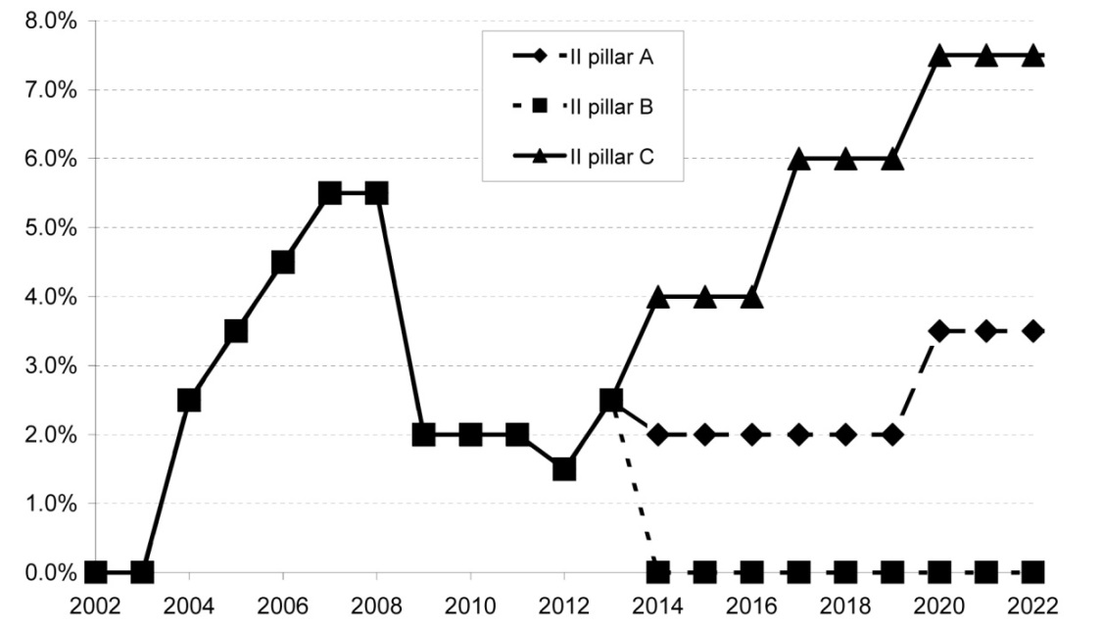

Figure 1: Planed payments to II pillar pension funds in period 2004-2020.

Moreover, if a citizen wants, he can stop accumulation in II pillar funds and stay only with I pillar (II pillar B, in Figure 1).

Currently there are 24 pension funds for II pillar of the system and some additional funds for III pillar. Funds are grouped into 4 classes:

* Conservative (0% stock);
* Small stock funds (less than 30% of stock);
* Medium stock funds (less than 70% of stock);
* Stock funds (up to 100% stock).

The current structure of funds market [1] is given in Table 2.

|  |  |  |  |  |  |
| --- | --- | --- | --- | --- | --- |
|  | Number of funds available | Number of participants | | Value of  managed assets | |
|  | % | LTL  millions | % |
| Conservative | 9 | 110 525 | 9.74% | 680.06 | 11.45% |
| Small stock | 4 | 282 919 | 24.94% | 1 553.74 | 26.15% |
| Medium stock | 10 | 601 365 | 53.02% | 3 099.55 | 52.17% |
| Stock | 5 | 139 501 | 12.30% | 607.53 | 10.23% |
| Total | 28 | 1 134 310 |  | 5 940.88 |  |

Table 2: Funds market structure in 4th quarter of 2013.

As one can see the most popular group is medium stock with 53.02% of participants and market capitalization of 52.17%.

**2. Related works**

Declining birth rates and increasing life expectancy led to the pension system reforms in many countries around the world. Lithuania is not an exception, since its social insurance is based on the solidarity principle, i.e. social security contributors in real-time finance social security beneficiaries [18, 3]. The points of previous pension system were examined by a number of Lithuanian scientists [14, 8].

From mathematical point of view, the II pillar was the most difficult and hard to predict because it depends on the decisions taken by government members. Since 2014, the system is becoming more complex, because two pension systems as pillar II are available: old and new one. This problem can be formulated as decision making model, which can be used to plan long-term Lithuanian Republic citizen’s pension accrual in optimal way.

Cause of advantages of stochastic programming methodology, its application in the management of personal finances becomes a focus in current researches: analysis of asset allocation into investments as a loss avoidance function for the objective formulation [4] comparison of investment opportunities that are offered to invest in retirement and life insurance alternatives [5], the integration of stochastic and dynamic programming methods to study the personal finance and retirement pension [13]. Stochastic programming methodology also has the advantage to provide the opportunity for rebalancing the decisions in long-term planning period, as well as to provide restrictions, describing them in the algebraic form.

Stochastic programming methodology relies on a particular representation of the random process in connection with the decision stages, commonly referred to as the scenario tree. Approaches of scenario tree generation are based on various principles [9,10,17]: (a) bound-based constructions, (b) Monte-Carlo schemes or Quasi Monte-Carlo based methods, (c) EPVI-based sampling and reduction within decomposition schemes, (d) moment-matching principle, (e) probability metric based approximations. In general, the approaches have to be adapted for a problem to be considered in the research. Scenario tree generation is generated to describe main random risk factors (financial, social, economic or demographic) that might influence the decision to be made in financial planning.

**3. Methodology**

**3.1 Data analysis**

The return of funds value was fitted to some known probability distributions (normal, α-stable). All analyzed data are non-normally distributed [19]; however, most of them are α-stable distributed with $α$ close to 1.5. Parameter $β$ in almost all cases is negative and this indicates that expected return probably will be less than mean return.

Retirement age in Lithuania currently is 61 for women and 63 for man. Since 2026 this age will be equal to 65 years for both genders. The work record ($wr$) is the most important parameter for pension accrual. Usually it is necessary to have 30 years work record to get bigger social security pension. However, if person starts to work immediately after university or college (or even earlier), his work record will be 40-45 years. Minimal employment period is 30 year to get some bonuses from social security funds.

The average salary before taxes (gross salary) in 4th quarter of 2013 was 677.77 €/month. The complete list of gross salary in period 2004-2013 is given in Table 3.

|  |  |  |  |  |  |  |  |  |  |  |
| --- | --- | --- | --- | --- | --- | --- | --- | --- | --- | --- |
| Year | 2004 | 2005 | 2006 | 2007 | 2008 | 2009 | 2010 | 2011 | 2012 | 2013 |
| Average gross salary, €/month | 332.86 | 369.61 | 433.18 | 522.01 | 623.18 | 595.46 | 575.79 | 592.53 | 615.09 | 645.85 |
| Minimal salary, €/month | 139.98 | 152.05 | 166.53 | 188.25 | 231.70 | 231.70 | 231.70 | 231.70 | 237.73 | 289.62 |

Table 3: Average gross and minimal salary in Lithuania in period 2004-2013 [6,7].

Minimal salary is controlled by government and currently (in 2014) is equal to 289.62 €/month (~20% of population has such salary). In our model we will use different yearly salary increment ratio $\frac{current salary-initial salary}{current salary}$ (depending on the scenario): 0%, 1%, 2%,…,37%.

**3.2 Stochastic programming framework (linear single stage formulation)**

In general we have to solve the following single stage stochastic optimization linear problem [2, 15, 16]



 (1)

with decision variables  which are set to 0 if that pillar is not used, and set to 1 if it is used.

Stochastic parameters are given by the payoffs *xI,s**xII,s*and *xIII,s* from pillars I, II and III where $s$ is a scenario index and *ps* is the scenario probability.

Payoffs *xI,s**xII,s*and *xIII,s* depend by the following parameters:, ,  and is expected to satisfy following relation , where $wr$ is work record, *sis* salary increment is expected to be non-negative, $S_{s}$ is salary of a person, $MS$ is mean salary of a person for some period before retirement; $-δ<<+∞$ annual return from pension fund, from recent researches [19] is known that  or (alpha-stable or mixed alpha-stable distributed); $a$ is annuity rate, and $γ$ is payment to the fund $γ∈\{0;2; 3.5; 3+1; 4+2; 5.5+2\}$ percent from gross salary (see Figure 1).

**3.2.1 Payout from I pillar**

*xI,*smay be pre-calculated by using calculator given by SODRA (State social insurance fund) [19]. Currently payoff from I pillar is calculated by formula (2)

 (2)

Here $bp$– base pension (managed by Ministry of Social Security), $ap$– additional pension, $sp$– supplementary pension, $S$– is salary. This payout very weakly depends on decisions made by the person, i.e. to increase the payout citizen may only change the job or he may work more years to get bigger salary.

I pillar theoretically is always available, however if country defaults payoff *xI,*sfrom it will be equal to 0. Probability of default for most of the countries is given by credit ratings and risk analysis companies (Moody, S&P Capital IQ, etc.).

**3.2.2 Payout from II and III pillars**

Payouts from II and III pillars are similar, however, II pillar is more complicated and we will explain this more widely.  *xII,*2may be pre-calculated using formula

 (3)

where *a* is the annuity rate, *n* is expected lifetime in pension. The accumulated sum in II pillar  is a solution of the following difference equation

  (4)

with initial conditions . Currently , but depending on the year (see Figure 3) it will change. The salary in $i$ th year can be calculated by using formula .

Probability that II pillar will not be available in future, i.e. the law of pension system will be changed or because of fund default, is expected to be very small. However, cases of Poland and Hungary show that this probability is not equal to 0. Moreover, this is mostly related to political risk. On the other hand, pension funds are reinsured and if they are closed (default) then the payout is not lost.

**3.2.3 Simplified case**

In simplified single stage SP case we suppose that: , i.e., the long term fund return is constant and approximately equal to weighted average;  i.e., the long term salary increment is constant and approximately equal to weighted average (salary increases linearly). The difference equation is reduced to where  is initially accumulated sum in fund, and is a year. In this case the equation (4) has unique solution

 (5)

The simplified version of the problem may be used in most of the cases, especially in case of single stage stochastic programing. Since we do not care what will happen in the middle of the working life, we need information only about the fund return at the retirement moment.

In simplified case we can treat that the default of Lithuania in next 5 years is equal to 9.3%. The probability that II pillar will not be available is very small (0.1%), however, in 2016 there will be parliament elections in Lithuania and some candidates will discuss possible changes in pension system. Then this probability may increase but only small part of population wants to stop payments to II pillar pension funds (mostly current pensioners).

**3.2.4 Scenario generation**

Several are the factors which we have to take into account in order to generate scenarios and build the scenario tree:

* Inflation (influences net salary increment and net returns from conservative fund)
* Condition of economy (crisis, normal, upturn) – influences salary increment and returns from funds:
  + Unemployment (influences salary increment);
  + Salary (below average, ~average, higher, very high);
* Political risk (decisions made in parliament can destroy I or II pillar, Poland experience) – usually not included.

Figure 2 represents the scenario tree considered, where a person at beginning of work selects pension fund and works until retirement, paying some amount of money to the same pension fund. The outcome of tree is pension fund return under uncertainty of economical situation.

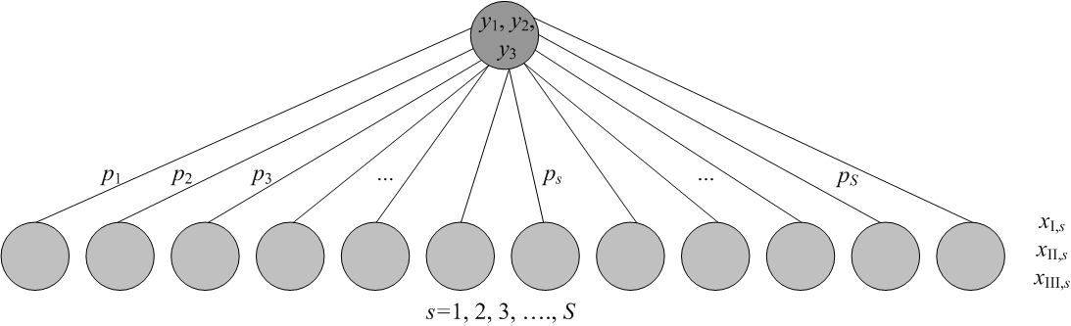

Figure 2: Scenario tree representation.

The values at the tree nodes (stochastic parameters), with exception of the root, are triple vectors , , , representing the payoffs during the period from the moment of the choice to the retirement moment.

Values ,  and  are calculated using their definitions as described in the previous subsections.

Probability *p*s of scenario *s* is calculated as conditional probability combining events of participants fund type choice $B=\{\text{conservative, small stock, medium stock, stock}\}$, event of condition of economy $C=\{\text{crisis, normal, upturn}\}$, event if I pillar is available $D=\{\text{yes, no}\}$, event if II pillar is available $E=\{\text{yes, no}\}$ etc.

 (6)

Events B, C, and D, E mostly are independent or we can let them to be independent in simplified case. Then

.

However D and E cannot have value ‘no’ at the same time, because at least one of them must be available all the time, then .

Probability  of participants fund type choice is obtained from Table 2 as statistical probability. In practice they are time dependent, because the number of participants is increasing and participants are likely to migrate between funds. However, we can simplify this and threat that probabilities are constant.

The economic situation does not depend on participants’ choice, so probabilities P(C) are calculated as probability of corresponding economic situation during the work life of a person (or some time period if we solve multi-stage problem). Probability of upturn *P*(*C*=upturn) is calculated as

$P(C=upturn)=\frac{t_{u}}{T}$, (6)

here $T$ is length of time period analyzed, *tu* is length of time period when economy is above some average level. Probability of normal situation $P(C=normal)$ is calculated in similar way $P(C=normal)=\frac{t_{n}}{T}$, here *tn* is length of time period when economy is some “historically typical” around the long term trend situation. Probability of crisis is found from $P(C=crisis)=\frac{t_{c}}{T}$, here *tc* is length of time period when economy is in recession or crisis. Time lengths *tu*, *tn* and *tc* are measured in days and calculated from some global or local indices (OMX Baltic Benchmark, S&P 500, etc.) as run time.

For example, since 2004 until 2007 (~1000 days) in Lithuania there was upturn; since 2007 until 2009 (700 days) was crisis; in period 2009–2011 (700 days) there was slow upturn; and since 2011 up to now (2014) there is a typical situation or normal case (1000 days). Taking that information into account *T*=3400, *tu*=1700, *tn*=1000, and *tc*=700. Finally, probability of upturn

$$P(C=upturn)=\frac{1700}{3400}=0.5.$$ However, if more precise results are necessary one can use some comparative indices to measure mentioned time lengths for each fund group separately. In this case probabilities *P*(*C*) would be dependent on probabilities *P*(*B*).

In simplified case (only events B, C, D, E are analyzed) there will be $S=4·3· 2· 2=48$ scenarios in the tree (see figure 2).

Because of interdependency between scenarios, the scenario tree is mainly constructed from individual scenario paths employing know-how design.

We expect to find “best” combination of pension pillars, i.e. optimal values of variables *y*1, *y*2 and *y*3.

**5. Discussion**

In this paper pension system of Lithuania is discussed. Special attention is given to the development of model which might be used to obtain the payout from II pillar pension funds. The structure of payout is described and explained in details. The simplified mathematical model of the pension accrual is given. The described linear single stage stochastic problem allows to model payout from Lithuanian pension funds. Analysis of literature and *a-priori* assumptions suggests that II pillar (version C, from Figure 1) will give maximal payout. However, Kilianova and Pflug [11] have showed that better performance of II pillar pension funds are achieved by using dynamic management. Such modification to the model described in this paper will be explored in future. Additional research should be done in the generation of scenario tree with inter-stage dependent coefficients if multistage stochastic program is designed.

**Acknowledgement**

All co-authors, especially <*add here 3rd co-author*>, wants to acknowledge the Research Council of Lithuania for the contract of delivering cycle of lectures “Stochastic programming and its applications to energy and logistics problems” at <*add here institution*> in 2013.

**References**

1. Bank of Lithuania. (2013). Reviews of Lithuania's 2nd and 3rd Pillar Pension Funds and of the Market of Collective Investment. <https://www.lb.lt/reviews_of_lithuanias_2nd_and_3rd_pillar_pension_funds_and_of_the_market_of_cellective_investment_undertakings_1> [Accessed 23/09/14].
2. Birge, J. R., Louveaux, F. (2011). Introduction to stochastic programming. Springer-Verlag, New York.
3. Bitinas, A., Maccioni, A.F. (2014). Lithuanian Pension System‘S Reforms Transformations and Forecasts. Universal Journal of Industrial and Business Management, 2(1), 13–23.
4. Cai J, Ge C (2012) Multi-objective private wealth allocation without subportfolios. Economic Modelling, 29(3), 900-907.
5. Consigli, G., Iaquinta, G., Moriggia, V., Tria, M.D., Musitelli, D. (2012). Retirement planning in individual assetliability management. IMA Journal Management Mathematics, 23(4), 365-396.
6. Department of Statistics. (2013). Average monthly earnings by sector, year. <http://db1.stat.gov.lt/statbank/SelectVarVal/Define.asp?Maintable=M3060801&PLanguage=0> [Accessed 23/09/14].
7. Department of Statistics. (2013). Minimum monthly and hourly wages by category of employees, month. <http://db1.stat.gov.lt/statbank/SelectVarVal/saveselections.asp> [Accessed 23/09/14].
8. Gudaitis, T. (2012). Applying investment management models into fully funded pension system [in Lithuanian]. <http://jmk.vvf.vgtu.lt/index.php/conference/2012/paper/viewFile/14/61> [Accessed 23/09/14].
9. Gülpinar, N., Rustem, B., Settergren, R. (2004). Simulation and optimization approaches to scenario tree generation. Journal of Economic Dynamics & Control, 28, 1291–1315.
10. Heitsch, H., Romisch W. (2005). Scenario tree modeling for multistage stochastic programs. Mathematics for Key Technologies, DFG Research Center MATHEON, Berlin, Germany, Preprint, 296.
11. Kilianova, S., Pflug., G.Ch. (2009). Optimal pension fund management under multi-period risk minimization. Annals of Operational Reserch, 166, 261–270
12. Konicz, A.K., Pisinger, D., Rasmussen, K. M., Steffensen, M. (2013). A combined stochastic programming and optimal control approach to personal finance and pensions. <http://www.staff.dtu.dk/agko/Research/~/media/agko/konicz_combined.ashx> [Accessed 23/09/14].
13. Lazutka, R. (2007). Development of pension schemes in Lithuania [in Lithuanian]. Filosofija. Sociologija, 18( 2), 64–80.
14. Maggioni, F., Allevi, E., Bertocchi, M. (2014). Bounds in multistage linear stochastic programming. Journal of Optimization, Theory and Applications, 163(1), 200-229
15. Maggioni, F., Wallace, W. S. (2012). Analyzing the quality of the expected value solution in stochastic programming. Annals of Operations Research, 200(1), 37–54
16. Mitra, S. (2006). A White Paper on Scenario Generation for Stochastic Programming. [www.optirisk-systems.com/papers/SGwhitepaper.pdf](http://www.optirisk-systems.com/papers/SGwhitepaper.pdf) [Accessed 23/09/14].
17. Rudytė, D., Beržinskienė, D. (2012). Model of the Lithuanian Pension System: Challenges and Opportunities. Socialiniai tyrimai, 2(27), 29–35.
18. SODRA (State social insurance fund) (2010). Old-Age Pension. <http://sena.sodra.lt/index.php?cid=1946> [Accessed 23/09/14].
19. Sutiene, K., Kabasinskas, A., Strebeika, D., Kopa, M., Reichardt, R. (2014). Estimation of VaR and CVaR from financial data using simulated alpha-stable random variables. To appear in: Proceedings of the 28th European Simulation and Modelling Conference - ESM'2014, October 22-24, 2014, FEUP - University of Porto, Porto, Portugal.