Modelling emergency department patient surge in disaster conditions by simulation

Abstract
The efficiency of emergency departments (EDs) is very important in meeting the patient surge during disaster times with the available resources. Many EDs require additional resources to struggle with the bottlenecks in their systems. It is assumed that EDs consider staff dispatching among others temporarily in order to respond to the increased demand or hiring of medical staff outside the hospital for a while. Discrete event simulation (DES) which is one of the well-known simulation methods and based on process modeling idea is used for building ED operations and management related models. In this study, a DES model is developed to investigate both normal time analysis of an ED and disaster time scenario considering increased disaster-victim patient arrivals. By doing this, early preparedness of departments in terms of physical and human resources will be performed. The studied ED is located in an earthquake zone in Istanbul. According to the report presented by Japan International Cooperation Agency (JICA) and Istanbul Metropolitan Municipality (IMM) on disaster preparedness of Istanbul, the district where the ED is located is estimated to have the highest injured rate. Based on information taken from a real case, the study aims to suggest a model on pre-planning of the ED resources against the disasters. The results indicate that in time of a possible disaster, when the percentage of red patients’ arrival exceeds 20% of the total patient arrivals, number of red area nurses and space of red area patients’ area will be insufficient for the department. As a methodological improvement, a different distribution function was tested for service time of the treatment areas. It is concluded that Weibull distribution function used in service process of injection room fits the model better than Gamma distribution function.

Keywords: Emergency departments, patient surge, disaster time, simulation

Received: xx xx, 201x; accepted: yy yy 201x; available online: zz zz; 201x

1. Introduction

In recent years, Turkey faces to the various disasters. By the consequence of the Marmara (17th August 1999) and Düzce (23rd November 1999) earthquake, according to the official figures 18.287 people lost their lives, 46.857 injured, 164.711 workplaces or houses moderately damaged and 1.100.000 people became homeless [1]. In 23rd October 2011, an earthquake with a magnitude of 7.2 on the Richter scale was occurred in Van and 604 people lost their lives [7]. More recently, 301 miners died due to the carbon monoxide poisoning and 140 injured in an underground coal mine in Soma, Manisa. Such these disaster events cause an increase in demand of emergency patients to hospital EDs. Therefore, effective and functional utilization of the ED resources to meet the patient surge by using apparent methods is so crucial during these conditions.
Simulation modeling is extensively applied to ED operations in the literature. Studies focus on wait time reduction, patient productivity, staff allocation, facility redesign, and costs control. There are many literature surveys regarding the use of simulation in EDs. Lim et al. [21] investigated twenty-nine studies to evaluate hospital ED waiting time reduction strategies by using the mathematical modeling techniques-queuing models, DES, system dynamics (SD) and agent based simulation (ABS). Jun et al. [15] combined DES applications in health care clinics and systems of clinics (hospitals, EDs, outpatient clinics and pharmacies). In recent literature, studies by Choon et al. [6] and Konrad et al. [19] focused on decreasing patient total stay in the ED. Morgareidge et al. [22] integrated DES and space syntax analysis (SAA) to optimize patient flow and to design the space of the ED. In another study, Kang et al. [17] revealed the impact of various patient admission processes on patient flow of the ED. A miscellaneous example on ED simulation was presented by Kadri et al. [16]. They developed a simulation-based DSS to prevent and predict strain situations in an ED in order to improve their management by the hospital system. On patient productivity, Al-Refaie et al. [3] proposed a DES model to reduce average patient waiting time, to improve nurses' utilization and to increase number of served patients.
Besides all these recent studies, simulation modeling is a significant analytical tool in analyzing behavior of ED systems under disaster conditions to enhance the preparedness. In order to reduce the impact of disasters, ED executives improve strategies whether they are ready in terms of resource efficiency, system performance and ability to eliminate the bottlenecks with the aid of scenarios tested by the constructed simulation models [7, 11, 12]. In the literature, there are limited studies such as [25], [5], [14], [2] and [23]. Xiao et al. [25] optimized workflow during a patient surge of a disaster event by an ED DES model. Joshi and Rys [14] and Patvivatsiri [23] studied on terror disaster event cases. The first paper analyzes different arrival patterns on an ED capacity during a conventional terror disaster event using DES. In the second one, patient flow is analyzed throughout the treatment process, utilization of ED resources are assessed, impact of a hypothetical bioterrorist attack is evaluated, and the appropriate resource and staff levels for such a bioterrorism scenario is determined. Al-Kattan and Abboud [2] modeled ED operations during disaster times as well normal times by a different scenario.
The related previous studies abstracted above have limitations. Xiao et al. [25] and Al-Kattan and Abboud [2] use only patient waiting time as performance measures. In this study, multiple key performance indicators (KPIs) including length of stay (LOS), utilization of medical staff and, utilization of locations are considered. Unlike the current study, Joshi and Rys [14] and Patvivatsiri [23] focus on terror disaster conditions. This study uses patient arrival percentages from a study of a previous catastrophic earthquake event in Turkey. Therefore, it can be said that it is related to the earthquake disaster conditions.
It can be made an inference that ED simulation applications must focus on disaster conditions and early preparedness of departments in terms of physical and human resources. Immediately after the disasters, increasing of complexity on ED processes in proportion to the normal times triggers seeking ways to normalize the system then enhance. At this point simulation modelling takes an important place to be capable for functioning of EDs. The current study investigates both normal time analysis of the ED and disaster time scenario considering increased disaster-victim patient arrivals in a public hospital located in an earthquake zone in Istanbul.
In summary, the contributions of this study to the literature are as follows: (1) It presents DES model of the ED that enables generating various scenarios depending on patient arrival variability created by benefiting from a previous earthquake condition. The model generates outputs with respect to several KPIs that are not taken into consideration by the previous studies. (2) It runs and validates the model by changing the distribution function in service time of treatment areas. It is observed that there is a statistical difference between the models with different distribution functions. (3) It presents a real-world case study in the ED of a public hospital in Istanbul, Turkey. The simulation model performed in this ED is the first attempt in order to respond the question "Is the ED ready to meet a patient surge after a major earthquake that is expected to be unavoidable in Istanbul province according to the authorities".
In this study, it was aimed at showing the impacts of the various arrival configurations on ED performance indicators such as LOS, human and location resources utilizations with fixed staff quantity. By the way, it was tried to determine the threshold value (20% in this study) by which the current resources can become insufficient for the ED. Therefore, we endeavour to suggest a strategy for ED’s behaviour in case of a possible disaster.
The paper is prepared in the following manner. Section 2 presents DES methodology and the observed ED environment. Section 3 reveals the simulation model. Section 4 shows the results of both normal and disaster time scenario. At last section, the conclusion and limitation of the study and future recommendations are provided.

2. Method of discrete event simulation

Static dependencies between variables fail to work while describing the systems with dynamic behavior. At that time, simulation modeling technology comes into play for analyzing dynamic systems [4]. It has penetrated several application areas from manufacturing to healthcare. Numerous authors have applied simulation for the problems of healthcare facilities such as EDs, inpatient units, intensive care units and outpatient clinics. The reason for choosing simulation modeling method among other operations research methods is stemmed from the stochastic nature of patient arrival and treatment processes [10]. In the literature it is indicated that it is so difficult to model the complexity of EDs by a single analytical model [8]. Therefore, simulation based models are required to monitor ED systems.
Discrete event simulation is one of the most known simulation methods used for building healthcare facility related models. It is based on the idea that the modeler considers the system being modeled as a process [4]. DES modeling is widely applied to model ED operations [9]. The ED operations include delays, service by various medical resources, choosing the process branch, and some others. Since an ED DES model is based on tracking patients as entities, it has a strong queuing structure [13]. The reason for choosing DES modeling among other simulation methodologies such as ABS and SD modeling is stemmed from the followings: (1) DES can easily model the stochastic factors affecting ED system. (2) EDs have queues and waiting time related performance. Therefore, the queuing structure can be modeled by DES easily. (3) DES presents visual representation by its animation feature. It provides ED executive to monitor their systems easily. (4) Individual patient behavior at the EDs can be monitored by DES modeling.

3. Simulation of the case study department

3.1. Emergency department environment

The observed emergency department serves approximately 800-1000 patients per month in Istanbul. It implements a three color-triage system: green, yellow and red. Green stands for patients who have the least severe cases and red represents real emergencies with life-threatening risks. The current bed capacity under red, yellow and green categories; child observation and injection area in total is altogether 24. The department has also a laboratory for blood tests, an X-ray room as wells as a computer-aided tomography (CT), an ultrasonography (USG) and a plaster room. It employs 2 physicians, 4 practitioners, 30 nurses, 6 registrars and a few technicians. All of the staff including the medical and auxiliary personnel render service to patients arriving 7/24 and 52/365. They often work in two shifts. The shift hours are arranged between 08:00 am and 04:00 pm for physicians and nurses whereas technicians work in 24-hour single shifts.

3.2. Process description and data collection

Arrivals at the ED are by two mode: walk-in and by ambulance. Since the ambulance patients have a life threatening situation, they skip the registration process and enter directly from the front door of the ED to the red patients' area (resuscitation). Walk-in patients are registered and triaged by a registrar and nurse concurrently. After registration they are sent to the green patients' area or injection area. Patients who sent to the green area are treated there in an available bed if the treatment will be estimated to end in a short time or are sent to the yellow patients' area (is used as a patient observation room) if treatment will be estimated to last long. Also, transfers from the green and yellow patients' area to red are performed if needed (see the patient flow of the ED in Figure 1).

Figure 1: Patient flow of ED in the observed hospital

Data collection and analysis is a crucial phase of simulation projects. Reliability of the simulation model depends on quality of the input data and assumptions [2]. Therefore in this study, it was used the historical data obtained from the hospital information management system (called as HBYS) database. The data used in the study consist of 266.693 patient records at the ED between January 1st and December 31th in 2012. The data set includes the treatment area that patients are directed, arrival time, demographic data, triage color, treatment start and end time, decision time and decision type.
The average number of patient arrivals per day is 729. According to the Figure 2 about the arrival pattern, the ED is busy between 9 a.m. and 11 p.m. and average patient inter arrival time is 1.45 minutes. Between 11 p.m. and 7 a.m. the ED is idle and average patient inter arrival time is 11.64 minutes.
Probabilities of distribution of patients to the treatment locations are as follows: 1.5% of patients enter to the red patients' area, 39% of them to the yellow patients' area, 24% of them to the green patients' area and the remained 35% to the injection room. Although the HBYS database provides patient data information about the ED, some data used in the simulation model are not obtained directly from the automation system. So, they were collected by on site observation and expert staff opinions.

Figure 2: Patient arrival pattern

3.3 Model implementation

Based on the gathered data, the simulation model of the ED is built by using multi method simulation software AnyLogic Professional 6.4.1 (http://www.anylogic.com). ED systems consist of many stochastic factors such as arrivals and service processes. It may be very difficult to model such these complicated systems by analytical models (e.g. queuing theory, mathematical programming). Also, decision makers on EDs can easily understand and make changes on a simulation model with a user-friendly interface and animation [20]. Therefore in this study, discrete event simulation approach was applied to model the ED system and monitor the changes of a disaster condition scenario on it. To design the ED DES model, some assumptions and simplifications were made. Firstly, it is combined walk-in and ambulance patients' arrivals into patients' arrivals. Secondly, in the ED there is no appointment system. Thirdly, the registration area and the queues have an infinite capacity. Fourthly, the service times are fitted to a triangular distribution except the service in injection room (Table 1). It follows a Weibull distribution as in Figure 3. The Weibull distribution is a continuous distribution bounded on the lower side. It has two parameters as shape and scale. In particular, the Weibull distribution is used to represent health related issues, reliability and so on [24]. It was benefited from Arena Input Analyzer to fit the suitable distributions for the data. Weibull distribution was selected for service time in injection room since it has less square error (0.000225) than the other distribution function alternatives that the software proposed. Moreover, the distribution for service time in injection room is statistically tested via Chi Square and Kolmogorov Smirnov goodness of fit tests.

Room name | Distribution name and parameters | Number of resources
Green | Triangular (15, 18, 20) | 4 nurses
Yellow | Triangular (35, 45, 50) | 4 nurses
Red | Triangular (60, 100, 140) | 2 nurses
Injection | 1+Weibull (20.4, 1.19) | 2 nurses

Table 1: Service time distributions

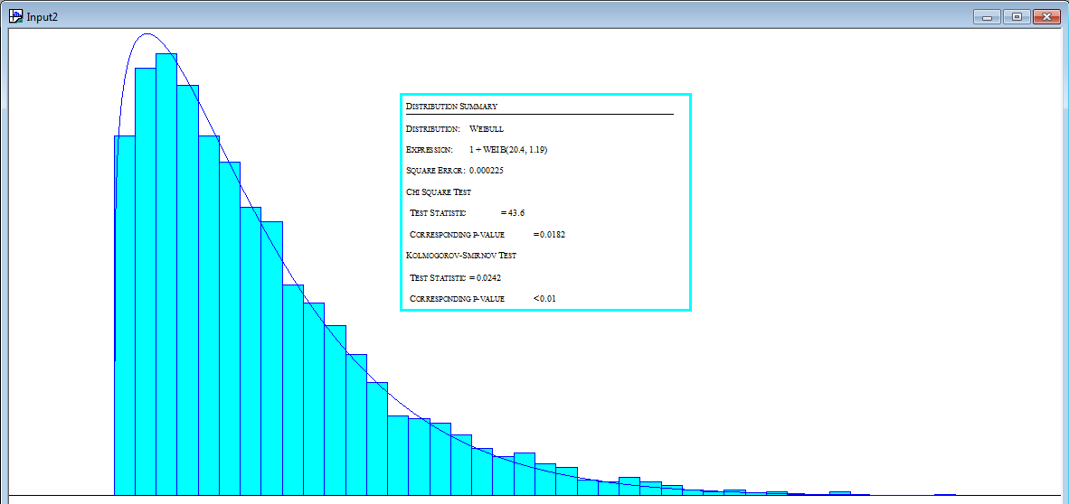

Figure 3 Weibull distribution function fitted to service time in injection room of the observed ED
Then, verification and validation of the ED simulation model is carried out. Verification is related to the computer program which the simulation model is constructed. Computer program controls the model whether it works properly as a presentation of a real world system. Validation aims to reach that whether the model will be a picture of the real system. Validation is completed when model logic and inputs are constructed on the computer accurately. Various approaches are used in the literature for verification and validation of simulation models. These are correctness of data, animation of the model and correctness of operations and outputs [9]. The computer model is checked whether it flows correctly. Then the model is run on a pilot basis and ED executive obeys that the flow is close to the real ED system by the aid of animation.
The simulation model has one source that creates patients with respect to the rates in Figure 2. In the source element of the model built in AnyLogic’s Enterprise Library which is a library for building process-centric discrete event simulations, it is assigned category of the patients. Figure 4 represents a snapshot of the ED simulation model.
The inputs of the ED simulation model includes patient arrival rates (as in Figure 2) and treatment times in each area of the ED. Since the inter-arrival times (IATs) are very random and no distribution with a good fit could be found, an indirect method is followed in modelling of patient arrivals [18]. It was used some performance metrics (in other words KPIs) such as average LOS, average throughput (number of patients who are discharged from the ED), utilization of human resources, and utilization of locations.

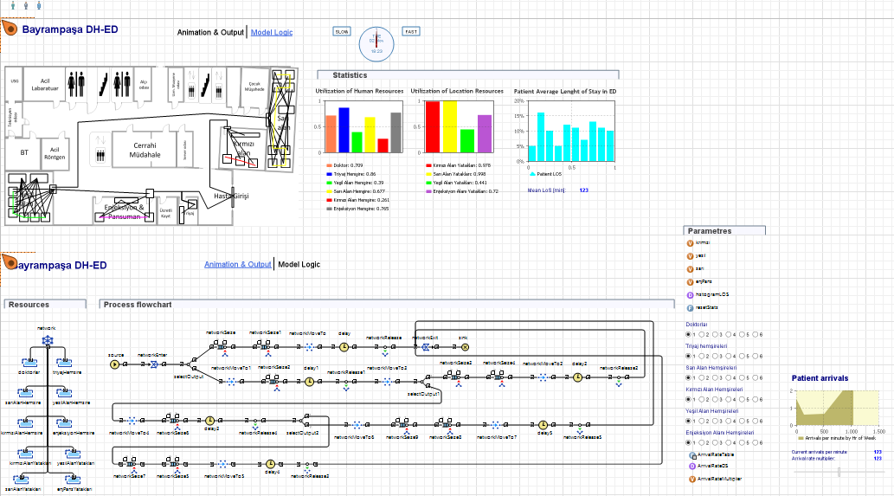
Figure 4: A screenshot showing the ED simulation model

4. Model results and patient surge scenario

The values of the average patient LOS and resource utilizations under normal time are obtained after the model run of the as-is scenario. According to this current state scenario, it can be drawn the followings: (1) the patient LOS is 168 minutes on average; (2) the busiest human resources of the ED are nurses who are responsible for the injection room with a utilization rate of 77%. The idlest of them are nurses of red patients' area with the utilization rate of 23%; (3) of course as a result of these utilization rates of human resources, the busiest location is the injection room with the rate of 76% and the idlest of them is red patients' area with the rate of 19%.
In addition with normal time operations analysis of the ED by the simulation model, it was run patient surge based disaster time scenarios. Xiao et al. [25] defines the patient surge as the distortion in the ratio of the number of patients to the amount of resources in the ED, which leads to inadequate ability in facing the demand.
As emphasized above, EDs face an increase in patient demand during disasters. According to the results of a study by Dursun et al. [7] for the earthquake case of an ED in Van, Turkey, patient arrivals increase 30% of the normal state in the first day of the disaster. Total number of arrivals are composed 94% of disaster-victim patient arrivals and 6% of non-disaster-victim patient arrivals. Therefore, it was developed some additional scenarios for different arrival rates and patient type percentage as [17]. Table 2 shows proposed disaster scenarios with different arrivals.

Model | Arrival rate | Patient type percentage
 |  | Red | Yellow | Green and Injection room
As-is scenario | 729 pt./day | 1.5% | 24% | 74.5%
Scenario 1 | 948 pt./day | 10% | 30% | 60%
Scenario 2 | 765 pt./day | 5% | 30% | 65%
Scenario 3 | 948 pt./day | 20% | 40% | 40%

Table 2 Scenario settings

The as-is scenario uses an arrival rate of 729 patients per day with the percentage of 1.5%, 24% and 74.5% for red, yellow and green & injection room patients respectively. The remaining three scenarios include both an increase in arrival rate and a change in percentage of patient type. First scenario represents an alert for disaster time which uses a percentage of 10% for red patients, 30% for yellow patients and 60% for green and injection room patients with an arrival of 948 patients per day. Second scenario decreases percentage of red patients from 10% to 5% and increases percentage of green & injection room patients from 60% to 65% while keeping yellow patients’ percentage as per the first scenario with an arrival of 765 patients per day. The third scenario represents a major disaster case condition for the ED. It assumes a percentage of 20% for red patients and 40% for yellow and green & injection room patients with an arrival of 948 patients per day. This scenario was developed in order to take into account an expected increase in number of severely injured patients in major disasters compared to normal times. The complete results from running the ED simulation model for these scenarios are shown in Table 3.

 | LOS (min) | Utilization rates (%)
 |  | Human resources (HR) |  |  |  |  |  | Location resources (LR)
 |  | HR1 | HR2 | HR3 | HR4 | HR5 | HR6 | LR1 | LR2 | LR3 | LR4
As-is scenario | 168.315 | 35.2 | 72.8 | 71.0 | 74.7 | 22.6 | 76.4 | 17.8 | 36.4 | 67.4 | 75.9
Scenario 1 | 203.213 | 34.0 | 72.2 | 50.6 | 78.0 | 86.3 | 74.0 | 80.5 | 38.1 | 36.2 | 73.7
Scenario 2 | 178.482 | 36.1 | 73.7 | 61.1 | 80.6 | 63.8 | 77.8 | 62.4 | 39.3 | 49.9 | 77.5
Scenario 3 | 364.326 | 33.1 | 68.8 | 51.6 | 79.4 | 98.4 | 75.2 | 98.4 | 38.7 | 38.1 | 78.0
Note: HR1: Doctors, HR2: Triage nurses, HR3: Green area nurses, HR4: Yellow area nurses, HR5: Red area nurses, HR6:Injection room nurses, LR1: Red patients area, LR2: Yellow patients area, LR3: Green patients area, LR4: Injection room

Table 3 Complete results of disaster-based scenarios
According to the Scenario 1 and Scenario 3 which test the ED behavior in the possible disaster, patient total LOS increases by 20.73% (from 168.315 to 203.213) and 116.45% (from 168.315 to 364.326) as against the as-is scenario. A remarkable result is about the utilization rate of red area nurses and red patients’ area. The scenario 1 results show that red area nurses and red patients’ area reach 281.86% and 352.25% increase on their utilizations, respectively. In Scenario3, the utilization rates have higher scores than the first scenario. While the utilization of red area nurses leads to an increase of 335.40%, the red patients’ area has a percentage of 452.81% (see Figure 5). This means that in time of a possible disaster, when the percentage of red patients’ arrival exceeds the 20% of the total patient arrivals, number of red area nurses and space of red patients’ area will be insufficient for the department. In such a case, the management needs additional resources to respond patient surge.
The major disaster case scenario will results in shortage of two important types of resources. Firstly, available nurses in red patients’ area will not be adequate to handle the large number of expected victims. To overcome problems associated with shortage of resources, it is suggested to the ED executive hiring nurses from outside the hospital. These staff should be available as early as possible in the case of a major disaster event. So, this suggestion can be performed by means of dispatching them from some inpatient departments which do less work in time of disasters. The injection room nurses who are the busiest human resources of the ED according to the normal time scenario can be utilized in order to struggle with the shortage in case of major disaster. On the other hand, the ED executive will meet a bed shortage. It is advised them to plan to set mobile hospitals required in disasters recovery. Under the extreme case (major disaster) with an arrival rate 948 patients/day, the average LOS is 364.326 minutes. This implies that improving performance of the ED is hardly needed to reduce these LOS.
As a methodological improvement, a different distribution function was tested for service time of injection room. The distribution fitting software proposes a number of distribution functions fitted our data. However, they should be tested in terms of goodness of fit. Weibull function was used for service process in injection room in our model since it has the least square error. Then, we decide to propose an alternative distribution function as 1+Gamma (14.3, 1.34) with a square error of 0.000230. The abovementioned Gamma distribution function is presented in Figure 6.
The as-is scenario was run with fifty replications considering service time of injection room fitted to Gamma distribution. It was compared the patient LOS values for service time of injection room with both Weibull and Gamma functions with a hypothesis test for mean (T-test) as in Table 4. It indicates that p-value is smaller than 0.05. The comparison verifies that the patient LOS derived from a comparison between the distribution functions of the injection room service process (Weibull and Gamma) is significantly different.
It is concluded that Weibull distribution function used in service process of injection room fits the as-scenario better than Gamma distribution function.

Figure 5: Comparison of the scenarios under four arrival configurations

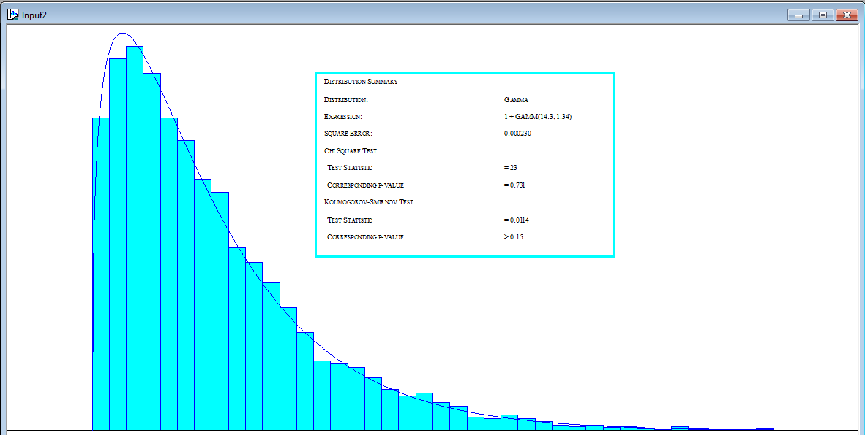

Figure 6 Gamma distribution function fitted to service time in injection room of the observed ED

KPI | Model output (Distribution function of injection room service time) |  | Significance (p-value)
Patient LOS | 1+Weibull (20.4, 1.19) | 1+Gamma (14.3, 1.34) | 0.000 <0.05
 | 168.315 | 188.165

Table 4 Comparison of different distribution functions for service time in injection room

5. Conclusion

In this study, a DES study of a public hospital ED located in an earthquake zone in Istanbul, Turkey was presented in order to analyze both normal time operations of the ED and a disaster time scenario considering increased disaster-victim patient arrivals. DES, which has a long history in simulation methodologies, is applied for ED operations in this study since it has capabilities to test normal and disaster time related scenarios. The data was collected regarding patient arrival patterns and service time in each treatment area of the ED. By a distribution fitting tool, the related data was fitted to suitable theoretical distribution functions. The patient flow of the observed hospital ED was conceptually introduced and DES model was created using a commercial simulation software. By the constructed simulation model, four scenarios (As-Is Scenario and Scenarios 1, 2 and 3) were created to represent the changes of KPIs resulting from disaster related patient surge.
The study is varied from others with some aspects. First, it presents a DES model of the ED that enables generating various scenarios depending on patient arrival variability created by benefiting from a previous earthquake condition. The model generates outputs with respect to several KPIs that are not taken into consideration by the previous studies in the literature. Second, it runs and validates the model by changing the distribution function in service time of treatment areas in order to observe which distribution function fits the model better. Third, it represents a real-world application study in a public hospital ED. The simulation model performed in this ED is the first attempt in order to provide insights for disaster preparedness.
The DES model results show that the ED is affected by the disaster related patient surge scenarios. In time of a possible disaster, when the percentage of red patients’ arrival exceeds 20% of the total patient arrivals, number of red area nurses and space of red patients’ area will be insufficient for the department. So that, the observed ED cannot be adequate to meet the patient surge with the current human and physical resources. Therefore, it is recommended that medical staff dispatching among other EDs temporarily in order to respond to the increased demand or hiring of nurses outside the hospital for a while will be useful on reducing the average LOS and surviving of disaster-victims.
It should be acknowledged that this study has some limitations. Firstly, it is assumed that there is no task switching between medical staff (physicians and nurses). We do this since it is so difficult for us to obtain doctor or nurse time that they spend for more than one patient concurrently. However in real life situation, medical staff may provide service several patients concurrently especially in peak hours. Second limitation of the study is about scenario design. It is proposed four scenarios that are almost based on arrival variability for a possible disaster. However, it can include the scenarios about number of additional medical staff and spaces that are required to keep the KPIs the same as in the as-is scenario. The third potential limitation is that it is of concern in one hospital ED case. Although the application case is for only one specific hospital this model could be adapted to any other hospitals in their disaster preparedness activity.
In order to gain a more comprehensive insight into the level of EDs located in the most risky zone of Istanbul in terms of earthquakes, the model can be expanded to multiple the single ED DES model to a network model. On the other hand, revealing a disaster preparedness guidance for public, university and private hospital ED executives at macro level could be of even greater interest because it would result in guidelines for creating a collaborative work and decision making mechanism with this simulation model. These issues can be addressed for future research.

References

- Alkan, N. Elmas, İ. Karakuş, M. and Akkay, E. (2001). Doğal afetler sırasında karşılaşılan sorunlar: Bir anket çalışması (Problems encountered during natural disasters: A questionnaire study). Turkish Journal of Trauma & Emergency Surgery, 7(3), 195-200.
- Al-Kattan, I. and Abboud, B. (2009). Disaster recovery plan development for the emergency department–case study. Public Administration and Management, 13(3), 75-99.
- Al-Refaie, A. Fouad, R. H. Li, M. H. and Shurrab, M. (2014). Applying simulation and DEA to improve performance of emergency department in a Jordanian hospital. Simulation Modelling Practice and Theory, 41, 59-72.
- Borshchev, A. (2013). The Big Book of Simulation Modeling: Multimethod Modeling with AnyLogic 6. AnyLogic North America.
- Cao, H. and Huang, S. (2012). Principles of Scarce Medical Resource Allocation in Natural Disaster Relief A Simulation Approach. Medical Decision Making, 32(3), 470-476.
- Choon, O. H. Dali, Z. Beng, P. T. and Magdalene, C. P. Y. (2014). Uncover effective process improvement strategies in emergency department with aid of discrete event simulation. Health Systems, 3(2), 93-104.
- Dursun, R. Görmeli, C. A. and Görmeli, G. (2012). 2011 Van depremi sonrası Van bölgesi Eğitim ve Araştırma Hastanesine başvuran olguların değerlendirilmesi (Evaluation of the patients in Van Training and Research Hospital following the 2011 Van earthquake in Turkey). Turkish Journal of Trauma & Emergency Surgery, 18(3), 260-264.
- Ghanes, K., Jouini, O., Jemai, Z., Wargon, M., Hellmann, R., Thomas, V., & Koole, G. (2014, December). A comprehensive simulation modeling of an emergency department: a case study for simulation optimization of staffing levels. In Proceedings of the 2014 Winter Simulation Conference (pp. 1421-1432). IEEE Press.
- Gul, M., & Guneri, A. F. (2012). A computer simulation model to reduce patient length of stay and to improve resource utilization rate in an emergency department service system. International Journal of Industrial Engineering, 19(5), 221-231.
- Gul, M. and Guneri, A.F. (2015a). A comprehensive review of emergency department simulation applications for normal and disaster conditions. Computers & Industrial Engineering, 83, 327-344.
- Gul, M., & Guneri, A. F. (2015b). A discrete event simulation model of an emergency department network for earthquake conditions. In Modeling, Simulation, and Applied Optimization (ICMSAO), 2015 6th International Conference on (pp. 1-6). IEEE.
- Gul, M., & Guneri, A. F. (2015c). Are emergency departments in Istanbul ready for the earthquakes? Past experience and suggestions for future preparedness from employees’ viewpoint and the literature. Journal of Homeland Security and Emergency Management, (in press) http://dx.doi.org/10.1515/jhsem-2014-0114.
- Gunal, M. M. (2012). A guide for building hospital simulation models. Health Systems, 1(1), 17-25.
- Joshi, A. J. and Rys, M. J. (2011). Study on the effect of different arrival patterns on an emergency department’s capacity using discrete event simulation. International Journal of Industrial Engineering: Theory, Applications and Practice, 18(1), 40-50.
- Jun, J. B. Jacobson, S. H. and Swisher, J. R. (1999). Application of discrete-event simulation in health care clinics: a survey. Journal of the operational research society, 50(2), 109-123.
- Kadri, F. Chaabane, S. and Tahon, C. (2014). A simulation-based decision support system to prevent and predict strain situations in emergency department systems. Simulation Modelling Practice and Theory, 42, 32-52.
- Kang, H. Nembhard, H. B. Rafferty, C. and DeFlitch, C. J. (2014). Patient Flow in the Emergency Department: A Classification and Analysis of Admission Process Policies. Annals of emergency medicine, 64(4), 335-342.e8.
- Kaushal, A. (2014). Improving Emergency Department performance using Discrete-event and Agent-based Simulation, MSc Thesis, University of Manitoba, Canada.
- Konrad, R. DeSotto, K. Grocela, A. McAuley, P. Wang, J. Lyons, J. and Bruin, M. (2013). Modeling the impact of changing patient flow processes in an emergency department: Insights from a computer simulation study. Operations Research for Health Care, 2(4), 66-74.
- Kuo, Y. H., Rado, O., Lupia, B., Leung, J. M., and Graham, C. A. (2014). Improving the efficiency of a hospital emergency department: a simulation study with indirectly imputed service-time distributions. Flexible Services and Manufacturing Journal, http://dx.doi.org/10.1007/s10696-014-9198-7.
- Lim, M. E. Nye, T. Bowen, J. M. Hurley, J. Goeree, R. and Tarride, J. E. (2012). Mathematical modeling: the case of emergency department waiting times. International Journal of Technology Assessment in Health Care, 28(02), 93-109.
- Morgareidge, D. Cai, H. and Jia, J. (2014). Performance-driven design with the support of digital tools: Applying discrete event simulation and space syntax on the design of the emergency department. Frontiers of Architectural Research, 3(3), 250-264.
- Patvivatsiri, L. (2006). A simulation model for bioterrorism preparedness in an emergency room. In Proceedings of the 38th conference on Winter simulation (pp. 501-508). Winter Simulation Conference.
- Stat::Fit Version 2-Statistical Fit Software, Geer Mountain Software Corporation, 2001.
- Xiao, N., Sharman, R., Rao, H. R., and Dutta, S. (2012). A simulation based study for managing hospital emergency department's capacity in extreme events. International Journal of Business Excellence, 5(1), 140-154.

