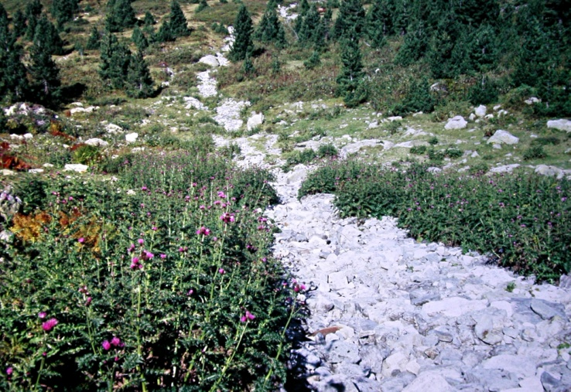

Fig. 1 − Community with dominance of Cirsium appendiculatum - All.: Cirsion appendiculati (Typus of Rumicetalia balcanici) – Serbia, Kosovo, Mt. Šarplanina, Jažinačko jezero, c. 1900 m, silicate (photo: D. Lakušić 10.07.1990)

