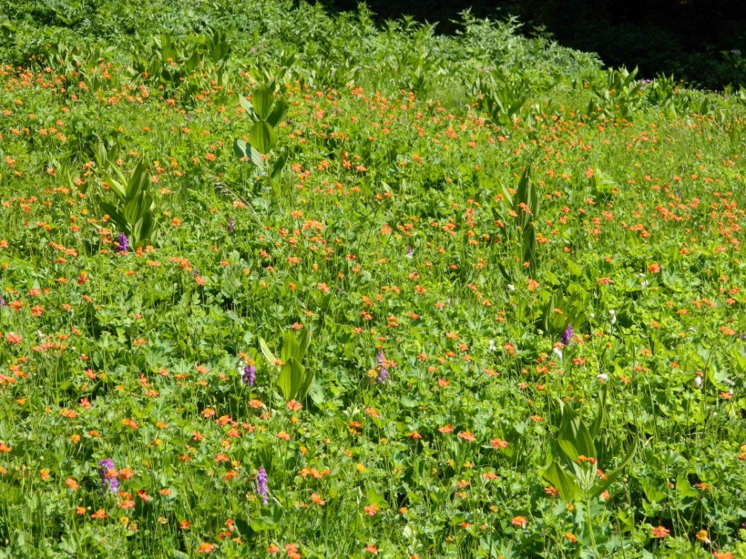

Fig. 2 − Community with dominance of Geum coccineum- All. : Geion coccinei. Macedonia, Mt. Jablanica, Krstec, c. 1700 m, silicate (photo: Ranđelović, V., 20.06.2013)

