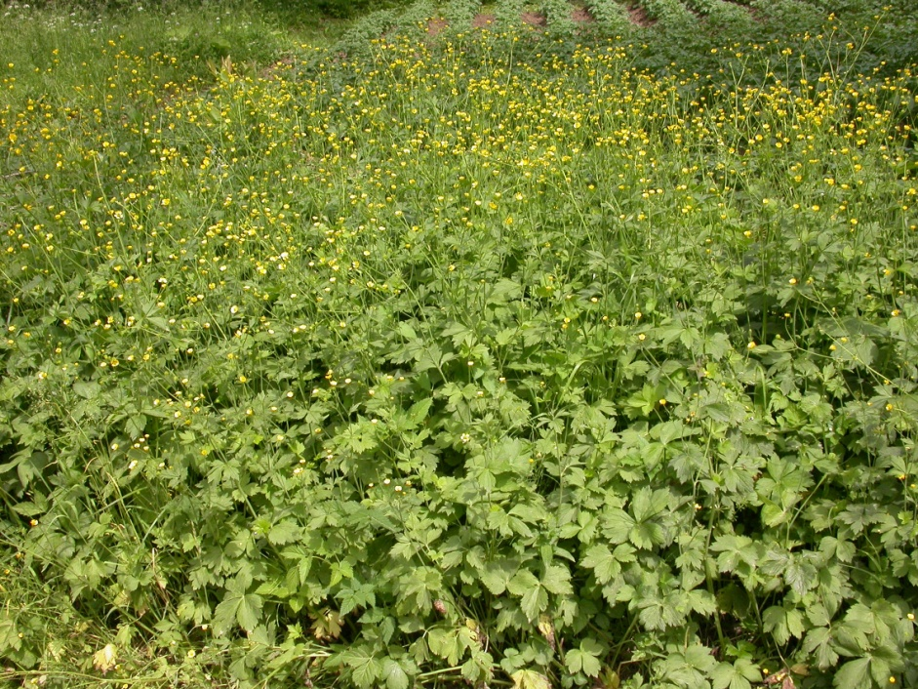

Fig. 5 − Community with dominance of Ranunculus serbicus, All.: Ranunculion serbici. Serbia, Mt. Suva planina, Donji Dušnik, c. 600 m, limestone (photo: D. Lakušić 31.05.2006).

