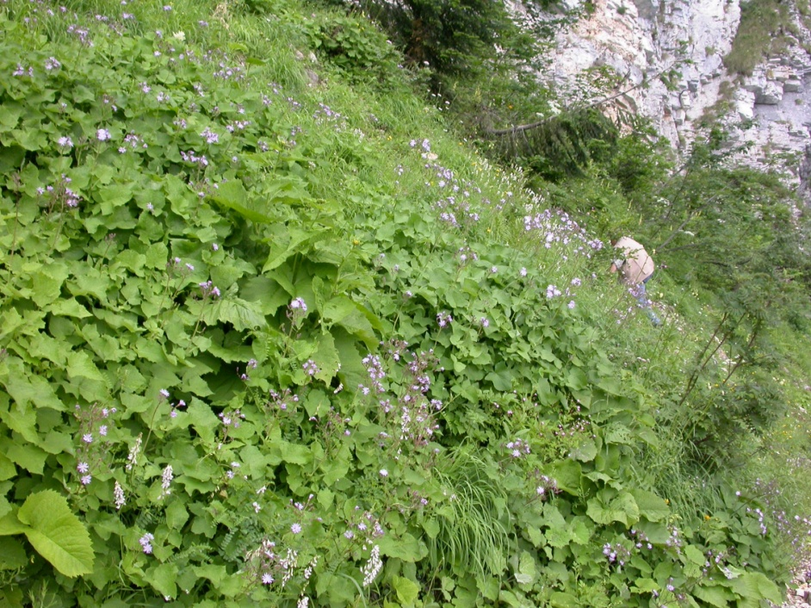

Fig. 6 − Community with dominance of Lactuca pancicii, All. : Cicerbition pancicii . Montenegro, Mt. Durmitor, Ćurovac, c. 1400 m, limestone (photo: D. Lakušić 16.07.2006).

