**Title:** Nomenclature adjustments of neglected and new syntaxa of the tall-herb hygrophilous communities of the SE-Europe

**Running title:** *Phytosociological nomenclature of the Balkan tall-herb vegetation*

**Authors:**

Dmitar Lakušić - University of Belgrade (Serbia)

Vladimir Ranđelović - University of Niš (Serbia)

Romeo Di Pietro - University of Rome (Italy)

**Corresponding author:** Romeo Di Pietro

Department of Planning, Design and Technology of Architecture, Section Environment and Landscape, Sapienza University of Rome, Via Flaminia 72, I-00196 Rome, Italy. E-mail: romeo.dipietro@uniroma1.it

**Running title**

*Phytosociological nomenclature of the Balkan tall-herb vegetation*

(1)Dmitar Lakušić, (2)Vladimir Ranđelović,(3)Romeo Di Pietro

1. Institute of Botany and Botanical garden Jevremovac, Faculty of Biology, University of Belgrade, Takovska 43, 11000 Belgrade, Serbia.E–mail: [dlakusic@bio.bg.ac.rs](mailto:dlakusic@bio.bg.ac.rs)
2. Department of Biology and Ecology, Faculty of Sciences and Mathematics, University of Niš, 18000 Niš, Serbia
3. Department of Planning, Design and Technology of Architecture, Section Environment and Landscape, Sapienza University of Rome, Via Flaminia 72, I-00196 Rome, Italy. E-mail: [romeo.dipietro@uniroma1.it](mailto:romeo.dipietro@uniroma1.it)

**ABSTRACT**

During the preparation of the European checklist of vegetation units, it emerged that some syntaxa characterizing the Balkan vegetation had been invalidly described in their original papers and needed some nomenclatural adjustments. Some other earlier published syntaxa were found to have been completely forgotten or considered invalid by the current phytosociological literature despite the fact that they had been validly published in their original papers. The present study deals with the vegetation of the *Rumicetalia balcanici* Lakušić 1973, a neglected order of the montane tall-herb vegetation of the Balkan Peninsula which is characterized by many Balkan endemic species.

All the paper bearing a nomenclatural importance as regards the tall-herb vegetation in the Balkans have been analysed. The nomenclatural adjustments were made according to the Code of Phytosociological nomenclature (ICPN).

The *Rumicetalia balcanici* order was subjected to a series of nomenclatural vicissitudes which led to it been proposed, misinterpreted and subsequenly forgotten. In the present paper we have made nomenclature adjustments which have resulted in the validation of several of its alliances and associations.

**INTRODUCTION**

The tall-herb vegetation in SE Europe has attracted researchers since the beginning of the 20th century. The first botanist who dealt with this vegetation type in the Balkan area was Adamović *(1)*. Subsequently Horvat, through many papers concerning the vegetation of the Macedonian and Bulgarian mountains *(2, 3, 4, 5, 6, 7, 8)*, formally described several associations of tall-herbs and classified them into two new alliances: the *Cirsion appendiculati* Ht., Pawl. et Walas 1937 and the *Geion coccinei* Ht. 1960. These alliances were included in the order *Adenostyletalia* Br-Bl. 1931 and in the class *Betulo-Adenostyletea* Br-Bl. 1931. Further studies were carried out by R. Lakušić *(9, 10, 11, 12)* who introduced four new alliances: *Petasition doerfleri* Lakušić 1968, *Rumicion balcanici* Lakušić 1973, *Ranunculion serbici* Lakušić et al 1987 and *Cicerbition pancicii* Lakušić (1970) 1987. These alliances were originally included in the Balkan endemic order *Rumicetalia* *balcanici* Lakušić 1973 and subsequently moved into a different order, *Cicerbidetalia pancicii* Lakušić 1987. More recently some contributions regarding the syntaxonomy of the Balkan tall-herb vegetation were carried out by Ranđelović & al *(13)*, Ranđelović *(14)*, Ranđelović & Zlatković *(15)* who, on the basis of the presumed nomenclatural invalidity of the name *Rumicetalia balcanici*, and in accordance with the concepts already expressed by R. Lakušić, described the new order *Cirsietalia appendiculatae* V. Ranđelović (2001) 2010. In addition to the afore-mentioned papers, which strongly influenced the high-rank syntaxonomical framework of the high-altitude Balkan tall-herb vegetation, several other studies dealing with this topic were published for the Balkan Peninsula *(16, 17, 18, 19, 20, 21, 22, 23)*. Despite the high number of published papers and proposed names it has now emerged that the majority of the associations and of the higher rank syntaxa describing the Balkan tall-herb vegetation were originally invalidly published. In the present paper we have made many nomenclature adjustments which have resulted in proposing again the name *Rumicetalia balcanici* and in the validation of Balkan tall-herb associations and alliances.

**MATERIALS AND METHODS**

All the paper bearing a nomenclatural importance as regards the tall-herb vegetation in the Balkans have been analysed. The nomenclatural adjustments of the syntaxa were made according to the Code of Phytosociological nomenclature ICPN *(24)*. The nomenclature of the plant species follows EURO+MED plant base *(25)*. For those plant families and genera which are not included in the EURO+MED plant base reference was made to *Flora Europaea* *(26)*.

**RESULTS AND DISCUSSION**

**Order rank**

The name *Rumicetalia balcanici* was proposed for the first time in Lakušić *(10)*, where he defined it as “*Balkan endemic vegetation of tall herbs on hydrogenic soils on silicate massifs”*. This order was originally composed of three alliances: *Cirsion appendiculati* Horvat et al. 1937, *Geion coccinei* Horvat 1949 and *Rumicion balcanici* Lakušić 1973. Only the first alliance was validly published, accordingly the order *Rumicetalia balcanici* was to be considered validly described in its first proposal and thus alliance *Cirsion appendiculati* (Fig. 1) has automatically assumed the status of holotypus. Strangely, after this first and valid proposal, the name *Rumicetalia balcanici* was gradually forgotten and no longer used by the Balkan phytosociologists, who preferred to substitute it with other (often invalid) names. Until 1987 the Balkan high-altitude tall-herb communities were included in the *Adenostyletalia* *(8, 27)* or in the *Montio Cardaminetalia* Pawl. 1938 *(28, 18)*. However Lakušić et al. *(11)* were of a different opinion and in a paper describing the new alliance *Ranunculion serbici* (nom. inval. Art. 3o; 5), they re-proposed the old concept of an endemic order restricted to the tall-herb vegetation of the Balkans. Moreover, they also extended the ecological range of this order to the basiphilous communities developed on the limestone bedrocks. In fact, the original proposal of *Rumicetalia balcanici* *(10)*, hypothesized that this order was restricted to the three acidophilous alliances *Rumicion balcanici, Cirsion appendiculati* and *Geion coccinei*. The ecological enlargement of the order was put into effect with the inclusion of the three alliances *Petasition doerfleri* Lakušić 1968, *Mulgedion pancicii* Lakušić 1970 and *Ranunculion serbici* Lakušić et al. 1987. As regards the name to be given to this Balkan endemic order, however, the authors did not opt for the already existing and valid name *Rumicetalia* *balcanici*, but introduced the reference of *Mulgedietalia pancicii* Lakušić 1970. Since none of the Lakušić’s paper published in 1970 (or in the years around it) reports a reference to the name *Mulgedietalia pancici*, this name is to be considered a phantom name. Some years later Lakušić & Redžić *(12)* corrected the name *Mulgedietalia* *pancicii* to *Cicerbidetalia* *pancicii* Lakušić 1987. In addition to being invalid (art. 5), the name *Cicerbidetalia* *pancicii* was clearly a syntaxonomical synonym (p.p.) of *Rumicetalia balcanici* Lakušić 1973, since it included the three alliances (*Rumicion balcanici, Cirsion appendiculati* and *Geion coccinei*) which were originally classified in *Rumicetalia balcanici*.

Owing to the invalidity of the name *Cicerbidetalia* *pancicii* Lakušić 1987 and because the name *Rumicetalia balcanici* had been completely neglected, Ranđelović *(14)* and Ranđelović & Zlatković *(15)* proposed the new order *Cirsietalia appendiculatii* V. Randj. 2001 (nom. inval. art. 1) to include all the Balkan tall-herb vegetation developed on the hydromorphic siliceous soils of the subalpine-alpine belt. Since the authors included the alliances *Cirsion appendiculatae*, *Geion coccinei* and *Rumicion* *balcanici* in the new order *Cirsietalia appendiculati*, this latter can be considered as perfectly overlapping the *Rumicetalia balcanici* Lakušić 1973.

The proposal of the order *Rumicetalia balcanici* Lakušić 1973 was justified by the occurrence of a large Balkan endemic floristic component in its communities. The presence of a high number of endemic species in a hygrophylous microclimatic vegetation is quite unusual especially considering that the tall-herb plant communities were developed on hydrophilic silicious bedrock where the circumboreal and C-European species often monopolize the floristic composition. Nevertheless, the possible coenological autonomy of the *Rumicetalia balcanici*, as opposed to the *Adenostyletalia*, cannot be clarified solely by means of the nomenclatural adjustments made in this paper. Additional field surveys and numerical comparisons of synoptic tables including plant communities from the surrounding areas and from central Europe would be required in order to establish a more plausible syntaxonomical arrangement.

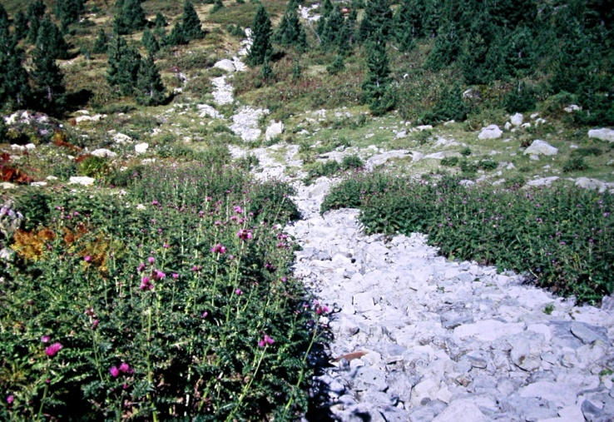

Fig. 1 − Community with dominance of *Cirsium appendiculatum* - All.: *Cirsion appendiculati* (Typus of *Rumicetalia balcanici*)– Serbia, Kosovo, Mt. Šarplanina, Jažinačko jezero, c. 1900 m, silicate (photo: D. Lakušić 10.07.1990)

**Alliance rank**

* ***Geion coccinei*** Ht. ex D. Lakušić et al. all. nov. hoc loco

(*Rumicetalia balcanici (Adenostyletalia)Mulgedio-Aconitetea*)

Basyonim: *Geion coccinei* Horvat 1960, (Art. 3o; 5)

Name-giving species: *Geum* *coccineum* Sibth. & Sm.

Nomenclature type:*Geo coccinei-Deschampsietum caespitosae* Horvat ex D. Lakušić et al. ass. nov. hoc loco

Diagnostic taxa: *Alchemilla* *viridiflora*, *Cirsium* *heterotrichum*, *Geum coccineum*, *Geum rhodopeum*, *Potentilla aurea* subsp. *chrysocraspeda*, *Pseudorchis frivaldii*, *Senecio pancicii*, *Silene asterias*

Constant taxa: *Agrostis canina*, *Alchemilla gracilis, Caltha palustris* subsp*. laeta, Chaerophyllum hirsutum agg., Crepis paludosa, Deschampsia cespitosa, Equisetum palustre, Filipendula ulmaria, Galium palustre, Geum rivale, Juncus effusus, Juncus thomasii, Mentha longifolia, Myosotis palustris, Potentilla erecta, Scirpus sylvaticus, Veratrum lobelianum.*

Diagnosis: The *Geion coccinei* communities are developed in the subalpine belt of the W-Balkan-Rhodopean and N-Scardo-Pindian mountains on the lime-poor substrates of places where the water flooding is about constant. The *Geion coccinei* communities are floristically characterized by a lower number of species and by species of smaller size than those occurring in the *Cirsion appendiculati*.

Distribution: The *Geion coccinei* is found in Serbia (Mt. Stara planina, Vlasina Plateau and Krajište region - Balkan-Rodopaean system), Kosovo (Mt. Šarplanina - Scardo-Pindian system), Macedonia (Mts. Bistra, Jablanica, Pelister - Scardo-Pindian system) and Bulgaria (Mts. Vitoša, Rila, Pirin - Rodopaean system).

Syntaxonomy and nomenclature: Although different dates of first publication of this alliance are to be found in vegetation surveys concerning the former Yugoslavian territory [1949 in *(27)*; 1937 in *(15)*], the correct nomenclatural reference is to be considered “Horvat 1960” (5). The *Geion coccinei* was defined as including the marshy meadows developed on the subalpine moist soils of the silicate mountains of Macedonia. In *(5)* the author provided only a short, informal description of the alliance: “"*On moist soils in the subalpine zone, where permanent water springs flooded the ground, a specific vegetation of marshy meadows was developed. This contains a small number of species, but at the time of flowering it afar highlights the extraordinary color characteristic of Geum coccineum* (see Fig. 2)……*The systematic relationships of the marshy meadows are not clear, perhaps the knowledge of the related communities occurring in the lower parts of the mountains could provide the key to their solution. As a consequence its links with the Adenostyletalia has a provisional character. The only community occurring in this alliance is the Coccinea-Deschampsietum (ass. Deschampsia caesitosa-Geum coccineum). It is widespread in all the Macedonian mountains, but it is composed of a low number of species"*. Here it is interesting to note that in the place of the term "tall-herb vegetation" which in *(5)* Horvat used for the description of *Cirsion appendiculati,* he used the term "marshy meadow" for the *Geion coccinei.* Moreover, Horvat clearly indicated that the inclusion of the *Geion coccinei* in the *Adenostyletalia* was to be considered just provisional. Subsequently in *(8)*, Horvat did not use the name *Geion coccinei,* and this is probably the reason why this namewas also neglected inthe overview on the European phytosociological alliances carried out by Rodwell et al. *(29)*.

Owing to the fact that Horvat did not include any phytosociological table or single relevés usable as nomenclatural type in his papers *(2, 5)*, both the association *Coccinea-Deschampsietum* Horvat 1935 and the alliance *Geion coccinei* Horvat 1960 are to be considered invalidly published (Art. 3; 5). Nonetheless, the name *Geion coccinei* was subsequently used in some other vegetation surveys concerning Serbia and Macedonia *(27; 30, 14; 15).*

The following associations are currently included in *Geion coccinei*:

*Geo coccinei-Deschampsietum caespitosae* Ht. ex D. Lakušić et al. ass. nov.

*Carici*- *Deschampsietum caespitosae* Roussakova 2000

*Trolio europaeae-Geetum rhodopaei* V. Ranđelović ex D. Lakušić et al. ass. nov.

*Geo rivale-Filipenduletum ulmariae* V. Ranđelović ex D. Lakušić et al. ass. nov.

***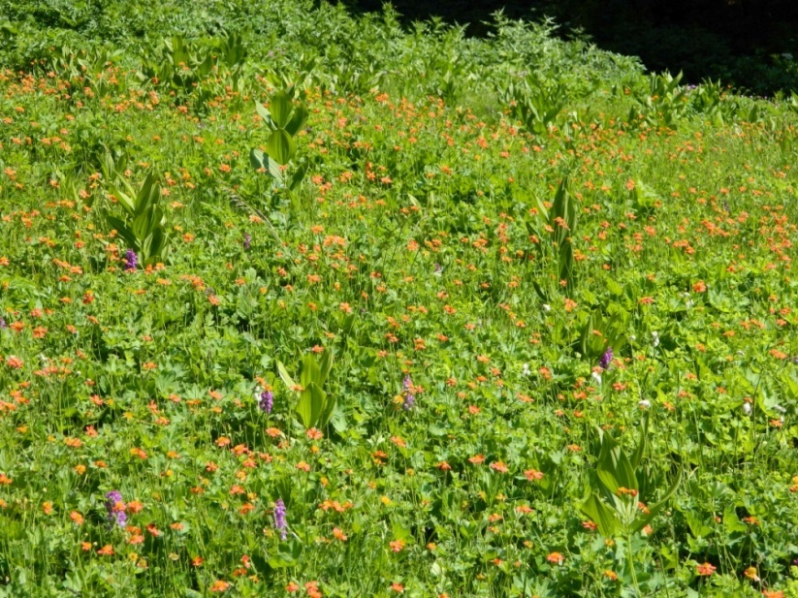***

Fig. 2 − Community with dominance of *Geum coccineum*- All. : *Geion coccinei.* Macedonia, Mt. Jablanica, Krstec, c. 1700 m, silicate (photo: Ranđelović, V., 20.06.2013)

* ***Rumicion balcanici*** Lakušić ex D. Lakušić et al. all. nov. hoc loco

(*Rumicetalia balcanici (Adenostyletalia), Mulgedio-Aconitetea*)

Basyonim: *Rumicion balcanici*Lakušić 1973, (Art. 3o; 5)

Name-giving species: *Rumex balcanicus* Rech. fil.

Nomenclature type:*Barbareo balcanae-Rumicetum balcanici* V. Randjelović ex D. Lakušić et al. ass. nov. hoc loco

Diagnostic taxa: *Barbarea* *balcana*, *Cardamine* *amara* subsp. *balcanica*, *Dactylorhiza cordigera* subsp. *bosniaca*, *Pinguicula balcanica*, *Rumex balcanicus*, *Willemetia stipitata* subsp. *albanica*.

Constant taxa: *Barbarea balcana,* *Caltha palustris* subsp*. laeta, Cardamine amara* subsp. *balcana*, *Cardamine matthioli*, *Carex flava, Carex goodenowii, Chaerophyllum hirsutum* agg., *Crepis paludosa, Dactylorhiza cordigera* subsp. *cordigera*, *Deschampsia cespitosa, Epilobium palustre, Filipendula ulmaria, Myosotis palustris, Rumex balcanicus, Veratrum lobelianum*.

Diagnosis: Tall-herb communities of the upper-montane and subalpine belts of the SE-Dinarids, W-Balkan-Rhodopean and N Scardo-Pindian mountains characterized by a mixture of tall-herbs and species coming from the meso-hygrophilous grasslands, cryo-hygrophilous peat-bogs and cold oligotrophic springs. The *Rumicion balcanici* communities can be found on the lime-poor substrates developed nearby the mountain creeks as well as within the humid mild slopes where a high degree of water retention occurs (Fig. 3).

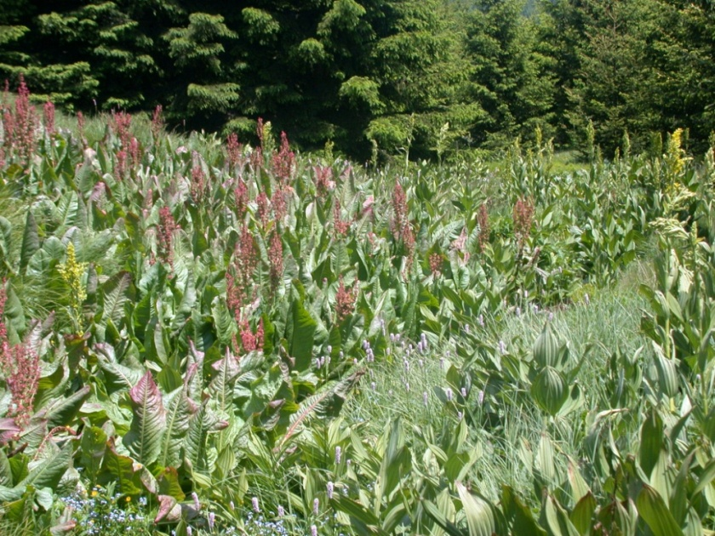

Fig. 3 − Ass. *Brachythecio rivulare-Rumicetum balcanici* V. Randjelović ex D. Lakušić et al. ass. nov. All. : *Rumicion balcanici*. Serbia, Mt. Čemernik, c. 1350 m (photo: Ranđelović, V., 23.06.2011)

Distribution: The *Rumicion balcanici* is found in Montenegro (Mt Bjelasica -SE Dinarides), Serbia (Mt. Kopaonik - continental Dinarides, Mt. Stara planina, Vlasina Plateau and Krajište region - Balkan-Rodopaean system), Kosovo (Mt Prokletije - SE Dinarides, Mt. Šarplanina - Scardo-Pindian system), and Mecedonia (Mt. Jablanica - Scardo-Pindian system). The distribution area of *Rumex balcanicus* (Fig. 4) suggests that communities belonging to the alliance *Rumicion balcanici* could also be found in Bulgaria and Albania.

Map_1_Rumex_balcanicus_distribution.tif

Fig. 4 : Distribution area of Rumex balcanicus. 1. Mt. Bjelasica, 2, Mt. Prokletije, 3. Mt. Kopaonik,. 4. Mt. Stara planina, 5. Mt. Čemernik, 6. Mt. Šarplanina, 7. Mt. Bistra, 8. Mt. Jablanica, 9. Mt. Pelister

B&H - Bosnia and Hercegovina, Mn - Montenengro, Sr - Serbia, Bu - Bulgaria, Ma - Macedonicaq, Gr - Grecee, Al - Albania

Syntaxonomy and nomenclature: The alliance *Rumicion balcanici* was proposed for the first time in *(10)*. It was defined as tall-herb vegetation on gleyic and hydrogenic soils developed on the silicate massif of the Prokletije phytogeographical sector of the high-Dinaric province. R. Lakušić did not present any phytosociological table or single relevés in his paper, but only a short informal description of the alliance: “*On the hydrogenic soils occurring within the* *subalpine belt of the volcanic massif of Troglav and Zekova Glava on Mt. Bjelasica. Rumex balcanicus Rech. fil. lives in association together with the following species: Barbarea balcana var., Caltha palustris subsp. laeta f., Filipendula ulmaria f., Tozzia alpina var., Pinguicula balcanica, Carex fusca f., Cardamine palustris f., Veratrum album var. viride, Trollius europaeus, Allium sibiricum f., Orchis bosniaca, Carex flava f. etc*.”. In the same paper Lakušić stated that the *Rumicion balcanici* substituted the Scardo-Rhodopian *Cirsion appendiculati* in the SE-Dinarids. Thus, he indirectly included the *Rumicion balcanici* in the class *Mulgedio-Aconitetea* Hadač et Klika in Klika et Hadač 1944 (at that time known as *Betulo-Adenostyletea*). In *(10)*, however, Lakušić did not refer to association as included in the *Rumicion balcanici*. Three years later, in the “Prodromus of phytocoenosis of Montenegro”*(28)* the author introduced the name *Rumicetum balcanici* Lakušić 65. The references “Lakušić 65”, or “Lakušić 1965”, or “Lkšć 1965” recurred frequently in the Montenegro phytosociological literature. Nevertheless, no trace of this (probably hand-written) manuscript has been found in the recent past, so that it is likely that Lakušić never published this 1965 paper. As *(10)* did not include any phytosociological table or single relevés usable as nomenclatural type in his paper, both the association *Rumicetum balcanici* Lakušić 1965 and the alliance *Rumicion balcanici* Lakušić 1973 are to be considered invalidly published (Art. 3; 5). Nonetheless, the name *Rumicion balcanici,* was subsequantly used in some other vegetation surveys concerning the Montenegro and Serbia territories *(28, 27, 14, 31, 15, 32).*

In order to be phytogeographically consistent with the original description of the alliance made in *(10)*, the association *Barbareo balcanae-Rumicetum balcanici* V. Randjelović ex D. Lakušić et al. ass. nov. hoc loco has here been here selected as the typus of the alliance *Rumicion balcanici*. This association was described for the Mt. Šutman (Šarplanina) which is located adjacent to Mt. Bjelasica (locus classicus of *Rumicion balcanici*) with which it shares a high degree of floristic and vegetational similarities.

In the present paper we have considered the *Rumicion balcanici* as a natural meso-hygrophilous tall-herb vegetation characterized by a negligible anthropogenic impact. As a consequence we have included it in the *Mulgedio-Aconitetea*. It is interesting to note, however, that other authors included the *R. balcanicus* communities in different orders and classes. Blečić & Lakušić *(28)* and Jovanović-Dunjić in Mišić et al. *(18)* classified them in the *Montio-Cardaminetea* Br.-Bl. et Tx. 1943, while Petrović et al. *(32)* included the whole alliance *Rumicion balcanici* in the *Rumicetalia alpini* Mucina in Karner & Mucina 1993. Actually, the low frequency of the the tall species of the genera *Mulgedium* (= *Lactuca*), *Aconitum*, *Ranunculus*, *Angelica*, *Doronicum* or *Cirsium*, and the dominance of medium-size herbaceous species of the genus *Cardamine* (e.g. *C. amara* subsp. *balcanica*, *C. acris*, *C. matthiolii*), as well as the high percentages of mosses (*Brachythecium rivulare, Plagiochilla asplenioides, Bryum pseudotriquetrum, Philonotis fontana, Sphagnum* sp. div., etc.), could justify the use of the class *Montio*-*Cardaminetea*. Thus, further field investigations are required to propose a more precise syntaxonomical classification.

The following associations are currently included in the *Rumicion balcanici*:

*Cardamino balcanicae-Rumicetum balcanici* R. Jovanović 1971 ex D. Lakušić et al. ass. nov.

*Barbareo balcanae-Rumicetum balcanici*. V. Randjelović ex D. Lakušić et al. ass. nov. *Brachythecio rivulare-Rumicetum balcanici* V. Randjelović ex D. Lakušić et al. ass. nov.

* ***Ranunculion serbici*** Lakušić et al. in 1987 ex D. Lakušić et al. all. nov. hoc loco

(*Rumicetalia balcanici (Adenostyletalia)Mulgedio-Aconitetea*)

Basyonim: *Ranunculion serbici*Lakušić et al. in 1987, [Art. 3o; 5]

Name-giving species: *Ranunculus* *serbicus* Vis.

Typus:*Ranunculetum serbici* Lakušić et al. 1987 ex D. Lakušić et al. ass. nov. hoc loco

Diagnostic taxa: *Ranunculus* *serbicus* Vis.

Constant taxa: *Agrostis capillaris, Caltha palustris, Cardamine matthioli, Centaurea jacea., Chaerophyllum hirsutum* agg*., Lactuca alpina, Deschampsia cespitosa, Epilobium hirsutum, Equisetum palustre, Filipendula ulmaria , Galium palustre, Lychnis flos-cuculi, Mentha longifolia, Myosotis palustris, Myosotis scorpioides, Oenanthe banatica, Polygonum bistorta, Ranunculus aconitifolius, Ranunculus serbicus, Scirpus sylvaticus, Senecio nemorensis, Stellaria graminea, Veratrum lobelianum.*

Diagnosis: Tall-herb vegetation of the flattened alluvial stream plains characterizing the spruce-fir-beech forests area in the C-Balkan peninsula (Fig. 5).

Distribution: On the basis of the phytosociological literature *(11, 33, 15)* and the personal observations of one of us, the *Ranunculion serbici* occursin Bosnia and Herzegovina (Leskovac near Han Pijesak), and in Serbia (Brzećka klisura gorge on Mt. Kopaonik, Vlasina Plateau, Donji Dušnik on Mt. Suva planina).

Syntaxonomy and nomenclature: The alliance *Ranunculion serbici* was invalidly proposed (Art. 3o; 5) in *(11)*. It was based on a single association, the *Ranunculetum serbici* Lakušić R., Mišić Lj. & Golić S. 1987 (nom. inval. Art. 3o; 5). The dominant species, *Ranucnulus serbicus*, was a sub-endemic Balkan species with few relic stations in the Calabria region in S-Italy *(34)*. The *Ranunculion serbici* communities exhibit many geographical, ecological and floristic similarities to the tall-herb communities with dominance of *Lactuca pancicii*. Therefore, it is possible that in the future it could beconsidered a syntaxonomical synonym of the alliance *Cicerbition pancicii.*

The following associations are currently included in the *Ranunculion serbici*.

*Ranunculetum serbici* Lakušić et al. 1987 ex D. Lakušić et al. ass. nov.

*Equiseto polystachii-Ranunculetum serbici* V. Randjelović ex D. Lakušić et al. ass. nov.

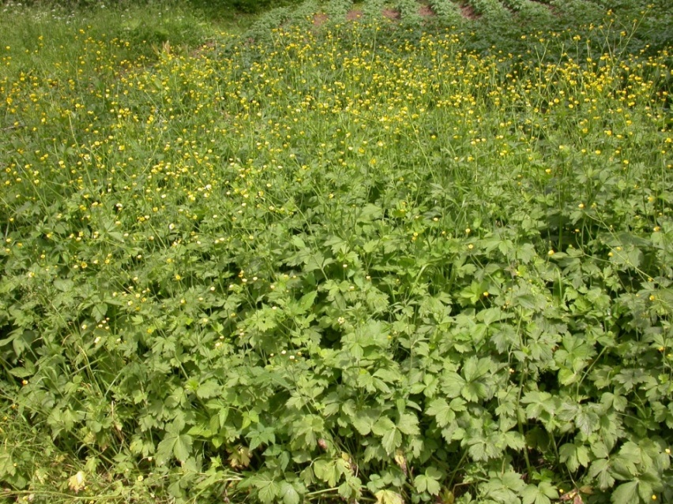

Fig. 5 − Community with dominance of *Ranunculus serbicus*, All.: *Ranunculion serbici*. Serbia, Mt. Suva planina, Donji Dušnik, c. 600 m, limestone (photo: D. Lakušić 31.05.2006).

* ***Cicerbition pancicii*** Lakušić in Lakušić & Redžić ex D. Lakušić et al. all. nov. hoc loco

(*Rumicetalia balcanici (Adenostyletalia)Mulgedio-Aconitetea*)

Basyonim: *Cicerbition pancicii* Lakušić R., in Lakušić & Redžić 1989, [Art. 3o; 5])

Name-giving species: *Lactuca* *pancicii* (=*Cicerbita* *pancicii*)

Typus:*Cirsio wettsteinii-Cicerbitetum pancicii* Lakušić & Redžić 1989

Diagnostic taxa : *Aconitum burnatii* subsp. *pentheri*, *Aconitum* *toxicum* subsp. *bosniacum*, *Angelica sylvestris,* *Aquilegia* *blecicii*, *Lactuca* *pancicii*, *Cirsium* *boujartii* subsp. *wettsteinii*, *Hesperis* *dinarica*, *Knautia* *sarajevensis*, *Lunaria telekiana, Lactuca aurea*

Constant taxa: *Aegopodium podagraria, Angelica sylvestris, Calamagrostis varia, Cardamine matthioli, Chaerophyllum hirsutum agg., Lactuca pancicii, Cirsium* *boujartii* subsp. *wettsteinii, Clematis recta, Equisetum palustre., Mentha longifolia, Molinia caerulea, Petasites hybridus, Petasites kablikianus, Prunella vulgaris, Ranunculus repens, Rubus caesius, Thalictrum simplex*

Diagnosis: Tall-herb communities developed within the humid and mild (15-30°) limestone slopes ranging between the submontane to the subalpine belts, on hydrogenic calkomelanosol soils. The vegetation cover ranges between 95 and 100 %, while the height of the dominant herb-layer between 150 and 200 cm (Fig. 6). The majority of the *Cicerbition pancicii* communities are typical form of natural vegetation (sometime potential) characterized by a negligible anthropogenic impact.

Distribution: In Montenegro this alliance occurs in the Canyon of the Tara river (Neviđeno, mouth of river Sušica, Bijele vode, Lazin kamen, Izvori near Sušićka pećina, Ćurovac). In Bosnia and Hercegovina it occurs in the Canyon of river Sutjeska (personal field observation). On the basis of the distribution of *Lactuca pancicii* it is hypothesizable that the alliance *Cicerbition pancicii* could occur also in some areas of Serbia, Albania and Macedonia.

Syntaxonomy and nomenclature: The alliance *Cicerbition pancicii* was proposed in *(10)* under the phantom name of *Mulgedion pancicii* Lakušić.Two years later Lakušić & Redžić *(12)* introduced the new name *Cicerbition pancicii* Lakušić (nomen novum), and included in it four new tall-herb associations which were described for the Tara Gorges in Montenegro (*Cirsio-Cicerbitetum pancicii, Cicerbito-Petasitetum hybridi, Molinio-Adenophoretum lilifoliae, Chaerophyllo-Cirsietum wettsteinii*). The phytosociological relevés of these associations were arranged in a phytosociological table (Tab. 4 page 150) composed of 5 relevés. The first two relevés made reference to *Molinio-Adenophoretum* while the other three to the associations *Cirsio-Cicerbidetum pancici*, *Cicerbito-Petasitetum* and *Chaerophyllo-Cirsietum*. The latter three associations were therefore validly published by virtue of their single relevès which automatically played the role of nomenclatural types. On the contrary the *Molinio-Adenophoretum* was invalidly described due to the occurrence of two relevés usable as nomenclatural type (Art. 3o; 5). For the same reason the occurrence of three valid associations included in the *Cicerbition pancicii* made this alliance as invalidly described (Art. 3o; 5). In the present paper the alliance *Cicerbition pancicii* is validated through the designation of the *Cirsio-Cicerbitetum pancicii* Lakušić & Redžić 1989 as lectotypus.

The following associations are currently included in the *Cicerbition pancicii*:

*Chaerophyllo hisuti-Cirsietum wettsteinii* Lakušić & Redžić 1989

*Cicerbito pancicii-Petasitetum hybridi* Lakušić & Redžić 1989

*Cirsio wettsteinii-Cicerbitetum pancicii* Lakušić & Redžić 1989

*Molinio arundinaceae-Adenophoretum lilifoliae* Lakušić & Redžić ex D. Lakušić et al. ass. nov.

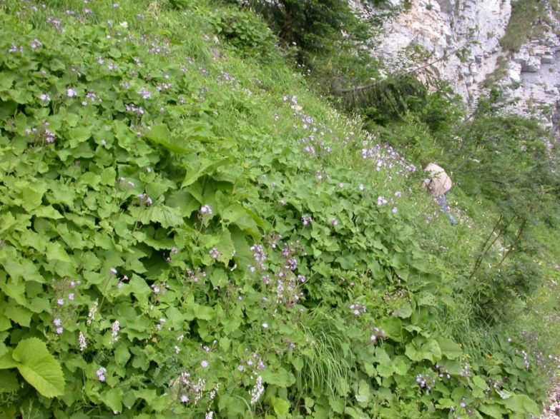

Fig. 6 − Community with dominance of *Lactuca pancicii*, All. : *Cicerbition pancicii* . Montenegro, Mt. Durmitor, Ćurovac, c. 1400 m, limestone (photo: D. Lakušić 16.07.2006).

* ***Petasition doerfleri*** Lakušić 1968 ex D. Lakušić et al. all. nov. hoc loco

(*Thlaspietea rotundifolii*)

Basyonim: *Petasition doerfleri* Lakušić 1968 [Art. 3o; 5])

Name-giving species: *Petasites doerfleri*

Nomenclature type:*Valeriano bertiscei-Petasitetum doerfleri*D. Lakušić & Di Pietro ass. nova hoc. loco

Diagnostic taxa: *Adenostyles alliariae*, *Geum bulgaricum*, *Heracleum sphondylium* subsp. *orsinii*, *Petasites doerfleri*, *Potentilla montenegrina*. *Wulfenia carinthiaca* *(=W. blecicii*)

Constant taxa: *Arabis alpine*, *Cardamine glauca*, *Cystopteris montana*, *Doronicum columnae*, *Ranunculus breyninus* (=*Ranunculus oreophilus*) *Saxifraga rotundifolia* s.l.. *Senecio rupestris*.

Diagnosis: Vegetation occurring within the humid and stable coarse-grained calcareous screes as well as in the boulder-strewn fields of the upper-montane and subalpine belts of the SE Dinarides. This vegetation is characterized by a mixture of small creeping plants and tall-herbs. The plant communities are developed on the flat to moderately inclined slopes (0-30°) characterized by initial calkomelanosol soils. The total covere ranges between 60 and 80 % while the height of the dominant herb-layer may reach 100 cm. The most of the *Petasition doerflerii* communities represent typical form of natural potential vegetation. (Fig. 7).

Distribution: Mts Prokletije in Montenegro and Albania. Physiognomically similar communities dominated by the tall-herbs *Adenostyles alliariae* and *Heracleum orsinii* were recorded in Montenegro within the subalpine humid stable screes of Mt. Durmitor and Mts Komovi.

Syntaxonomy and nomenclature: The alliance *Petasition doerflerii* was originally described in *(9).* This alliance included the plant communities with dominance of tall herbs developed on humid stable screes. Since the dominant tall herbs had a large cover (50-80 %), the alliance *Petasition doerfleri* was originally classified in the order *Adenostyletalia* Br.-Bl. 1931 of the class *Mulgedio-Aconitetea* (in that time *Betulo-Adenostyletea*).

Four new associations were considered as included in the *Petasition doerfleri*: *Adenostylo-Petasitetum doerfleri, Geetum bulgarici, Linario-Daphnetum oleoides* and *Doronico-Wulfenietum blecicii*. Only *Doronico-Wulfenietum blecicii* was described through a complete phytosociological table. The other three associations were simply arranged in a summarizing synoptic table reporting only the characteristic species of each association (three species per association). As a consequence, these three associations, are to be considered invalid. Because it is the only validly described association in the *Petasition doerflerii* the *Doronico-Wulfenietum* is the only published element suitable for use as nomenclatural type for this alliance. Unfortunately, the species *Petasites doerfleri* did not occur in the phytosociological table of *Doronico-Wulfenietum blecicii*. Owing to the absence of *Petasites doerfleri* from the only association that was validly published in the original diagnosis of the alliance, the name *Petasition doerfleri* is to be considered as not validly published (Art. 3f). Nonetheless, the name *Petasition doerfleri* was subsequently used in some important national and international vegetation surveys concerning Montenegro *(28, 31)*, former Yugoslavia *(27)* and Europe *(29).*

Although the association *Doronico-Wulfenietum* *blecicii* is suitable to be used as nomenclatural type for this alliance, we have found that it is more appropriate to select the association *Valeriano bertiscei-Petasitetum doerfleri* D. Lakušić & Di Pietro ass. nov. hoc loco as the typus of the alliance *Petasition doerfleri*. It was described for the Mt. Maja Jezerces (Mt. Prokletije) Albania. Two main reasons led us to opt for this solution. First, *Petasites doerfleri* isanendemic species of SE Dinarides typical of the humid stable calcareous screes, so it is perfectly suitable for representing, both geographically and ecologically, the vegetation in issue (Figure. 6). Second, the choice of *Doronico-Wulfenietum* *blecicii* - the only valid association in the original 1968’ Lakušić paper *(9)* - would prevent the use of a well-known alliance name (*Petasition doerflerii*), owing to the lack of the name-giving species(*Petasites doerfleri*) in the original phytosociological table. This would have meant introducing a new name, and therefore adding confusion to an already intricate and nomenclaturally confused topic. The majority of the characteristic and constant species of the alliance *Petasition doerflerii* exhibit ecological features which are closer to the scree habitats than to the tall-herb ones. In fact, with the exception of *Adenostyles alliariae* and *Lactuca pancicii*, which also occur in the typical tall-herb vegetation, all the other species are strictly linked to the scree vegetation. For this reason, and in contrast to the diagnosis made in *(9)*, the move of the alliance *Petasition doerfleri* into the class *Thlaspietea rotundifolii* can be hypothesized. As is also the case for many other poorly-known vegetational types occurring in the Balkan peninsula, for the humid scree environments, too, further field investigations are necessary in order to draw up a consistent syntaxonomical classification. A first step could be that of validating the two associations, *Geetum bulgarici, Linario-Daphnetum,* which were originally included in the *Petasition doerflerii* and for which no phytosociological tables are available at present.

The following associations are currently included in the *Petasition doerflerii*:

*Doronico-Wulfenietum blecicii*Lakušić 1968

*Valeriano bertiscei-Petasitetum doerfleri* D. Lakušić & Di Pietro ass. nova

**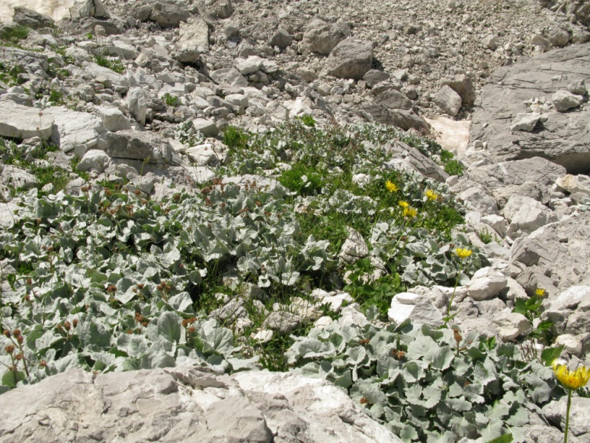**

Fig. 7 − Ass. *Valeriano bertiscei-Petasitetum doerfleri*. All. *Petasition doerfleri*, Albania, Mt. Prokletije, Maja e Jezerces, 2150 m, limestone (photo: D. Lakušić 27.07.2011).

**Validation of some association names originally included in the order *Rumicetalia balcanici***

*Chaerophyllo hirsuti-Cirsietum oleracei* V. Ranđelović ex D. Lakušić et al. ass. nov. hoc loco

*(Cirsion appendiculati, Rumicetalia balcanici (Adenostyletalia), Mulgedio-Aconitetea*)

[Orig. *Chaerophyllo-Cirsietum oleracei* V. Ranđelović in Ranđelović & Zlatković, B. 2010, (Art. 3b)]

* Type relevé (holotypus hoc loco designatus): Ranđelović & Zlatković, B. 2010, p. 286, Tab. 30, rel. 2
* Name-giving species: *Chaerophyllum hirsutum*, *Cirsium oleraceum*
* Diagnostic taxa: *Cirsim oleraceum, Chaerophyllum hirsutum*
* Constant taxa: *Mentha x verticillata, Filipendula ulmaria, Alchemilla gracilis, Potentilla erecta, Myosotis scorpioides, Galium palustre*

*Veratro lobeliani-Cirsietum helenioidei* V. Ranđelović ex D. Lakušić et al. ass. nov. hoc loco

*(Cirsion appendiculati, Adenostyletalia, Mulgedio-Aconitetea*)

[Orig. *Cirsietum helenioidei* V. Ranđelović in Ranđelović & Zlatković, B. 2010 (Art. 3b)]

* Type relevé (holotypus hoc loco designatus): Ranđelović & Zlatković, B. 2010, p. 283, Tab. 29, rel. 4
* Name-giving species: *Veratrum lobelianum*, *Cirsium helenioides*
* Diagnostic taxa: *Cirsium helenioides*
* Constant taxa: *Veratrum lobelianum, Filipendula ulmaria, Agrostis canina, Potentilla erecta*

*Geo coccinei-Deschampsietum caespitosae* Ht. ex D. Lakušić et al. ass. nov. hoc loco

*(Geion coccinei, Rumicetalia balcanici (Adenostyletalia), Mulgedio-Aconitetea*)

[Orig. *Deschampsia caespitosa-Geum coccineum* Ht. 1935, (Art. 3o; 5); Syn: *Geo coccinei-Deschampsietum* Ht. 1935 in Micevski 1994; *Coccineo-Deschampsietum* Ht. 1960]

* Type relevé (holotypus hoc loco designatus): Micevski 1994, Tab. XII, rel. 8
* Name-giving species: *Geum coccineum, Deschampsia caespitosa*
* Diagnostic taxa: *Geum coccineum*
* Constant taxa: *Geum coccineum, Deschampsia caespitosa, Silene asterias, Veratrum lobelianum, Polygonum bistorta*

*Trollio europaei-Geetum rhodopaei* V. Ranđelović ex D. Lakušić et al. ass. nov. hoc loco

*(Geion coccinei, Adenostyletalia, Mulgedio-Aconitetea*)

[Orig. *Trollio-Geetum rhodopaei* V. Ranđelović in Ranđelović & Zlatković, B. 2010, (Art. 3b)]

* Type relevé: (holotypus hoc loco designatus): Ranđelović & Zlatković, B. 2010, p. 269, Tab. 26, rel. 10.
* Name-giving species: *Geum rhodopeum, Trollius europaeus*
* Diagnostic taxa: *Geum rhodopeum, Trollius europaeus, Dactylorhyza cordigera*
* Constant taxa: *Veratrum lobelianum, Plagiomnium elatum, Juncus effusus, Potentilla erecta, Myosotis scorpioides.*

*Geo rivali-Filipenduletum ulmariae* V. Ranđelović ex D. Lakušić et al. ass. nov. hoc loco

(*Geion coccinei, Rumicetalia balcanici (Adenostyletalia), Mulgedio-Aconitetea*)

[Orig. *Geo-Filipenduletum ulmariae* V. Ranđelović in Ranđelović & Zlatković, B. 2010, (Art. 3b)]

* Type relevé (holotypus hoc loco designatus): Ranđelović & Zlatković, B. 2010, p. 278, Tab. 28, rel. 9.
* Name-giving species: *Geum rivale, Filipendula ulmaria*
* Diagnostic taxa: *Geum rivale, Geum rhodopeum, Geum rhodopeum x rivale, Filipendula ulmaria*
* Constant taxa: *Deschampsia caespitosa, Veratrum lobelianum, Equisetum palustre, Lathyrus pratensis, Scirpus sylvaticus, Myosotis scorpioides, Carex rostrata, Succisa pratensis, Carex nigra, Potentilla erecta.*

*Cardamino balcanicae-Rumicetum balcanici* R. Jovanović ex D. Lakušić et al. ass. nov. hoc loco

(*Rumicion balcanici, Rumicetalia balcanici (Adenostyletalia), Mulgedio-Aconitetea*)

[Orig.: *Cardamino-Rumici-Calthetum* R. Jov. 1971 (Art. 3b)]

[Synonyms: = *Cardamino-Rumici-Calthetum* R. Jov. 1971 in Jovanović-Dunjić 1971 (nomen nudum); *Cardamino-Rumici-Calthetum* R. Jov. Ex Mišić et al. 1978 (nom. Illeg. Art. 34c); *Cardamino balcanicae-Rumicetum balcanici* R. V. Ranđelović 2004 in Lakušić et al 2005: 121(nom. inval. Art. 3; 5]

* Type relevé (holotypus hoc loco designatus): Mišić et al. 1978, p. 346, Tab. 64, rel. 4.
* Name-giving species: *Cardamine amara* subsp. *balcanica*, *Rumex* *balcanicus*
* Diagnostic taxa: *Cardamine amara* subsp. *balcanica*, *Rumex* *balcanicus*
* Constant taxa: *Caltha cornuta, Crepis paludosa, Myosotis palustris, Epilobium palustre, Poa palustris*

Note:In the original paper of Jovanović-Dunjic *(17)* the epithet “*Cardamino*” occurring in the name of the association“*Cardamino-Rumici-Calthetum*” made reference to the taxon *Cardamine amara*. The community was described for the Mt.Stara planina where only the sub-species *C. amara* subsp. *balcanica* Marhold, Ančev & Kit Tan occurs *(35)*. The *Cardamino-Rumicetum* occurs in C-Serbia on the Mt. Kopaonik too (personal field observation).

*Barbareo balcanae-Rumicetum balcanici* V. Randjelović ex D. Lakušić et al. ass. nov. hoc loco

(*Rumicion balcanici, Rumicetalia balcanici (Adenostyletalia), Mulgedio-Aconitetea*)

[Orig. *Barbareo-Rumicetum balcanici* prov. V. Randjelović 1998 in Ranđelović et al. 1998: 381 nom. nud. (Art. 2, 4a)]

* Name-giving species: *Barbarea balcana*, *Rumex balcanicus*
* Diagnostic taxa (based on two releves made in locus classicus): *Rumex balcanicus*, *Barbarea balcana*, *Cardamine matthioli*, *Trifolium badium*, *Willemetia stipitata*, *Pedicularis verticillata*, *Silene asterias*, *Saxifraga rotundifolia*
* Type relevé (holotypus hoc loco designatus): Serbia (Kosovo), Šarplanina Mt., Šutman, between Tija Voda and Belojezerski Rid, altitude 2180 m, relevé area 25 m2, aspect SW, slope 0, cover 100%, silicate, sampled by V. Ranđelović using the 7-degree Braun-Blanquet scale, 01.08.1997.

Plant list: (cover: 100%): *Rumex balcanicus* 5, *Barbarea balcana* 1, *Veratrum lobelianum* 1, *Caltha palustris* 1, *Cardamine matthioli* 1, *Pedicularis* *verticillata* 1, *Phleum alpinum* +, *Saxifraga rotundifolia* +, *Trifolium badium* +, *Willemetia stipitata* +.

Note : The *Barbareo balcanae-Rumicetum balcanici* is developed on siliceous substrates of the spring peat-bogs occurring on the Mt. Šar planina. The association is mainly composed of medium-size herbaceous hygrophytic plants.

*Brachythecio rivulare-Rumicetum balcanici* V. Randjelović ex D. Lakušić et al. ass. nov. hoc loco

(*Rumicion balcanici, Rumicetalia balcanici (Adenostyletalia), Mulgedio-Aconitetea*)

[Orig. *Rumicetum balcanici* (Lakušić 1965) V. Ranđelović 2001 (Art. 3b)]

* Type relevé (holotypus hoc loco designatus): Ranđelović & Zlatković, B. 2010, p. 266, Tab. 25, rel. 2
* Name-giving species: *Brachythecium rivulare*, *Rumex balcanicus*
* Diagnostic taxa: *Rumex balcanicus*
* Constant taxa: *Plagiochilla asplenioides, Veratrum lobelianum, Chaerophyllum hirsutum, Brachythecium rivulare, Carex nigra, Caltha palustris, Ranunculus acris, Mentha longifolia, Potentilla erecta, Myosotis scorpioides*

Note: In his Phd thesis *(14)*, published later as Monograph “Flora and vegetation of Vlasina Plateau” *(15)*, V. Ranđelović provided an analytical table composed of 5 releves of a community dominated by *Rumex balcanicus*. In the table implied this community (from Vlasina Plateau in SE Serbia) and the similar community from Mt. Bjelasica in Montenegro, invalidly described in *(10)*, could belong to the same association. As a consequence, V. Ranđelović tried to arrange a valid combination under the new name *Rumicetum balcanici* (Lakušić 1965) V. Ranđelović 2001 In *(14)* V. Randjelović published many syntaxa bearing the authority reference “V. Randj. 2001”. The year “2001” refers to the first version of the PhD manuscript which was concluded in 2001, but formally published in 2002. Just nine copies of this PhD thesis were printed so it does not satisfy Art. 1 of the ICPN. Subsequently, the syntaxonomical results of this thesis were effectively published as a monograph entitled “Flora and vegetation of Vlasina Plateau” *(15)*. Out of the fifty-four species obtained summing the species occurring in the communities of *Rumex balcanicus* presented in *(10)* and in (15), only six (*Rumex balcanicus, Caltha palustris subsp. laeta, Carex flava, Carex nigra, Filipendula ulmaria* and *Veratrum lobelianum*) occur in both communities. In fact, these two communities were sampled in two mountainous massifs (Mt Bjelasica in Dinarides and Vlasina Plateau in-Rhodopean Mts.) belonging to two clearly different phytogeographical units. In our opinion the communities from Mt Bjelasica (*Rumicetum balcanici sensu* R. Lakušić) are significantly different from those from Vlasina Plateau (*Rumicetum balcanici sensu* V. Ranđelović). As a consequence, for the communities of Vlasina Plateau we propose here the new name *Brachythecio rivulare -Rumicetum balcanici*. Owing to the fact that R. Lakušić *(10)* did not provide any phytosociological table or single relevés usable as nomenclatural type, the name *Rumicetum balcanici* Lakušić (1965) 1973 from Mt. Bjelasica remains invalid.

*Molinio arundinaceae-Adenophoretum lilifoliae* Lakušić & Redžić ex D. Lakušić et al. ass. nov. hoc loco

(*Cicerbition pancicii, Rumicetalia balcanici (Adenostyletalia), Mulgedio-Aconitetea*)

[Orig. *Molinio-Adenophoretum lilifoliae* Lakušić & Redžić 1988, (Art. 3b)]

* Type relevé (holotypus hoc loco designatus): Lakušić, R. & Redžić, S. 1989, p. 150, Tab. 4, rel. 2.
* Name-giving species: *Molinia arundinacea*, *Adenophora lilifolia*
* Diagnostic taxa: *Molinia arundinacea*, *Adenophora lilifolia, Lactuca pancicii*, *Clematis recta.*
* Constant taxa: *Calamagrostis varia, Thalictrum simplex, Prunella vulgaris.*

*Ranunculetum serbici* Lakušić et al. 1987 ex D. Lakušić et al. ass. nov. hoc loco

(*Ranunculion serbici, Rumicetalia balcanici (Adenostyletalia), Mulgedio-Aconitetea*)

[Orig. *Ranunculetum serbici* Lakušić R., Mišić Lj. & Golić S. 1987, (Art. 3b)]

* Type relevé (holotypus hoc loco designatus): Lakušić et al, 1987, Tab. 1, rel. 5.
* Name-giving species: *Ranunculus serbicus*
* Diagnostic taxa: *Ranunculus serbicus*
* Constant taxa: *Myosotis palustris, Cardamine matthiolii, Filipendula ulmaria, Mentha longifolia, Ranunculus aconitifolius*

*Equiseto polystachii-Ranunculetum serbici* V. Randjelović ex D. Lakušić et al. ass. nov. hoc loco

(*Ranunculion serbici, Rumicetalia balcanici (Adenostyletalia), Mulgedio-Aconitetea*)

[Orig. *Polystachio-Ranunculetum serbicae* V. Ranđelović in Ranđelović & Zlatković, B. 2010 (Art. 3o; 5)]

* Type relevé (holotypus hoc loco designatus): Ranđelović & Zlatković, B. 2010, p 275, Tab. 27, rel. 1.
* Name-giving species: *Ranunculus serbicus*, *Equisetum palustris* var. *polystachis*
* Diagnostic taxa: *Ranunculus serbicus*, *Equisetum palustris* var. *polystachis*
* Constant taxa: *Chaerophyllum hirsutum, Epilobium hirsutum var. villosum, Fiipendula ulmaria, Veratrum lobelianum, Equistum palustre, Mentha longifolia, Myosotis scorpioides, Caltha palustris, Juncus effusus, Oenanthe banatica*.

**Validation of some association names related to the alliance *Petasition doerflerii***

*Doronico-Wulfenietum blecicii*Lakušić 1968

(*Petasition doerfleri Arabido alpinae-Petasitetalia paradoxi Thlaspietea rotundifolii*)

* Type relevé (lectotypus hoc loco designatus): Lakušić R. 1968, p 39, Tab. 27, rel. 3).
* Name-giving species: *Doronicum columnae*, *Wulfenia carinthiaca*
* Diagnostic taxa: *Doronicum columnae*. *Wulfenia carinthiaca, Ranunculus breyininus*
* Constant taxa: *Adenostyles alliariae, Sedum magellense, Arabis alpina, Cardamine glauca, Gymnocarpium robertianum.*

Note: A recent paper on the evolution, phylogeny and systematics of the genus *Wulfenia*, *(36)* has shown that the split of the *W. baldaccii*-*W. carinthiaca* aggregate into two geographically distinc taxa distributed in the SE-Alps (*W. carinthiaca* s.str.) and SE-Dinarids (*W. blecicii*) is not supported either by molecular or morphological data. According to these authors only one taxon *W. carinthiaca* is to be mainteined while *W. blecicii* is to be included in it as an invalidly published name.

*Valeriano bertiscei-Petasitetum doerfleri* D. Lakušić & Di Pietro ass. nova hoc. loco

(*Petasition doerfleri, Arabido alpinae-Petasitetalia paradoxi, Thlaspietea rotundifolii*)

* Type relevé (holotypus hoc loco designatus): Tab. 1, rel. 4.
* Name-giving species: *Valeriana bertiscea*, *Petasites doerfleri*
* Diagnostic taxa: *Petasites doerfleri, Valeriana bertiscea*
* Constant taxa: *Petasites doerfleri, Valeriana bertiscea, Poa alpina, Leontodon montanus Doronicum columnae*

Note : The *Valeriano bertiscei-Petasitetum doerfleri* is developed within the cold and humid stable coarse-grained calcareous screes and boulder-strewn fields of the subalpine belt of the Prokletije Mts. (Fig. 5). It occurs within moderately inclined slopes (5-20°) on the initial calkomelanosol soils . The total vegetation cover ranges between 50 and 80 %. The association is floristically poor with the cryophytic, tall-herb *Petasites doerfleri* playing the role of dominant species. The rest of the specific component is composed of small-size creeping or tufted hemicryptophytes and hameaphytes.

Table 1. ***Valeriano bertiscei-Petasitetum doerfleri*** D. Lakušić & Di Pietro ass. nova hoc. loco Sampled by: D. Lakušić (27.7.2011)

|  |  |  |  |  |  |
| --- | --- | --- | --- | --- | --- |
| Locality | Albania, Maja e Jezerces | | | | |
| Latitude (N) | 42.450252 | 42.450252 | 42.450252 | 42.449354 | 42.449354 |
| Longitude (E) | 19.804490 | 19.804490 | 19.804490 | 19.806983 | 19.806983 |
| Altitude (m) | 2100 | 2100 | 2100 | 2150 | 2150 |
| Cover (°) | 50 | 60 | 60 | 80 | 70 |
| Slope (%) | 20 | 10 | 10 | 5 | 5 |
| Aspect | SW | SW | SW | SW | SW |
| Relevé area (m2) | 16 | 8 | 2 | 10 | 6 |
| Rel.no. | 1 | 2 | 3 | 4(typus) | 5 |
| **Char. of association and alliance** |  |  |  |  |  |
| Petasites doerfleri | 3.4 | 3.4 | 3.4 | 4.4 | 3.4 |
| Valeriana bertiscea | 1.1 | 1.1 | + | 1.1 | 1.3 |
| Heracleum sphondylium subsp. orsinii | - | - | - | - | 1.1 |
| **Char. of order and class** |  |  |  |  |  |
| Adenostyles alliariae | - | - | - | - | 1.1 |
| Doronicum columnae | - | - | + | 1.2 | 1.1 |
| Leontodon montanus | 1.1 | 1.1 | + | 1.1 | - |
| Salix serpillifolia | + | 1.2 | 1.3 | - | - |
| Ranunculus crenatus | 1.1 | 1.1 | 1.1 | - | - |
| Arabis alpina | - | - | - | - | 1.1 |
| **Other species** |  |  |  |  |  |
| Poa alpina var. vivipara | 1.1 | 1.1 | 1.1 | 1.2 | 1.1 |
| Cystopteris montana | - | + | - | 1.1 | - |
| Taraxacum sp. | - | - | + | - | - |
| Armeria alpina | 1.1 | + | - | - | - |
| Senecio rupestris | - | - | - | - | + |

**Acknowledgements**

We acknowledge the financial support provided by the Serbian Ministry of Science and Technological Development (project no. 173030), and Vlado Matevski (Skopje) and Gordana Tomović (Belgrade) who provide us informations, literature and photo documentation about the occurrence of some syntaxa in Macedonia and Greece and to J.P. Theurillat for his nomenclatural help.

**References**

1. ADAMOVIĆ L 1909 Die Vegetationsverhältinisse der Balkanländer (Mösische Länder). Die Vegetation der Erde 11, Leizig.
2. HORVAT I 1935 Istraživane vegetacije planina Vardarske banovine. *Ljetopis Jugoslovenske akademije znanosti i umjetnosti* *47:* 142-160.
3. HORVAT I 1936 Istraživanje vegetacije planina Vardarske banovine, 2. *Ljetopis Jugoslovenske akademije znanosti i umjetnosti* *48:* 211- 227.
4. HORVAT I 1949 Nauka o biljnim zajednicama, Nakladni zavod Hrvatske. Zagreb.
5. HORVAT I 1960 Planinska vegetacija Makedonije u svijetlu suvremenih istraživanja. *Acta Musei macedonici scientarum naturalium 6(8):* 1-34.
6. HORVAT I 1962 Vegetacija planina zapadne Hrvatske, sa 4 karte biljnih zajednica sekcije Sušak. Prirodoslovna istraživanja JAZU 30. *Acta Biologica 2:* 1-179.
7. HORVAT I, PAWLOWSKI B, WALAS J 1937 Phytosoziologishe Studien über die Hochgebirgsvegetation der Rila Planina in Bulgarien. *Bulletin Académie Polonaise Science Lettres, Classe Sciences Mathématique et Naturelle - Série B: Science Naturelle (1):* 159-189.
8. HORVAT I, GLAVAČ V, ELLENBERG H 1974 Vegetation Südosteuropas. Gustav Fisher Verlag, Stuttgart.
9. LAKUŠIĆ R 1968 Planinska vegetacija jugoistočnih Dinarida. *Glas. Rep. Zavoda Zašt. Prir. Prirod. Muz. (Titograd) 1:* 9 -75.
10. LAKUŠIĆ R 1973 *Rumex balcanicus* Rech. fil. novi tercijerni relikt u florui Crne Gore. *Glas. Rep. Zavoda Zašt. Prir. Prirod. Muz. (Titograd) 5:* 29-32.
11. LAKUŠIĆ R, MIŠIĆ L J, GOLIĆ S 1987 *Ranunculetum serbici* Lakušić, Mišić & Golić Assoc. nova. *Bilten Društva ekologa BiH. Ekološke monografije 4:* 117-121.
12. LAKUŠIĆ R, REDŽIĆ S 1989 Flora i vegetacija vaskularnih biljaka u refugijalno-reliktnim ekosistemima kanjona rijeke Drine i njenih pritoka. The flora and the vegetation of vascular plants in refugial-relict ecosystems in the canyon of the river Drina and its tributaries. *Crnogorska akademija nauka i umjetnosti, Glasnik Odjeljenja Prirodnih Nauka, 7:* 107-206, Titograd.
13. RANDELOVIĆ V, ZLATKOVIĆ B, AMIDŽIĆ L 1998. Flora i vegetacija visokoplaninskih tresava Šar planine. *Zaštita prirode 50:* 377-387.
14. RANDELOVIĆ V 2002 Flora i vegetacija Vlasinske visoravni. Doktorska disertacija, Univerzitet u Beogradu, Biološki fakultet, Beograd.
15. RANDELOVIĆ V, ZLATKOVIĆ B 2010 Flora i vegetacija Vlasinske visoravni. Prirodno-matematički fakultet, Niš, pp. 448.
16. RUDSKI I 1938 Biljne zajednice na visokim planinama južne Srbije. *Šumarski list 12:* 611-623.
17. JOVANOVIĆ-DUNJIĆ R 1971 Ispitivanja strukture i ekoloških uslova fitocenoza u jednom mozaikkompleksu na tresavama Stare planine. *Glasnik Instituta za botaniku i Botaničke bašte Univerziteta u Beogradu 6(1-4):* 91-106.
18. MIŠIĆ V, JOVANOVIĆ-DUNJIĆ R, POPOVIĆ M, BORISAVLJEVIĆ L J, ANTIĆ M, DINIĆ A. DANON J, BLAŽENČIĆ Ž 1978: Biljne zajednice i staništa Stare planine. *Srpska akademija nauka i umetnosti, Posebna izdanja 511, Odeljenje prirodno-matematičkih nauka 49:* 1-389, Beograd.
19. MICEVSKI K 1994 Visokoplaninska vegetacija na planinata Bistra. Makedonska akademija na naukite i umetnostite, Bistra 3, Skopje.
20. VUKOJIČIĆ S, LAKUŠIĆ D 1994 Vegetacija sipara i visokih zeleni planine Mučanj (JZ Srbija). *Glasnik Instituta za botaniku i Botaničke bašte Univerziteta u Beogradu 28:* 221-235.
21. ROUSSAKOVA V 2000 Vegetation alpine et sous alpine superieure de la montagne de Rila (Bulgarie). *Braun-Blanquetia 25:* 3–132.
22. SURINA B 2005 The association *Doronico austriaci-Adenostyletum alliariae* Horvat ex Horvat et al. 1974 on the Mt. Snežnik (Liburnian karst, NW Dinaric Mts.). *Razprave 4. Razreda SAZU 46(2):* 145-160.
23. ČARNI A, MATEVSKI V 2010 Vegetation along mountain streams in the southern part of the Republic of Macedonia. *Braun-Blanquetia 46:* 157-170.
24. WEBER H E, MORAVEC J, THEURILLAT J P 2000 International code of phytosociological nomenclature. *Journal of Vegetation Science 11:* 739–768.
25. EURO+MED PLANTBASE 2006- the information resource for Euro-mediterranean plant diversity. Published on the Internet <http://ww2.bgbm.org/EuroPlusMed/> [30/04/2014].
26. TUTIN T G, HEYWOOD V H, BURGES N A, MOORE D M, VALENTINE D H, WALTERS S M, WEBB D A, (ed.) 1964-1980 *Flora Europaea*. Voll. 1-5. Cambridge university Press, Cambridge.
27. ZUPANČIĆ M 1986. Prodromus phytocoenosum Jugoslaviae ad mappam vegetationis m 1:200.000. Naučno veće vegetacijske karte Jugoslavije, Bribir-Ilok.
28. BLEČIĆ V, LAKUŠIĆ R 1976 Prodromus biljnih zajednica Crne Gore. *Glas. Rep. Zavoda Zašt. Prir. Prirod. Muz. (Titograd) 9:* 57-98.
29. RODWELL J S, SCHAMINÉE J H J, MUCINA L, PIGNATTI S, DRING J, MOSS D 2002 The diversity of European vegetation. An overview of phytosociological alliances and their relationships to EUNIS habitats. EC-LNV, Wageningen.
30. LAKUŠIĆ D 2005 Nacionalne klasifikacije staništa. In: LAKUŠIĆ D (ed) Rezultati projekta “Harmonizacija nacionalne nomenklature u klasifikaciji staništa sa standardima međunarodne zajednice”, Institut za Botaniku i Botanička Bašta “Jevremovac”, Biološki fakultet, Univerzitet u Beogradu, Ministarstvo za nauku i zaštitu životne sredine Republike Srbije, <http://habitat.bio.bg.ac.rs/nacionalne_klasifikacije_stanista.htm>.
31. MILOSAVLJEVIĆ V, RANDELOVIĆ V, ZLATKOVIĆ B, RANĐELOVIĆ N 2008 [Phytocenologic diversity of Krajište in southeastern Serbia](http://www.pmcg.co.me/nm7/Milosavljevic%20NM7.pdf). *Natura Montenegrina 7(3):* 193-204.
32. PETROVIĆ D, HADŽIABLAHOVIĆ S, VUKSANOVIĆ S, MAČIĆ V, LAKUŠIĆ D 2014 Catalogue of habitat types of EU importance of Montenegro. Podgorica-Beograd-Zagreb, pp. 116.
33. LAKUŠIĆ D, RANDELOVIĆ V 1996 Pregled biljnih zajednica Kopaonika. *Ekologija (Beograd) 31(1):* 1-16.
34. CONTI F, ABBATE G, ALESSANDRINI A, BLASI C (ed) 2005: An annotated checklist of the Italian vascular flora. Palombi, Roma. pp. 185.
35. TOMOVIĆ G, LAKUŠIĆ D, RANDELOVIĆ V, MARHOLD K 2009 *Cardamine amara* L. (Brassicaceae) in Serbia and Republic of Macedonia. *Biologia 64(6):* 1095-1099.
36. SURINA B, PFANZELT S, EINZMANN H J R, ALBACH D C 2014 Bridging the Alps and the Middle East: Evolution, phylogeny and systematics of the genus *Wulfenia* (*Plantaginaceae*). *Taxon 63(4):* 843-858.