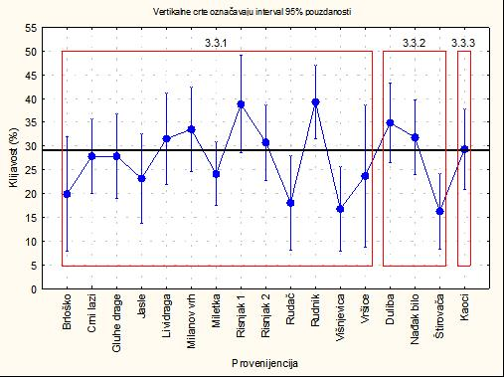

Figure 1. The average values of germination capacity (%) for provenances according to grand total average

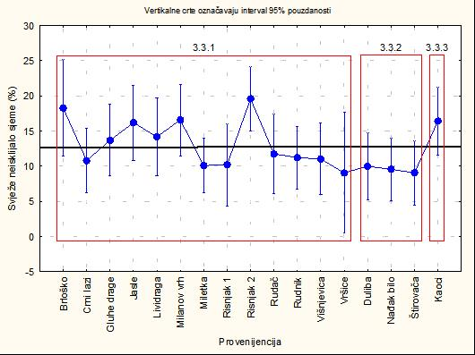

Figure 2. The average values of fresh ungerminated seeds (%) for provenances according to grandtotal average of provenances

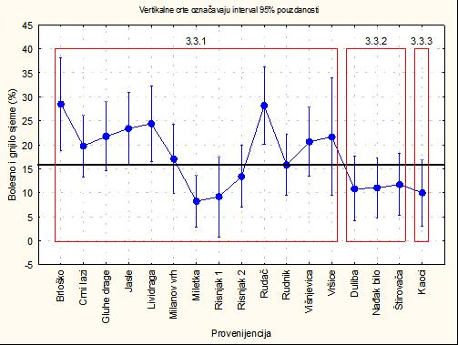

Figure 3. The average values of dead seeds (%) for provenances according to grandtotal average

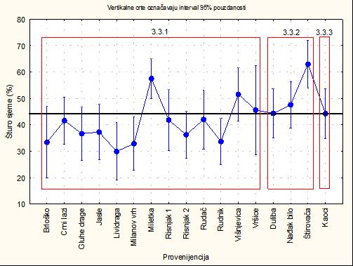

Figure 4. The average values of empty seeds (%) for provenances according to grand total average

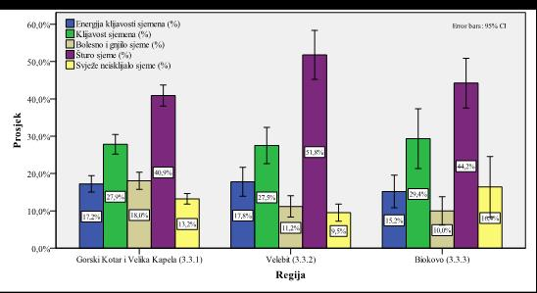
Figure 5. Average values of physiological properties of seeds according to seed regions

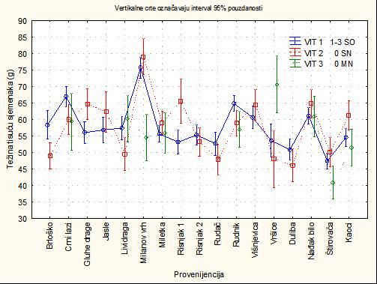

Figure 6. Average values of TSW (g) according to provenances and vitality

