Prof. Pietro Brandmayr  DiBEST – Dept. of Biology  Ecology and Earth Science  Zoology Section, Zoocoenoses Lab.  e-mail: brandmayr@unical.it  tel. ++39.984.492978 – fax 492981 | 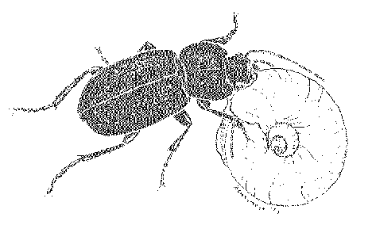

Dest.
To: Periodicum Biologorum Editors
http://hrcak.srce.hr/ojs/index.php/periodicum_biologorum

Rende, 12/02/2016

Oggetto: submission of the manuscript:

Climate change and its impact on epigean and hypogean carabid beetles.

Review by: Pietro Brandmayr and Roberto Pizzolotto

To be included in: Proceedings of the XVIIth European Carabidologists Meeting,
Primosten, Sept. 2015.

As corresponding author I declare that:

- The second author agrees with the submission of this MS
- The manuscript has never been submitted elsewhere nor published
- There are no ethical conflicts
As possible reviewers we may suggest:
Dr. Hans Turin - h.turin@hccnet.nl The Netherlands
Prof. John Spence - jspence@ualberta.ca University of Alberta – Canada

Sincerely yours
Prof. Pietro Brandmayr

