**Legends of Tables and Figures**

**Figure 1.** The vertical, horizontal and seasonal comparisons of heterotrophic bacteria (HB) counts in the lotic and lentic ecosystems: (a) HB in lentic ecosystem, (b) HB in lotic ecosystem, (c) HB in bottom, (d) HB in middle, (e) HB in surface, (f) HB in sediments

**Figure 2.** The vertical, horizontal and seasonal comparisons of total coliform bacteria (TCB) counts in the lotic and lentic ecosystems: (a) TCB in lentic ecosystem, (b) TCB in lotic ecosystem, (c) TCB in bottom, (d) TCB in middle, (e) TCB in surface, (f) TCB in sediments

**Figure 3.** Statistical analyses result on vertical distributions of bacteria in the sampled lotic and lentic ecosystems: (a) Bray-Curtis cluster analysis, (b) Correspondence analysis

**Figure 4.** Bray-Curtis similarity index results for physicochemical analyses in lentic and lotic ecosystems

**Table 1.** The seasonal, vertical, and horizontal distributions of bacteria in the lotic and lentic ecosystems (Units are cfu 100-1 mL for HB and MPN 100-1 mL for other bacteria in water columns; cfu 100-1 g for HB and MPN 100-1 g for other bacteria in sediments), (HB: heterotrophic bacteria, TCB: total coliform bacteria, FCB: faecal coliform bacteria, *E.coli*: *Escherichia coli,* cfu: colony forming unit, MPN: most probable number)

**Table 2.** The average values of physico-chemical features in the lotic and lentic ecosystems (b: bottom; m: middle; s: surface water columns; EC: conductivity; DO: dissolved oxygen; Temp:temperature; Ca: kalsiyum; Mg: magnezyum; Cl: chloride)

**Table 3.** The heavy metal concentrations in the ecosystems (bot: bottom; mid: middle; surf: surface; sho: shore; mud: deep sediment)

 

**(a) (b)**

 

**(c) (d)**

 

**(e) (f)**

**Figure 1.** The vertical, horizontal and seasonal comparisons of heterotrophic bacteria (HB) counts in the lotic and lentic ecosystems: (a) HB in lentic ecosystem, (b) HB in lotic ecosystem, (c) HB in bottom, (d) HB in middle, (e) HB in surface, (f) HB in sediments

 

**(a) (b)**

 

**(c) (d)**

 

**(e) (f)**

**Figure 2.** The vertical, horizontal and seasonal comparisons of total coliform bacteria (TCB) counts in the lotic and lentic ecosystems: (a) TCB in lentic ecosystem, (b) TCB in lotic ecosystem, (c) TCB in bottom, (d) TCB in middle, (e) TCB in surface, (f) TCB in sediments

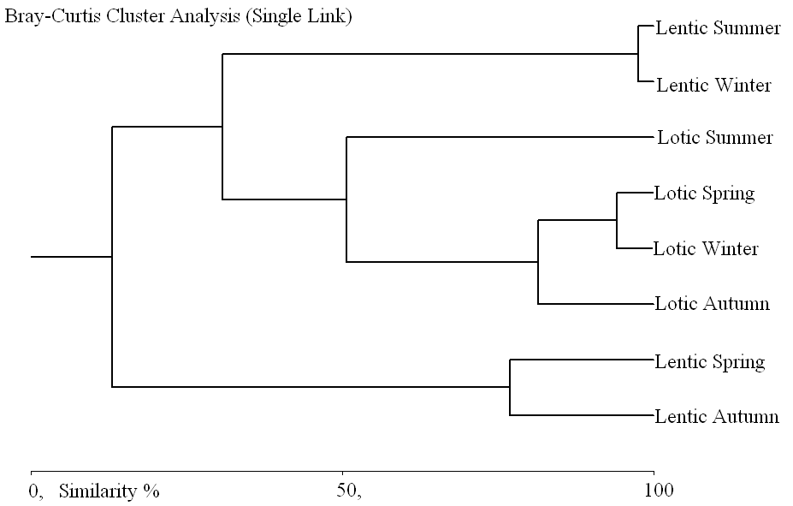

**(a)**

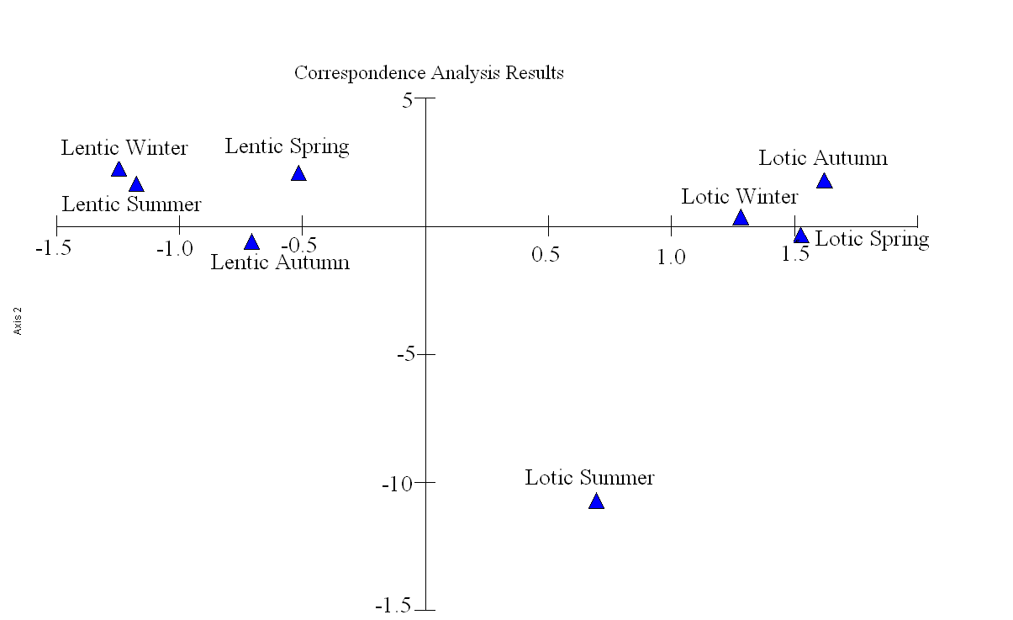

**(b)**

**Figure 3.** Statistical analyses result on vertical distributions of bacteria in the sampled lotic and lentic ecosystems: (a) Bray-Curtis cluster analysis, (b) Correspondence analysis

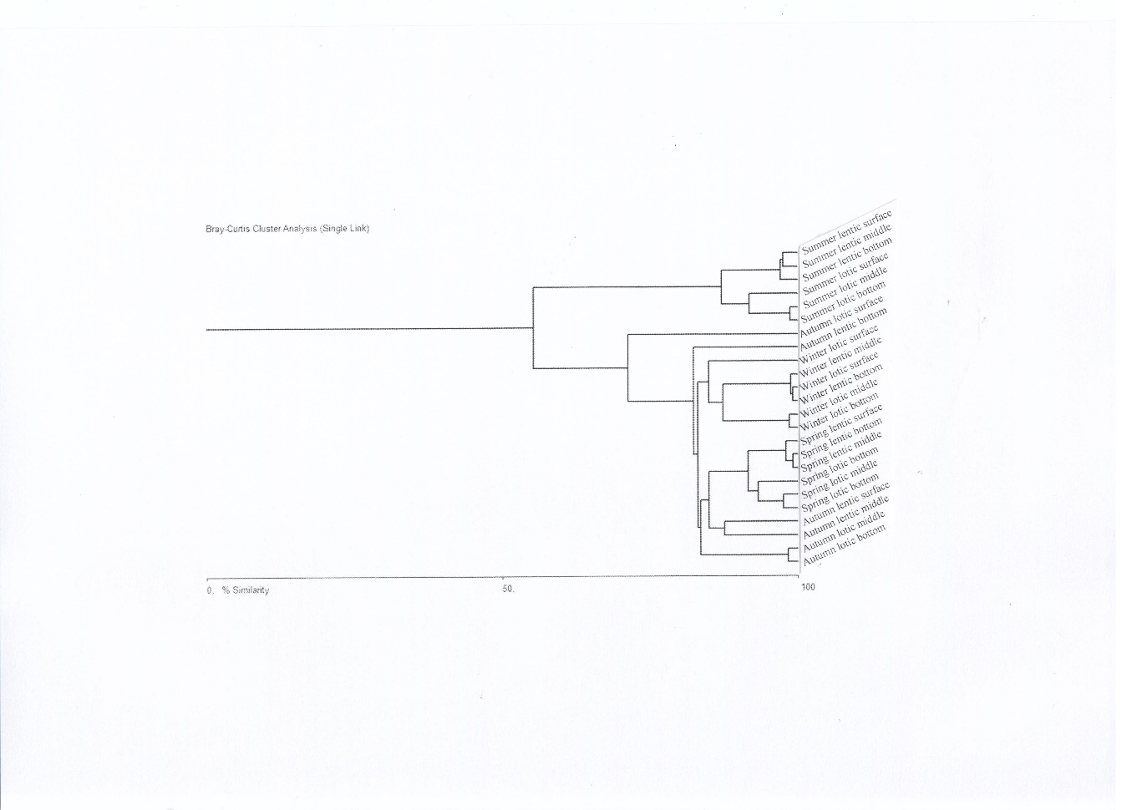

**Figure 4.** Bray-Curtis similarity index results for physicochemical analyses in lentic and lotic ecosystems

**Table 1.** The seasonal, vertical, and horizontal distributions of bacteria in the lotic and lentic ecosystems (Units are cfu 100-1 mL for HB and MPN 100-1 mL for other bacteria in water columns; cfu 100-1 g for HB and MPN 100-1 g for other bacteria in sediments), (HB: heterotrophic bacteria, TCB: total coliform bacteria, FCB: faecal coliform bacteria, *E.coli*: *Escherichia coli,* cfu: colony forming unit, MPN: most probable number)

|  |  |  |  |  |  |  |  |  |  |  |  |
| --- | --- | --- | --- | --- | --- | --- | --- | --- | --- | --- | --- |
| Autumn | | | | | | | Winter | | | | |
|  | | HB | | TCB | FCB | *E.coli* |  | HB | TCB | FCB | *E.coli* |
| Lotic | Bot | 1.1X106 | | 3.8X102 | 2.8X102 | 2.8X102 | 1.9x106 | 1.7x103 | 1.3x103 | 1.1x103 |
| Mid | 1.0X106 | | 3.5X102 | 3.4X101 | 3.4X101 | 1.7x106 | 1.6x103 | 3.0x102 | 2.2x102 |
| Surf | 1.2X106 | | 9.0X101 | 9.0X101 | 9.0X101 | 1.8x106 | 1.1x103 | 8.0x102 | 5.0x102 |
| Sho | 1.7X108 | | >1.6X104 | 1.6X104 | 1.6X104 | 1.9x108 | 9.0x103 | 7.0x102 | 4.0x102 |
| Mud | 9.0X107 | | 3.2X102 | 2.6X102 | 2.2X102 | 1.8x108 | 5.0x103 | 5.0x102 | 3.4x102 |
|  | | | | | | |  | | | |
| Lentic | Bot | 7.0X103 | | 8.0X100 | 8.0X100 | 2.0X100 | 2.0x105 | 8.0x100 | 2.0x100 | 2.0x101 |
| Mid | 2.0X103 | | 7.0X100 | 4.0X100 | 2.0X100 | 1.0x105 | 1.1x101 | <2.0x100 | <2.0x101 |
| Surf | 1.6X104 | | 4.0X100 | 4.0X100 | 4.0X100 | 3.0x105 | 1.7x101 | <2.0x100 | <2.0x101 |
| Sho | 1.0X107 | | 2.0x101 | 2.0x101 | 2.0x101 | 3.0x106 | <2.0x101 | <2.0x101 | <2.0x101 |
| Mud | 3.2X107 | | 2.2X102 | 2.2X102 | 2.2X102 | 9.0x107 | <2.0x101 | <2.0x101 | <2.0x101 |
| Spring | | | | | | | Summer | | | | |
|  | | HB | | TCB | FCB | *E.coli* |  | HB | TCB | FCB | *E.coli* |
| Lotic | Bot | 1.0x106 | | 1.7x103 | 1.3x103 | 8.0x102 | 5.0x106 | 2.2x103 | 2.8x102 | 1.3x102 |
| Mid | 1.0x106 | | 1.3x103 | 3.3x102 | 2.2x102 | 2.1x106 | 1.7x103 | 1.7x102 | 8.0x101 |
| Surf | 3.0x106 | | 1.4x103 | 9.0x102 | 5.0x102 | 9.0x106 | 3.5x103 | 3.4x102 | 2.7x102 |
| Sho | 5.8x109 | | 7.0x103 | 3.5x103 | 1.4x103 | 1.2x107 | 2.2x103 | 1.3x103 | 8.0x102 |
| Mud | 2.0x109 | | 5.0x103 | 2.2x103 | 1.1x103 | 1.0x107 | 2.1x103 | 7.0x102 | 5.0x102 |
|  | | | | | | |  | | | |
| Lentic | Bot | 1.0x104 | 1.4x101 | | 2.0x100 | 2.0x100 | 1.4x105 | 2.0x101 | <2.0x101 | <2.0x101 |
| Mid | 1.0x104 | 1.7x101 | | <2.0x100 | <2.0x100 | 7.0x104 | 2.0x101 | <2.0x101 | <2.0x101 |
| Surf | 2.0x104 | 4.0x101 | | <2.0x100 | <2.0x100 | 3.6x105 | 4.0x101 | <2.0x101 | <2.0x101 |
| Sho | 1.2x107 | 4.0x101 | | <2.0x101 | <2.0x101 | 1.8x107 | 5.0x103 | 2.0x101 | 2.0x101 |
| Mud | 3.1x107 | 1.1x102 | | <2.0x101 | <2.0x101 | 3.2x107 | 5.0x103 | 1.1x103 | 9.0x102 |

**Table 2.** The average values of physico-chemical features in the lotic and lentic ecosystems (b: bottom; m: middle; s: surface water columns; EC: conductivity; DO: dissolved oxygen; Temp:temperature; Ca: kalsiyum; Mg: magnezyum; Cl: chloride)

|  |  |  |  |  |  |  |  |  |  |  |  |  |  |  |  |  |  |  |  |  |  |  |  |  |
| --- | --- | --- | --- | --- | --- | --- | --- | --- | --- | --- | --- | --- | --- | --- | --- | --- | --- | --- | --- | --- | --- | --- | --- | --- |
| Season 🡪 | Autumn | | | | | | Winter | | | | | | Spring | | | | | | Summer | | | | | |
| ecosysystem 🡪 | Lotic | | | Lentic | | | Lotic | | | Lentic | | | Lotic | | | Lentic | | | Lotic | | | Lentic | | |
| column 🡪  parameters↓ | **b** | **m** | **s** | **b** | **m** | **s** | **b** | **m** | **s** | **b** | **m** | **s** | **b** | **m** | **s** | **b** | **m** | **s** | **b** | **m** | **s** | **b** | m | s |
| EC (mS cm-1) | 0,3 | 0,3 | 0,3 | 0,3 | 0,3 | 0,3 | 0,3 | 0,3 | 0,3 | 0,2 | 0,2 | 0,2 | 0,6 | 0,6 | 0,6 | 0,2 | 0,2 | 0,2 | 0,6 | 0,6 | 0,6 | 0,2 | 0,3 | 0,3 |
| pH | 7,8 | 7,8 | 7,8 | 8,5 | 8,5 | 8,4 | 7,8 | 7,8 | 7,8 | 7,8 | 7,7 | 8,4 | 7,6 | 7,3 | 7,4 | 9,1 | 8,9 | 9,0 | 8,4 | 8,4 | 8,4 | 9,2 | 9,2 | 9,1 |
| DO (mg L-1) | 8,9 | 8,8 | 8,3 | 7,8 | 7,7 | 7,7 | 8,9 | 8,7 | 8,4 | 8,3 | 8,6 | 8,4 | 11,9 | 11,6 | 12,0 | 17,9 | 17,8 | 17,6 | 5,8 | 5,9 | 5,9 | 6,9 | 6,8 | 6,5 |
| Temp. (0C) | 9,0 | 10 | 10 | 17 | 17 | 18 | 4,0 | 4,0 | 5,0 | 5,0 | 5,0 | 5,0 | 19,0 | 20,0 | 19,0 | 18,0 | 19,0 | 19,0 | 21 | 22 | 23 | 24 | 24 | 25 |
| Salinity (‰) | 0,1 | 0,1 | 0,1 | 0,1 | 0,1 | 0,1 | 0,3 | 0,3 | 0,3 | 0,1 | 0,1 | 0,1 | 0,16 | 0,16 | 0,16 | 0,1 | 0,1 | 0,1 | 0,3 | 0,3 | 0,3 | 0,1 | 0,1 | 0,1 |
| Ca (mg L-1) | 4,6 | 4,6 | 4,6 | 2,6 | 3,4 | 4,2 | 4,4 | 4,5 | 4,6 | 0,7 | 0,7 | 0,5 | 4,8 | 4,4 | 5,2 | 8,0 | 8,4 | 9,5 | 172 | 169 | 173 | 77 | 82 | 84 |
| Mg (mg L-1) | 11 | 11 | 14 | 73 | 11 | 33 | 1,0 | 1,0 | 1,1 | 1,0 | 1,0 | 0,9 | 1,8 | 1,7 | 1,7 | 0,9 | 0,9 | 0,8 | 225 | 219 | 214 | 225 | 217 | 206 |
| NO2N (mg L-1) | 0,08 | 0,09 | 0,16 | 0,15 | 0,15 | 0,15 | 0,08 | 0,09 | 0,14 | 0,05 | 0,05 | 0,04 | 0,09 | 0,09 | 0,10 | 0,11 | 0,11 | 0,15 | 0,08 | 0,09 | 0,15 | 0,17 | 0,17 | 0,17 |
| NO3N (mg L-1) | 4,8 | 4,7 | 3,2 | 0,8 | 0,7 | 0,8 | 13 | 13 | 12 | 6,2 | 6,3 | 6,1 | 4,2 | 4,2 | 4,5 | 3,2 | 3,2 | 3,5 | 4,8 | 4,7 | 3,2 | 3,1 | 3,0 | 2,8 |
| PO4 (mg L-1) | 0,6 | 0,6 | 1,0 | 0,9 | 0,9 | 0,9 | 0,4 | 0,4 | 0,5 | 0,3 | 0,3 | 0,3 | 0,5 | 0,5 | 0,6 | 0,4 | 0,4 | 0,5 | 0,6 | 0,6 | 1,0 | 0,5 | 0,5 | 0,5 |
| SO4 (mg L-1) | 38 | 40 | 57 | 22 | 24 | 24 | 28 | 30 | 47 | 21 | 22 | 21 | 22 | 20 | 25 | 23 | 23 | 24 | 38 | 40 | 57 | 24 | 24 | 21 |
| Cl (mg L-1) | 13 | 13 | 70 | 14 | 14 | 15 | 12 | 12 | 21 | 12 | 12 | 12 | 12 | 12 | 20 | 13 | 13 | 14 | 13 | 13 | 70 | 22 | 13 | 12 |

**Table 3.** The heavy metal concentrations in the ecosystems (bot: bottom; mid: middle; surf: surface; sho: shore; mud: deep sediment)

|  |  |  |  |  |  |  |  |  |  |  |  |  |  |  |  |
| --- | --- | --- | --- | --- | --- | --- | --- | --- | --- | --- | --- | --- | --- | --- | --- |
|  |  |  | Na | Al | Cr | Mn | Fe | Co | Ni | Cu | Zn | As | Se | Cd | Pb |
| Autumn | Lotic | bot* | 0.02 | 0.00 | 0.01 | 0.05 | 1.759 | 0.00 | 0.04 | 0.04 | 0.09 | 0.00 | 0.02 | 0.00 | 0.05 |
| mid* | 0.02 | 0.04 | 0.01 | 0.07 | 3.500 | 0.00 | 0.06 | 0.04 | 0.1 | 0.00 | 0.02 | 0.00 | 0.05 |
| surf* | 0.05 | 0.03 | 0.01 | 0.06 | 2.903 | 0.00 | 0.04 | 0.03 | 0.07 | 0.00 | 0.02 | 0.00 | 0.05 |
| sho** | 0.14 | 6.41 | 21.8 | 212 | 6547 | 2.97 | 27.2 | 11.2 | 77 | 4.26 | 0.73 | 0.93 | 24.8 |
| mud** | 0.28 | 10.0 | 22.5 | 491 | 11638 | 5.10 | 14.4 | 20.1 | 153 | 12.1 | 1.37 | 0.24 | 65.2 |
|  | | | | | | | | | | | | | | |
| Lentic | bot* | 0.59 | 0.00 | 0.01 | 0.01 | 0.095 | 0.00 | 0.04 | 0.02 | 0.09 | 0.01 | 0.02 | 0.00 | 0.04 |
| mid* | 0.02 | 0.00 | 0.01 | 0.02 | 0.095 | 0.00 | 0.03 | 0.02 | 0.09 | 0.00 | 0.02 | 0.00 | 0.04 |
| surf* | 0.08 | 0.00 | 0.01 | 0.02 | 0.096 | 0.00 | 0.05 | 0.02 | 0.1 | 0.00 | 0.02 | 0.00 | 0.05 |
| sho** | 0.03 | 4.37 | 2.75 | 81.4 | 5163 | 1.62 | 4.80 | 0.71 | 23 | 0.82 | 0.86 | 0.01 | 3.48 |
| mud** | 0.04 | 5.56 | 4.67 | 116 | 6255 | 1.98 | 0.36 | 1.50 | 19 | 1.01 | 0.75 | 0.02 | 4.33 |
|  | | | | | | | | | | | | | | | |
| Winter | Lotic | bot* | 0.02 | 0.00 | 0.01 | 0.02 | 0.26 | 0.00 | 0.05 | 0.02 | 0.09 | 0.00 | 0.01 | 0.00 | 0.05 |
| mid* | 0.02 | 0.00 | 0.01 | 0.02 | 0.26 | 0.00 | 0.05 | 0.02 | 0.09 | 0.00 | 0.01 | 0.00 | 0.05 |
| surf* | 0.02 | 0.00 | 0.01 | 0.02 | 0.24 | 0.00 | 0.05 | 0.02 | 0.09 | 0.00 | 0.01 | 0.00 | 0.05 |
| sho** | 0.06 | 1.05 | 2.25 | 291 | 1638 | 0.51 | 2.34 | 2.31 | 83.1 | 0.45 | 0.67 | 0.24 | 4.21 |
| mud** | 0.07 | 1.03 | 2.51 | 280 | 1508 | 0.69 | 2.33 | 2.38 | 83.9 | 0.48 | 0.69 | 0.29 | 4.83 |
|  | | | | | | | | | | | | | | |
| Lentic | bot* | 0.00 | 0.00 | 0.01 | 0.01 | 0.38 | 0.00 | 0.01 | 0.03 | 0.12 | 0.00 | 0.01 | 0.00 | 0.06 |
| mid* | 0.00 | 0.00 | 0.01 | 0.01 | 0.38 | 0.00 | 0.01 | 0.03 | 0.11 | 0.00 | 0.01 | 0.00 | 0.06 |
| surf* | 0.00 | 0.00 | 0.01 | 0.01 | 0.40 | 0.00 | 0.01 | 0.03 | 0.11 | 0.00 | 0.01 | 0.00 | 0.06 |
| sho** | 0.04 | 0.09 | 0.97 | 2.82 | 40.4 | 0.55 | 2.82 | 3.40 | 11.4 | 0.45 | 1.95 | 0.60 | 6.54 |
| mud** | 0.04 | 0.09 | 0.97 | 2.82 | 40.4 | 0.55 | 2.82 | 3.40 | 11.4 | 0.45 | 1.95 | 0.60 | 6.54 |
|  | | | | | | | | | | | | | | | |
| Spring | Lotic | bot* | 0.00 | 0.00 | 0.01 | 0.01 | 2.14 | 0.00 | 0.02 | 0.04 | 0.06 | 0.00 | 0.51 | 0.00 | 0.06 |
| mid* | 0.00 | 0.00 | 0.01 | 0.01 | 2.09 | 0.00 | 0.02 | 0.05 | 0.07 | 0.00 | 0.49 | 0.00 | 0.09 |
| surf* | 0.00 | 0.00 | 0.01 | 0.00 | 2.08 | 0.00 | 0.02 | 0.04 | 0.07 | 0.00 | 0.49 | 0.00 | 0.05 |
| sho** | 0.19 | 11.3 | 21.8 | 427 | 8206 | 4.55 | 10.8 | 28.9 | 95.9 | 5.71 | 1.34 | 1.34 | 34.9 |
| mud** | 0.18 | 12.1 | 25.5 | 307 | 9078 | 4.10 | 10.1 | 25.4 | 100 | 5.65 | 1.45 | 1.45 | 33.0 |
|  | | | | | | | | | | | | | | |
| Lentic | bot* | 0.00 | 0.00 | 0.01 | 0.02 | 1.28 | 0.00 | 0.01 | 0.03 | 0.05 | 0.00 | 0.12 | 0.00 | 0.05 |
| mid* | 0.00 | 0.00 | 0.01 | 0.02 | 1.27 | 0.00 | 0.01 | 0.03 | 0.07 | 0.00 | 0.11 | 0.00 | 0.05 |
| Surf* | 0.00 | 0.00 | 0.01 | 0.02 | 1.20 | 0.01 | 0.02 | 0.08 | 0.06 | 0.00 | 0.04 | 0.00 | 0.05 |
| sho** | 0.02 | 0.34 | 0.38 | 6.03 | 333 | 0.11 | 1.92 | 0.56 | 4.69 | 5.23 | 0.04 | 0.04 | 0.85 |
| mud** | 0.02 | 0.25 | 0.33 | 4.15 | 199 | 0.17 | 0.61 | 0.46 | 1.43 | 5.69 | 0.01 | 0.04 | 0.75 |
|  | | | | | | | | | | | | | | | |
| Summer | Lotic | bot* | 0.44 | 0.00 | 0.26 | 1.52 | 18.4 | 0.02 | 0.27 | 0.45 | 1.25 | 0.08 | 2.30 | 0.00 | 0.10 |
| mid* | 0.42 | 0.00 | 0.24 | 0.80 | 16.9 | 0.02 | 0.25 | 0.49 | 0.75 | 0.07 | 2.10 | 0.00 | 0.05 |
| surf* | 0.47 | 0.00 | 0.24 | 0.81 | 15.7 | 0.02 | 0.17 | 0.12 | 0.31 | 0.08 | 1.93 | 0.00 | 0.06 |
| sho** | 0.10 | 3.03 | 5.17 | 122 | 164 | 1.72 | 4.31 | 3.05 | 31.4 | 1.61 | 1.29 | 0.01 | 8.23 |
| mud** | 0.28 | 16.3 | 37.4 | 279 | 260 | 6.93 | 15.9 | 117 | 254 | 33.3 | 4.08 | 0.12 | 149 |
|  | | | | | | | | | | | | | | |
| Lentic | bot* | 0.25 | 0.00 | 0.34 | 0.53 | 31.0 | 0.02 | 1.02 | 0.43 | 0.38 | 0.04 | 3.22 | 0.00 | 0.03 |
| mid* | 0.33 | 0.00 | 0.35 | 0.59 | 30.2 | 0.02 | 0.54 | 0.37 | 0.39 | 0.05 | 3.11 | 0.00 | 0.04 |
| surf* | 0.23 | 0.00 | 0.36 | 0.60 | 28.9 | 0.04 | 1.83 | 0.10 | 0.27 | 0.08 | 3.02 | 0.02 | 0.16 |
| sho** | 0.05 | 0.27 | 2.99 | 73.3 | 271 | 1.78 | 1.98 | 1.39 | 11.2 | 0.62 | 2.66 | 0.00 | 1.94 |
| mud** | 0.07 | 0.47 | 6.83 | 130 | 177 | 2.51 | 3.60 | 2.48 | 22.0 | 1.07 | 3.49 | 0.00 | 3.02 |

* μg mL-1; **μg g-1