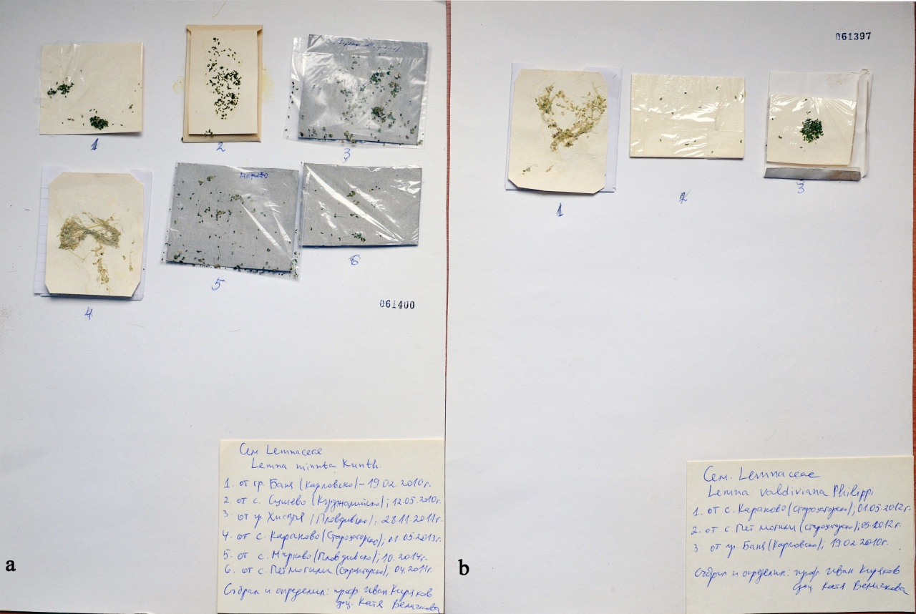
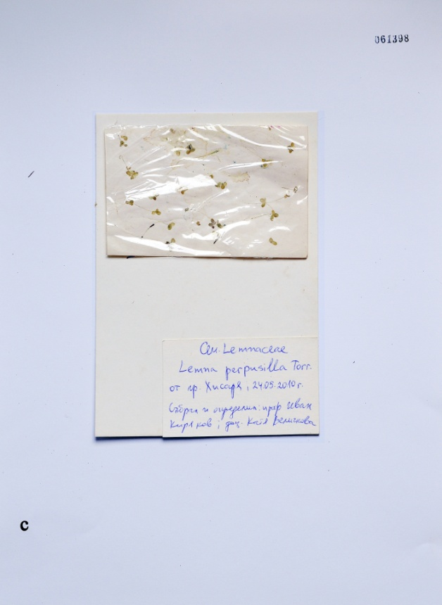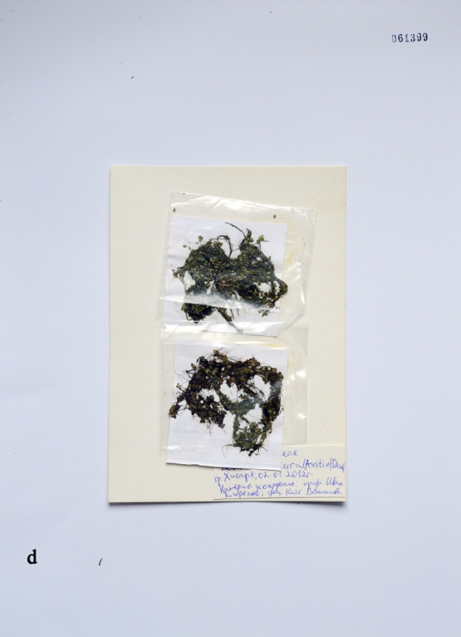
Fig.1. Herbarium sheets of the studied Lemna species deposited at herbarium of the Agricultural University – Plovdiv in Bulgaria: a – L. minuta SOA – 061400, b – L. valdiviana SOA – 061397, c – L. perpusilla SOA – 061398, d – L. obscura SOA – 061399.

