Zagreb, 31.01.2017.

EDITORIAL OFFICE

Periodicum Biologorum

Dear Editor(s),

Here enclosed is the manuscript by Dario Hruševar, Dalibor Vladović, Nediljko Ževrnja, Diana Vlahović, and Božena Mitić, entitled: "CONVOLVULUS SABATIUS SUBSP. MAURITANICUS (BOISS.) MURB. - JUST A NEW CASUAL ALIEN PLANT IN DALMATIA (CROATIA) OR…?", which is being submitted for possible publication (as a Short communication) in the journal Periodicum Biologorum.

This manuscript comprises results of original research, has not been submitted for publication elsewhere. All authors concur with its content and submission to your journal, and declare no conflict of interests.

Sincerely yours,

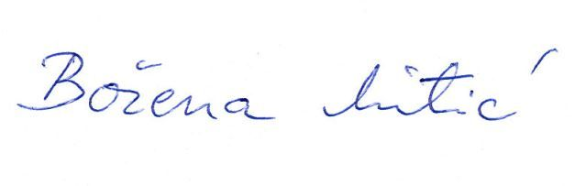
Corresponding author:
Božena Mitić
Tel. +385 1 48 98 086
E-mail: bozena.mitic@biol.pmf.hr

Suggestion of reviewers:

Mitja Kaligarič
Univerza v Mariboru
Fakulteta za naravoslovje in matematiko
mitja.kaligaric@uni-mb.si

Nejc Jogan
Biotehnička fakulteta, Oddelek za biologijo
nejc.joganbf.uni-lj.si

Goran Anačkov
Univerzitet u Novom Sadu, Prirodno-matematički fakultet Novi Sad, Departman za biologiju i ekologiju
goran.anackov@dbe.uns.ac.rs

Danijela Stešević
Univerzitet Crne Gore
Prirodno - matematički fakultet, Podgorica
danijela.denist@gmail.com

Igor Boršić
Hrvatska agencija za okoliš i prirodu
Radnička cesta 80/7
10 000 Zagreb
igor.borsic@dzzp.hr

Milenko Milović
Medical and Chemical School, Ante Šupuk Street, HR-22000 Šibenik
E-mail: mmilovic@inet.hr

