Table 1. Discriminative variables and the discriminative function correlation structure matrix (N=20).
Variable | Function
Features accentuating youthfulness | -.495
Features of physical appearance | -.470
Ambition or industriousness | .455
Access to resources or material possessions | .455
Social status | .399
Flirtatious behavior | -.276
Physical strength or athleticism | .223
High activity level | .173
Intelligence | .088

Table 2. One-way analysis of variance (N=20).
Variables | Mf | Mm | sdf | sdm | λ | F | p | η2
1 | 2.04 | 2.51 | .407 | .850 | .879 | 2.472 | .133 | .121
2 | 2.20 | 2.78 | .396 | .414 | .636 | 10.322 | .005** | .364
3 | 2.12 | 2.68 | .292 | .474 | .635 | 10.334 | .005** | .365
4 | 2.29 | 2.74 | .310 | .414 | .698 | 7.772 | .012* | .302
5 | 2.26 | 2.36 | .297 | .441 | .797 | .390 | .540 | .021
6 | 2.92 | 2.21 | .586 | .339 | .620 | 11.036 | .004** | .380
7 | 3.14 | 2.41 | .401 | .530 | .595 | 12.233 | .003** | .405
8 | 2.44 | 2.78 | .546 | .682 | .924 | 1.487 | .238 | .076
9 | 2.71 | 2.04 | .817 | .696 | .826 | 3.792 | .067 | .174
*p<.05, **p<.01. Variables: (1) physical strength or athleticism, (2) access to resources or material possessions, (3) ambition or industriousness, (4) social status, (5) intelligence, (6) features of physical appearance, (7) features accentuating youthfulness, (8) high activity level, and (9) flirtatious behavior.

Figure 1. Mean evaluations of nine evolutionarily-relevant variables across sex (error bars represent standard deviations).
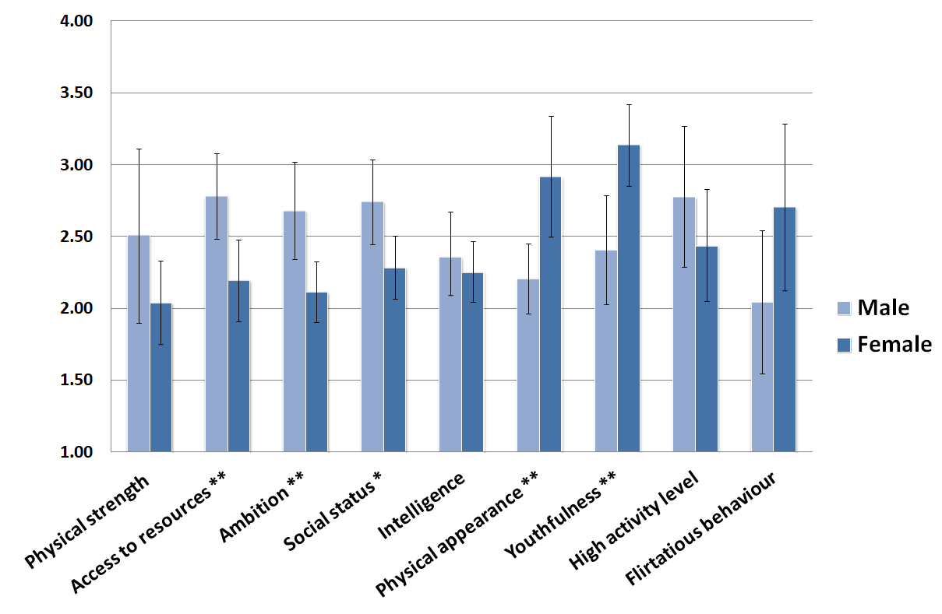
*p<.05, **p<.01.

Table 3. Classification of the results, in respect to sex, after cross validations (N=20).
 |  |  | Predicted group membership
 |  | Sex | Female | Male
Group membership | N | Female | 8 | 2
 |  | Male | 3 | 7
 | % | Female | 80 | 20
 |  | Male | 30 | 70

