Supplementary Material: Seismic imaging beneath Sumatra Island and its surroundings, Indonesia, from local-regional P-wave earthquake tomography (Supplementary Document)

Bayu Pranata¹, Mohamad Ramd

han², Muhammad Hanif³, Muhammad Iqbal Sulaiman⁴, Mufti Putra Maulana⁵, Wandono⁶, Sri Widiyantoro⁷, Sandy Kurniawan Suhardja⁸, Edi Hidayat⁹, Pepen Supendi¹⁰, Ridwan Kusnandar¹¹, Wiko Setyonegoro¹²
¹ Indonesian Agency for Meteorology, Climatology, and Geophysics (BMKG), Jalan Angkasa I, No. 2, Kemayoran, Jakarta 10720, Indonesia, ORCID
² Research Center for Geological Disaster, National Research and Innovation Agency (BRIN), KST Samaun Samadikun, Jl. Cisitu Sangkuriang, Bandung 40135, Indonesia, ORCID
³ Research Center for Geological Disaster, National Research and Innovation Agency (BRIN), KST Samaun Samadikun, Jl. Cisitu Sangkuriang, Bandung 40135, Indonesia, ORCID
⁴ University of Pertamina, Jl. Teuku Nyak Arief, Simprug, Kebayoran Lama, Jakarta 12220, Indonesia; Luwu Disaster Management Agency (BPBD Kab. Luwu), Jl. Andi Djemma, Senga, Belopa, Kab. Luwu 91994, Indonesia, ORCID
⁵ School of Meteorology, Climatology, and Geophysics of Indonesia (STMKG), Jl. Perhubungan I No. 5, Pondok Betung, Tangerang Selatan 15221, Indonesia, ORCID
⁶ School of Meteorology, Climatology, and Geophysics of Indonesia (STMKG), Jl. Perhubungan I No. 5, Pondok Betung, Tangerang Selatan 15221, Indonesia, ORCID
⁷ Global Geophysics Research Group, Faculty of Mining and Petroleum Engineering, Institut Teknologi Bandung, Bandung 40132, Indonesia; Faculty of Engineering, Maranatha Christian University, Bandung 40164, Indonesia, ORCID
⁸ University of Pertamina, Jl. Teuku Nyak Arief, Simprug, Kebayoran Lama, Jakarta 12220, Indonesia, ORCID
⁹ Research Center for Geological Disaster, National Research and Innovation Agency (BRIN), KST Samaun Samadikun, Jl. Cisitu Sangkuriang, Bandung 40135, Indonesia, ORCID
¹⁰ Indonesian Agency for Meteorology, Climatology, and Geophysics (BMKG), Jalan Angkasa I, No. 2, Kemayoran, Jakarta 10720, Indonesia, ORCID
¹¹ Indonesian Agency for Meteorology, Climatology, and Geophysics (BMKG), Jalan Angkasa I, No. 2, Kemayoran, Jakarta 10720, Indonesia, ORCID
¹² Research Center for Geological Disaster, National Research and Innovation Agency (BRIN), KST Samaun Samadikun, Jl. Cisitu Sangkuriang, Bandung 40135, Indonesia, ORCID

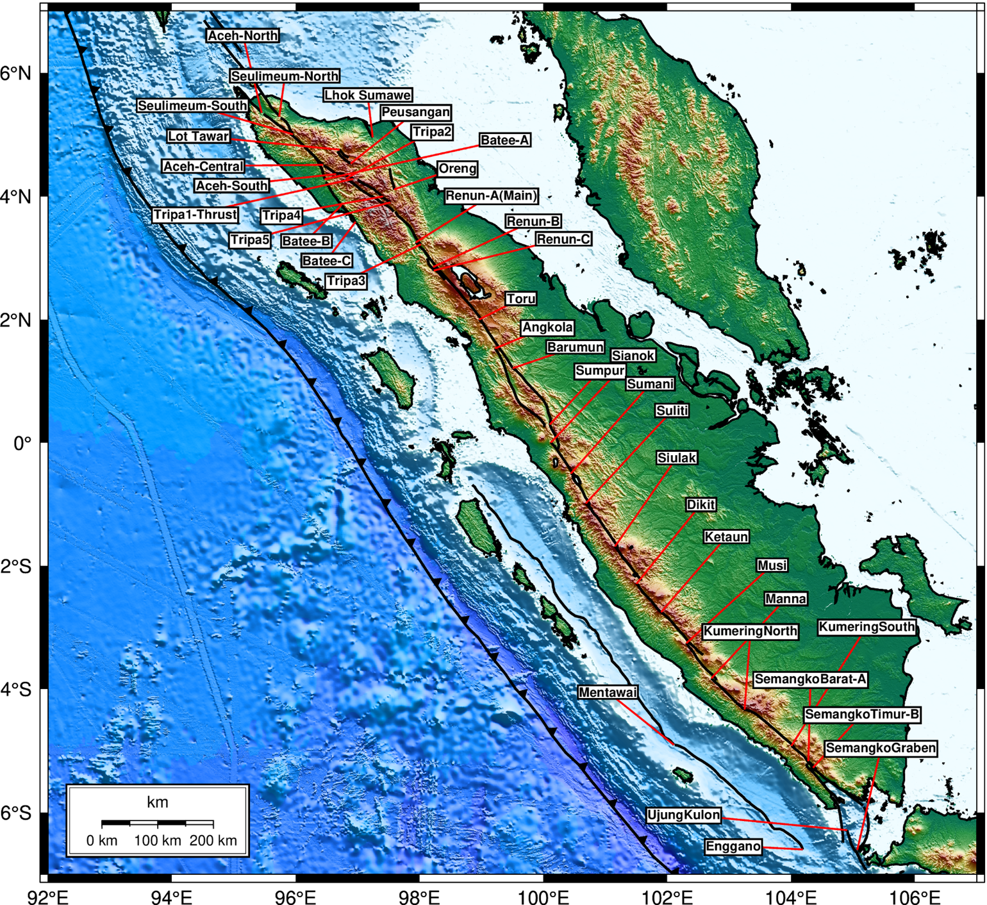
Figure S1: Complete Sumatran fault segments based on the recent fault map (Irsyam et al., 2017)
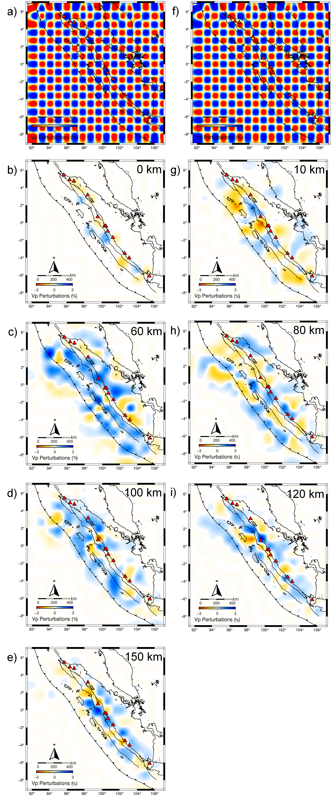
Figure S2: Checkerboard resolution test (CRT) Vp results for horizontal sections spanning the depth range of 0-150 km. On the left side, the input velocity model (a) is presented along with its corresponding Vp results at depths of 0 km (b), 60 km (c), 100 km (d), and 150 km (e). On the right side, the input velocity model (f) is displayed for depths of 10 km (g), 80 km (h), and 120 km (i). The displayed velocity is with respect to the AK135 1D model (modified from Kennett et al., 1995)

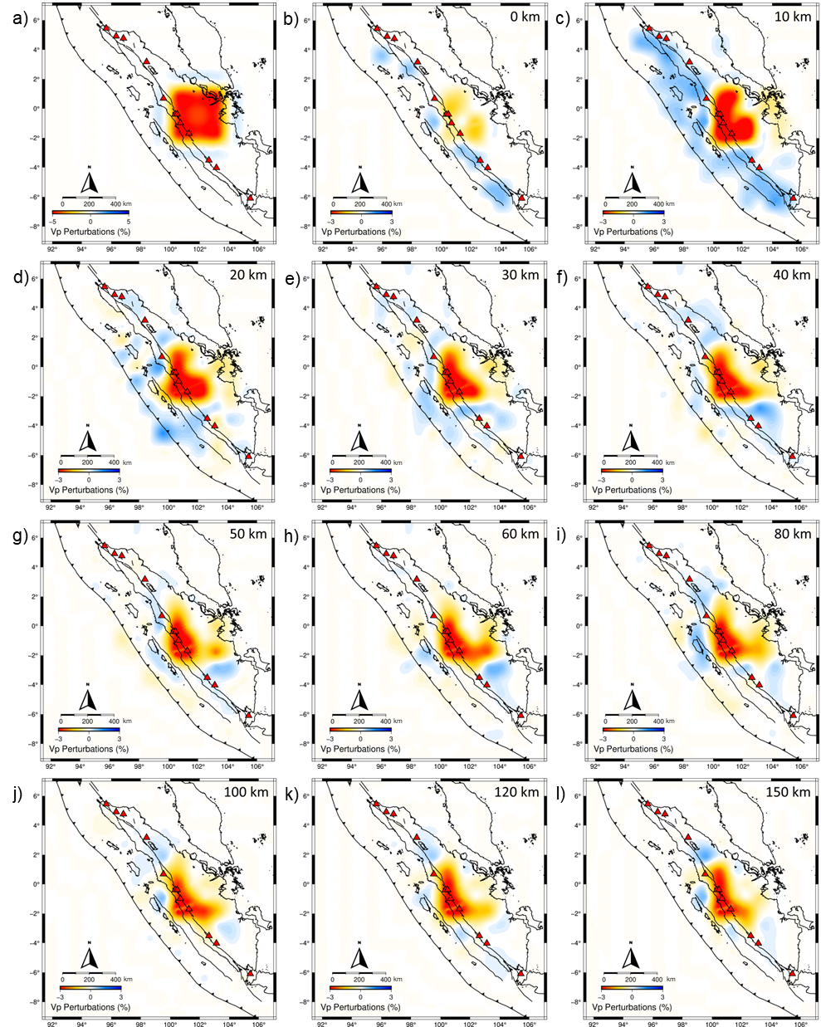

Figure S3: The input velocity model for single block test (a) for depths of 0 km (b), 10 km (c), 20 km (d), 30 km (e), 40 km (f), 50 km (g), 60 km (h), 80 km (i), 100 km (j), 120 km (k), and 150 km (l). A negative perturbation of 5% relative to the 1-D reference velocity model is used. The velocity shown is with respect to the AK135 1D model (modified from Kennett et al., 1995).

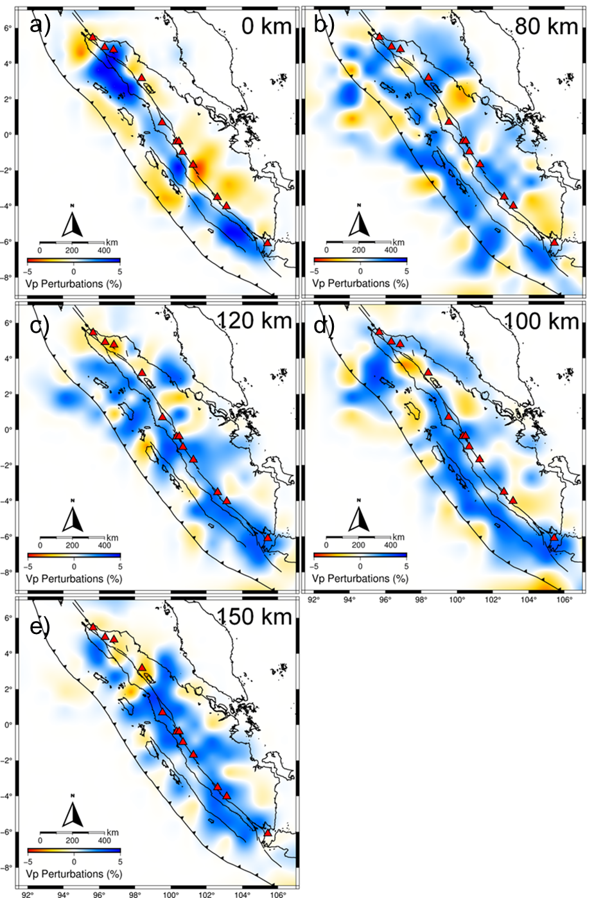
Figure S4: Vp tomographic inversion results for horizontal sections at depths of 0 km (a), 80 km (b), 100 km (c), 120 km (d), and 150 km (e).

Additional References

Irsyam, M., Widiyantoro, S., Natawidjaja, D., Meilano, I., Rudyanto, A., Hidayati, S., Triyoso, W., Hanifa, N., Djarwadi, D., Faizal, L., and others (2017): Peta sumber dan bahaya gempa Indonesia tahun 2017, Pusat Penelitian Dan Pengembangan Perumahan Dan Permukiman, Kementerian Pekerjaan Umum Dan Perumahan Rakyat (in Indonesian).
Kennett, B. L. N., Engdahl, E. R., and Buland, R. (1995): Constraints on seismic velocities in the Earth from traveltimes, Geophysical Journal International, 122(1), 108–124. https://doi.org/10.1111/j.1365-246X.1995.tb03540.x

