CROATIAN SOCIETY FOR RHEUMATOLOGY  CRAOTIAN MEDICAL ASSOACIATION  Šubićeva 9, 10000 Zagreb | 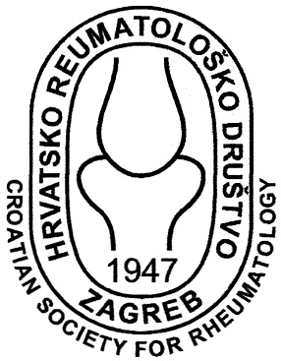
JOURNAL
Reumatizam

Klinički bolnički centar Zagreb
Kišpatićeva 12, 10000 Zagreb, Hrvatska
Editor end chief: Ivan Padjen
Assistant to the head Editor: Mirna Reihl Crnogaj
Secretary of the editorial board: Marija Bakula
http://www.reumatizam.hlz.hr

Scope of the journal

Reumatizam (Rheumatism) is the official peer-reviewed journal of the Croatian Society for Rheumatology of the Croatian Medical Association. The journal is published twice a year.
Rheumatism publishes editorials, scientific papers, professional papers, brief communications (reports), reviews, preliminary reports and case reports. It informs professionals in the field of rheumatology on developments that affect clinical and nonclinical aspect of their practices.
Periodically, supplements with abstracts or full-texts presented at the congresses or symposia are published. The journal brings relevant information on the evaluation of diagnostic and therapeutic procedures, as well as on comprehensive care for individuals with rheumatic diseases.
Papers are published in English and Croatian, provided they are not already
published elsewhere.

