Author 1 (family name, first name)
Author 2
Author 3

http://dx.doi.org/10.21278/brodvvnP (provided by the Editor) ISSN 0007-215X
eISSN 1845-5859
document title in english
UDC 629.5(05) Provided by the Author or by the Editor
Categorization suggested by the reviewers provided by the Editor
Summary
Summary. Summary summary summary summary summary summary summary summary. Summary summary. Use this file as a template for writing your paper. Summary summary. Summary summary summary summary summary summary summary summary summary summary summary summary.
Key words: key words in English separated by ;

Introduction
The paper should be written in MS Word. The document should be set to DIN A4 format (297x210 mm). The margins should be set to 30 mm top and 20 mm bottom and mirrored to 25 mm both outside and inside. The header should be set to 16 mm in height and the footer to 10 mm. The first section should begin as an odd-numbered page. The header on the first page should be different from others (blank).
Footers of the whole document should be left blank.
If possible, the paper should be written on an even number of pages.
The paper should be formatted as follows:
- The whole document should be written in English (UK), 12 pt regular Times New Roman, justified, spaced 3 pt before (Body Text Indent style for first line hanging 10 mm or Body Text style for text without hanging as authors find convenient).
- Document title: 14 pt bold.
- Authors: 12 pt italic.
- Summary title: 12 pt bold.
- Chapter titles: 12 pt bold, numbered.
- Subtitles: 12 pt regular, outline numbered.
- Sub-subtitles: 12 pt regular, outline numbered.
- Figure captions should be placed below figures, 10 pt regular.
- Table captions should be placed above tables.
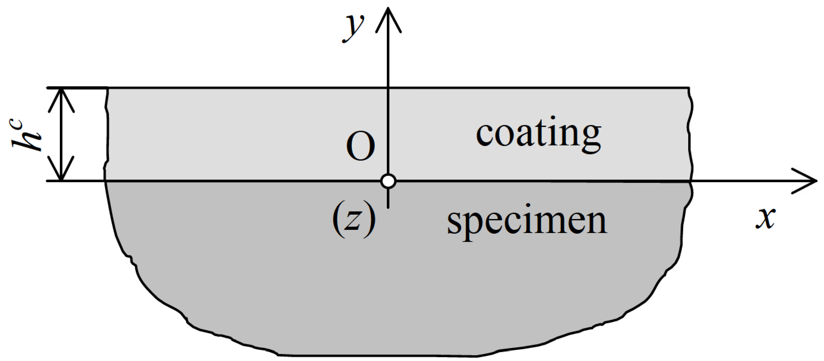
Fig. 1 Single figure example
- Figures should be inserted “In line with text” (see Format object, Layout) Figures could be aligned to the left/right side with the text wrapping enabled if the author finds it necessary.
- Twin figures should be formatted using twin_picture_body style (with tabs).
- Twin figure captions should be formatted using.
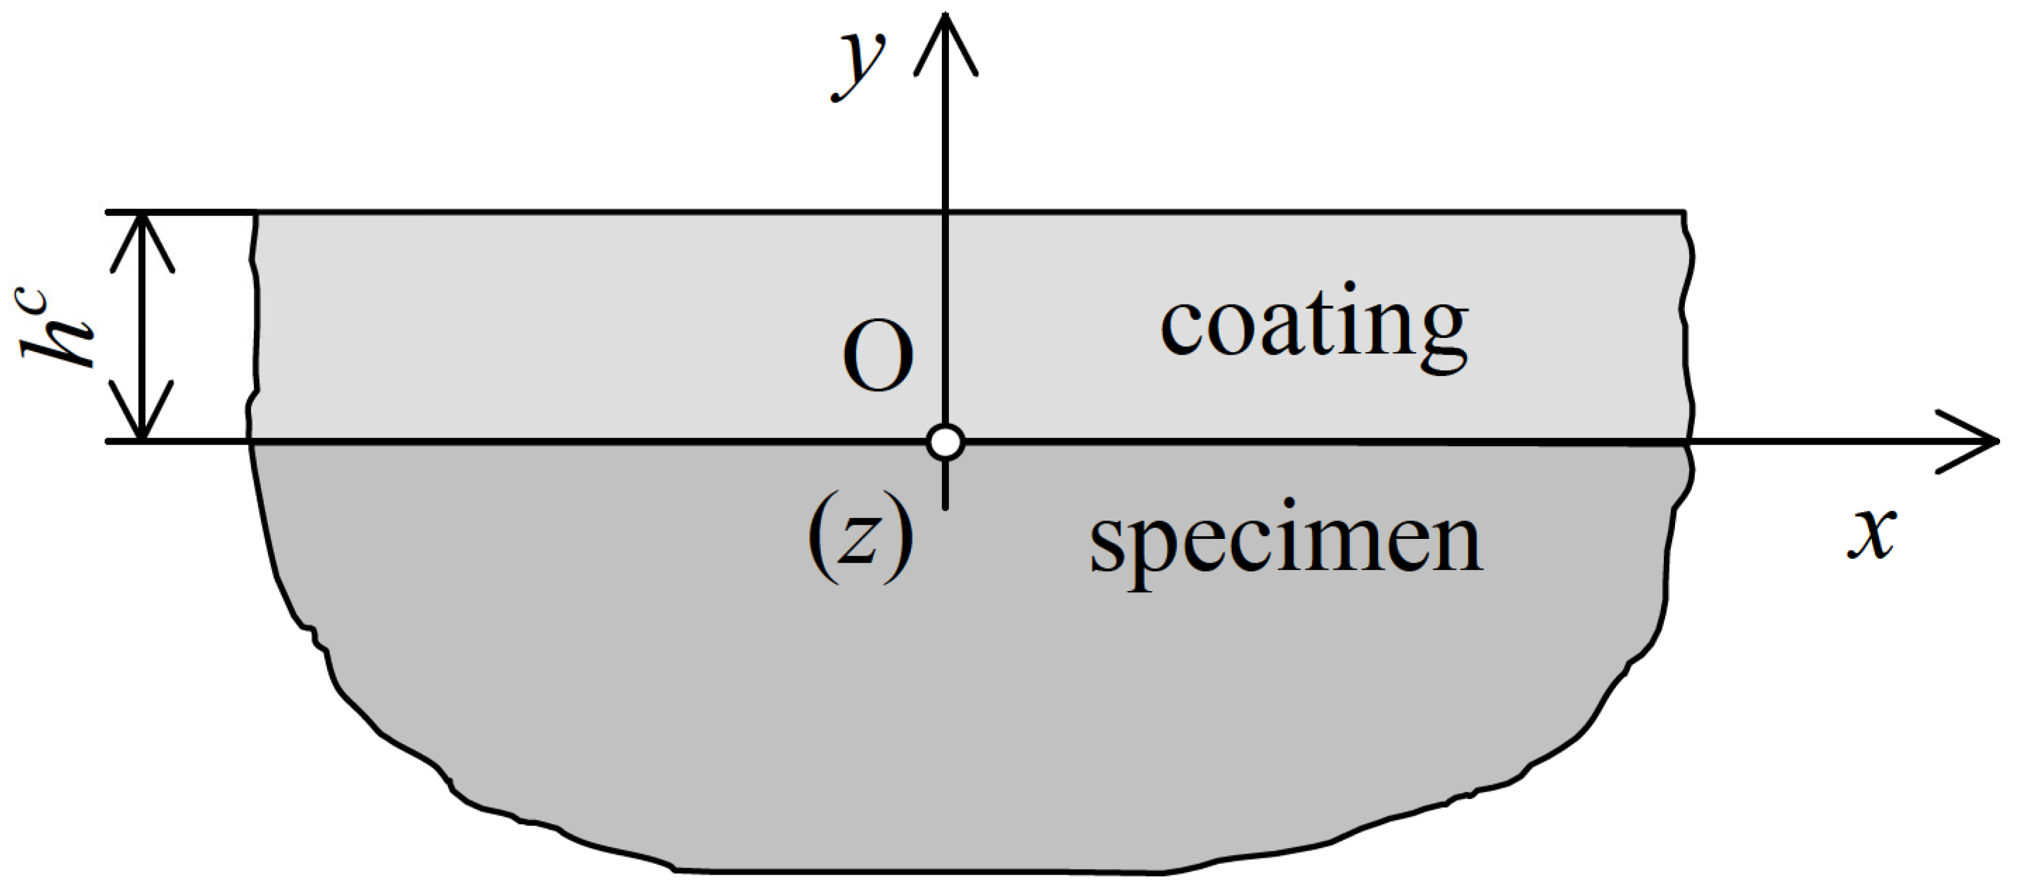
Fig. 2 First figure example Fig. 3 Second figure example

Figures
Try to provide good quality figures, as you would wish them to look when published. Do not use embedded vector graphics because of possible side effects. Use raster graphics in a resolution not less than 300 dpi. Try to balance the figure size according to information you are trying to present to reader. Allow a small percentage of figure resizing for the sake of typesetting.

Fonts
Please, do not use exotic fonts but those enclosed in the regular MS Windows installation. Missing fonts could have serious drawbacks in the final paper layout. In figures and equations, Times New Roman, Arial and Symbol can meet most of demands. If other fonts have to be used, please supply their names.

Minimal font size and line thickness
Note that, even this template is in A4 format, the final print will be scaled down approximately to B5 (that would be about 20% smaller). For writing (text, equation or graphics) do not use font size smaller than 6 pt. When creating raster graphics do not use lines thinner than 0.12 mm (0.34 pt). Otherwise both text and graphics could be lost in the printing.

Tables
Tables should be left aligned or centred; inside grid thickness of ½ pt and border of 1 pt. The grid could be also omitted. Additional changes inside tables (merging cells, different thickness, etc.) can be made as authors find convenient. The text and numbers inside the tables should be formatted using Body Text style, aligned as needed.
Table 1 Explanation of table content (Table_caption style)
If the text follows a table, 12 pt space before should be applied.

Equations
Equations should be written preferably in MathType or using Equation Tools or similar math editor, compatible with MS Word, using the size settings as follows:
- Full 12pt,
- Subscript/Superscript 9pt,
- Sub-Subscript/Superscript 6pt,
- Symbol 18pt,
- Sub-Symbol 12pt.
Equations should be formatted with tabs, spaced before and after with 6pt in general, indented 20 mm from left.
$a=b+c$ (1)
Equation numbers on the right side should be entered manually.

REFERENCES
Submitted: dd.mm.yyyy.  Accepted: dd.mm.yyyy. | Author 1, e-mail  Author 2, e-mail  Affiliation and address  or  Author 1, e-mail  Affiliation 1 e-mail, and address  Author 2, e-mail  Affiliation 2 and address
- References should be formatted look as presented. Long references will spread across lines.
- Reference 2.
- Reference 3. …

Authors and submission data

Author’s information should be placed at the bottom of the last page of the paper.

In the table positioned at the bottom of the last page supply authors data (title, first name, family name. position, affiliation and address).
E-mail address of the corresponding author must be provided.
E-mail adders can be can be supplied for other authors as well.

