(Times New Roman 14 pt)
TITLE OF THE PAPER (Times New Roman - TNR 14 pt Bold)
(Times New Roman 10 pt – to be deleted)
First Name Surname ^{1*}, First Name Surname ², First Name Surname ³, …(TNR 11 pt Bold)
¹ University, Institution, Address of the institution, Post number and Town/City, Country (TNR 10 pt)
² University, Institution, Address of the institution, post number and Town/City, Country (TNR 10 pt)
*E-mail of corresponding author: email@email.com (TNR 10 pt)
(TNR 10 pt)
(TNR 10 pt)
Abstract (TNR 9 pt Bold): The abstract should not exceed 300 words, type of font TNR 9 points normal, aligned to both left and right).
Keywords (TNR 9 pt Bold): keyword 1, keyword 2, keyword 3, keyword 4, keyword 5 (max. 5, TNR 9 pt).
(TNR 10 pt)
Received: ---------- / Accepted: -------------
Published online: -------------
(TNR 10 pt)
Proposed classification of the paper (scientific paper, technical paper, …) (TNR 9 pt)
(TNR 10 pt)
(TNR 10 pt)
(TNR 10 pt)

1. INTRODUCTION (TNR 11 pt Bold)
(TNR 10 pt)
The document should be in A4 format with 25 mm margins on both sides, and with single-spaced text aligned both to the left and right margins, without being split into columns. The paper should be written in the Latin alphabet in a normal, usual font (Times New Roman), and the Greek alphabet can be used for annotations. The font size is 10 pt (unless specified otherwise). While writing their paper, authors have to use automatic page numbering, shown in the bottom right corner of the page. The text prepared in such a way will facilitate the proofreading and review process.
The editors recommend that the paper should start with an introductory paragraph where the problem or topic dealt with in the paper will be described.
(TNR 10 pt)
2. OTHER SECTIONS (TNR 11 pt Bold)
(TNR 10 pt)
The text is divided into several sections (and subsections), depending on the topic being presented. The editors recommend that readers should not be burdened by being presented previously published and generally known and accepted facts; instead, previously published papers should rather be referred to wherever this is required.
(TNR 10 pt)
2.1. Other subsections (TNR 11 pt Bold)
(TNR 10 pt)
The section and subsection headings should be written in a 11 pt font in bold; they should be numbered and aligned on both sides. Section headings should be written in uppercase, and subsection headings in lowercase. After each section and subsection heading, a 11 pt line should be left blank, as well as after every section and subsection.
(TNR 11 pt)
3. TEXT FORMATTING (TNR 11 pt Bold)
(TNR 10 pt)
The text of the paper should be written in the third person singular and should be terminologically harmonized with legal regulations and the international system of units (SI). Abbreviations and acronyms should be defined when they are first mentioned in the text and used consistently thereafter. To emphasize specific parts of the text, the italic function should be used rather than the underline function. Footnotes should not be used in the text. Every figure, table and equation in the paper should be numbered, and the reference to it should be specified in the text.
(TNR 10 pt)
3.1. Citing papers in the text (TNR 11 pt Bold)
(TNR 10 pt)
When citing other papers in the text with blue colour,, only previously published papers are referred to (!) by listing the author(s) and the year when the paper was published. If the authors deem it necessary, personal communication and unpublished papers can be citied in the paper. However, this should be done in an appropriate place in the text itself or in acknowledgments at the end of the paper.
More papers by the same author should be chronologically ordered, starting from the most recent paper.
An example of citing a paper published by one author:
…a recent study investigated the spatial heterogeneity of epikarst copepods (Pipan 2005) or …Pipan (2005) has investigated the spatial heterogeneity of epikarst copepods.
An example of citing a paper which has up to two authors:
…carbonate rocks occupy about 12% of the planet's dry, ice-free land (Ford & Williams 2007) or Ford and Williams (2007) estimate that carbonate rocks occupy about 12% of the planet's dry, ice-free land.
When a paper is cited which has three or more authors, only the surname of the first author should be given, followed by et al. and the year of the publication of the paper:
…karst aquifers heterogeneity makes them extremely difficult to model (Gabrovšek et al. 2004).
Several papers cited simultaneously should be mentioned by being separated by a semicolon (;):
…several authors (Shuster & White 1971; Bakalowicz 1979) used interpretation of karst spring hydrographs…
If papers of the same author that are written in the same year are cited, then the letters a, b, c etc. should be used after the year of the publication of the paper, and every year should be separated by a comma, e.g.:
…complex analyses of karren morphology are the basis for their classification (Veress 2000a, b).
When citations referred to come from a book which contains several chapters written by different authors, only the authors are cited of the chapters from which the data have been taken, and not the authors of the book.
Secondary references can be used only when the primary source of data is not available. In such cases, both secondary and primary references should be mentioned, e.g.:
…according to Gonzalez and Lohmann (1988) as cited by Gillieson (1996) in Carlsbad Caverns evaporation played….
(TNR 10 pt)
4. FORMATTING OF FIGURES, TABLES AND EQUATIONS (TNR 11 pt Bold)
(TNR 10 pt)
In the phase when the paper is submitted for review, no attention is paid to the quality of figures for print; the only prerequisite is for the figures to be legible and comprehensible to reviewers/the editorial board. If this prerequisite is not met, authors will be asked to resend the figure.
(TNR 10 pt)
4.1. Creation of tables (TNR 11 pt Bold)
(TNR 10 pt)
To create tables, the function “insert a table” should be used; Excel tables (spreadsheets) should not be used because this can entail unforeseen mistakes in the technical production of the paper. Smaller font sizes can be used in tables. For citation of table in text use bold font, for example: “Table 1 show…”. All tables should be width of 8 cm or 16 cm.
(TNR 10 pt)
Table 1. Example of a table (TNR 10 pt Bold)
(TNR 10 pt)
ELEMENT NAME | COLUMN 1 | COLUMN 2
Example 1 | abc | ''dd
Example 2 | QWE | ?ea
Example 1 | A3 | @d
CO2, % | dF# | dsds
(TNR 10 pt)
4.2. Writing of equations (TNR 11 pt Bold)
(TNR 10 pt)
To write equations, Equation Editor or MathType for Equations (English version) should be used, as well as standard mathematic notations: italic for letters denoting mathematical constants, variables, unknown quantities; roman characters for numbers, operators, punctuation, common functions, measurement units, abbreviations (e.g. sin, cos, exp, lim, max, min…); bold characters for vectors, tensors and matrices; multiplication should not be marked with an asterisk (*) but alternatively as AxB, AB, or A•B. The explanation of the used characters should be given after the equation. The equation should be centrally aligned, and the equation number should be aligned to the right margin. For citation of equations in text use bold font, for example: “Equation 1 show…”.
(TNR 10 pt)
(1)
(TNR 10 pt)
4.3. Images, photographs and similar. (TNR 11 pt Bold)
(TNR 10 pt)
Figures are printed in greyscale, and authors should take this into account when preparing them. However, authors may, in agreement with the editorial board, prepare figures in colour when they deem it necessary for the understanding of what the figure shows. The figures in colour approved by the editorial board will not be additionally charged. If the paper is accepted for publication, the authors will have to submit high quality inserts; therefore, they should take this into consideration in the preparation phase. For citation of figures in text use bold font, for example: “Figure 1 show…”. All figures should be width of 8.2 cm or 17 cm.
(TNR 10 pt)
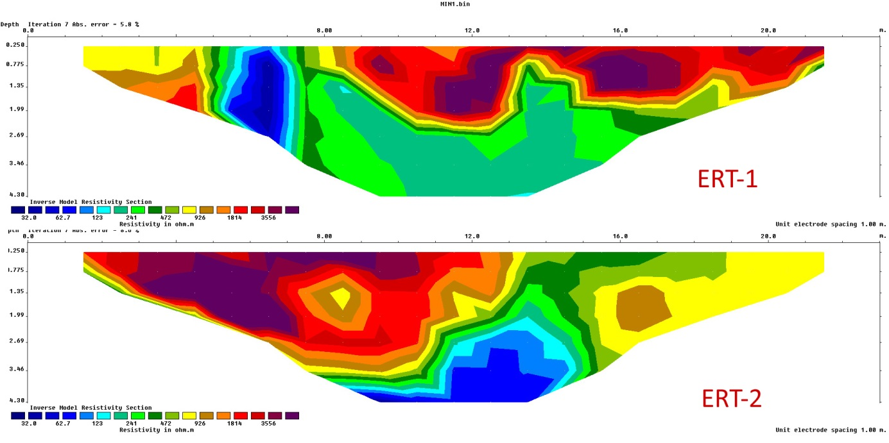
(TNR 10 pt)
Figure 1. Description of image, photograph, diagram (TNR 10, Bold, italic, centre)
(TNR 10 pt)
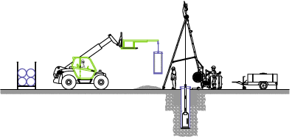
(TNR 10 pt)
Figure 2. Description of image, photograph, diagram (TNR 10, Bold, italic, centre)
(TNR 10pt)
Acknowledgments: Acknowledgments are not an obligatory part of the article. If they are used, they should be put in a separate section, before References. It is appropriate that the authors should thank commercial and other institutions which helped them to collect, finance and publish data. The names of such institutions are provided in full, and not in the form of abbreviations or acronyms. At the end of the paper, the list of references and figures should be given. (TNR 10 pt)
Funding information: Authors should clearly state funding information. If no external funding is received, authors should state: “No external funding received” (TNR 10 pt)
Conflict of interest: Authors should state any conflict of interest. (TNR 10 pt)
Authors contribution: Authors contribution should be in accordance with CRediT (Contributor Roles Taxonomy - https://credit.niso.org/ ) (TNR 10 pt)

5. REFERENCES (TNR 11 pt Bold)
(TNR 10 pt)
The list of references is compiled alphabetically based on the references mentioned in the text of the article. Single line spacing should be used. In the list of references use font Times New Roman, 9 pt, and only the published papers are included! Personal communication and unpublished papers are not mentioned. The Harvard citation style (or its derivates) should be used. Several papers by the same author should be chronologically ordered, starting with the most recent one. The abbreviations for magazine names should be used according to the ISSN list: http://www.issn.org/2-22661-LTWA-online.php.
Journal article:
Smith J, Jones M Jr, Houghton L et al (1999) Future of health insurance. N Engl J Med 965:325–329 (TNR 10 pt)
Book citation:
South J, Blass B (2001) The future of modern genomics. Blackwell, London (TNR 10 pt)
Book chapter citation:
Brown B, Aaron M (2001) The politics of nature. In: Smith J (ed) The rise of modern genomics, 3rd edn. Wiley, New York (TNR 10 pt)
Citation of article by DOI -digital object identifier:
Slifka MK, Whitton JL (2000) Clinical implications of dysregulated cytokine production. J Mol Med. doi:10.1007/s001090000086 (TNR 10 pt)
Citation of online documents:
Doe J (1999) Title of subordinate document. In: The dictionary of substances and their effects. Royal Society of Chemistry. Available via DIALOG. http://www.rsc.org/dose/title of subordinate document. Cited 15 Jan 1999 (TNR 10 pt)

