Title of the Paper:
Optional Subtitle of the Paper

First name Last name¹, First name Last name² and First name Last name³
¹Department name, Institution name
²Department name, Institution name
³Department name, Institution name

Author Note
We have no conflict of interest to disclose.
Correspondence concerning this article should be addressed to name, institution, postal address. Email: email address
Abstract
This is the template for how the paper should look like. This is where you enter the text using the Times New Roman as your font choice. The size of the font should be 12, it needs to be justified and use 1,5 spacing. This is the template for how the paper should look like. This is where you enter the text using the Times New Roman as your font choice. The size of the font should be 12, it needs to be justified and use 1,5 spacing. This is the template for how the paper should look like. This is where you enter the text using the Times New Roman as your font choice. The size of the font should be 12, it needs to be justified and use 1,5 spacing. This is the template for how the paper should look like. This is where you enter the text using the Times New Roman as your font choice. The size of the font should be 12, it needs to be justified and use 1,5 spacing…
Keywords: keyword, keyword, keyword, keyword, keyword
Heading Level 1
This is the template for how the paper should look like. This is where you enter the text using the Times New Roman as your font choice (Author, 2020). The size of the font should be 12, it needs to be justified and use 1,5 spacing (Author & Author, 2020). This is the template for how the paper should look like. This is where you enter the text using the Times New Roman as your font choice. The size of the font should be 12 and it needs to be justified (Author & Author, 2020: 33). This is the template for how the paper should look like. This is where you enter the text using the Times New Roman as your font choice. The size of the font should be 12 and it needs to be justified (Author et al., 2020). This is the template for how the paper should look like. This is where you enter the text using the Times New Roman as your font choice. The size of the font should be 12, it needs to be justified and use 1,5 spacing. (Author et al., 2020: 33–36).
Heading Level 2

This is the template for how the paper should look like. This is where you enter the text using the Times New Roman as your font choice. The size of the font should be 12 and it needs to be justified. This is the template for how the paper should look like. This is where you enter the text using the Times New Roman as your font choice. The size of the font should be 12, it needs to be justified and use 1,5 spacing.

Heading Level 3
This is the template for how the paper should look like. This is where you enter the text using the Times New Roman as your font choice. The size of the font should be 12 and it needs to be justified. This is the template for how the paper should look like. This is where you enter the text using the Times New Roman as your font choice. The size of the font should be 12 and it needs to be justified.
Heading Level 4. This is the template for how the paper should look like. This is where you enter the text using the Times New Roman as your font choice. The size of the font should be 12 and it needs to be justified. This is the template for how the paper should look like. This is where you enter the text using the Times New Roman as your font choice. The size of the font should be 12 and it needs to be justified.
Heading Level 5. This is the template for how the paper should look like. This is where you enter the text using the Times New Roman as your font choice. The size of the font should be 12 and it needs to be justified. This is the template for how the paper should look like. This is where you enter the text using the Times New Roman as your font choice. The size of the font should be 12 and it needs to be justified.
References
Author’s surname, Initial(s). (Year of publication). Title of the book. Publisher.
Author’s surname, Initial(s). (Year of publication). Title of the article. Title of Journal, Volume(Issue), Pages.
Author’s surname, Initial(s). (Year, Month Day of publication). Title of the work. Website. https://URL
Author’s surname, Initial(s). (Year of publication). Title of the article. Newspaper. https://URL
Author’s surname, Initial(s). [Channel]. (Year, Month Day of publication). Title of the video [Video]. Website. https://URL
Organization. (Year of publication). Word. In Dictionary. Publisher. https://URL

Table 1
Table Title
College | New students | Graduating students | Change
University A | 110 | 103 | +7
University B | 223 | 214 | +9
University C | 197 | 120 | +77
University D | 134 | 121 | +13
University E | 202 | 210 | -8
Total | 866 | 768 | 98

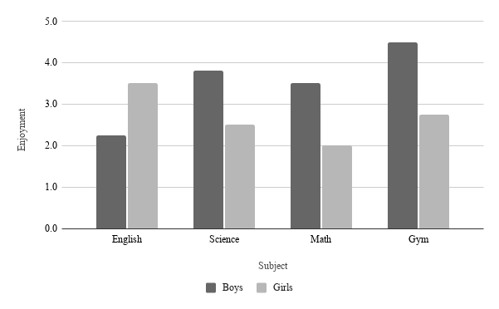
Figure 1
Figure Title
Note. Number of boys = 30, number of girls = 31, total N = 61.

