ISSN 1330-3651(Print), ISSN 1848-6339 (Online) https://doi.org/10.17559/TV-00000000000000
Categorization of paper (Style: Ariel Narrow, 8pt)
14pt
14pt
Instructions for Authors
(Style: Ariel Narrow, 14pt, Bold)
14pt
Name SURNAME 1, Name SURNAME 2, etc.
(Author's name, Co-author's name etc. - Style: Ariel Narrow, 10pt)
14pt
Abstract: The journal Tehnicki vjesnik/Technical Gazette publishes scientific and professional papers in the area of mechanical, electrical and civil engineering and also their boundary areas. The submitted paper should not have been previously published elsewhere in the same or similar form and may not simultaneously be submitted to another journal for publication. The author is the only one responsible for the contents, data reliability and all the statements in the paper. The title of paper has no more than 15 words. Write full names and surnames of the authors, without grades and ranks. The abstract has not more than 200 words and it must reflect the content of the article more faithfully. It cites the methods used and highlights the achieved results as well as the contribution of the article without any symbols and units. Keywords are, as a rule, from the title of the article, and only from the abstract of the article. The article is not proofread and authors are responsible for the linguistic and grammatical correctness. After the review procedure is over, the authors may be asked to make certain corrections or additions to the article. (Style: Ariel Narrow, 8pt – you must erase text in brackets and also the brackets after finishing your paper).
8pt
Keywords: Alphabetic list of keywords in British English separated with ; (Style: Ariel Narrow, 8pt)
10pt
10pt

1 INTRODUCTION (Introductory remarks)

(Style: Ariel Narrow, 10pt, Bold)
10pt
(Tab 6 mm) Upon its acceptance the article is categorized as follows: original scientific paper, preliminary notes, subject review and professional paper.
Original scientific papers should report original theoretical or practical research results. The given data must be sufficient in order to enable the experiment to be repeated with all effects described by the author, measurement results or theoretical calculations.
Preliminary communications present one or more new scientific results but without details that allow the reported data to be checked. The papers of this category inform about experimental research, small research projects or progress reports that are of interest.
Subject reviews cover the state of art and tendencies in the development of the specific theory, technology and application with given remarks by the author. Such a paper ends with a list of reference literature with all the necessary items in the related field.
Professional papers report on the original design of an instrument, device or equipment not necessarily resulting from the original research. The paper contributes to the application of well-known scientific results and to their adaptation for practical use.
The Editorial Board welcomes contributions to the section "Curiosities" that are about manufacturing procedures, experiences with specific equipment applications, etc. The author should propose and give arguments for the category of the submitted article. Papers presented at scientific conferences can also be published in the journal upon the agreement of the conference organizer and the author. (Style: Times New Roman, 10pt, Normal)
Papers to be published in the journal TEHNIČKI VJESNIK/TECHNICAL GAZETTE, should be written in British English. The metrology and terminology used in the paper have to meet legal regulations, standards and International System of Units (SI) (Quantities and Units: ISO 80.000 - from Part 1 to Part 14).

1.1 Subtitle 1 (Writing Instructions)
(Style: Ariel Narrow, 10pt, Bold)
10pt
The text of the paper is arranged in sections and when necessary into subsections. Sections are marked with one Arabic numeral and subsections with two Arabic numerals, e.g. 1.1, 1.2, 1.3, ... When a subsection is arranged in smaller parts, each of them is marked with three Arabic numerals, e.g. 1.1.1, 1.1.2, ... Further divisions are not allowed.
10pt
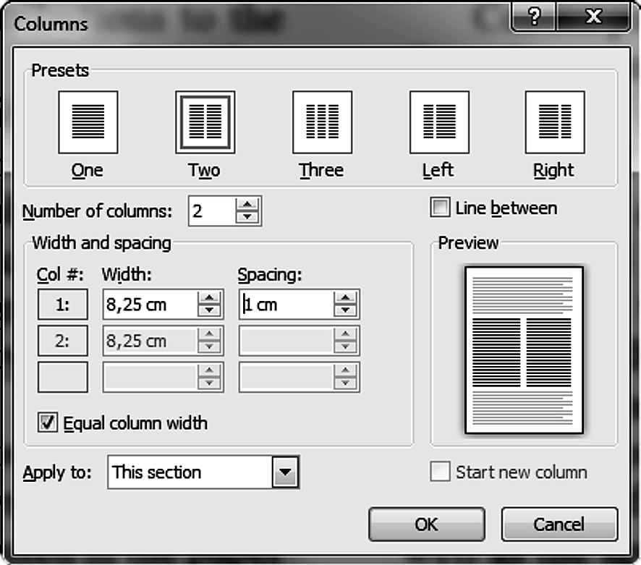
Figure 1 The texts under figures
(Style: Ariel Narrow, 8pt)
10pt
The text has to be organized in the following order:
ISSN and https://doi.org/10.17559/ID
Title of the paper (not more than 15 words). Papers should be headed by a concise but informative title that clearly reflects the subject of the paper.
Authors' full names (without grades and ranks).
Abstract (not more than 200 words) should present a brief and factual account of content and conclusions of the paper, and an indication of the relevance of the new material presented.
Alphabetic list of keywords in English. Keywords normally originate from the title and from the abstract (use ; between keywords).
Introduction should state the reason for the work, with brief reference to previous work on the subject. It informs about the applied method and its advantages.
Central part of the paper may be arranged in sections. Complete mathematical procedures for formula derivations should be avoided. The necessary mathematical descriptions may be given in an appendix. Authors are advised to use examples to illustrate the experimental procedure, applications or algorithms. In general, all the theoretical statements have to be experimentally verified.
In Conclusions all the results are stated, and all the advantages of the used method are pointed out. The limitations of the method should be clearly described as well as the application areas.
List of references should be brought together at the end of the article and numbered in square brackets in order of their appearance in the text followed by other literature.
Authors' full names (with grades and ranks) followed by the name and address of the institution in which the work was carried on.
A List of used symbols and their SI units is optional after the list of references.
10pt
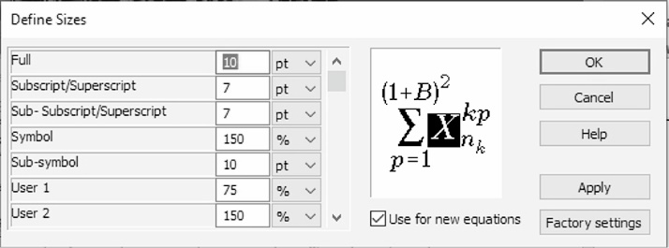
Figure 2 The texts under figures
(Style: Ariel Narrow, 8pt)
10pt
1.1.1 Subtitle 2 (Preparation of Manuscript)
(Style: Ariel Narrow, 10pt, Bold)
10pt
The paper should be written using Latin characters. Greek letters may be used for symbols. The volume of the article is limited to 8 pages (A4 format). That includes blanks and equivalent number of characters covered by figures and tables. Number of pages must be even.
The text should be sent to the Editorial Board using e-mail. For the text preparing may be used only MS Word for Windows respectively *.doc, *.docx (Word Document) format of records. The text has to be prepared in accordance with this template.
The Editorial Board may exceptionally request the CD-ROM with recorded articles and figures and tables. In that case the figures (drawings, diagrams and photographs) should be submitted stored on the CD-ROM in JPG/JPEG, PNG, TIF (TIFF Bitmap) or BMP (Windows Bitmap) format, min. resolution of 300 dpi. Each figure is labelled the same as it is in the paper and recorded format (e.g. fig-1.JPG). If figures are inserted into text they must be also with min. resolution of 300 dpi.
Latin or Greek characters in italics are used for physical symbols and normal characters for measuring units and numerical values. Text in figures is also written with normal letters (see obligatory Quantities and Units: ISO 80.000 - Part 1 and Part 2). Character size is to be chosen on the basis of the following criteria: after expected figure size reduction a capital Latin character should be about 2 mm high (no less than 6pt).
All figures in the Journal will be printed in black and white technique.
Coloured figures will be seen only in the PDF format on the Web address http://hrcak.srce.hr/technicki-vjesnik.
Tables are created with the word processing program. Each table is positioned in the desired place in the text. In the case of decimal numbers use comas (e.g. 0,253); use a small gap separating the thousands (e.g. 25.000, but not in the case of 1500).
The texts under figures and table titles are only in the English language.
Section titles and titles of subsections are typed in small letters only in the English language. Equations are numbered with Arabic numerals in parenthesis at the right margin of the text. In the text an equation is referenced by its number in parenthesis like "... from Eq. (5) follows ...".
Create equations with MathType Equation Editor (some examples are given below) (adjustments of sizes see Fig. 2).
10pt
(1)
(2)
(3)
(4)
(5)
10pt
(Notice: Equation Editor (Microsoft Equation 3.0) was included in previous versions of Word but has removed from all versions that have installed the January 2018 Public Update (PU)).
10pt
Figure 3 The texts under figures [7]
10pt
Figures and tables are numbered with Arabic numerals (1 ÷ n) (symbol ÷ is used instead of "from … to …"). In the text in figure or table is referenced by its number (e.g. in Fig. 1, in Tab. 1, etc.).
When reference to literature is made the publication number from the list of references in square brackets is used like "... in [7] the authors showed ...". In the list of references literature is cited in accordance with APA (see http://www.bibme.org/citation-guide/apa/).
10pt
2 COPYRIGHT TRANSFER AGREEMENT
10pt
Copyright assignment. The author hereby assigns to the journal TEHNIČKI VJESNIK - TECHNICAL GAZETTE (TV/TG) the copyright in the above article (for U. S. government employees: to the extent transferable), throughout the world, in any form, in any language, for the full term of copyright, effective upon acceptance for publication. TEHNIČKI VJESNIK - TECHNICAL GAZETTE is an Open Access journal. All content is made freely available. Users are allowed to copy and redistribute, and alter, transform, or build upon the material as long as they attribute the source in an appropriate manner (CC-BY).
Author's warranties. The author warrants that the article is original, written by stated author/s, has not been published before and it will not be submitted anywhere else for publication prior to acceptance/rejection by TV/TG, contains no unlawful statements, does not infringe the rights of others, and that any necessary written permissions to quote from other sources have been obtained by the author/s.
Rights of authors. Authors retain the following rights:
- all proprietary rights relating to the article, other than copyright, such as patent rights,
- the right to use the substance of the article in future own works, including lectures and books,
- the right to reproduce this article for own purposes, provided the copies are not offered for sale.

10pt
Figure 4 Page setup (paper size A4)
10pt

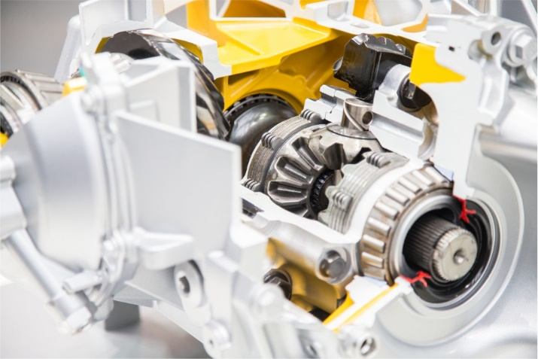
Figure 5 Photography resolution of 300 dpi (min)
10pt
An author may self-archive an author-created version of his/her article on his/her own website and or in his/her institutional repository. He/she may also deposit this version on his/her founder’s or founder's designated repository at the founder's request or as a result of a legal obligation, provided it is not made publicly available until 12 months after official publication. Furthermore, the author may only post his/her version provided acknowledgement is given to the original source of publication and a link is inserted to the published article on http://hrcak.srce.hr/tehnicki-vjesnik. The link must be accompanied by the following text: "The original publication is available also at http://hrcak.srce.hr/ tehnicki-vjesnik" or https://doi.org/10.17559/article ID. He/she may use the publisher's PDF version, which is posted on http://hrcak.srce.hr/tehnicki-vjesnik, for the purpose of self-archiving or deposit. Any other use of the article requires permission from the publisher.
Co-authorship. If the article was prepared jointly with other authors, the signatory of this form warrants that he/she has been authorized by all co-authors to sign this agreement on their behalf, and agrees to inform his/her co-authors of the terms of this agreement.
10pt
3 PUBLICATION ETHICS AND PUBLICATION MALPRACTICE STATEMENT
10pt
The publication of an article in a peer reviewed journal is an essential model for our journal TEHNIČKI VJESNIK/TECHNICAL GAZETTE.
It is necessary to agree upon standards of expected ethical behaviour for all parties involved in the act of publishing: the author, the journal editor, the peer reviewer and the publisher.
Our ethic statements are based on COPE's Best Practice Guidelines for Journal Editors.
Publication decisions. The editor of the TEHNIČKI VJESNIK/TECHNICAL GAZETTE is responsible for deciding which of the articles submitted to the Journal should be published.
The editor may be guided by the policies of the Journal's editorial board and constrained by such legal requirements as shall then be in force regarding libel, copyright infringement and plagiarism. The editor may confer with other editors or reviewers in making this decision.
Fair play. An editor at any time evaluates manuscripts for their intellectual content without regard to race, gender, sexual orientation, religious belief, ethnic origin, citizenship, or political philosophy of the authors.
Confidentiality. The editor and any editorial staff must not disclose any information about a submitted manuscript to anyone other than the corresponding author, reviewers, potential reviewers, other editorial advisers, and the publisher, as appropriate.
Disclosure and conflicts of interest. Unpublished materials disclosed in a submitted manuscript must not be used in an editor's own research without the express written consent of the author.
Contribution to editorial decisions. Peer review assists the editor in making editorial decisions and through the editorial communications with the author may also assist the author in improving the paper.
Acknowledgement of sources. Reviewers should identify relevant published work that has not been cited by the authors. Any statement that an observation, derivation, or argument had been previously reported should be accompanied by the relevant citation. A reviewer should also call to the editor's attention any substantial similarity or overlap between the manuscript under consideration and any other published paper of which they have personal knowledge.
We are using iThenticate for similarity check and find it an invaluable tool. We run all revised papers through the program and report to our editorial team at the "decision-making" meetings, where we compose each issue. The iThenticate reports have become a standard part of the evaluation of each paper; in addition, we use them as teaching tools for authors, many of whom have never been "called on the carpet" for self-plagiarism and other ethical violations. (http://www.ithenticate.com/)
10pt
Table 1 Table titles (Style: Ariel Narrow, 8pt)
Engineering  stress  σ_{e} / MPa | Engineering  plastic strain  ε_{e,pl} / % | True stress  σ_{t} / MPa | True plastic  strain  ε_{t,pl} / %
250,0 | 0,00 | 250,8 | 0,00
250,0 | 0,21 | 250,8 | 0,21
285,7 | 1,35 | 290,0 | 1,34
322,7 | 2,13 | 330,1 | 2,10
358,4 | 3,06 | 370,0 | 3,00
393,1 | 4,35 | 411,0 | 4,24
423,6 | 6,05 | 450,1 | 5,85
449,7 | 8,76 | 490,1 | 8,36
(Style in table: Times New Roman, 9pt, Normal)
10pt
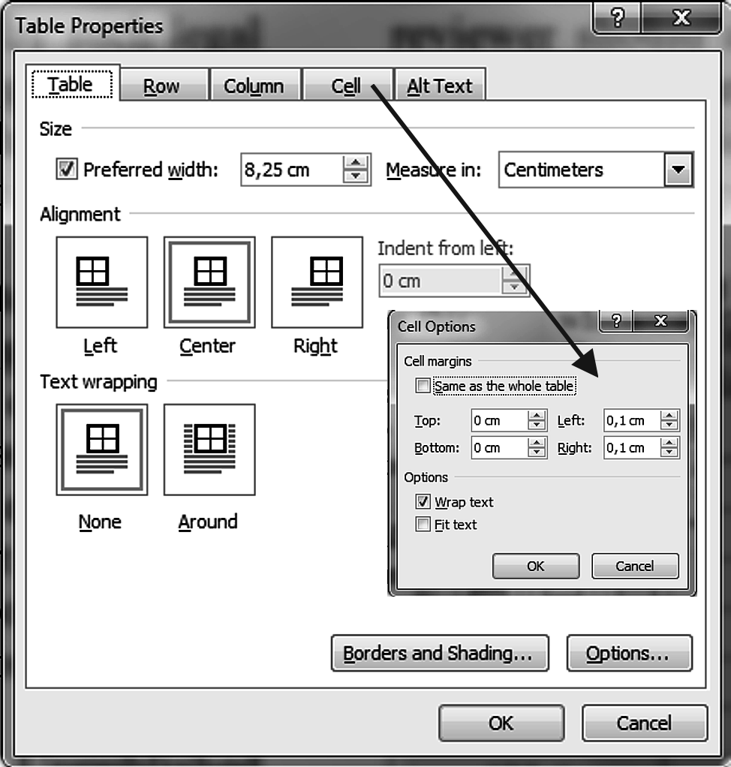
Figure x Table properties

10pt
Table x Table titles [4]
1 | 2 | 3 | 4 | 5 | 6 | 7 | 8
Row | α / % | β / % | α / % | TC(Q*) | Q*_{J} | TC(Q*_{J})
1 | 50 | 4 | 239 | 1.563.600 | 267 | 1.564.500 | 0,06
2 | 10 | 5 | 179 | 324.030 | 267 | 327.540 | 1,08
3 | 15 | 6 | 148 | 185.150 | 267 | 190.310 | 2,79
4 | 20 | 7 | 130 | 131.280 | 267 | 137.680 | 4,87
5 | 25 | 8 | 116 | 102.540 | 267 | 109.920 | 7,20
6 | 30 | 9 | 106 | 84.607 | 267 | 92.824 | 9,71
(Style in table: Times New Roman, 9pt, Normal)

10pt

x CONCLUSION
10pt
Paper manuscripts, prepared in accordance with these Instructions for Authors, are to be submitted to the Editorial Board of the TEHNIČKI VJESNIK/ TECHNICAL GAZETTE journal. Manuscripts and the CD-ROM are not returned to authors. When being prepared for printing the text may undergo small alternations by the Editorial Board. Papers not prepared in accordance with these Instructions shall be returned to the first author. When there are several authors the first author is to be contacted. The Editorial Board shall accept the statements made by the first author.
The author warrants that the article is original, written by stated author/s, has not been published before and it will not be submitted anywhere else for publication prior to acceptance/rejection by TEHNIČKI VJESNIK/ TECHNICAL GAZETTE (TV/TG), contains no unlawful statements, does not infringe the rights of others, and that any necessary written permissions to quote from other sources have been obtained by the author/s.
10pt
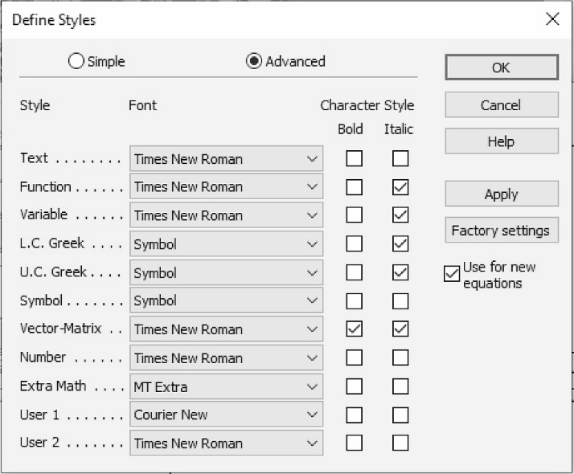
Figure X The texts under figures
(Style: Ariel Narrow, 8pt)
10pt

x.1 How long does the review process take?
10pt
Most papers will be reviewed by two or more independent reviewers. They may also be read and considered by members of the Journal's Editorial Board and ultimately by the editor(s) before the decision is rendered. The reviewers are academics or professionals working in the respective field, who are also writers of papers themselves. They offer their time and their expertise voluntarily in order to assist in improving the papers and to encourage new research in their topic of interest. Delays will inevitably occur when reviewers are busy. They may have a number of journals sending them papers to be reviewed. Our Journal may also receive large quantities of submissions throughout the year. The Editorial Board members of our Journal work tirelessly to ensure that peer reviews are as timely and rigorous as possible. Waiting times can vary, depending on the subject area.
10pt

x.2 What are the Benefits of Online Submission?
10pt
Online submissions by the Paper Submission Tool (PST) are automatically acknowledged. Authors can easily check the status of their submission during the review process. Papers are easier to track, amend, and update. It is a simple method of sharing documents and sending communications throughout the review process. Electronic submissions can also be edited more easily.
(http://www.tehnicki-vjesnik.com/web/public/page)
10pt
Acknowledgements
10pt
For all articles authors will be asked to pay a publication fee prior to the article appearing in the journal. However, this fee is only to be paid after the article has been accepted for publishing. The fee is 400 EUR for articles with maximum of 8 pages, 50 EUR for each additional page (+25 % VAT) (according to the decision No. tv-ps-260515-1 of 26 May 2015 this shall be applied from 1 June 2015 – the conclusion of the Journal’s Council due to increased costs of publishing).
10pt
xx REFERENCES (According to APA)
10pt
[1] See http://www.bibme.org/citation-guide/apa/
[2] See http://sites.umuc.edu/library/libhow/apa_examples.cfm
[3] (Style: Times New Roman, 9pt, according to APA)
[4] Amidzic, O., Riehle, H. J., & Elbert, T. (2006). Toward a psychophysiology of expertise: Focal magnetic gamma bursts as a signature of memory chunks and the aptitude of chess players. Journal of Psychophysiology, 20(4), 253-258. https://doi.org/10.1027/0269-8803.20.4.253
[5] Reitzes, D. C. & Mutran, E. J. (2004). The transition to retirement: Stages and factors that influence retirement adjustment. International Journal of Aging and Human Development, 59(1), 63-84. Retrieved from http://www.baywood.com/journals/PreviewJournals.asp?Id=0091-4150
[6] Jans, N. (1993). The last light breaking: Life among Alaska's Inupiat Eskimos. Anchorage, AK: Alaska Northwest Books.
[7] Miller, J. & Smith, T. (Eds.). (1996). Cape Cod stories: Tales from Cape Cod, Nantucket, and Martha's Vineyard. San Francisco, CA: Chronicle Books.
[8] Chaffe-Stengel, P. & Stengel, D. (2012). Working with sample data: Exploration and inference.
https://doi.org/10.4128/9781606492147
[9] Freitas, N. (2015, January 6). People around the world are voluntarily submitting to China’s Great Firewall. Why? Retrieved from http://www.slate.com/blogs/future_tense/ 2015/01/06/tencent_s_wechat_worldwide_internet_users_are_voluntarily_submitting_to.html
10pt
10pt
Contact information:

Name SURNAME 1, grades and ranks
(Corresponding author)
Institution
Postal address
E-mail

Name SURNAME 2, grades and ranks
Institution
Postal address
E-mail

Name SURNAME x, grades and ranks
Institution
Postal address
E-mail

