Author 1
Author 2
Author 3
DOI: placeholder
ISSN 1333-1124
eISSN 1849-1391
document title in english
Summary
Summary. Summary summary summary summary summary summary summary summary. Summary summary. Use this file as a template for writing your paper. Summary summary. Summary summary summary summary summary summary summary summary summary summary summary summary.
Key words: key words in English

Introduction
The paper should be written in MS Word. The document should be set to DIN A4 format (297x210 mm). The margins should be set to 30 mm top and 20 mm bottom and mirrored to 25 mm both outside and inside. The header should be set to 16 mm in height and the footer to 10 mm. The header on the first page should be different from others (blank). The header on other pages (sections) should be as follows:
- For odd pages the authors are to be written on the right and the document title on the left side,
- For even pages the authors are to be written on the left and the document title on the right side.
Footers in the whole document should be left blank.
If possible, the paper should be written on an even number of pages. Extra space between paragraphs, figures and tables should not be gained by inserting blank paragraphs. If in doubt, place and number the figures at the end of the paper and put captions at desired positions in the text.

Paper formatting and styles
The paper should be formatted using styles provided in this document. Each style is carefully prepared for corresponding purpose as shown in this document. Here are some guidelines:
- The whole document should be written in English (UK), 12 pt regular Times New Roman, justified, spaced 3 pt before (Body Text Indent style for first line hanging 10 mm or Body Text style for text without hanging, as authors find convenient).
- Document title: 14 pt bold (Master_Heading_En style).
- Authors: 12 pt italic (Author style).
- Summary title: 12 pt bold (Summary_Caption_En style).
- Key words: 12 pt italic (KeyWords_En style).
- Chapter titles: 12 pt bold, numbered (Heading 1 style).
- Subtitles: 12 pt regular, outline numbered (Heading 2 style).
- Sub-subtitles: 12 pt regular, outline numbered (Heading 3 style).
- Figure body: - (Fig_body style)
- Figure captions should be placed below figures, 10 pt regular (Caption style).
- Twin figure body: - (Twin_picture_body style)
- Twin figure captions
- Table captions should be placed above tables (Table_caption style).

Fonts
Please, do not use exotic fonts but those enclosed in the regular MS Windows installation. Missing fonts could have serious drawbacks in the final paper layout. In figures and equations, Times New Roman, Arial and Symbol can meet most of demands. If other fonts have to be used, please supply their names.

Minimal font size and line thickness
Note that, even this template is in A4 format, the final print will be scaled down approximately to B5 (that would be about 20% smaller). For writing (text, equation or graphics) do not use font size smaller than 6 pt. When creating raster graphics do not use lines thinner than 0.12 mm (0.34 pt). Otherwise, both text and graphics could be lost in the printing process.

SI units system

Figures
Try to provide good quality figures, as you would wish them to look when published. Do not use embedded vector graphics because of possible side effects. Use raster graphics in a resolution not less than 300 dpi. Try to balance the figure size according to information you are trying to present to reader. Text in figures should preferably be of the same size as document text. Allow a small percentage of figure resizing for the sake of typesetting.
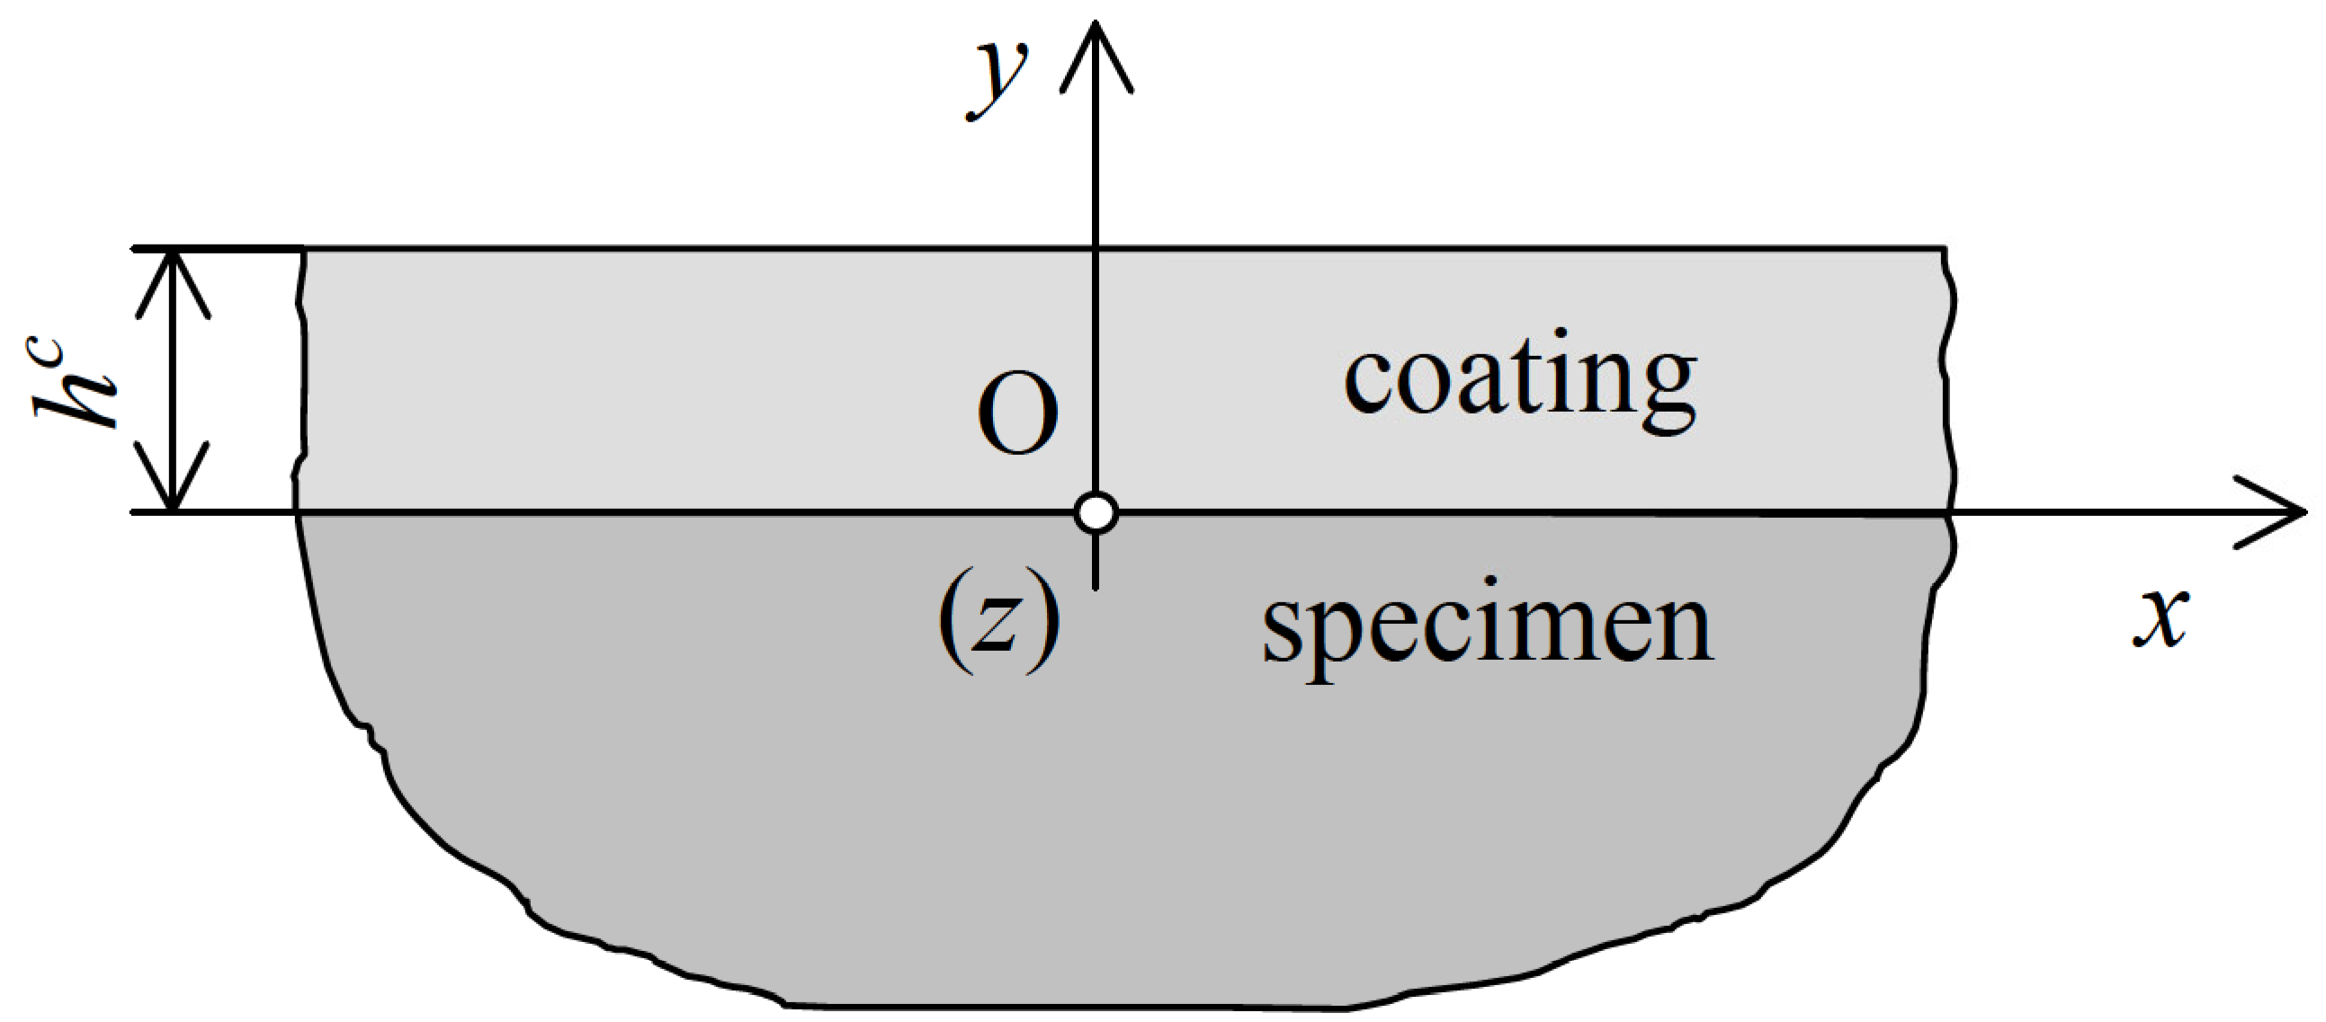
Fig. 1 Single figure example
- Figures should be inserted “In line with text” (see Format object, Layout) if possible, containing a paragraph formatted using Fig_body style. Figures could be aligned to the left/right side with the text wrapping enabled if the author finds it necessary.
- Twin figures should be formatted using twin_picture_body style (with tabs).
- Twin figure captions should be formatted using twin_pictures_caption style (positioned with tabs).
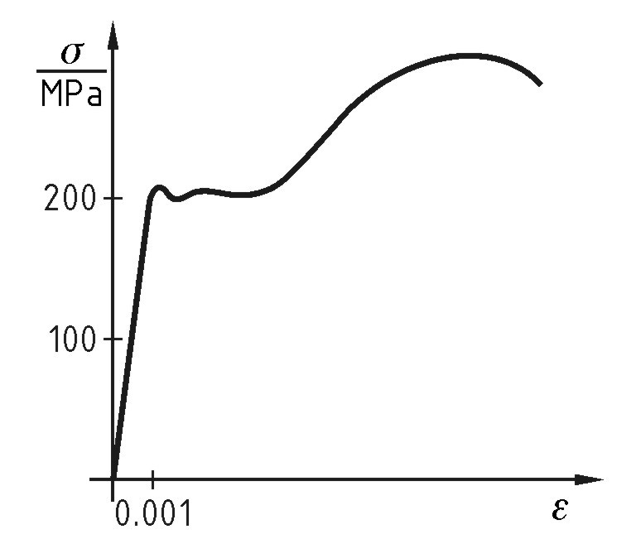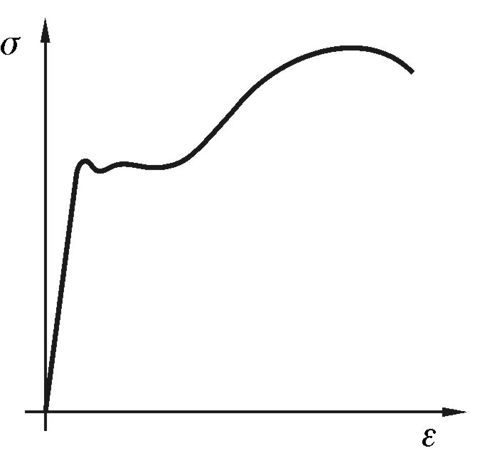
Fig. 2 First figure example Fig. 3 Second figure example

Tables
Tables should be left aligned or centred; inside grid thickness of ½ pt and border of 1 pt. The grid could be also omitted. Additional changes inside tables (merging cells, different thickness, etc.) can be made as authors find convenient. The text and numbers inside the tables should be formatted using Body Text style (the one without hanging), aligned as needed.
Table 1 Explanation of table content (Table_caption style), in this case ways of entering units into tables
Sliding speed v_{g} | Centre distance a |  | Density | F/N
1…7.5 m/s | 65…160 mm |  | 7,850 | 1,000
If the text follows a table, 12 pt space before should be applied.

Equations
Equations should be written in MS Equation or similar math editor, compatible with MS Word, using the size settings as follows:
- Full 12pt,
- Subscript/Superscript 9pt,
- Sub-Subscript/Superscript 6pt,
- Symbol 18pt,
- Sub-Symbol 12pt.
Equations should be formatted using equation_1 style with tabs, spaced before and after with 6pt in general, indented 20 mm from left (defined within the style).
$a=b+c$ (1)
Equation numbers on the right side should be entered manually.
REFERENCES
Submitted: date  Accepted: | Author 1  Author 2  Facility and address  or  Author 1  Facility 1 and address  Author 2  Facility 2 and address
- References should be formatted using REF_Body style to look as presented. Long references will spread across lines.
- Reference 2.
- Reference 3. …
- In the table positioned at the bottom of the last page supply authors data and submission date only. E-mail address of the corresponding author can be supplied as well.

