TITLE OF THE PAPER
(16 PT, BOLD, CAPITAL LETTERS)
(14 pt)
Name1 Surname1¹∗ – Name2 Surname2² – Name3 Surname3³ (11pt, bold)
(14 pt)
¹Department Name, Faculty Name, University Name, Address (10 pt)
²Department Name, Faculty Name, University Name, Address
³Department Name, Faculty Name, University Name, Address
(10 pt)
ARTICLE INFO (10 pt, bold) … filled by the publisher |  | Abstract: (10 pt, bold italic)
Article history: (10 pt, bold italic)  Received:  Received in revised form:  Accepted: |  | The abstract should not contain more than 250 words including objective, methods, procedures, experimental investigations as well as main outcomes and results. Do not cite references and do not use abbreviations in the abstract.
Keywords: (10 pt, bold italic, max 6 keywords)
Keyword1
Keyword2
Keyword3
DOI:
(11 pt)
- Introduction (12 pt, bold)
(5 pt)
  - Manuscript preparation (11 pt italic)
(5 pt)
Journal article submission implies that the article is not simultaneously considered for publication elsewhere, should be original and previously unpublished. Author is responsible for the data presented in his article. Manuscript to be published in the journal Engineering Review should be written in British English. Submission should be made using the online manuscript submission system. Please register yourself at the journal web site. You can upload your manuscript after logging in as an author.
For manuscript preparation only A4 paper format in Microsoft Word should be used and file should be saved in .doc, .docx or .rtf (Rich Text Format) format. Manuscript should be written in the third person, in a metrological correct way, using SI units and allowed terminology. The manuscript should be written using Times New Roman with font size 11 pt. Single line spacing in the form of single column text should be used and indentation of the first row should be set to 0.6 cm. The whole manuscript (including figures, tables etc.) should have at least 6 pages. Corresponding author’s personal information should be placed in the footnote at the first page of the manuscript by double-clicking on the asterisk or as editing the simple text.
(11 pt)
- Experimental investigation
(5 pt)
  - Basic information
(5 pt)
The margin at top should be set to 3.5 cm, while bottom, left and right margin should be set to 2 cm. The header position from the top should be set at 2.3 cm. The text of the paper should be arranged in sections and when necessary into subsections. Sections should be numerated with one Arabic numeral, and subsection with two Arabic numerals e.g. 1.1, 1.2, 1.3 etc. The paper's title should be brief and informative, it must also clearly describe the paper's subject matter.
(11 pt)
  - Additional Information
(5 pt)
The equation should be written in the MathType Equation Editor and positioned in the middle of the single text column. All equations should be numerated in brackets on the right side, as follows:
(11 pt)
(1)
(5 pt)
(2)
(11 pt)
The settings that should be adjusted within the MathType Equation Editor are shown in Figure 1. Text, functions, variables, matrix – vectors, and number should be written in Times New Roman font. Furthermore, all variables must be written in italic, and matrix – vectors in bold.
(11 pt)
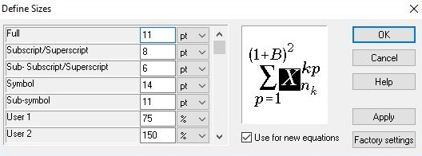
(5 pt)
Figure 1. Defined MathType settings
(11 pt)
Each figure (drawing, diagram, and photograph) must have a title at the bottom, e.g. in Figure. 2 (Times New Roman italic font 11 pt). The following formats are recommended: JPG/JPEG, PNG, TIFF and BMP. All images must be acquired with a minimum resolution of 600 dpi. All descriptions placed on the figure must be readable, clear, and minimal 10 pt font size should be used.
(11 pt)
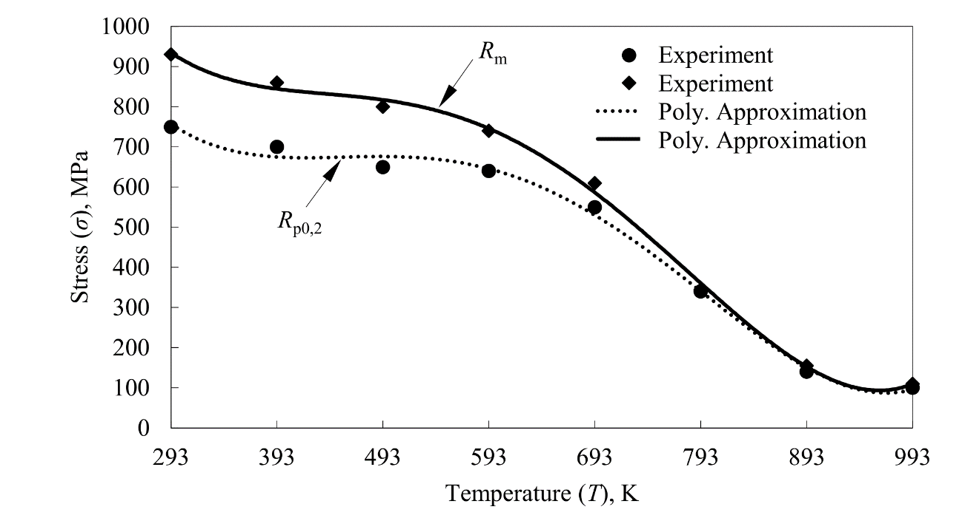
(5 pt)
Figure 2. Strength dependence on temperature for material xxx.
(11 pt)
Table must have a title at the top, e.g. in Table 1 (Times New Roman italic font 11 pt). When creating a table, it is recommended to use the style shown in Table 1. Visibility between rows, in case when there is a larger amount of data displayed by the table, can be improved by shading in lighter shades of grey colour. Numbers written in decimal form should be separated by decimal point.

(11 pt)
Table 1. Achieved result for STT and GMAW processes.
(5 pt)
 | Arc time, min | Heat input, J/mm | Electrical energy consumption, kWh
STT 1 | 3.42 | 725.2 | 0.74
STT 2 | 3.54 | 712.6 | 0.72
STT 3 | 3.86 | 695.5 | 0.69
STT 4 | 4.32 | 650.7 | 0.66
STT 5 | 4.50 | 638.4 | 0.61
STT 6 | 4.89 | 605.3 | 0.54
STT 7 | 5.17 | 580.6 | 0.43
STT 8 | 5.48 | 551.2 | 0.37
STT 9 | 5.91 | 537.4 | 0.29
STT 10 | 6.05 | 513.9 | 0.21
MAG / GMAW | 7.33 | 825.6 | 0.337
(11 pt)
- Results and discussion
(5 pt)
The Editor/Editorial Board may reserve the right to decide whether a paper is acceptable for publication, and if necessary, may require changes to the content, length, or language.
(11 pt)
- Conclusion
(5 pt)
Conclusion should summarize main results of the paper. In the case when the list of notifications is given it should be placed before introduction, but not numerated. Acknowledgement, on the other hand, should be placed prior to the references. References to other papers, books, etc., should be arranged according to their appearance from the beginning of the text using square brackets, and must be listed at the end of the paper. All used references in the paper should be cited according to IEEE referencing style [1]. When citing several sources at once, each reference should be placed separately, in its own brackets, with a comma placed between them, e.g. [1], [2] or [1] - [5]. Citation according to the previously mentioned style is possible using reference management software such as Mendeley.
(11 pt)
References
(5 pt)
[1] See https://pitt.libguides.com/citationhelp/ieee
[2] E. R. Tufte, “The visual display of quantitative information,” IEEE Power Eng. Rev., vol. 8, no. 2, p. 20, 1988, doi: 10.1109/MPER.1988.587534. (Book)
[3] H. Attar, M. Calin, L. C. Zhang, S. Scudino, and J. Eckert, “Manufacture by selective laser melting and mechanical behavior of commercially pure titanium,” Mater. Sci. Eng. A, vol. 593, pp. 170–177, 2014, doi: 10.1016/j.msea.2013.11.038. (Journal article)
[4] H. Wasel, S. Mingle, and I. Hassoun, “A Novel Design and Analysis of C-Shaped Thickness of Metamaterial for Multi-Band Microwave Applications,” 1st Int. Conf. Adv. Res. Eng. Sci. ARES 2018, pp. 1–5, 2018, doi: 10.1109/ARESX.2018.8723290. (Conference paper)
[5] J. Lach, "SBFS: Steganography based file system," in Proc. of the 2008 1st Int. Conf. on Information Technology, IT 2008, 19-21 May 2008, Gdansk, Poland [Online]. Available: IEEE Xplore, http://www.ieee.org. [Accessed: 28 Sept. 2020]. (Conference paper from the internet)

∗ Corresponding author E-mail address:

